# AR Remediation Plan – Rational Number- Estimation and Operations

### Division of Fractions – Investigating Using Paper Folding

### STRAND: Computation and Estimation

### STRAND CONCEPT: Rational Number -Estimation and Operations

### SOL 6.5a

#### Remediation Plan Summary

Students use paper folding to investigate division with fractions. This is only an introduction but will help students start to formulate a rule/generalization and understand that fraction division is the same as whole number division in that the “whole” is being separated into equal groups.

#### Common Misconceptions

* Some students use their whole number understanding and believe the quotient gets smaller when dividing by a fraction.
* Some students confuse division with multiplication when using models or real world examples.

#### Materials

Candy Bar Model - Introductory Activity, blank paper, divided paper (template provided below)

#### Introductory Activity

Students complete the Candy Bar Model Introductory Activity independently. Once students are finished their first attempt, have students discuss their answers with a partner. Conduct a whole class discussion on the math sentences the students created. Ask, “*How did you determine what procedure was appropriate?”*

#### Plan for Instruction

1. Hand each student a piece of blank paper. Have them fold it in half and draw a line down the fold. Ask*, “How many half size sections did you make out of the whole sheet of paper?”* Have students discuss the group size () and how many groups were created. Next, display the equation 1 divided by  = 2 and ask, *“How does the model support this equation?”*

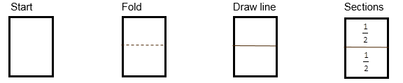

1. Have students fold the paper in half again so there are 4 equal sections. (The fold should be in the opposite direction.) Have them draw a line on the new fold. Ask, *“How many  size sections did you create?”* Have students write in each section. Display the equation 1 divided by  = 4. Have students discuss how the model support the equation?”

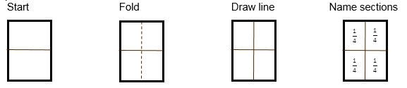

1. Have students either cut or tear the paper on one of the folds so they have two halves with a line down the middle and written on each section. Ask, *“How many  sections were created on half of the paper*? Display the equation  divided by  equals 2. Have a class discussion on how the model represents the equation. Ask, *“does anyone see a pattern or can anyone make a generalization?”*

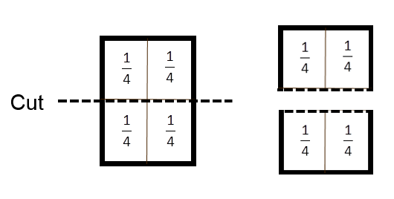

1. Hand each student a piece of paper which is divided into 3 equal parts. Have them fold the dotted line. Ask*, “How many  size sections did you make out of the whole sheet of paper?”* Have students discuss the group size () and how many groups were created. Next, display the equation 1 divided by  = 3 and ask, *“How does the model support this equation?”*
2. Have students fold the paper in half so there are 6 equal sections. (The fold should be in the opposite direction.) Have them draw a line on the new fold. Ask, *“How many  size sections did you create?”* Have students write ** in each section. Display the equation 1 divided by ** = 6. Have students discuss how the model support the equation?”
3. Ask students, “How would I represent divided by ? How about  divided by ? Give students time to use the model and discuss their ideas with a partner.

* If students are struggling to understand with just the paper, use real examples to help them visualize the problem.

#### Pulling It All Together (Reflection).

How would you model divided by ? Use pictures and words to help you explain your reasoning.

**Note: The following pages are intended for classroom use for students as a visual aid to learning.**

Virginia Department of Education 2018

**Candy Bar Model - Introductory Activity**

Bazinga Chocolate Company makes candy bars divided into 12 sections as illustrated below. Use the candy bar to answer the questions.

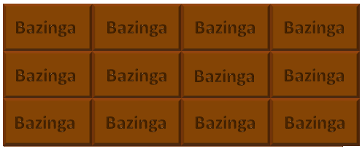

1. John wants to share one candy bar with himself and 2 friends. What fraction of the candy bar will each person get? Write a number sentence to model the situation and justify it with words.
2. Mary wants to give each of her friends of one candy bar. How many friends can she give a piece? Write a number sentence to model this situation and justify it with words.

Divided Paper