Attachment B, Memo No. 2019-2020-15

September 20, 2019

Instructions for Uploading Direct Certification Excel Spreadsheet to SSWS
- Log in to SSWS. At the main menu, in the gray column to the right, scroll down to Dropbox. Click the link to enter the Dropbox.
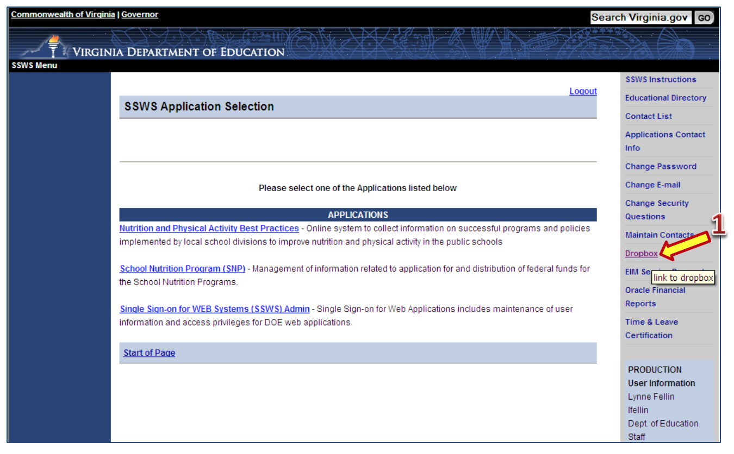

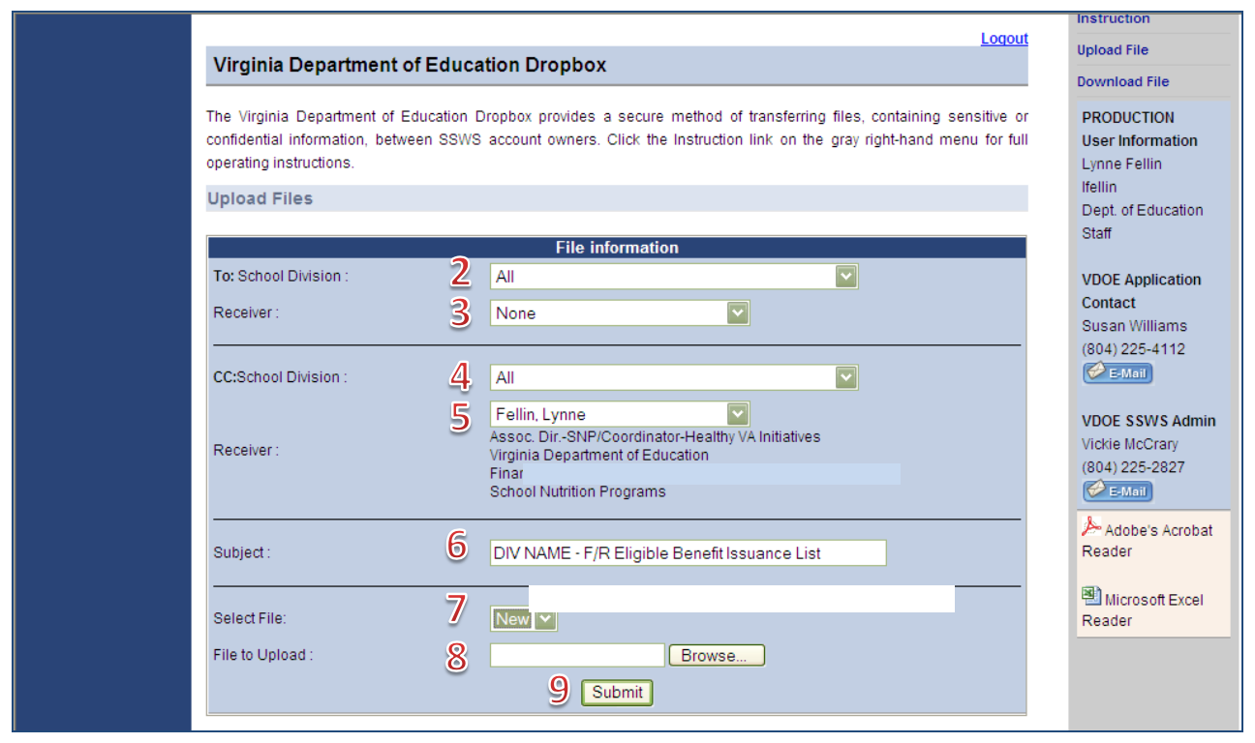
- In the To: School Division field, leave it set to All.
- In the Receiver field, select the name of the person who should receive the file (Fellin, Lynne) from the dropdown list.
- In the CC: School Division field, leave it set to All.
- In the second Receiver field, select the person who should be copied on the file (Patterson, Karen).
- In the Subject field, enter the name of the file being sent: “(Name/Number of Private SFA) Student Enrollment for DC”.
- In the Select File field, leave it set to New.
- In File to Upload field, select Browse then find the file on your computer and select it.
- Important: Before submitting the file, check the Receiver fields (numbers 3 and 5) to be sure the correct persons are selected. If not, this confidential information could be sent to the wrong person, breaching the confidentiality. Select Submit to send the file.

