Skill | Expert  Wow, Awesome!  Exceptional Understanding  Exceeds the standard  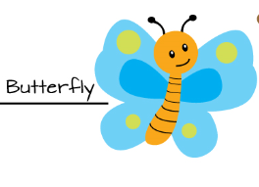 | Practitioner  Got it!  Strong understanding  Meets the standard  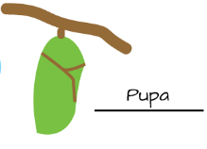 | Apprentice  Almost.  Student has some understanding  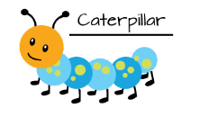 | Novice  Getting started.  No or little understanding  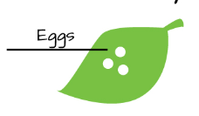
Questioning | I asked a question that can be investigated and know what data needs to be collected.  I predicted an outcome to a question and I used what I learned in science to explain my prediction. | I asked a question that can be investigated and know what data needs to be collected.  I predicted an outcome related to the question. | I asked a question that can be investigated but need help in determining what data needs to be collected.  I predicted an outcome but it was not related to the question. | I did not have a question that could be answered through an investigation.  I could not predict an outcome to the question.
Investigating | I worked with my team to determine the steps in the experiment and then was able to follow the steps to complete the investigation. | I used science tools and followed all the steps in the experiment. | I followed most of the steps in the experiment.  I tried to use my science tools | I mixed up my steps.  I did not use my science tools.
Recording and Interpreting Data | My data is complete, I recorded the data correctly in tables and graphs. I also identified patterns in the data or recognized data that did not follow a pattern. | My data is complete and I recorded it in the correct tables and graphs. | My data is started but is not in right place on the tables or graphs. | I have no data
Explaining | I recorded and shared my ideas, related them to what we have learned in class, and can suggest how these ideas can fit in to other science content. | I recorded and shared my ideas using science terms and relate it to what we have learned in class. | I started to record and share my ideas but I am not sure how it fits in to what we are learning. | I did not record or share my ideas.
Communicating | I accurately explained my results, used evidence from the investigation to support my results, and used science concepts to support the results. | I was able to explain my results and used evidence from the investigation to support my results. | I explained my results but did not use evidence in my explanation | I did not accurately explain the results of the experiment.

