Attachment A, SNP Memo No. 2020-2021-52

March 16, 2021

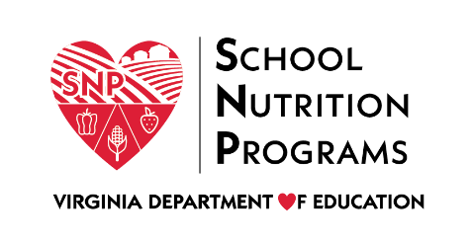

Meal Pattern Compliance Attestation Form
School Food Authority: Click or tap here to enter text.
As the authorized representative of the organization listed above, I do hereby attest that the aforementioned school food authority (SFA) and all schools under its jurisdiction applying to operate the National School Lunch Program and/or the School Breakfast Program will be compliant with the meal pattern requirements as set forth in 7 CFR Part 210.10 and 220.23.
I also attest to the following:
- Documentation submitted for certification is representative of the planned meal service within the SFA.
- If and when menu changes occur, meal pattern compliance will be reassessed.
- The minimum required food quantities for all meal components will be available to students in every serving line.
- All labels and/or manufacturer specifications for food products and ingredients used to prepare school meals will indicate zero grams of trans fat per serving.
- All pre-K meals are compliant with the current meal patterns for the age/grade group being served, as applicable.
I certify that this attestation is true and correct, and therefore, I believe the SFA is eligible for performance-based reimbursement. I understand that if the state agency determines the SFA to be noncompliant with one or more of the requirements set forth in this attestation statement, fiscal action will include, deactivating the performance-based reimbursement, disallowance of meals, and/or withholding of payment.

Attestation of Superintendent or Executive Director
Name: Click or tap here to enter text.
Title: Click or tap here to enter text.
Signature:
Date: Click or tap here to enter text.

