Attachment A, SNP Memo No. 2020-2021-50

March 5, 2021

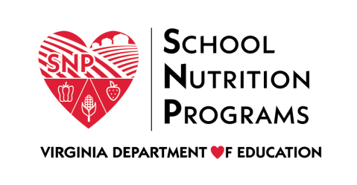

2021 Virtual Spring Regional Meeting

Agenda

Meeting Dates
- Tuesday, April 20: Regions 1, 2, 3, and 8
- Thursday, April 29: Regions 4, 5, 6, and 7

Agenda
Time | Topic | Presenter(s)
8:30-8:45 a.m. | Welcome, Cameo, and School Breakfast Highlights | Sandy Curwood, Kelly Shomo
8:45-9:15 a.m. | Triennial Assessment and Updating Your Local School Wellness Policy | Laura Burns
9:15-9:45 a.m. | Governor’s Scorecard on Nutrition and Physical Activity | Kelly Shomo, Laura Burns, Sandy Curwood
9:45-10:15 a.m. | Farm to School Data Collection | Trista Grigsby
10:15-10:25 a.m. | Break
10:25-11:10 a.m. | Equity in School Nutrition Programs: Part 2 | Ron Walters
11:10 a.m.-12:10 p.m. | Procurement Review Panel | Joy Washington
12:10-12:40 p.m. | Lunch
12:40-1:40 p.m. | Meal Distribution Best Practices | Catherine Spacciapoli
1:40-2:40 p.m. | Boosting Morale during Challenging Times | Laura Burns
2:40-2:50 p.m. | Break
2:50-3:15 p.m. | Virginia Food for Virginia Kids | Kelly Shomo/Sandy Curwood
3:15-3:45 p.m. | Advisory Council Updates | Advisory Council Members
3:45-4:30 p.m. | Regulation Updates | Courtney Jones/Lynne Fellin

