Attachment B, SNP Memo #2020-2021-39

January 12, 2021
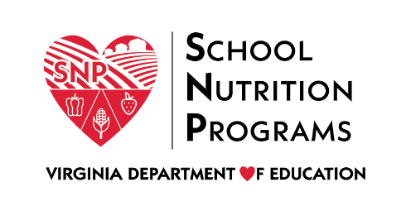

Child Nutrition Programs Advisory Council Application
The Virginia Department of Education, Office of School Nutrition Programs (VDOE-SNP) Child Nutrition Programs (CNP) Advisory Council was developed to promote leadership and collaboration between school and community organizations that sponsor the Summer Food Service program (SFSP) and the At-Risk component of the Child and Adult Care Food Program (CACFP) and the VDOE-SNP. School and community nutrition partners, stakeholders, and the VDOE-SNP will work together by sharing successful strategies; by addressing local, regional, and state resources, program implementation, and training needs; and by improving processes and communications within the state.

General Information
Sponsoring Organization’s Name: Click or tap here to enter text.
Applicant’s Name: Click or tap here to enter text.
Applicant’s Position Title: Click or tap here to enter text.
Applicant’s Email: Click or tap here to enter text.
Applicant’s Phone Number: Click or tap here to enter text.

Provide a brief explanation for the following questions:
Describe your strengths in child nutrition program operations that will make you a good candidate for the CNP Council.
Click or tap here to enter text.
How do you envision the council improving child nutrition programs in the state of Virginia?
Click or tap here to enter text.

Commitment Statement
I certify that I will promote leadership and collaboration between sponsors, the VDOE-SNP, and school nutrition partners and stakeholders by sharing my knowledge, skills and abilities in developing successful strategies.
I will work with local, regional, and state resources to facilitate program training needs and improve processes and communications within the state.

Signature

Date
Please submit this application to Maggie Parker, CNP Manager, at maggie.parker@doe.virginia.gov.

