Attachment D, SNP Memo #2020-2021-31

October 22, 2020

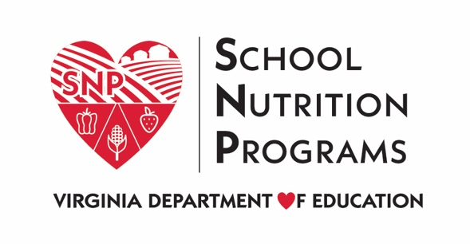

School Year 2020-2021 Waivers - NSLP
Waiver Title | Description | Sponsor Actions | Data Requirements
Nationwide Waiver to Allow Non-congregate Feeding in the Child Nutrition Programs | Program regulations require that participants consume meals onsite in the child nutrition programs. This waiver allows meals to be taken offsite for consumption.  Effective: July 1, 2020 through June 30, 2021 | School food authorities (SFAs) must request to elect this waiver from the VDOE by completing the 2020-2021 School Nutrition Waiver Survey. | - A summary of the use of the waiver by the state agency and local program operators.  - A description of whether and how this waiver resulted in improved services to program participants.
Nationwide Waiver to Allow Meal Service Time Flexibility in the Child Nutrition Programs | Program regulations set meal time restrictions for child nutrition programs. This waiver supports access to nutritious meals by eliminating the meal time requirements.  Effective: July 1, 2020 through June 30, 2021 | SFAs must request to elect this waiver from the VDOE by completing the 2020-2021 School Nutrition Waiver Survey. | - A summary of the use of the waiver by the state agency and local program operators.  - A description of whether and how this waiver resulted in improved services to program participants.
Nationwide Waiver to Allow Parents and Guardians to Pick-up Meals for Children | Program regulations site specific times must pass between meals. This waiver allows for sponsors to serve meals that best meet their program needs. This can be through approved pick-up times or delivery plans with designated times for distribution.  This waiver requires an approved non-congregate waiver.  Effective: July 1, 2020 through June 30, 2021 | NSLP sponsors must request to elect this waiver from the VDOE by completing the 2020-2021 School Nutrition Waiver Survey. | - A summary of the use of the waiver by the state agency and local program operators.  - A description of whether and how this waiver resulted in improved services to program participants.
Nationwide Waiver to Allow Meal Pattern Flexibility in the Child Nutrition Programs | Program regulations require that sponsors follow a prescribed meal pattern. During the public health emergency, sponsors can apply to the state agency for flexibilities in the meal pattern. Under normal emergency feeding, the USDA would have to approve these flexibilities; this waiver allows the state agencies to approve requests from sponsors to waive meal pattern requirements.  This requires justification and approval from the VDOE before implementation.  Effective: July 1, 2020 through June 30, 2021 | SFAs must request to elect this waiver from the VDOE by completing the 2020-2021 School Nutrition Waiver Survey. | - A summary of the use of the waiver by the state agency and local program operators.  - A description of whether and how this waiver resulted in improved services to program participants
Nationwide Waiver to Allow Offer Versus Serve Flexibility for High Schools in the NSLP for School Year (SY) 2020-2021 | Program requirements mandate that high schools participating in the NSLP must participate in Offer Versus Serve (OVS). This waiver allows program operators to opt out of the OVS requirement.  Effective: July 1, 2020 through June 30, 2021 | SFAs must request to elect this waiver from the VDOE by completing the 2020-2021 School Nutrition Waiver Survey. | - A summary of the use of the waiver by the state agency and local program operators.  - A description of whether and how this waiver resulted in improved services to program participants.
State Agency and SFAs  Nationwide Waiver of Onsite Monitoring Requirements in the Schools Meals Programs | This waiver allows SFAs to conduct their accountability reviews offsite. It also allows the VDOE to conduct their administrative reviews offsite.  Effective from July 1, 2020 through June 30, 2020 | SFAs must request to elect this waiver from the VDOE by completing the 2020-2021 School Nutrition Waiver Survey. | - A summary of the use of the waiver by the state agency and local program operators.  - A description of whether and how this waiver resulted in improved services to program participants.
Nationwide Waiver to Allow Summer Food Service Program (SFSP) and Seamless Summer Option (SSO) Operations through June 2021 | This waiver allows states to grant approval for SFAs to operate the SFSP and SSO.  Effective through June 20, 2021. | SFAs must complete the 2020-2021 SFSP/SSO Waiver Survey to notify the VDOE that they are switching to the SFSP or SSO for meal service during the first half of the school year (through June 31, 2021). | - A summary of the use of the waiver by the state agency and local program operators.  - A description of whether and how this waiver resulted in improved services to program participants.
Questions and Answers for the Child Nutrition Programs during School Year 2020-2021 #5 | This guidance nullifies the 2018 Final Rule entitled Child Nutrition Program: Flexibilities for Milk, Whole Grains, and Sodium Requirements. The NSLP meal pattern must return to the requirements of the 2012 Final Rule, requiring that flavored milk only be nonfat, all grains offered must be whole grain-rich, and Target 2 weekly sodium levels must be met for breakfast and lunch.  Effective immediately | SFAs may request to elect this waiver from the VDOE by completing the 2012 Nutrition Standards Final Rule Waiver Survey. | - A summary of the use of the waiver by the state agency and local program operators.  - A description of whether and how this waiver resulted in improved services to program participants.

