Attachment A, SNP Memo #2020-2021-30

October 13, 2020

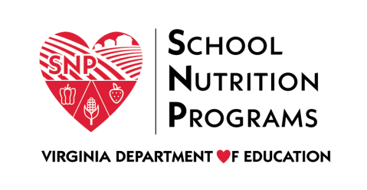

2020 Virtual Fall Regional Meeting

Agenda

Meeting Dates
- Wednesday, November 4: Regions 1 and 8
- Thursday, November 5: Regions 2 and 3
- Tuesday, November 10: Regions 4 and 5
- Thursday, November 12: Regions 6 and 7

Agenda
Time | Topic | Presenter(s)
9:00-9:10 a.m. | Introduction/Overview | Sandy Curwood, Kelly Shomo, Regional Specialists
9:10-9:15 a.m. | 4th Annual Crunch Heard ‘Round the Commonwealth Photo Slideshow | Kelly Shomo
9:15-10:15 a.m. | Program Spotlights, Accomplishments, P-EBT, and Meal Service Data | Catherine Spacciapoli, Sarah Steely, Lynne Fellin
10:15-10:25 a.m. | Break
10:25-10:55 a.m. | Creating Positive Work Environments | Laura Burns
10:55-11:25 a.m. | Strive for 35 (Dairy Alliance) | Roseann Liberatore
11:25-11:55 a.m. | Farm to Breakfast | Trista Grigsby
11:55 a.m.-12:25 p.m. | Lunch
12:25-1:25 p.m. | LSWP, Triennial Assessment, and Governor’s Scorecard | Laura Burns, Sandy Curwood, Kelly Shomo
1:25-1:35 p.m. | Break
1:35-2:05 p.m. | Advisory Council Updates and Recruitment | Sandy Curwood, Maggie Parker
2:05-2:35 p.m. | Q&A/Listening Session with Regional Specialists | Regional Specialists
2:35-3:05 p.m. | Equity in School/Child Nutrition Programs | Ron Walters, Casey Dickinson
3:05-4:05 p.m. | SFSP Training | Maggie Parker/CNP Team
4:05-4:50 p.m. | CACFP Training | Maggie Parker/CNP Team

