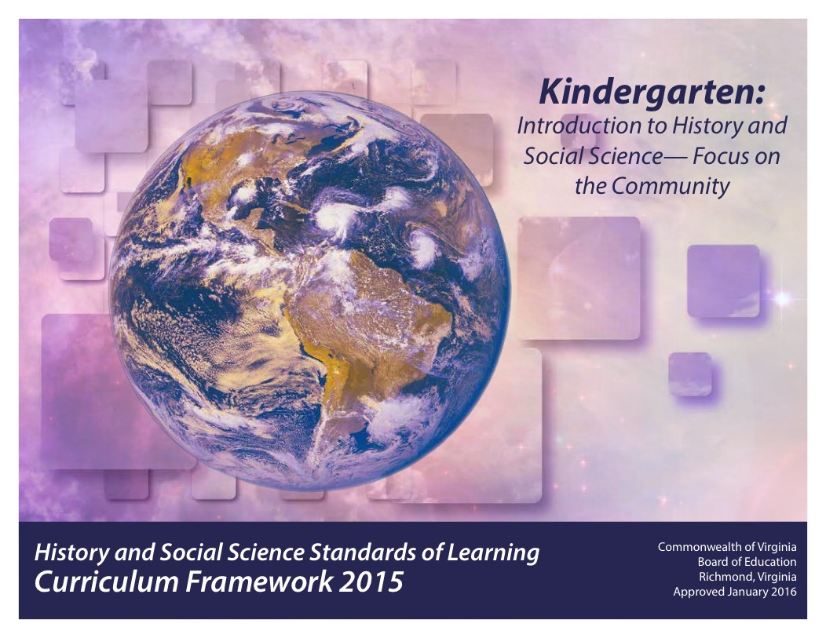
Updated: December 2020

Copyright © 2016
by the
Virginia Department of Education
P. O. Box 2120
Richmond, Virginia 23218-2120

All rights reserved. Reproduction of these materials for instructional purposes in public school classrooms in Virginia is permitted.

Superintendent of Public Instruction
Steven R. Staples
Chief Academic Officer/Assistant Superintendent for Instruction
John W. “Billy” Haun

Office of Humanities and Early Childhood
Christine A. Harris, Director
Christonya B. Brown, History and Social Science Coordinator
Betsy S. Barton, History and Social Science Specialist

NOTICE
The Virginia Department of Education does not unlawfully discriminate on the basis of race, color, sex, national origin, age, or disability in employment or in its educational programs or services.

INTRODUCTION
The History and Social Science Standards of Learning Curriculum Framework 2015, approved by the Board of Education on January 28, 2016, is a companion document to the 2015 History and Social Science Standards of Learning for Virginia Public Schools. The Curriculum Framework amplifies the Standards of Learning by defining the content understandings, knowledge, and skills that are measured by the Standards of Learning assessments.
The standards and Curriculum Framework are not intended to encompass the entire curriculum for a given grade level or course, nor to prescribe how the content should be taught. School divisions are encouraged to incorporate the standards and Curriculum Framework into a broader, locally designed curriculum. The Curriculum Framework delineates in greater specificity the minimum content that all teachers should teach and all students should learn. Teachers are encouraged to go beyond the standards and select instructional strategies and assessment methods appropriate for their students. Additional details such as the names of historical figures whose study further enriches the standards and clarifies the concepts under investigation will be found in the Curriculum Framework.
The Curriculum Framework facilitates teacher planning by identifying essential understandings, knowledge, and skills. Together, these key elements provide the focus of instruction for each standard. The purpose of each section is explained below:

Standard of Learning Statement
Each page begins with a Standard of Learning statement as a focus for teaching and learning. Students will apply social science skills to understand the interrelationships between the history, geography, economics, and civics content, as well as become actively engaged in their learning.

Essential Skills (Standard 1)
The essential history and social science skills are outlined in Standard 1 for each grade level or course. Students use these skills to increase understanding of the history and social sciences content, including historical, geographic, political, and economic events or trends. The development of these skills is important in order for students to become better-informed citizens.
The first column for Standard 1 contains “Essential Understandings,” which are described below. The second column contains examples of how the skill may be applied in the classroom.

Note: The skills will not be assessed in isolation; rather, they will be assessed as part of the content in the History and Social Science Standards of Learning.

Essential Understandings
This column includes the fundamental background information necessary to acquire and apply the essential knowledge. The understandings should help students develop a sense of context, including why the essential knowledge is relevant to the standard; thus, teachers should use these understandings as a basis for lesson planning.

Essential Knowledge
This column delineates the key content facts, concepts, and ideas that students should grasp in order to demonstrate understanding of the standard. This information is not meant to be exhaustive or a limitation on what is taught in the classroom. Rather, it is meant to be the principal knowledge defining the standard.

The Curriculum Framework serves as a guide for Standards of Learning assessment development; however, assessment items may not and should not be verbatim reflections of the information presented in the Curriculum Framework.

STANDARD K.1a
The student will demonstrate skills for historical thinking, geographical analysis, economic decision making, and responsible citizenship by
a) viewing artifacts and primary and secondary sources to develop an understanding of history;
Essential Understandings
Viewing artifacts and primary and secondary sources involves making observations and asking questions.
An artifact is an object or tool that reveals something about the past.
A primary source is an artifact, document, image, or other source of information that was created during the time under study.
A secondary source is a document, image, or other source of information that relates or discusses information originally presented elsewhere.
Experiences may include but are not limited to the following:
- View works of art, such as a mural or statue from the local community.
- View maps of the local community.
- View photographs from the past and from the present depicting people working in the local community.
- View photographs of an American flag from long ago.
- Listen to or talk with citizens from the local community about life in the past.

STANDARD K.1b
The student will demonstrate skills for historical thinking, geographical analysis, economic decision making, and responsible citizenship by
b) using basic map skills to support an understanding of the community;

Essential Understanding
Maps help develop an awareness of where places are located in the community.
Using a map involves making observations and connections, asking questions, and reflecting.

Experiences may include but are not limited to the following:
- Make simple observations and ask questions about where places are located in the community.
- Use a map (may be digital) or a globe to identify the location of places referenced in stories and real-life situations.
- Create a simple map of the classroom, playground, or neighborhood.
- Explain how colors are used to show land and water features on maps and globes.
- Compare maps of the local community from the past and from the present.
- Share examples of how communities across the state and country are diverse and celebrate their diverse community members.

STANDARD K.1c
The student will demonstrate skills for historical thinking, geographical analysis, economic decision making, and responsible citizenship by
c) gathering and classifying information, sequencing events, and separating fact from fiction to improve understanding of the community;

Essential Understandings
Gathering information involves using a variety of resources.
Classifying information involves grouping like information.
Sequencing events involves placing events in chronological order.
Separating fact from fiction involves determining whether or not information can be proven with evidence.

Experiences may include but are not limited to the following:
- Listen to community members, of diverse backgrounds, discuss events, stories, and narratives to learn about the community.
- Sequence events from the past that show how the community has changed over time.
- Create a timeline with five events from the life of a student or a community member.
- Create a list of statements about the community. Sort them according to which ones can be proven with evidence and which cannot.

STANDARD K.1d
The student will demonstrate skills for historical thinking, geographical analysis, economic decision making, and responsible citizenship by
d) asking appropriate questions to solve a problem;

Essential Understandings
Asking a variety of questions extends learning and deepens understanding.

Experiences may include but are not limited to the following:
- Create a simple survey or questionnaire to gain a deeper understanding of the local community.
- Ask adults in the community a variety of questions about a community issue.
- Create a class story proposing solutions to a problem.

STANDARD K.1e
The student will demonstrate skills for historical thinking, geographical analysis, economic decision making, and responsible citizenship by
e) comparing and contrasting people, places, or events;

Essential Understandings
Comparing and contrasting examines similarities and differences among people, places, or events.
Communities have different physical and cultural characteristics.

Experiences may include but are not limited to the following:
- Discuss how community helpers are alike and different in the services they provide.
- Use positional words such as near/far, above/below, behind/in front of, and left/right to describe how places are alike and different.
- Compare maps and images of the local community from the past and from the present.
- Create a Venn diagram to compare how holidays are celebrated.

STANDARD K.1f
The student will demonstrate skills for historical thinking, geographical analysis, economic decision making, and responsible citizenship by
f) recognizing direct cause-and-effect relationships;

Essential Understandings
A cause-and-effect relationship is a relationship in which one event (the cause) makes another event (the effect) happen.
Cause-and-effect relationships can be observed in the classroom, school, and community.

Experiences may include but are not limited to the following:
- Explain how the location, climate, and physical surroundings of the community affected the way people met basic wants (e.g., food, clothing, shelter) in the past and how they meet them in the present.
- Discuss the effects of following or breaking a classroom rule.
- Draw pictures to show the effects of helping others.

STANDARD K.1g
The student will demonstrate skills for historical thinking, geographical analysis, economic decision making, and responsible citizenship by
g) making connections between past and present;

Essential Understandings
Everyday life in our community today is different from everyday life long ago.
People, events, and developments have brought changes to the community.

Experiences may include but are not limited to the following:
- Read stories about the community in the past.
- Show images of foods, clothing, and houses from the past and make connections to foods, clothing, and houses of the present.
- Discuss how community jobs have changed over time.
- Use maps from the past and from the present to show how the community boundaries have changed over time.
- Use maps or images from the past and from the present to show how maps have changed over time.

STANDARD K.1h
The student will demonstrate skills for historical thinking, geographical analysis, economic decision making, and responsible citizenship by
h) using a decision-making model to make informed decisions;

Essential Understandings
Making choices involves getting more of one thing by giving up something else.
All decisions involve costs (disadvantages) and benefits (advantages).
A cost is what you give up when you decide to do something.
A benefit is what satisfies a want.

Experiences may include but are not limited to the following:
Use a decision-making model to discuss the costs and benefits of
- a way to improve the classroom, school, or community
- buying a toy
- choosing a snack
- working in a group
- completing a classroom job
Sample Decision-Making Model
Decision to be made:
Benefits (Advantage) | Costs (Disadvantage)

STANDARD K.1i
The student will demonstrate skills for historical thinking, geographical analysis, economic decision making, and responsible citizenship by
i) practicing good citizenship skills while collaborating, compromising, and participating in classroom activities;

Essential Understandings
The classroom provides opportunities for students to develop the qualities of a good citizen.

Experiences may include but are not limited to the following:
- Identify the importance of classroom chores and determine a way to distribute responsibilities fairly.
- Work in groups to choose among several fruits for a snack, demonstrating how people must choose something and give up something else when they cannot have everything they want.
- Take turns while playing a matching game.
- Create a classroom or school map, having each student draw a location on the map.

STANDARD K.1j
The student will demonstrate skills for historical thinking, geographical analysis, economic decision making, and responsible citizenship by
j) developing fluency in content vocabulary and comprehension of oral, written, and visual sources.

Essential Understandings
Developing fluency in social studies vocabulary improves comprehension of oral, written, and visual sources of information about the community.
Comprehending content vocabulary involves using and interacting with a variety of sources.

Experiences may include but are not limited to the following:
- Participate in class discussions about rules and the consequences of following or breaking rules, using new content vocabulary.
- Match pictures of workers with simple descriptions of the work people do.
- Sequence events in oral or written stories about families in the past and in the present.

STANDARD K.2a, b
The student will recognize that history describes events and people from other times and places by
a) identifying examples of historical events, stories, and legends that describe the development of the local community; and
b) identifying people who helped establish and lead the local community over time.

Essential Understandings
History relates events that have already happened.
History teaches us about the interesting lives of people long ago.
Localities in Virginia recognize people who helped establish and lead the local community over time.

Essential Knowledge
Terms to know
- history: Events that have already happened
- community: A place where people live, work, and play

Each local community has a unique history that includes stories and narratives that have developed over time.

Localities recognize people who contributed to the development of the community over time.

Local schools and divisions may determine community-related events, stories, narratives, and people to be studied.

STANDARD K.3
The student will sequence events in the past and present and begin to recognize that things change over time.

Essential Understandings
Everyday life today is different from everyday life long ago.
Stories and people can describe events from the past.

Essential Knowledge
Terms to know
- past: Something that has already happened
- present: What is happening now

Information about events and traditions of the past is gained through the study of Thanksgiving; Martin Luther King, Jr., Day; George Washington Day (Presidents’ Day); Juneteenth (June 19th); and Independence Day (Fourth of July).

Events and traditions can be placed in chronological order to show change over time.

Descriptions of life in the past and in the present can be shared by people through pictures and stories and can show how communities change over time.

STANDARD K.4
The student will describe the relative location of people, places, and things by using positional words, with emphasis on near/far, above/below, left/right, and behind/in front.

Essential Understandings
The location of people, places, and things can be described in terms of their relationship to other people, places, and things.
There are certain words that help us describe where people, places, and things are located.

Essential Knowledge
Terms to know (positional words)
- near, far
- above, below
- left, right
- behind, in front of

Positional words are used daily to describe where people, places, and things are located in relation to each other.

STANDARD K.5a, b, c, d, e
The student will use simple maps and globes to
a) develop an awareness that a map is a drawing of a place to show where things are located and that a globe is a round model of Earth;
b) describe places referenced in historical events, stories, and real-life situations;
c) locate land and water features;
d) identify basic map symbols in a map legend; and
e) identify places and objects of a familiar area.

Essential Understandings
Maps and globes represent Earth and sometimes include map legends.
The location of places referenced in stories and real-life situations can be shown on maps and globes.
Land and water features can be found on maps and globes.

Essential Knowledge
Terms to know
- map: A drawing that shows what a place looks like from above
- globe: A round model of Earth
- model: Something that stands for something else
- symbol: A picture or thing that stands for something else
- map legend: A list of shapes and symbols used on a map and an explanation of what each one stands for

Maps or globes can show the location of places referenced in stories and real-life situations.

Maps can show simple representations of classrooms, playgrounds, neighborhoods, rivers, and oceans.

Land and water features on maps and globes are shown by different colors.

STANDARD K.6a, b, c
The student will develop an awareness that maps and globes
a) show a view from above;
b) show things in smaller size; and
c) show the position of objects.

Essential Understandings
Basic map concepts will help students use maps and globes.

Essential Knowledge
Basic concepts about maps and globes
- Land and water features can be shown on a map as viewed from above.
- Maps and globes show features in a smaller size than they are in real life.
- Locations can be found using a map, globe, geographic tool, or electronic device.

Viewing and using simple maps helps to develop an awareness of where people and things are located in the community.

STANDARD K.7
The student will describe how the location, climate, and physical surroundings of a community affect the way people live, including their food, clothing, shelter, transportation, and recreation.

Essential Understandings
Geography includes the study of locations, climates, and physical surroundings.
Location, climate, and physical surroundings affect the way people live.

Essential Knowledge
Terms to know
- location: Where people live
- climate: The kinds of weather an area has over a long period of time
- physical surroundings: Land and bodies of water present in a given location
- season: Any one of the four phases of the year (spring, summer, fall, or winter)
- transportation: A way of moving people and things from one place to another

Location, climate, and physical surroundings affect the way people in a community meet their basic wants. This includes the
- foods they eat
- clothing they wear
- types of houses they build

Communities use various types of transportation to meet their needs.

Geography affects how people travel from one place to another and determines which recreational activities are available in a location.

STANDARD K.8
The student will match simple descriptions of work that people do with the names of those jobs.

Essential Understandings
People work at jobs.
People work at jobs to earn money to meet their wants.

Essential Knowledge
Examples of jobs
- Doctors and nurses are people who take care of other people when they are sick.
- Construction workers are people who build houses and other buildings.
- Teachers are people who help students learn.
- Chefs are people who prepare meals.
- Farmers are people who grow crops and raise animals.
- Firefighters are people who put out fires.

STANDARD K.9a, b
The student will
a) recognize that people make choices because they cannot have everything they want; and
b) explain that people work to earn money to buy the things they want.

Essential Understandings
People cannot have everything they want. A decision-making model helps people make choices.
People have to make choices about things they want.
People work to earn money and use it to buy the things they want.

Essential Knowledge
Terms to know
- choice: Deciding among two or more things
- wants: Things people would like to have
- money: What people use to buy the things they want (paper bills and coins are examples of money)

When people cannot have everything they want, they must choose something and give up something else.

Sample Decision-Making Model
Decision to be made:
Benefits | Costs

STANDARD K.10a, b, c, d, e, f, g
The student will demonstrate that being a good citizen involves
a) taking turns and sharing;
b) taking responsibility for certain classroom chores;
c) taking care of personal belongings and respecting what belongs to others;
d) following rules and understanding the consequence of breaking rules;
e) practicing honesty, self-control, and kindness to others;
f) participating in decision making in the classroom; and
g) participating successfully in group settings.

Essential Understandings
Good citizens are involved in their homes, schools, and communities.
Good citizens take responsibility for their own actions.
Good citizens participate in making decisions in the classroom.
Good citizens work well with their classmates in groups.
Good citizens help others in their community.

Essential Knowledge
Terms to know
- community: A place where people live

Examples of being a good citizen
- Taking turns
- Sharing
- Completing classroom assignments
- Taking care of one’s things
- Respecting what belongs to others
- Being honest
- Practicing self-control
- Being kind to others
- Participating in making classroom decisions
- Working well with classmates in groups

STANDARD K.11a, b, c, d
The student will develop an understanding of how communities express patriotism through events and symbols by
a) recognizing the American flag;
b) recognizing the Pledge of Allegiance;
c) knowing that the president is the leader of the United States; and
d) recognizing the holidays and the people associated with the holidays Thanksgiving Day; Martin Luther King, Jr., Day; George Washington Day (Presidents’ Day); and Independence Day (Fourth of July).

Essential Understandings
The United States has a national flag.
The United States has a national pledge to the flag.
The United States has a leader, who is called the president.
We celebrate holidays to remember people and events of long ago. Some holidays inspire patriotism.

Essential Knowledge
Term to know
- patriotism: Feeling of respect for and love of country and state

The American flag has white stars on a blue rectangle, and it also has red and white stripes.
The pledge to the American flag is called the Pledge of Allegiance.
The president is the leader of the United States.

Holidays to know
- Thanksgiving Day: This is a day to remember the sharing of the harvest between the American Indians and the Pilgrims. It is observed in November.
- Martin Luther King, Jr., Day: This is a day to remember an African American man who worked so that all people would be treated fairly. It is observed in January.
- George Washington Day (Presidents’ Day): This is a day when we honor all presidents of the United States, especially George Washington. It is observed in February.
- Independence Day (Fourth of July): This is a day to remember when the United States became a country. It is sometimes called America’s birthday. It is observed in July.

Teachers are encouraged to explore and recognize holidays representing Virginia’s diverse populations and cultures.
Juneteenth is traditionally the day that celebrates the end of the enslavement of African Americans in the United States. It is observed on June 19th.

