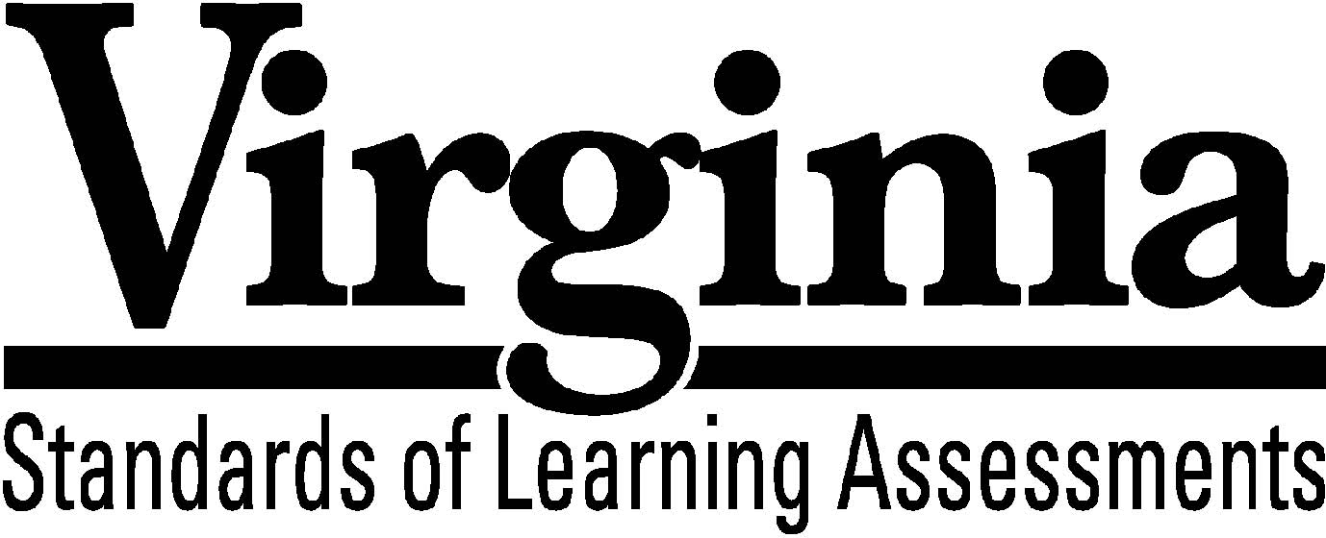
Test Blueprint

Virginia Studies

2015 History and Social Science Standards of Learning

This test blueprint will be effective with the administration of the spring 2020 History and Social Science Standards of Learning (SOL) tests.

Notice to Reader

In accordance with the requirements of the Civil Rights Act and other federal and state laws and regulations, this document has been reviewed to ensure that it does not reflect stereotypes based on race, color, national origin, sex, age, or disability.

The Virginia Department of Education does not discriminate on the basis of race, sex, color, national origin, religion, sexual orientation, gender identity, age, political affiliation, or against otherwise qualified persons with disabilities in employment or provisions of service.

Copyright ©2019 by the Commonwealth of Virginia, Department of Education, P.O. Box 2120, Richmond, Virginia 23218-2120. All rights reserved. Except as permitted by law, this material may not be reproduced or used in any form or by any means, electronic or mechanical, including photocopying or recording, or by any information storage or retrieval system, without written permission from the copyright owner. Commonwealth of Virginia public school educators may reproduce any portion of this test blueprint for non-commercial educational purposes without requesting permission. All others should direct their written requests to the Virginia Department of Education at the above address or by email to Student_Assessment@doe.virginia.gov.
Virginia Studies
Standards of Learning

Test Blueprint

TABLE OF CONTENTS

General Test Information 1
Defines common terms

Test Blueprint Summary Table 2
Organizes the SOL and the number of items assessed

Expanded Test Blueprint 3
Full text of each SOL as organized for the test

General Test Information

Test Blueprint
Much like the blueprint for a building, a test blueprint serves as a guide for test construction. The blueprint indicates the content areas that will be addressed by the test and the number of items that will be included by content area and for the test as a whole. There is a blueprint for each test (e.g., grade 3 reading, grade 5 mathematics, grade 8 science, Virginia and United States History).

Reporting Categories
Each test covers a number of Standards of Learning. In the test blueprint, the SOL are grouped into categories that address related content and skills. These categories are labeled as reporting categories. For example, a reporting category for the Virginia Studies Standards of Learning test is Geography. Each of the SOL in this reporting category addresses the influence geography has had on the history of Virginia. When the results of the SOL tests are reported, the scores will be presented for each reporting category and as a total test score.

Assignment of Standards of Learning to Reporting Categories
Different bullets of a Standard of Learning may be assigned to different reporting categories. For example, Virginia Studies SOL VS.3a, which covers the reasons for English colonization in America, is assigned to the reporting category History in the Virginia Studies SOL test. SOL VS.3b, which involves describing how geography influenced the decision to settle at Jamestown, is assigned to the reporting category Geography.

Coverage of Standards of Learning
Due to the large number of SOL in each grade level content area, every Standard of Learning will not be assessed on every version (form) of an SOL test. By necessity, to keep the length of a test reasonable, each version will sample from the SOL within a reporting category. Every SOL in the blueprint will be tested within a three year period, and all of these SOL are eligible for inclusion on each version of an SOL test.

Use of the Curriculum Framework
The History and Social Science Standards of Learning, amplified by the Curriculum Framework, define the essential understandings, knowledge, and skills that are measured by the Standards of Learning tests. The Curriculum Framework identifies essential understandings, defines essential content knowledge, and describes essential skills students need to master.

Virginia Studies

Test Blueprint Summary Table
Reporting Category | Virginia Studies  Standards of Learning | Number of Items
Assessed with Other SOL | VS.1a-g | blank
History | VS.2f-g  VS.3a, e-g  VS.5b-c  VS.6a  VS.7a-c  VS.9b, d | 16
Geography | VS.2a-e  VS.3b  VS.4b-c  VS.5d  VS.6c | 10
Civics | VS.3c-d  VS.5a  VS.6b  VS.8b  VS.9c  VS.10a | 7
Economics | VS.4a, d-e  VS.8a, c  VS.9a  VS.10b-c | 7
Number of Operational Items | blank | 40
Number of Field-Test Items* | blank | 10
Total Number of Items on Test | blank | 50

*Field-test items are being tried out with students for potential use on subsequent tests and
will not be used to compute students’ scores on the test.

Virginia Studies

Expanded Test Blueprint

Assessed with Other History and Social Science Standards of Learning
The following skill-based standards will be assessed through the reporting categories by applying them to other Standards of Learning content:

VS.1 The student will demonstrate skills for historical thinking, geographical analysis, economic decision making, and responsible citizenship by
a) analyzing and interpreting artifacts and primary and secondary sources to understand events in Virginia history;
b) analyzing the impact of geographic features on people, places, and events to support an understanding of events in Virginia history;
c) interpreting charts, graphs, and pictures to determine characteristics of people, places, or events in Virginia history;
d) recognizing points of view and historical perspectives;
e) comparing and contrasting ideas and cultural perspectives in Virginia history;
f) determining relationships with multiple causes or effects in Virginia history; and
g) explaining connections across time and place.

Reporting Category: History
Number of Items: 16
Standards of Learning:

VS.2 The student will demonstrate an understanding of the relationship between physical geography and the lives of the native peoples, past and present, of Virginia by
f) describing how archaeologists have recovered new material evidence at sites including Werowocomoco and Jamestown; and
g) describing the lives of American Indians in Virginia today.

VS.3 The student will demonstrate an understanding of the first permanent English settlement in America by
a) explaining the reasons for English colonization;
e) identifying the impact of the arrival of Africans and English women to the Jamestown settlement;
f) describing the hardships faced by settlers at Jamestown and the changes that took place to ensure survival; and
g) describing the interactions between the English settlers and the native peoples, including the role of the Powhatan in the survival of the settlers.

VS.5 The student will demonstrate an understanding of the role of Virginia in the American Revolution by
b) identifying the various roles of American Indians, whites, enslaved African Americans, and free African Americans in the Revolutionary War era, including George Washington, Thomas Jefferson, Patrick Henry, the Marquis de Lafayette, and James Lafayette; and
c) identifying the importance of the American victory at Yorktown.

VS.6 The student will demonstrate knowledge of the role of Virginia in the establishment of the new American nation by
a) explaining why George Washington is called the “Father of our Country” and James Madison is called the “Father of the Constitution”.

VS.7 The student will demonstrate an understanding of the issues that divided our nation and led to the Civil War by
a) explaining the major events and the differences between northern and southern states that divided Virginians and led to secession, war, and the creation of West Virginia;
b) describing Virginia’s role in the war, including identifying major battles that took place in Virginia; and
c) describing the roles of American Indians, whites, enslaved African Americans, and free African Americans.

VS.9 The student will demonstrate an understanding of Virginia during the twentieth century and beyond by
b) describing how national events, including women’s suffrage and the Great Depression, affected Virginia and its citizens; and
d) describing the political, social, or economic impact made by Maggie L. Walker; Harry F. Byrd, Sr.; Oliver W. Hill, Sr.; Arthur R. Ashe, Jr.; A. Linwood Holton, Jr.; and L. Douglas Wilder.

Reporting Category: Geography
Number of Items: 10
Standards of Learning:

VS.2 The student will demonstrate an understanding of the relationship between physical geography and the lives of the native peoples, past and present, of Virginia by
a) locating Virginia and its bordering states on maps of the United States;
b) locating and describing Virginia’s Coastal Plain (Tidewater), Piedmont, Blue Ridge Mountains, Valley and Ridge, and Appalachian Plateau;
c) locating and identifying water features important to the early history of Virginia (Atlantic Ocean, Chesapeake Bay, James River, York River, Potomac River, Rappahannock River, and Lake Drummond and the Dismal Swamp);
d) locating three American Indian language groups (the Algonquian, the Siouan, and the Iroquoian) on a map of Virginia; and
e) describing how American Indians related to the climate and their environment to secure food, clothing, and shelter.

VS.3 The student will demonstrate an understanding of the first permanent English settlement in America by
b) describing the economic and geographic influences on the decision to settle at Jamestown.

VS.4 The student will demonstrate an understanding of life in the Virginia colony by
b) describing how the culture of colonial Virginia reflected the origins of American Indians, European (English, Scots-Irish, German) immigrants, and Africans; and
c) explaining the reasons for the relocation of Virginia’s capital from Jamestown to Williamsburg.

VS.5 The student will demonstrate an understanding of the role of Virginia in the American Revolution by
d) examining the reasons for the relocation of Virginia’s capital from Williamsburg to Richmond.

VS.6 The student will demonstrate an understanding of the role of Virginia in the establishment of the new American nation by
c) explaining the influence of geography and technological advances on the migration of Virginians into other states and western territories in the first half of the 1800s.

Reporting Category: Civics
Number of Items: 7
Standards of Learning:

VS.3 The student will demonstrate an understanding of the first permanent English settlement in America by
c) describing the importance of the charters of the Virginia Company of London in establishing the Jamestown settlement; and
d) identifying the importance of the General Assembly (1619) as the first representative legislative body in English America.

VS.5 The student will demonstrate an understanding of the role of Virginia in the American Revolution by
a) identifying the reasons why the colonies went to war with Great Britain, as expressed in the Declaration of Independence.

VS.6 The student will demonstrate an understanding of the role of Virginia in the establishment of the new American nation by
b) identifying the ideas of George Mason, as expressed in the Virginia Declaration of Rights, and Thomas Jefferson, as expressed in the Virginia Statute for Religious Freedom.

VS.8 The student will demonstrate an understanding of the reconstruction of Virginia following the Civil War by
b) identifying the effects of segregation and “Jim Crow” on life in Virginia for American Indians, whites, and African Americans.

VS.9 The student will demonstrate an understanding of Virginia during the twentieth century and beyond by
c) describing the social and political events in Virginia linked to desegregation and Massive Resistance and their relationship to national history.

VS.10 The student will demonstrate an understanding of Virginia government, geography, and economics by
a) identifying the three branches of Virginia government and the function of each.

Reporting Category: Economics
Number of Items: 7
Standards of Learning:

VS.4 The student will demonstrate an understanding of life in the Virginia colony by
a) explaining the importance of agriculture and its influence on the institution of slavery;
d) describing how money, barter, and credit were used; and
e) describing everyday life in colonial Virginia.

VS.8 The student will demonstrate an understanding of the reconstruction of Virginia following the Civil War by
a) identifying the effects of Reconstruction on life in Virginia; and
c) describing the importance of railroads, new industries, and the growth of cities to Virginia’s economic development.

VS.9 The student will demonstrate an understanding of Virginia during the twentieth century and beyond by
a) describing the economic and social transition from a rural, agricultural society to a more urban, industrialized society.

VS.10 The student will demonstrate an understanding of Virginia government, geography, and economics by
b) describing the major products and industries important to Virginia’s economy; and
c) explaining how advances in transportation, communications, and technology have contributed to Virginia’s prosperity and role in the global economy.

