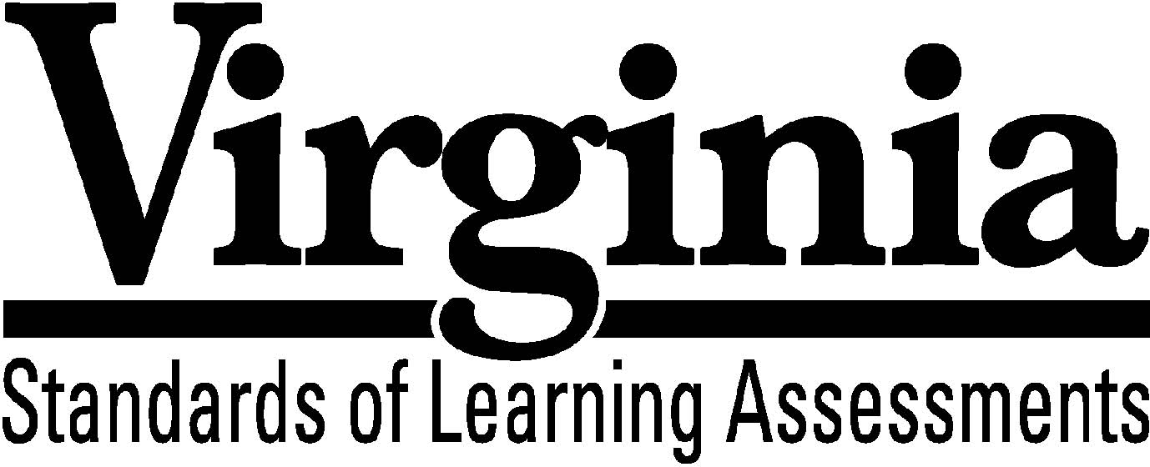
Test Blueprint

Civics and Economics

2015 History and Social Science Standards of Learning
This test blueprint will be effective with the administration of the spring 2020 History and Social Science Standards of Learning (SOL) tests.

Notice to Reader

In accordance with the requirements of the Civil Rights Act and other federal and state laws and regulations, this document has been reviewed to ensure that it does not reflect stereotypes based on race, color, national origin, sex, age, or disability.

The Virginia Department of Education does not discriminate on the basis of race, sex, color, national origin, religion, sexual orientation, gender identity, age, political affiliation, or against otherwise qualified persons with disabilities in employment or provisions of service.

Copyright ©2019 by the Commonwealth of Virginia, Department of Education, P.O. Box 2120, Richmond, Virginia 23218-2120. All rights reserved. Except as permitted by law, this material may not be reproduced or used in any form or by any means, electronic or mechanical, including photocopying or recording, or by any information storage or retrieval system, without written permission from the copyright owner. Commonwealth of Virginia public school educators may reproduce any portion of this test blueprint for non-commercial educational purposes without requesting permission. All others should direct their written requests to the Virginia Department of Education at the above address or by email to Student_Assessment@doe.virginia.gov.

Civics and Economics
Standards of Learning

Test Blueprint

TABLE OF CONTENTS

General Test Information 1
Defines common terms

Test Blueprint Summary Table 2
Organizes the SOL and the number of items assesse

Expanded Test Blueprint 3
Full text of each SOL as organized for the test

General Test Information

Test Blueprint
Much like the blueprint for a building, a test blueprint serves as a guide for test construction. The blueprint indicates the content areas that will be addressed by the test and the number of items that will be included by content area and for the test as a whole. There is a blueprint for each test (e.g., grade 3 reading, grade 5 mathematics, grade 8 science, Virginia and United States History).

Reporting Category
Each test covers a number of Standards of Learning. In the test blueprint, the SOL are grouped into categories that address related content and skills. These categories are labeled as reporting categories. For example, a reporting category for the Civics and Economics Standards of Learning test is Principles of American Government and Citizenship. Each of the SOL in this reporting category addresses the foundations of American government or citizenship. When the results of the SOL tests are reported, the scores will be presented for each reporting category and as a total test score.

Assignment of Standards of Learning to Reporting Categories
Different bullets of a Standard of Learning may be assigned to different reporting categories. For example, Civics and Economics SOL CE.9a, which covers the organization of the judicial system, is assigned to the reporting category Structure of American Government in the Civics and Economics SOL test. SOL CE.9b, which involves describing the exercise of judicial review, is assigned to the reporting category Political and Governmental Processes.

Coverage of Standards of Learning
Due to the large number of SOL in each grade level content area, every Standard of Learning will not be assessed on every version (form) of an SOL test. By necessity, to keep the length of a test reasonable, each version will sample from the SOL within a reporting category. Every SOL in the blueprint will be tested within a three year period, and all of these SOL are eligible for inclusion on each version of an SOL test.

Use of the Curriculum Framework
The History and Social Science Standards of Learning, amplified by the Curriculum Framework, define the essential understandings, knowledge, and skills that are measured by the Standards of Learning tests. The Curriculum Framework identifies essential understandings, defines essential content knowledge, and describes essential skills students need to master.

Civics and Economics

Test Blueprint Summary Table

Reporting Category | Civics and Economics  Standards of Learning | Number of Items
Assessed with Other SOL | CE.1a-g
Principles of Government and Citizenship | CE.2a-d  CE.3a-e | 7
Structure of American Government | CE.6a-b, d  CE.7a-b, d  CE.8a-b  CE.9a | 9
Political and Governmental Processes | CE.5a-f  CE.6c  CE.7c  CE.8c  CE.9b-d  CE.10a-c | 10
Economic Principles and Decisions | CE.11a-b  CE.14a-f | 7
United States Economy | CE.12a-f  CE.13a-f | 7
Number of Operational Items | blank | 40
Number of Field-Test Items* | blank | 10
Total Number of Items on Test | blank | 50

*Field-test items are being tried out with students for potential use on subsequent tests and
will not be used to compute students’ scores on the test.
Civics and Economics

Expanded Test Blueprint

Assessed with Other History and Social Science Standards of Learning
The following skill-based standards will be assessed through the reporting categories by applying them to other Standards of Learning content:

CE.1 The student will demonstrate skills for historical thinking, geographical analysis, economic decision making, and responsible citizenship by
a) analyzing and interpreting evidence from primary and secondary sources, including charts, graphs, and political cartoons;
b) analyzing how political and economic trends influence public policy, using demographic information and other data sources;
c) analyzing information to create diagrams, tables, charts, graphs, and spreadsheets;
d) determining the accuracy and validity of information by separating fact and opinion and recognizing bias;
e) constructing informed, evidence-based arguments from multiple sources;
f) determining multiple cause-and-effect relationships that impact political and economic events; and
g) taking informed action to address school, community, local, state, national, and global issues.

Reporting Category: Principles of Government and Citizenship
Number of Items: 7
Standards of Learning:

CE.2 The student will apply social science skills to understand the foundations of American constitutional government by
a) explaining the fundamental principles of consent of the governed, limited government, rule of law, democracy, and representative government;
b) examining and evaluating the impact of the Magna Carta, charters of the Virginia Company of London, the Virginia Declaration of Rights, the Declaration of Independence, the Articles of Confederation, and the Virginia Statute for Religious Freedom on the Constitution of Virginia and the Constitution of the United States, including the Bill of Rights;
c) describing the purposes for the Constitution of the United States as stated in its Preamble; and
d) describing the procedures for amending the Constitution of Virginia and the Constitution of the United States.

CE.3 The student will apply social science skills to understand citizenship and the rights, duties, and responsibilities of citizens by
a) describing the processes by which an individual becomes a citizen of the United States;
b) describing the First Amendment freedoms of religion, speech, press, assembly, and petition, and the rights guaranteed by due process and equal protection of the laws;
c) describing the duties of citizenship, including obeying the laws, paying taxes, defending the nation, and serving in court;
d) examining the responsibilities of citizenship, including registering and voting, communicating with government officials, participating in political campaigns, keeping informed about current issues, and respecting differing opinions in a diverse society; and
e) evaluating how civic and social duties address community needs and serve the public good.

Reporting Category: Structure of American Government
Number of Items: 9
Standards of Learning:

CE.6 The student will apply social science skills to understand the American constitutional government at the national level by
a) describing the structure and powers of the national government;
b) explaining the principle of separation of powers and the operation of checks and balances; and
d) describing the roles and powers of the executive branch.

CE.7 The student will apply social science skills to understand the American constitutional government at the state level by
a) describing the structure and powers of the state government;
b) explaining the relationship of state governments to the national government in the federal system; and
d) describing the roles and powers of the executive branch and regulatory boards.

CE.8 The student will apply social science skills to understand the American constitutional government at the local level by
a) describing the structure and powers of the local government; and
b) explaining the relationship of local government to the state government.

CE.9 The student will apply social science skills to understand the judicial systems established by the Constitution of Virginia and the Constitution of the Unitzed States by
a) describing the organization of the United States judicial system as consisting of state and federal courts with original and appellate jurisdiction.

Reporting Category: Political and Governmental Processes
Number of Items: 10
Standards of Learning:

CE.5 The student will apply social science skills to understand the political process at the local, state, and national levels of government by
a) describing the functions of political parties;
b) comparing and contrasting political parties;
c) analyzing campaigns for elective office, with emphasis on the role of the media;
d) evaluating and explaining the role of campaign contributions and costs;
e) examining the history of and requirements for voter registration, and participating in simulated local, state, and/or national elections; and
f) describing the role of the Electoral College in the election of the president and vice president.

CE.6 The student will apply social science skills to understand the American constitutional government at the national level by
c) explaining and/or simulating the lawmaking process.

CE.7 The student will apply social science skills to understand the American constitutional government at the state level by
c) explaining and/or simulating the lawmaking process.

CE.8 The student will apply social science skills to understand the American constitutional government at the local level by
c) explaining and/or simulating the lawmaking process.

CE.9 The student will apply social science skills to understand the judicial systems established by the Constitution of Virginia and the Constitution of the United States by
b) describing the exercise of judicial review;
c) comparing and contrasting civil and criminal cases; and
d) explaining how due process protections seek to ensure justice.

CE.10 The student will apply social science skills to understand how public policy is made at the local, state, and national levels of government by
a) examining the impact of the media on public opinion and public policy;
b) describing how individuals and interest groups influence public policy; and
c) describing the impact of international issues and events on local decision making.

Reporting Category: Economic Principles and Decisions
Number of Items: 7
Standards of Learning:

CE.11 The student will apply social science skills to understand how economic decisions are made in the marketplace by
a) explaining that because of scarcity, consumers, producers, and governments must make choices, understanding that everyone’s choice has an opportunity cost; and
b) comparing and contrasting how traditional, free market, command, and mixed economies decide how to allocate their limited resources.

CE.14 The student will apply social science skills to understand personal finance and career opportunities by
a) identifying talents, interests, and aspirations that influence career choice;
b) identifying human capital such as attitudes and behaviors that strengthen the individual work ethic and promote career success;
c) identifying human capital such as abilities, skills, and education and the changing supply of and demand for them in the economy;
d) examining the impact of technological change and globalization on career opportunities;
e) describing the importance of education to lifelong personal finances; and
f) analyzing the financial responsibilities of citizenship, including evaluating common forms of credit, savings, investments, purchases, contractual agreements, warranties, and guarantees.

Reporting Category: United States Economy
Number of Items: 7
Standards of Learning:

CE.12 The student will apply social science skills to understand the United States economy by
a) describing the characteristics of the United States economy, including limited government, private property, profit, markets, consumer sovereignty, and competition;
b) describing how in a market economy supply and demand determine prices;
c) describing the types of business organizations and the role of entrepreneurship;
d) explaining the circular flow that shows how consumers (households), businesses (producers), and markets interact;
e) explaining how financial institutions channel funds from savers to borrowers; and
f) analyzing the relationship of Virginia and the United States to the global economy, with emphasis on the impact of technological innovations.

CE.13 The student will apply social science skills to understand the role of government in the United States economy by
a) examining competition in the marketplace;
b) explaining how and why government provides certain goods and services;
c) describing how local, state, and federal governments allocate their budgets and collect taxes to pay for goods and services they provide;
d) explaining the structure and main function of the Federal Reserve System and how it acts as the nation’s central bank;
e) describing how governments regulate to protect consumers, labor, the environment, competition in the marketplace, and property rights; and
f) explaining the role of government currency and analyzing the purpose of a money economy.

