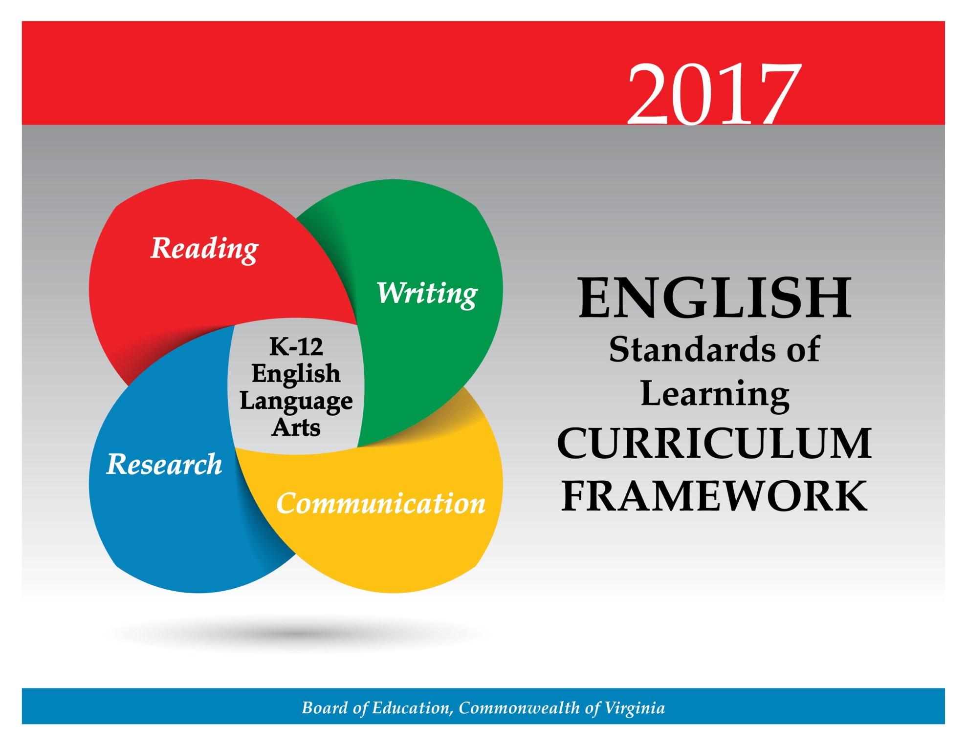

Copyright © 2017
by the
Virginia Department of Education
P.O. Box 2120
Richmond, Virginia 23218-2120
http://www.doe.virginia.gov

All rights reserved. Reproduction of these materials for instructional purposes in public school classrooms in Virginia is permitted.

Superintendent of Public Instruction
Steven R. Staples, EdD

Chief Academic Officer/Assistant Superintendent for Instruction
Steven M. Constantino, EdD

Office of Humanities and Early Childhood
Christine A. Harris, PhD, Director
Tracy Fair Robertson, English Coordinator
Crystal Page Midlik, Elementary English/Reading Specialist
Denise Bunker Fehrenbach, English Specialist
Jill Holt Nogueras, English/History Specialist

Statement of Non-Discrimination
The Virginia Department of Education does not discriminate on the basis of race, sex, color, national origin, religion, sexual orientation, gender identity, age, political affiliation, or against otherwise qualified persons with disabilities. The policy permits appropriate employment preferences for veterans and specifically prohibits discrimination against veterans.
2017 Virginia English Standards of Learning Curriculum Framework
Introduction
The 2017 English Standards of Learning Curriculum Framework is a companion document to the 2017 English Standards of Learning and amplifies the English Standards of Learning by defining the content knowledge, skills, and understandings. The Curriculum Framework is not meant to be an entire curriculum, but rather to provide additional guidance to school divisions and their teachers as they develop their local programs of studies appropriate for their students. It assists teachers in their lesson planning by identifying essential understandings, defining essential content knowledge, and describing the intellectual skills students need to use. This supplemental framework delineates in greater specificity the content that all teachers should teach and all students should learn. The concepts, skills, and content in English Language Arts spiral; teachers should note each grade level builds skills that carry to the following grades. Each grade level within the English Curriculum Framework builds from kindergarten through grade 12, creating a comprehensive instructional tool, which prepares students for success in future postsecondary education and the workplace. Teachers should review the Curriculum Framework for the scope of learning in each of the strands in previous grades and in the grades to follow.

The format of the Curriculum Framework facilitates teacher planning by identifying the key concepts, knowledge, and skills that should be the focus of instruction for each standard. The Curriculum Framework is divided into two columns: Essential Understandings; and Essential Knowledge, Skills and Processes (EKSP). The purpose of each column is explained below.

Overview of Standard and Teacher Notes
This section includes background information for teachers. It contains content that may extend teachers’ knowledge of each standard beyond the current grade level. This section may also contain best practices, instructional strategies, and suggestions that will help teachers plan lessons focusing on integrating the standard(s). Teacher Notes are found at the beginning of each strand in the English Curriculum Framework.

Essential Understandings
This section delineates the key concepts and ideas that all students should grasp to demonstrate an understanding of the Standards of Learning. These essential understandings are presented to facilitate teacher planning.

Essential Knowledge, Skills, and Processes
Standards are expanded in the EKSP column. This column outlines what students should know and be able to do in each standard. This is not meant to be an exhaustive list, nor one that limits what is taught in the classroom. It is meant to identify the key knowledge, skills, and processes that define the standard. The EKSP is not a one-to-one match of the Standards. If the standard is self-explanatory, there will be no additional explanation in this column. For example, the nonfiction reading strand requires students to identify the main idea; there is not a corresponding entry in the EKSP column explaining how to identify a main idea.

The Curriculum Framework serves as a guide for English Standards of Learning assessment development. Assessment items may not and should not be a verbatim reflection of the information presented in the Curriculum Framework. Students are expected to continue to apply knowledge, skills, and processes from Standards of Learning presented in previous grades as they build expertise in English.
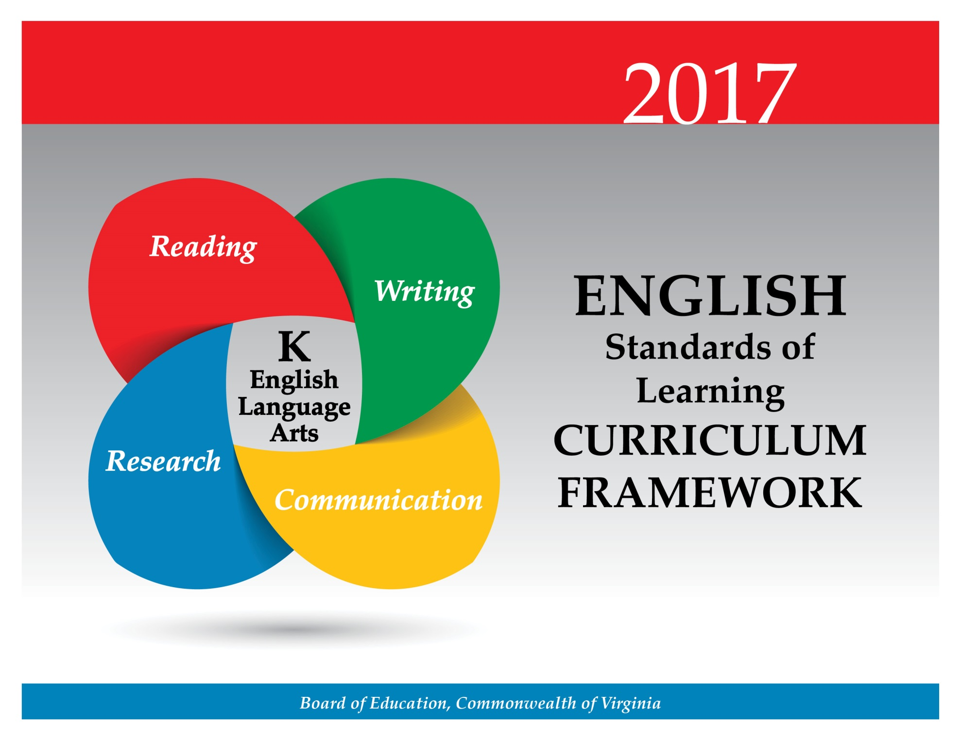

At the kindergarten level, students will develop their understanding of language and enhance their ability to communicate effectively. Emphasis will be placed on having students build and use listening and speaking vocabularies through participation in oral language activities employing poems, rhymes, songs, and stories. Students will learn rules for conversation, skills for participation in discussions, and strategies for working respectfully with others. Teachers will encourage the development of interpersonal skills that are foundational to effective communication and collaboration. These skills are essential for success in future postsecondary education and workplace environments.

Teacher Notes
- Teachers should provide daily opportunities for student communication and participation in oral language activities in a variety of settings.
- Multimodal is the strategic use of two or more interdependent modes of communication where both/all modes are essential to convey the intended message (e.g., graphics, written language, moving images, music, audio, presentation technologies, and movement).

K.1 The student will build oral communication skills.
- Listen actively and speak using agreed-upon rules for discussion.
- Express ideas in complete sentences and express needs through direct requests.
- Initiate conversations.
- Follow implicit rules for conversation, including taking turns and staying on topic.
- Listen and speak in informal conversations with peers and adults.
- Discuss various texts and topics collaboratively and with partners.
- Use voice level, phrasing, and intonation appropriate for various language situations.
- Follow one- and two-step directions.
- Ask how and why questions to seek help, get information, or clarify information.
- Work respectfully with others.
ESSENTIAL UNDERSTANDINGS | ESSENTIAL KNOWLEDGE, SKILLS, AND PROCESSES
All students should  - understand that communication includes expressing needs, asking questions, and sharing information  - understand that conversation is interactive  - understand that the setting influences rules for communication. | To be successful with this standard, students are expected to  - speak audibly in complete sentences, expressing thoughts, feelings, and ideas clearly  - participate in a range of collaborative discussions building on others’ ideas and clearly expressing thoughts and opinions  - initiate conversations with peers and teachers in a variety of school settings  - listen actively to others in a variety of formal and informal settings involving peers and adults  - wait for a turn to speak, allowing others to speak without unnecessary interruptions  - maintain conversation on topic through multiple exchanges  - match language to the purpose, situation, environment, and audience  - repeat and follow one- and two-step oral directions.

K.2 The student will demonstrate growth in oral, early literacy skills.
- Listen and respond to a variety of text and media.
- Participate in a variety of oral language activities, including choral and echo speaking and recitation.
- Tell stories orally.
- Participate in creative dramatics.
ESSENTIAL UNDERSTANDINGS | ESSENTIAL KNOWLEDGE, SKILLS, AND PROCESSES
All students should  - understand that choral and echo speaking builds oral literacy skills  - understand that telling oral stories and participating in creative dramatics develops comprehension. | To be successful with this standard, students are expected to  - listen to texts read aloud and ask and answer questions for further understanding  - participate in choral and echo speaking and recitation of short poems, rhymes, songs, and stories with repeated patterns and refrains  - use drama to retell familiar stories, rhymes, and poems  - participate in creative dramatics, such as classroom songs, plays, skits, and group activities.

Kindergarten students will be immersed in a text-rich environment to develop phonological awareness, phonemic awareness, vocabulary, comprehension, and an appreciation for reading. The exposure to fiction and nonfiction texts will enable students to develop an awareness of reading materials as sources of information and enjoyment. Students will learn to identify and name the capital and lowercase letters of the alphabet, understand that letters represent sounds, and identify initial and final consonant sounds in one-syllable words. Kindergarten students will expand listening and speaking vocabularies. They will learn to comprehend and think creatively as they relate stories through drama, retelling, drawing, and their own writing. Teachers will encourage the development of reading skills that are foundational to effective comprehension and critical thinking. These skills are essential for success in future postsecondary education and workplace environments.

Teacher Notes
- Teachers should teach the concepts of print, basic phonetic principles, comprehension of stories, and letter identification skills through systematic, direct instruction; individual and small group activities; and time spent exploring and reading books and other print material.
- Please note there is not a specific list or number of sight words students must learn. To build a personal word bank, students will develop the ability to read their own names and common high-frequency words in context.
- Teachers need to read texts aloud to model language and introduce students to new words, expand working vocabularies, and improve comprehension.
- Please note that although the strands are developed separately, teachers should integrate all strands seamlessly.
  - Teachers may integrate the strands through the use of thematic units..
  - Teachers should have students write about what they have read.

K.3 The student will orally identify, segment, and blend various phonemes to develop phonological and phonemic awareness.
- Begin to discriminate between spoken sentences, words, and syllables.
- Identify and produce words that rhyme.
- Blend and segment multisyllabic words at the syllable level.
- Blend and segment one-syllable words into phonemes including onset and rime.
- Identify words according to shared beginning and/or ending sounds.
- Blend sounds to make one-syllable words.
- Segment one-syllable words into individual phonemes.
ESSENTIAL UNDERSTANDINGS | ESSENTIAL KNOWLEDGE, SKILLS, AND PROCESSES
All students should  - understand that words are made up of small units of sound and that these sounds can be blended to make a word  - understand that words are made up of syllables  - understand that a spoken sentence is made up of individual words. | To be successful with this standard, students are expected to  - segment a word into individual syllables using strategies including, but not limited to, clapping hands or snapping fingers  - identify and discriminate between sentences, words, and syllables  - identify a word that rhymes with a spoken word  - supply a word that rhymes with a spoken word  - produce rhyming words and recognize pairs of rhyming words presented orally  - generate rhyming words based on a given rhyming pattern, familiar nursery rhyme, or predictable text  - blend and segment onsets and rimes of spoken words (e.g., /b/- /oat/ = boat, black = /bl/- /ack/)  - blend and segment multisyllabic words into syllables (e.g., The teacher asks students to say robot without the /ro-/ and students respond with /bot/.)  - blend individual phonemes to make one-syllable words (e.g., /sh/-/i/-/p/= ship)  - segment one-syllable words into individual phonemes (e.g., rat= /r/-/a/-/t/)  - recognize similarities and differences in beginning and ending sounds of words  - produce a word that has the same beginning or ending sound as a spoken word (e.g., /sock/- /sun/ and /hot/- /rat/)  - identify pictures of objects whose names share the same beginning or ending sound  - sort pictures or objects whose names share the same beginning or ending sound.

K.4 The student will understand how print is organized and read.
- Hold print materials in the correct position.
- Identify the front cover, back cover, and title page of a book.
- Distinguish between print and pictures.
- Follow words from left to right and from top to bottom on a printed page.
- Match voice with print.
ESSENTIAL UNDERSTANDINGS | ESSENTIAL KNOWLEDGE, SKILLS, AND PROCESSES
All students should  - understand that all print materials in English follow similar patterns  - understand that there is a one-to-one correspondence between the spoken and written word. | To be successful with this standard, students are expected to  - hold printed material the correct way  - identify the front and back covers of a book  - distinguish the title page from all the other pages in a book  - turn pages appropriately  - follow text with a finger, pointing to each word as it is read from left-to-right and top-to-bottom  - locate lines of text, words, letters, and spaces  - match voice with print in syllables, words, and phrases  - locate and name periods, question marks, and exclamation points.

K.5 The student will demonstrate an understanding that print conveys meaning.
- Identify common signs and logos.
- Explain that printed materials provide information.
- Read and explain own writing and drawings.
- Read his/her name and commonly used high-frequency words.
ESSENTIAL UNDERSTANDINGS | ESSENTIAL KNOWLEDGE, SKILLS, AND PROCESSES
All students should  - understand that print conveys meaning  - recognize own writing as a form of print. | To be successful with this standard, students are expected to  - recognize and identify a variety of environmental print  - recognize and read a selection of high-frequency and sight words from familiar text (Each student may know a different set of words.)  - recognize and identify their own first and last names.

K.6 The student will develop an understanding of basic phonetic principles.
- Identify and name the capital and lowercase letters of the alphabet.
- Match consonant, short vowel, and initial consonant digraph sounds to appropriate letters.
- Demonstrate a speech-to-print match through accurate finger-point reading in familiar text that includes words with more than one syllable.
- Identify initial consonant sounds in one-syllable words.
- Identify final consonant sounds in one-syllable words.
ESSENTIAL UNDERSTANDINGS | ESSENTIAL KNOWLEDGE, SKILLS, AND PROCESSES
All students should  - understand that there is a one-to-one correspondence between spoken and written words  - understand that written words are composed of letters that represent specific sounds. | To be successful with this standard, students are expected to  - recognize capital and lowercase letters in sequence and in random order and name them rapidly  - match capital and lowercase letter pairs  - differentiate between vowels and consonants  - produce the sounds of consonants, short vowels, and initial consonant digraphs  - demonstrate concept of word by  - tracking familiar print from left to right and top to bottom  - matching spoken words to print, including words with more than one syllable  - write the letter or digraph that represents a spoken sound  - use basic knowledge of one-to-one letter-sound correspondences by producing sounds for each consonant  - isolate initial consonants in single-syllable words (e.g., /t/ is the first sound in top)  - identify short sounds with common spellings for the five major vowels.

K.7 The student will expand vocabulary and use of word meanings.
- Discuss meanings of words.
- Increase vocabulary by listening to a variety of texts read aloud.
- Use vocabulary from other content areas.
- Ask about words not understood.
- Use number words.
- Use nouns to identify and name people, places, and things.
- Use adjectives to describe location, size, color, and shape.
- Use verbs to identify actions.
ESSENTIAL UNDERSTANDINGS | ESSENTIAL KNOWLEDGE, SKILLS, AND PROCESSES
All students should  - understand that vocabulary is made up of words and that words have meaning  - understand that learning new words enhances communication  - understand that word choice makes communication clearer  - understand that information can be gained by asking about words not understood. | To be successful with this standard, students are expected to  - discuss meanings of specific words using synonyms and antonyms (e.g., This giraffe is tall. He can eat leaves on a tree. If he were short, he couldn’t reach his food.)  - identify new meanings for familiar words and apply them accurately (e.g., knowing water as a drink and learning the verb, as in water the flowers)  - sort common objects into categories (e.g., shapes, foods) to gain a sense of the concepts the categories represent  - use common adjectives to distinguish objects (e.g., the small red square; the shy white cat) (Students are not required to know the term adjective at this level.)  - ask and respond to questions about unknown words in a text  - identify real-life connections between words and their use (e.g., places that are loud)  - use newly-learned words in literacy tasks  - use number words in conversations  - use words to describe or name people, places, feelings, and things  - use size, shape, color, and spatial words to describe people, places, and things  - use words to show direction and location (e.g., on, off, in, out, over, under, between, and beside)  - recognize when they do not understand a word or phrase and seek clarification.

K.8 The student will demonstrate comprehension of fictional texts.
- Identify the role of an author and an illustrator.
- Relate previous experiences to what is read.
- Use pictures to make predictions.
- Ask and answer questions about what is read.
- Use story elements of characters, settings, and events to retell stories sequentially using beginning, middle, and end.
ESSENTIAL UNDERSTANDINGS | ESSENTIAL KNOWLEDGE, SKILLS, AND PROCESSES
All students should  - understand that fiction texts tell a story  - understand that authors tell stories through words and illustrators tell stories with pictures. | To be successful with this standard, students are expected to  - identify and explain the roles of the author and the illustrator of selected texts  - make ongoing predictions based on illustrations and text  - describe the relationship between illustration and the story  - link knowledge from own experiences to make sense of and talk about a text  - give evidence that they understand the meaning of what is being read aloud, including who, what, when, where, why, and how  - ask and respond to questions about the content of a book  - use vocabulary from a story in discussions and retellings  - retell a story in own words using the characters, settings, and events in the correct sequence from beginning to end  - use words to sequence events (e.g., before, after, and next)  - demonstrate comprehension of text through drawings or a written response  - recognize various types of fiction texts (e.g., storybooks, poems).

K.9 The student will demonstrate comprehension of nonfiction texts.
- Use pictures to identify topic and make predictions.
- Identify text features specific to the topic, such as titles, headings, and pictures.
- Ask and answer questions about what is read.
ESSENTIAL UNDERSTANDINGS | ESSENTIAL KNOWLEDGE, SKILLS, AND PROCESSES
All students should  - understand that nonfiction texts provide information  - understand that text features serve a purpose. | To be successful with this standard, students are expected to  - make ongoing predictions based on graphics and text  - relate pictures and illustrations to the text in which they appear  - identify the topic of a nonfiction selection  - ask and respond to questions about the content of a book  - discuss facts and information relevant to the topic.

At the kindergarten level, students will begin to build a connection between oral and written language. Awareness that spoken language can be written and written language can be read is a fundamental concept in communicating ideas. Students will learn to print the capital and lowercase letters of the alphabet as well as their first and last names. Kindergarten writing reflects the students’ oral language, and students will communicate their ideas through pictures and writing. Teachers will encourage the development of writing skills that are foundational to effective written communication and critical thinking. These skills are essential for success in future postsecondary education and workplace environments.

Teacher Notes
- Teachers should model the writing process for students.
- The focus of writing in kindergarten is narrative and descriptive.
- Teachers should model real-world writing experiences.
- Teachers should encourage students to write about what they know and what they experience.

K.10 The student will print in manuscript.
- Print capital and lowercase letters of the alphabet independently.
- Print his/her first and last names.
ESSENTIAL UNDERSTANDINGS | ESSENTIAL KNOWLEDGE, SKILLS, AND PROCESSES
All students should  - understand that there are correct ways to write the manuscript letters of the alphabet  - understand that their written name provides identification  - understand that printing properly formed letters makes manuscript writing legible. | To be successful with this standard, students are expected to  - use appropriate pencil grip  - print capital and lowercase letters of the alphabet legibly and independently  - use manuscript letter formation  - use manuscript number formation  - form the letters of their first and last names, spacing them correctly  - print first and last names, beginning each with a capital letter.

K.11 The student will write in a variety of forms to include narrative and descriptive.
- Differentiate pictures from writing.
- Use prewriting activities to generate ideas including drawing pictures.
- Use letters to phonetically spell words that describe pictures or experiences.
- Write left-to-right and top-to-bottom.
- Compose simple sentences.
- Begin each sentence with a capital letter and use ending punctuation.
- Share writing with others.
ESSENTIAL UNDERSTANDINGS | ESSENTIAL KNOWLEDGE, SKILLS, AND PROCESSES
All students should  - understand that their writing serves a variety of purposes  - understand that writing communicates thoughts and ideas. | To be successful with this standard, students are expected to  - distinguish print from pictures  - write daily for a variety of purposes, including narrative stories to describe experiences  - write on assigned and/or self-selected topics  - use writing, dictation, and drawing to tell a story  - write to describe a person, place, or thing  - generate text to communicate and make meaning by creating drawings, letter strings, scribbles, letter approximations, or other graphic representations, as well as phonetically spelled words  - capitalize the first word in a sentence and the pronoun I  - write left-to-right and top-to-bottom.

Students will be introduced to the research process by asking investigative questions, which will be used to solve problems. Research in kindergarten prepares students for more formalized research in subsequent grades.

Teacher Notes
- Teachers should have students collaborate in whole or small groups to generate topics, ask questions, and find information.
- Please note that kindergarten students are not expected to complete research products.

K.12 The student will conduct research to answer questions or solve problems using available resources.
- Generate topics of interest.
- Generate questions to gather information.
- Identify pictures, texts, or people as sources of information.
- Find information from provided sources.
ESSENTIAL UNDERSTANDINGS | ESSENTIAL KNOWLEDGE, SKILLS, AND PROCESSES
All students should  - understand that research can be used to answer questions or solve problems  - understand that many different sources, including people, can help provide information. | To be successful with this standard, students are expected to  - generate ideas for topics based on interest or content areas (e.g., favorite animals, community helpers, or life cycles)  - work collaboratively to generate questions to gather information  - identify various pictures, texts, media, and people that can be used as sources of information  - use provided sources to answer questions or solve problems.

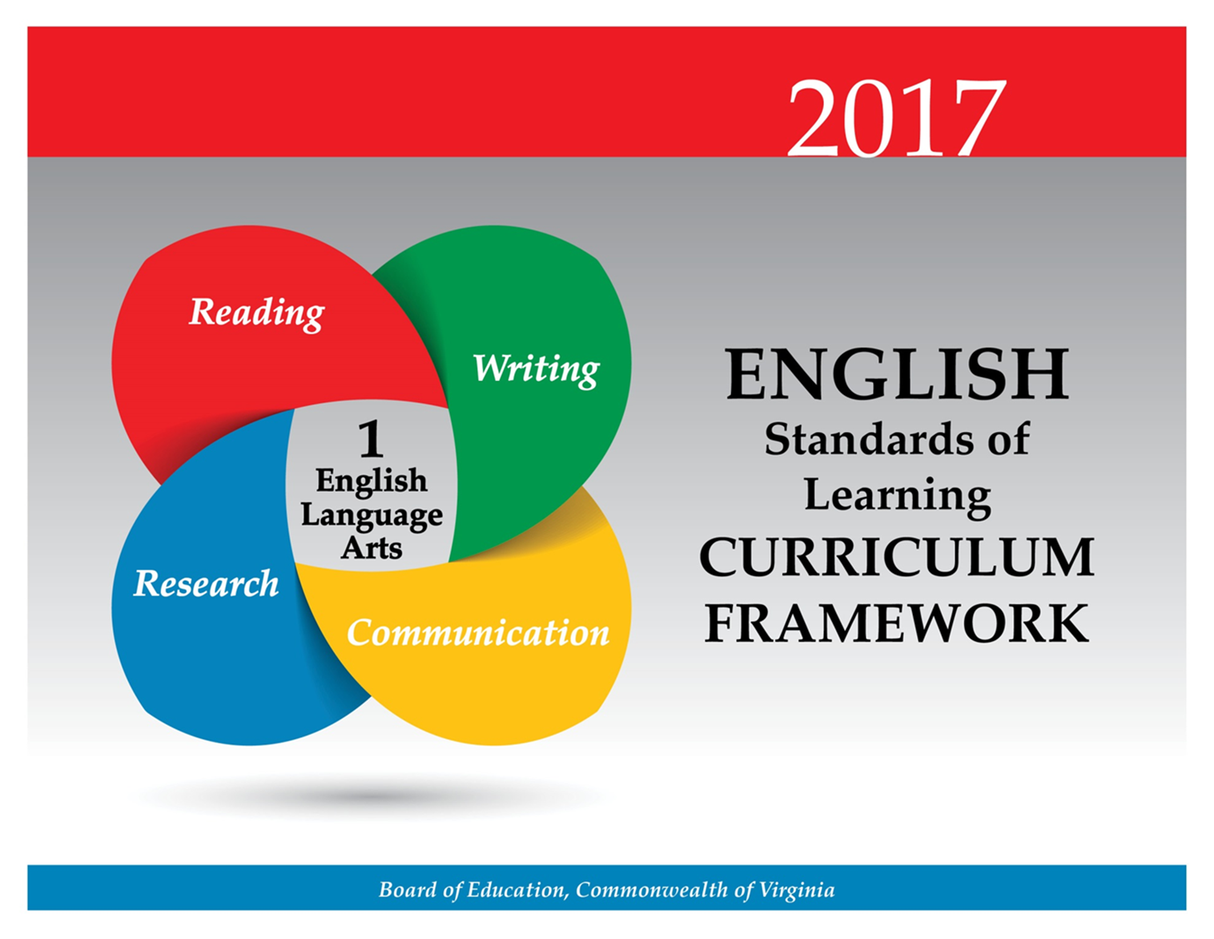
At the first grade level, students will further develop their understanding of language and enhance their ability to communicate effectively. Students will use listening and speaking skills to participate in classroom discussions and work respectfully with others. They will also begin to use oral language skills to gain and explain information. Students will build and use listening and speaking vocabularies to tell and retell stories and participate in choral speaking, recitation, and creative dramatics.

Teacher Notes
- Teachers should provide daily opportunities for student communication and participation in oral language activities in a variety of settings.
- Multimodal is the strategic use of two or more interdependent modes of communication where both/all modes are essential to convey the intended message (e.g., graphics, written language, moving images, music, audio, presentation technologies, movement).

1.1 The student will develop oral communication skills.
- Listen actively and speak using agreed-upon rules for discussion.
- Initiate conversation with peers and adults.
- Adapt or change oral language to fit the situation.
- Use appropriate voice level, phrasing, and intonation.
- Participate in collaborative and partner discussions about various texts and topics.
- Follow rules for conversation, using appropriate voice level in small-group settings.
- Ask and respond to questions to seek help, get information, or clarify information.
- Restate and follow simple two-step oral directions.
- Give simple two-step oral directions.
- Express ideas orally in complete sentences.
- Work respectfully with others.
- Increase listening and speaking vocabularies.
ESSENTIAL UNDERSTANDINGS | ESSENTIAL KNOWLEDGE, SKILLS, AND PROCESSES
All students should  - understand that communication includes expressing needs, asking questions, and sharing information  - understand that the setting influences the rules for communication  - understand that information can be gained by asking and answering relevant questions about a specific topic  - understand that specific word choice makes communication clearer. | To be successful with this standard, students are expected to  - initiate conversation in a variety of school settings  - participate in a range of collaborative discussions building on others’ ideas and clearly expressing thoughts and opinions  - ask and respond to questions to check for understanding  - sustain two-person conversation through multiple exchanges  - use voice level and intonation appropriate for small-group settings  - follow rules for conversation, including listening and taking turns  - give and follow simple two-step oral directions  - use words of time and position, including first, second, next, on, under, beside, and over, to give directions orally  - use verbs to give directions orally  - speak in complete sentences when appropriate to task and situation.

1.2 The student will demonstrate growth in oral early literacy skills.
- Listen and respond to a variety of print and media materials.
- Tell and retell stories and events in sequential order.
- Participate in a variety of oral language activities, including choral speaking and recitation.
- Participate in creative dramatics.
ESSENTIAL UNDERSTANDINGS | ESSENTIAL KNOWLEDGE, SKILLS, AND PROCESSES
All students should  - understand that choral and echo speaking build oral literacy skills  - understand that telling oral stories and participating in creative dramatics develops comprehension. | To be successful with this standard, students are expected to  - participate in a variety of oral language activities, such as  - listening to stories and poems read aloud  - participating in discussions about stories and poems  - talking about words and their meanings as they are encountered in stories, poems, and conversations  - providing reactions to stories and poems  - asking and answering questions about what is said in order to gather additional information or clarify something not understood  - describe people, places, things, and events with details  - tell and retell stories and events in logical order by  - retelling stories orally and through informal drama  - dictating or retelling stories  - indicating first, next, and last events in a story  - creating stories, poems, plays, and songs  - participate in daily oral language activities (e.g., choral speaking and the reciting of short poems, rhymes, songs, and stories with repeated patterns)  - participate in creative dramatics (e.g., classroom songs, plays, skits, and group activities) designed to give students frequent opportunities for listening and speaking  - participate in listening and speaking activities.

Students will be immersed in a text-rich environment to develop phonological awareness, phonetic skills, vocabulary, comprehension, and to use reading materials as sources of information and enjoyment. Having developed a concept of word and letter-sound correspondence, students will concentrate on learning and integrating basic phonetic principles, decoding words in isolation and in context, using meaning clues, and employing language and sentence structure to read and substantially increase sight-word vocabulary. Students will use a variety of strategies to read new words and will read familiar selections with fluency, accuracy, and expression. Students will continue to develop an understanding of fiction and nonfiction texts and respond to readings through group discussions and writing. Students will increase vocabulary and comprehension strategies through cross-content reading. Teachers will encourage the development of reading skills that are foundational to effective comprehension and critical thinking. These skills are essential for success in future postsecondary education and workplace environments.

Teacher Notes
- These concepts and skills should be taught through systematic, explicit, direct instruction; individual and small-group activities; and time spent reading books and other print material.
- Teachers should provide opportunities for independent reading with options for student choice.
- Teachers need to read texts aloud to model language and expose students to new words, expand students’ working vocabularies, and improve comprehension.
- Teachers should provide opportunities for students to apply strategies as they read and reread a variety of texts.
- Teachers should teach theme with fiction texts and main idea with nonfiction texts. Please note these terms are not interchangeable.
- Please note although the strands are developed separately, teachers should seamlessly integrate all strands.
  - Teachers may integrate the strands through the use of thematic units.
  - Teachers should have students write about what they have read.

1.3 The student will orally identify, produce, and manipulate various phonemes within words to develop phonological and phonemic awareness.
- Create rhyming words.
- Count phonemes (sounds) in one-syllable words.
- Blend sounds to make one-syllable words.
- Segment one-syllable words into individual phonemes.
- Add or delete phonemes to make new words.
- Blend and segment multisyllabic words at the syllable level.
ESSENTIAL UNDERSTANDINGS | ESSENTIAL KNOWLEDGE, SKILLS, AND PROCESSES
All students should understand that spoken words are made up of units of speech sounds within words, which can be manipulated to make new words. | To be successful with this standard, students are expected to  - orally produce words that rhyme by changing the initial phoneme (e.g., sip/ship, heart/part)  - count phonemes in one-syllable words  - blend separately spoken phonemes to make one-syllable words  - segment words by producing each phoneme  - determine whether the medial vowel sound is the same or different in a set of one-syllable words  - sort picture cards by initial, medial, and final phonemes  - remove a phoneme from an orally presented word to make a new word (e.g., rice/ice, beach/bee, weight/weigh, couch/cow)  - add a phoneme from an orally presented word or rime to make a new word (e.g., pie/pipe, four/fork, cab/crab, ot/lot, ap/map)  - change phonemes orally to make new words (e.g., rug/jug, bunch/lunch, card/cart, sat/sit).

1.4 The student will apply knowledge of how print is organized and read.
- Read from left-to-right and from top-to-bottom.
- Match spoken words with print.
- Identify letters, words, sentences, and ending punctuation.
ESSENTIAL UNDERSTANDINGS | ESSENTIAL KNOWLEDGE, SKILLS, AND PROCESSES
All students should  - understand that all print in English follows similar patterns  - understand that written text consists of letters, words, and sentences. | To be successful with this standard, students are expected to  - demonstrate concept of word by tracking print from left-to-right and top-to-bottom, following print from one line to the next line (return sweep), and matching spoken words to print  - differentiate between letters and words by recognizing spaces between words in sentences  - recognize that a sentence starts with a capital letter and ends with a period, question mark, or an exclamation point.

1.5 The student will apply phonetic principles to read and spell.
- Use initial and final consonants to decode and spell one-syllable words.
- Use two-letter consonant blends to decode and spell one-syllable words.
- Use consonant digraphs to decode and spell one-syllable words.
- Use short vowel sounds to decode and spell one-syllable words.
- Blend initial, medial, and final sounds to recognize and read words.
- Use word patterns to decode unfamiliar words.
- Read and spell simple two-syllable compound words.
- Read and spell commonly used sight words.
ESSENTIAL UNDERSTANDINGS | ESSENTIAL KNOWLEDGE, SKILLS, AND PROCESSES
All students should understand that knowledge of phonetic principles can be applied to read and spell words. | To be successful with this standard, students are expected to  - apply knowledge of letter sounds in single-syllable words by  - recognizing initial, medial, and final phonemes  - segmenting the phonemes in a word into their complete sequence of individual phonemes (e.g., top: /t/-/o/-/p/, jump: /j/-/u/-/m/-/p/)  - blending phonemes to decode or spell a word  - accurately decode unfamiliar, orthographically regular, single-syllable words and nonsense words (e.g., sit, zot) using letter-sound mappings to sound them out  - differentiate between vowels and consonants  - apply knowledge of word patterns to decode unfamiliar words by recognizing word patterns (e.g., CVC) and using onsets and rimes to create, read, and spell new words that include blends (e.g., the l and r blends) and digraphs (e.g., ch, sh, th, and wh)  - use the consonant-vowel patterns CVC (e.g., pin), VC (e.g., in), and CVCC (e.g., wind) to decode and spell single-syllable words with a short vowel sound  - use the consonant-vowel patterns CVVC and CVCE to decode and spell some single-syllable words with a long vowel sound  - use knowledge that every syllable has a vowel sound to help determine if a word has one or two syllables  - read and spell simple two-syllable compound words following basic patterns by segmenting the words into syllables.

1.6 The student will use semantic clues and syntax for support when reading.
- Use words, phrases, and sentences.
- Use titles and pictures.
- Use information in the story to read words.
- Use knowledge of sentence structure.
- Reread and self-correct.
ESSENTIAL UNDERSTANDINGS | ESSENTIAL KNOWLEDGE, SKILLS, AND PROCESSES
All students should understand that they will use a variety of strategies to read unfamiliar words and confirm meaning. | To be successful with this standard, students are expected to  - expand vocabulary by using frequently occurring root words to read inflectional forms (e.g., look, looks, looked, looking)  - use sentence-level context as a clue to the meaning of words and phrases  - use titles, pictures, and information in the story to make predictions about vocabulary  - use pictures and/or rereading to confirm vocabulary choice  - notice when words or sentences do not make sense in context  - use intonation, pauses, and emphases that signal the structure of the sentence when reading aloud  - use punctuation clues, including period, question mark, exclamation point, commas, and quotation marks to guide comprehension  - reread and self-correct when text does not make sense.

1.7 The student will expand vocabulary and use of word meanings.
- Discuss meanings of words in context.
- Develop vocabulary by listening to and reading a variety of texts.
- Ask for the meaning of unknown words and make connections to familiar words.
- Use text clues such as words or pictures to discern meanings of unknown words.
- Use vocabulary from other content areas.
- Use singular and plural nouns.
- Use adjectives to describe nouns.
- Use verbs to identify actions.
ESSENTIAL UNDERSTANDINGS | ESSENTIAL KNOWLEDGE, SKILLS, AND PROCESSES
All students should  - understand that word meanings can be comprehended through context, discussion, connections to familiar words, and knowledge of vocabulary from other content areas  - understand and discuss the meanings of new words as presented in context. | To be successful with this standard, students are expected to  - develop vocabulary by listening to and reading a variety of texts  - ask for the meaning of unknown words and make connections to familiar words by  - sorting words into categories (e.g., colors, animals)  - defining words by category and by one or more attributes (e.g., a swan is a bird that swims, a cardinal is a red bird)  - identifying real-life connections between words and their use (e.g., places that are safe)  - use vocabulary from other content areas in literacy tasks  - ask for meanings and clarification of unfamiliar words and ideas  - use common irregular plural forms, such as man/men, child/children, and mouse/mice.

1.8 The student will use simple reference materials.
- Use knowledge of alphabetical order by first letter.
- Use a picture dictionary to find meanings of unfamiliar words.
ESSENTIAL UNDERSTANDINGS | ESSENTIAL KNOWLEDGE, SKILLS, AND PROCESSES
All students should  - understand that many reference materials are organized in alphabetical order  - understand that reference materials provide information. | To be successful with this standard, students are expected to  - use simple reference materials  - alphabetize a list of five-to-eight words according to first letter  - use a picture dictionary to locate unfamiliar words.

1.9 The student will read and demonstrate comprehension of a variety of fictional texts.
- Preview the selection.
- Set a purpose for reading.
- Relate previous experiences to what is read.
- Make and confirm predictions.
- Ask and answer who, what, when, where, why, and how questions about what is read.
- Identify characters, setting, and important events.
- Retell stories and events, using beginning, middle, and end in a sequential order.
- Identify theme.
- Read and reread familiar stories and poems with fluency, accuracy, and meaningful expression.
ESSENTIAL UNDERSTANDINGS | ESSENTIAL KNOWLEDGE, SKILLS, AND PROCESSES
All students should  - understand that they should use a variety of strategies to assist with comprehension of fictional texts.  - understand that orally read text has a rhythm and expression that helps convey meaning. | To be successful with this standard, students are expected to  - preview reading material by looking at the book’s cover, title, and illustrations  - set a purpose for reading by looking at the illustrations, activating prior knowledge, and predicting the outcome of the selection  - use knowledge from own experience to make sense of and talk about a text  - identify and describe characters, settings, and important events in a story using details  - retell stories using the characters, settings, and events in correct sequence from beginning to end  - demonstrate comprehension by writing about what is read  - identify the overall theme of a fiction selection (e.g., friendship, family, working hard)  - use expression to convey meaning when reading aloud  - reread as necessary to confirm and self-correct word recognition and understanding  - practice reading and rereading texts at their independent reading level.

1.10 The student will read and demonstrate comprehension of a variety of nonfiction texts.
- Preview the selection.
- Use prior and background knowledge as context for new learning.
- Set a purpose for reading.
- Identify text features such as pictures, headings, charts, and captions.
- Make and confirm predictions.
- Ask and answer who, what, where, when, why, and how questions about what is read.
- Identify the main idea.
- Read and reread familiar texts with fluency, accuracy, and meaningful expression.
ESSENTIAL UNDERSTANDINGS | ESSENTIAL KNOWLEDGE, SKILLS, AND PROCESSES
All students should  - understand that nonfictional texts provide information  - understand text features serve a purpose  - understand a variety of strategies assist with comprehension of nonfiction texts. | To be successful with this standard, students are expected to  - read with purpose and understanding  - preview reading material and set a purpose by looking at the book’s cover and graphics and by reading titles and headings  - identify and use text features to locate facts and information in a text  - distinguish between information provided by pictures or illustrations and information provided by words in the text  - read various nonfiction forms, including letters, lists, recipes, newspapers, and magazines  - identify the main idea and key details  - practice reading and rereading texts on their independent reading level.

At the first grade level, reading and writing will develop together. Students will be given daily opportunities to write and read their writing. Students will write in a variety of forms to communicate ideas. As their knowledge of letter-sound correspondence and their sight-word vocabulary increases, they will be able to use these skills to put their ideas and thoughts on paper. With teacher guidance and support, they will also begin to revise and edit selected pieces of their writing for a specific audience. Teachers will encourage the development of writing skills that are foundational to effective written communication and critical thinking. These skills are necessary for success in future postsecondary education and workplace environments.

Teacher Notes
- Teachers should model the writing process for students.
- Teachers should refer to examples of writing in mentor texts.
- The focus of writing in first grade is narrative, descriptive, and opinion.
- Teachers should provide opportunities for students to express opinions with a reason both orally and in writing.
1.11 The student will print legibly in manuscript.
- Form letters accurately.
- Space words within sentences.
ESSENTIAL UNDERSTANDINGS | ESSENTIAL KNOWLEDGE, SKILLS, AND PROCESSES
All students should understand that there are correct ways to write the letters of the alphabet and that proper spacing is necessary in order for writing to be legible. | To be successful with this standard, students are expected to  - use appropriate pencil grip  - use manuscript letter formation  - print all capital and lowercase letters in sequence and in random order  - print first and last names, beginning each with a capital letter  - use manuscript number formation.

1.12 The student will write in a variety of forms to include narrative, descriptive, and opinion.
- Identify audience and purpose.
- Use prewriting activities to generate ideas.
- Focus on one topic.
- Organize writing to suit purpose.
- Revise by adding descriptive words when writing about people, place, things, and events.
- Write to express an opinion and give a reason.
- Use letters to phonetically spell words.
- Share writing with others.
ESSENTIAL UNDERSTANDINGS | ESSENTIAL KNOWLEDGE, SKILLS, AND PROCESSES
All students should  - understand that writers communicate ideas for a variety of purposes  - understand that writers plan, write, revise, and share their writing with others  - understand sound-symbol correspondence is used to write unfamiliar words. | To be successful with this standard, students are expected to  - use previous experiences to generate ideas  - identify the intended audience and purpose for writing (e.g., letters, stories, journals, etc.)  - participate in teacher-directed brainstorming activities to generate ideas  - participate in shared writing projects  - use prewriting strategies, including, but not limited to: webbing, clustering, brainstorming, and semantic mapping, to organize ideas and information  - write to express an opinion with supporting reason(s)  - write narratives that include at least two sequenced events, with details, and a conclusion  - write to describe a person, place, or thing using adjectives  - revise writing with additional descriptive words (i.e., adjectives)  - apply the alphabetic principle when writing words  - share writing with others.

1.13 The student will edit writing for capitalization, punctuation, and spelling.
- Use complete sentences.
- Begin each sentence with a capital letter and use ending punctuation.
- Use correct spelling for commonly used sight words and phonetically regular words.
ESSENTIAL UNDERSTANDINGS | ESSENTIAL KNOWLEDGE, SKILLS, AND PROCESSES
All students should  - understand the difference between revision and editing  - understand that editing writing helps others to read and understand what is written. | To be successful with this standard, students are expected to  - use complete sentences that begin with a capital letter, use correct ending punctuation, and use commas in dates  - capitalize the pronoun I  - capitalize days of the week and months of the year  - capitalize names of people  - spell commonly used sight words and phonetically regular words correctly  - use resources in the classroom to spell words  - use tools to produce and publish writing  - share writing with others.

Students will continue to research to answer questions and solve problems by using available resources. Teachers will encourage the development of research skills that are foundational to effective critical thinking and responsible use of information. These skills are necessary for success in future postsecondary education and workplace environments.

Teacher Notes
- Teachers should have students collaborate in whole or small groups to generate topics, ask questions, and find and record information.
- Please note first grade students are not expected to complete research products.

1.14 The student will conduct research to answer questions or solve problems using available resources.
- Generate topics of interest.
- Generate questions to gather information.
- Identify pictures, texts, or people as sources of information.
- Find information from provided sources.
- Record information.
ESSENTIAL UNDERSTANDINGS | ESSENTIAL KNOWLEDGE, SKILLS, AND PROCESSES
All students should  - understand that research can be used to answer questions or solve problems  - understand that many different sources, including people, can help provide information. | To be successful with this standard, students are expected to  - generate ideas for topics based on interest or content areas (e.g., favorite animals, life cycles, community helpers)  - work collaboratively to generate questions to gather information.  - identify if pictures, various texts, media, or people can be used as sources of information  - use provided sources to answer questions or solve problems  - use templates (e.g., graphic organizers, charts, graphs) to organize information.

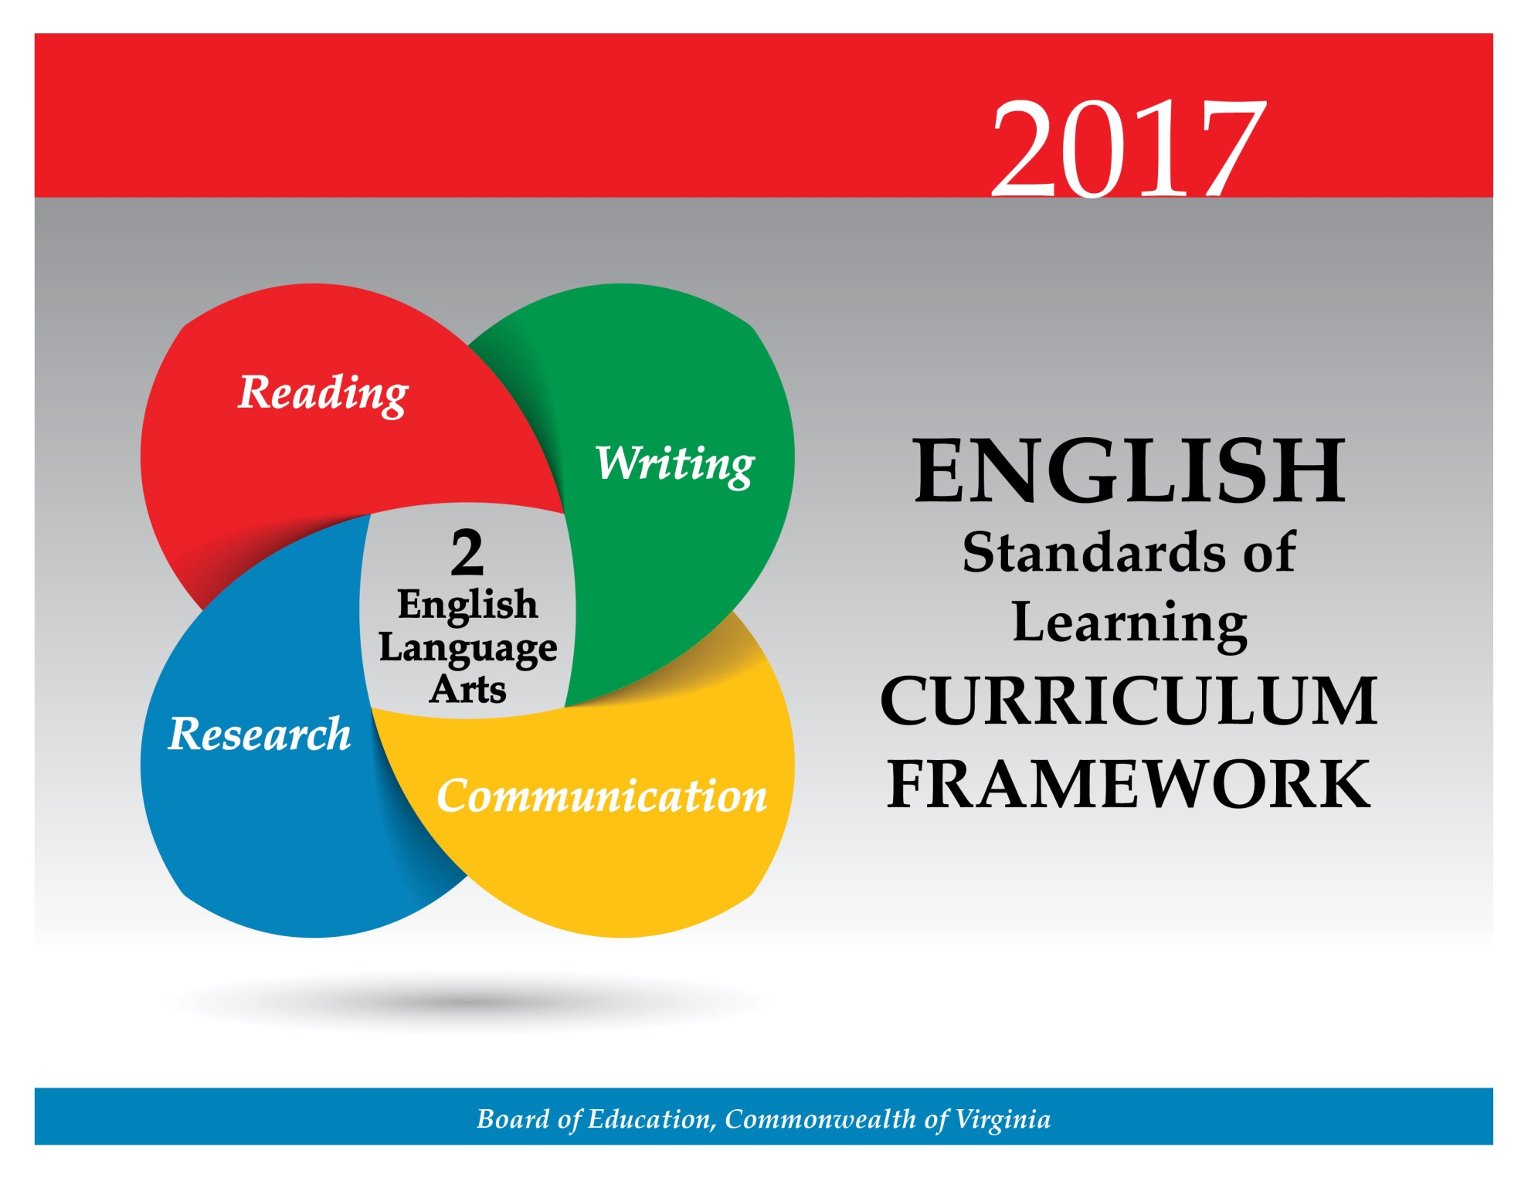
At the second grade level, students will develop an understanding of language structure and enhance their ability to communicate effectively. Students will use listening and speaking skills to participate in classroom discussions, work respectfully with others, and develop simple presentations using multimodal tools. Students will create oral stories and participate in choral speaking, recitation, and creative dramatics. Students will take turns in different roles during collaborative activities. Teachers will encourage the development of interpersonal skills that are foundational to effective communication and collaboration. These skills are essential for success in future postsecondary education and workplace environments.

Teacher Notes
- Teachers should provide daily opportunities for student communication and collaboration in a variety of settings.
- Teachers should provide opportunities for students to create multimodal presentations independently or collaboratively.
- Multimodal is the strategic use of two or more interdependent modes of communication where both/all modes are essential to convey the intended message (e.g., graphics, written language, moving images, music, audio, presentation technologies, movement).

2.1 The student will use oral communication skills.
- Listen actively and speak using appropriate discussion rules.
- Use oral language for different purposes: to inform, persuade, entertain, clarify, and respond.
- Speak audibly with appropriate voice level, phrasing, and intonation.
- Share information orally with appropriate facts and relevant details.
- Use increasingly complex sentence structures in oral communication.
- Begin to self-correct errors in language use.
- Participate as a contributor and leader in collaborative and partner discussions.
- Ask and answer questions to seek help, get information, or clarify information.
- Retell information shared by others.
- Restate and follow multi-step directions.
- Give multi-step directions.
- Work respectfully with others and show value for individual contributions.
- Create a simple presentation using multimodal tools.
ESSENTIAL UNDERSTANDINGS | ESSENTIAL KNOWLEDGE, SKILLS, AND PROCESSES
All students should understand that oral communication can be used for a variety of purposes. | To be successful with this standard, students are expected to  - participate in a range of collaborative discussions by building on others’ ideas and clearly expressing thoughts and opinions  - participate in collaborative conversations for various purposes  - ask and respond to questions to check for understanding of information presented (e.g., stay on topic, link remarks to those of others)  - follow rules for discussion  - use proper pitch and volume  - speak clearly and distinctly  - share and retell an experience or story to an audience in a logical order, with appropriate facts and descriptive details  - select vocabulary appropriate to purpose and audience  - express ideas clearly and in an organized manner  - confer with small-group members about how to present information to the class  - carry out a specific group role, such as leader, recorder, materials manager, or reporter  - engage in taking turns in conversations by  - making certain all group members have an opportunity to contribute  - listening attentively by making eye contact while facing the speaker  - eliciting information or opinions from others  - give and follow multi-step directions  - speak in complete sentences when appropriate to task and situation to provide details and clarification.

2.2 The student will demonstrate an understanding of oral early literacy skills.
- Create oral stories to share with others.
- Create and participate in oral dramatic activities.
- Participate in a variety of oral language activities, including choral speaking and recitation.
ESSENTIAL UNDERSTANDINGS | ESSENTIAL KNOWLEDGE, SKILLS, AND PROCESSES
All students should  - understand that telling oral stories and participating in creative dramatics develop comprehension  - understand that choral and echo speaking build oral literacy skills. | To be successful with this standard, students are expected to  - use the story structure of beginning, middle, and end to tell a story of an experience  - maintain and manipulate voice, such as pausing, tempo, and pitch, to convey mood  - add appropriate elaboration and detail while telling oral stories  - dramatize familiar stories (e.g., plays, skits, reader’s theater)  - participate in frequent oral language activities through choral speaking and the reciting of poems and stories with repeated patterns.

Developing literacy skills continues to be a priority in the second grade. Students will be immersed in an environment filled with fiction and nonfiction texts, which relate to all content areas and personal interests. Students will expand vocabulary, use a combination of strategies when reading, and read familiar selections with fluency, accuracy, and expression. Students will identify story elements including plot, characters, setting, theme, conflict, and resolution. Students will demonstrate comprehension skills by identifying main ideas, making and confirming predictions, questioning, summarizing, and drawing conclusions. Students will learn and apply comprehension strategies while reading cross-content materials. Teachers will encourage the development of reading skills that are foundational to effective comprehension and critical thinking. These skills are essential for success in future postsecondary education and workplace environments.

Teacher Notes
- Teachers should provide opportunities for both independent and silent reading with options for student choice.
- Teachers should introduce students to longer, more complex texts.
- At this point, students should understand that plot is important events that occur in fiction. Theme can be defined as topical theme (e.g., friendship, family, working hard) or lesson in fiction (e.g., lesson learned in The Ugly Duckling).
- Expansion of vocabulary comes through the use of authentic texts whether read aloud or independently.
- Teachers should teach theme as a literary term with fiction texts and main idea with nonfiction texts. Please note these terms are not interchangeable. However, identifying main idea in a paragraph or portion of text is an essential skill for comprehension.
- In teaching fiction, teachers should also note the introduction of story elements including plot, conflict, and resolution.
- Please note although the strands are developed separately, teachers should seamlessly integrate all strands.
  - Teachers may integrate the strands through the use of thematic units.
  - Teachers should ask students to write about what they have read.

2.3 The student will orally identify, produce, and manipulate various phonemes within words to develop phonemic awareness.
- Count phonemes within one-syllable words.
- Blend sounds to make one-syllable words.
- Segment one-syllable words into phonemes.
- Add or delete phonemes to make words.
- Blend and segment multisyllabic words at the syllable level.
ESSENTIAL UNDERSTANDINGS | ESSENTIAL KNOWLEDGE, SKILLS, AND PROCESSES
All students should understand that spoken words are made up of individual phonemes, which can be manipulated to make new words. | To be successful with this standard, students are expected to  - count phonemes in one-syllable words (e.g., man has three phonemes /m/-/a/-/n/, chop has three phonemes /ch/-/o/-/p/, and drop has four phonemes /d/-/r/-/o/-/p/)  - isolate and manipulate phonemes  - blend sounds to make one-syllable words (e.g., /p/-/a/-/n/ → pan , /d/-/r/-/i/-/p/ → drip)  - segment words by saying each sound (e.g., pan → /p/-/a/-/n/, drip → /d/-/r/-/i/-/p/)  - add a phoneme from an orally presented word or rime to make a new word (e.g., pie/pipe, four/fork, cab/crab, ot/lot, ap/map)  - delete a phoneme from an orally presented word to make a new word (e.g., rice/ice, beach/bee, weight/weigh, couch/cow)  - blend and segment multisyllabic words at the syllable level  - identify syllables in a word (e.g., students tap snowball → /snow/- /ball/, clap out the word hamburger → /ham/- /bur/-/ger/)  - state the word created by blending given syllables together (e.g., /fan/-/tas/-/tic/ → fantastic)  - delete a syllable from a word and state what remains (e.g., say celebrate without brate [cele])  - manipulate sounds in words to form new or nonsense words.

2.4 The student will use phonetic strategies when reading and spelling.
- Use knowledge of consonants, consonant blends, and consonant digraphs to decode and spell words.
- Use knowledge of short, long, and r-controlled vowel patterns to decode and spell words.
- Decode regular multisyllabic words.
- Apply decoding strategies to confirm or correct while reading.
ESSENTIAL UNDERSTANDINGS | ESSENTIAL KNOWLEDGE, SKILLS, AND PROCESSES
All students should understand the need to apply phonetic strategies to decode and spell words. | To be successful with this standard, students are expected to  - apply knowledge of consonants and consonant blends to decode and spell words  - apply knowledge of consonant digraphs (e.g., sh, wh, ch, th) to decode and spell words  - distinguish long and short vowels when reading one-syllable regularly spelled words  - apply knowledge of the consonant-vowel patterns, such as CV (e.g., go), VC (e.g., in), CVC (e.g., pin), CVCE (e.g., take), CVVC (e.g., wait), and CVCC (e.g., wind) to decode and spell words  - apply knowledge of r-controlled vowel patterns to decode and spell words  - read regularly spelled one- and two-syllable words automatically  - decode regular multisyllabic words  - use a variety of decoding strategies while reading to confirm or correct the pronunciation and use of words.

2.5 The student will use semantic clues and syntax to expand vocabulary when reading.
- Use information and context clues in the story to read words.
- Use knowledge of sentence structure to determine the meaning of unknown words.
ESSENTIAL UNDERSTANDINGS | ESSENTIAL KNOWLEDGE, SKILLS, AND PROCESSES
All students should  - understand that a variety of strategies can be used to read unfamiliar words  - understand that specific vocabulary helps explain and clarify ideas. | To be successful with this standard, students are expected to  - use meaning clues to support decoding  - use surrounding words in a sentence to determine the meaning of a word  - determine which of the multiple meanings of a word in context makes sense  - use knowledge of word order, including subject, verb, and adjectives, to check for meaning.

2.6 The student will expand vocabulary and use of word meanings.
- Use knowledge of homophones.
- Use knowledge of prefixes and suffixes.
- Use knowledge of antonyms and synonyms.
- Discuss meanings of words and develop vocabulary by listening to and reading a variety of texts.
- Use word-reference materials including dictionaries, glossaries and indices.
- Use vocabulary from other content areas.
ESSENTIAL UNDERSTANDINGS | ESSENTIAL KNOWLEDGE, SKILLS, AND PROCESSES
All students should understand that knowledge of homophones, prefixes, suffixes, synonyms, and antonyms can be used to read unfamiliar words. | To be successful with this standard, students are expected to  - use the context of a sentence to apply knowledge of homophones (e.g., such as pair and pear)  - identify and recognize meanings of common prefixes and suffixes (e.g., un-, re-, mis-, dis-, -y, -ly, -er, -ed, -ing, -est, -ful, -less, -able)  - use common prefixes and suffixes to decode words  - determine the meaning of words when a known prefix and/or suffix is added to a known root word (e.g., tie/untie, fold/unfold, write/rewrite, call/recall)  - supply synonyms and antonyms for a given word  - use knowledge of antonyms when reading (e.g., hot/cold, fast/slow, first/last)  - use knowledge of synonyms when reading  - use a thesaurus to expand synonym knowledge  - demonstrate an understanding of what the apostrophe signifies in singular possessive words  - demonstrate an understanding of the meaning of contractions  - discuss meanings of words and develop vocabulary (e.g., closely related adjectives such as slender, thin, scrawny; closely related verbs such as look, peek, glance)  - use knowledge of the meaning of individual words to predict the meaning of compound words  - alphabetize words to the second and third letter  - use specific vocabulary from content area study.

2.7 The student will read and demonstrate comprehension of fictional texts.
- Make and confirm predictions.
- Connect previous experiences to new texts.
- Ask and answer questions using the text for support.
- Describe characters, setting, and plot events in fiction and poetry.
- Identify the conflict and resolution.
- Identify the theme.
- Summarize stories and events with beginning, middle, and end in the correct sequence.
- Draw conclusions based on the text.
- Read and reread familiar stories and poems with fluency, accuracy, and meaningful expression.
ESSENTIAL UNDERSTANDINGS | ESSENTIAL KNOWLEDGE, SKILLS, AND PROCESSES
All students should  - understand the elements of fiction (i.e., characters, setting, plot events)  - understand details are important to comprehend the text. | To be successful with this standard, students are expected to  - set a purpose for reading  - use titles to generate ideas about the text  - use details from the text to confirm and revise predictions made before, during, and after reading  - explain how illustrations and images contribute to and clarify text  - describe a character’s traits, feelings, and actions as presented in fictional texts  - describe the characters, settings, and important plot events using details  - identify the main conflict and resolution in fictional texts  - determine the theme of fictional texts (e.g., friendship, family, working hard)  - thematic topic  - lesson learned  - use knowledge of transition words (e.g., first, next, and soon) to understand how information is organized in sequence  - demonstrate comprehension by writing responses to what they read  - practice reading and rereading text that is on their independent reading level to develop accuracy, fluency, and meaningful expression.

2.8 The student will read and demonstrate comprehension of nonfiction texts.
- Preview the selection using text features including table of contents, headings, pictures, captions, and maps.
- Make and confirm predictions.
- Use prior and background knowledge as context for new learning.
- Set purpose for reading.
- Ask and answer questions using the text as support.
- Identify the main idea.
- Draw conclusions based on the text.
- Read and reread familiar texts with fluency, accuracy, and meaningful expression.
ESSENTIAL UNDERSTANDINGS | ESSENTIAL KNOWLEDGE, SKILLS, AND PROCESSES
All students should  - understand texts provide information or explain a process  - understand text features serve a purpose  - understand that comprehension requires making, confirming and revising predictions  - understand that details and information from the text are used to draw conclusions. | To be successful with this standard, students are expected to  - explain how illustrations and images contribute to and clarify text  - skim text for section headings, bold type, and picture captions to help set a purpose for reading  - use print clues, such as bold type, italics, and underlining, to assist in reading  - use text features to make, revise, and confirm predictions, locate information, and answer questions  - use knowledge of sequence to read and follow recipes and other sets of directions  - determine the main idea using details for support  - ask and answer questions about what is read to demonstrate understanding (e.g., who, what, when, where, why, and how)  - begin to use knowledge of transition words (signal words; e.g., first, next, and soon) to understand how information is organized  - demonstrate comprehension by writing about what is read  - use information from the text to draw conclusions.

At the second grade level, students will continue to develop reading and writing together. They will be given daily opportunities to write and will be expected to revise selected pieces and share them with others. Students will begin to make the transition to cursive handwriting. Students will understand writing as a process and will write in a variety of forms. Students will organize writing according to type and purpose and will elaborate to provide support and detail. They will also begin to apply written communication skills across all content areas. Teachers will encourage the development of writing skills that are foundational to effective written communication and critical thinking. These skills are necessary for success in future postsecondary and workplace environments.

Teacher Notes
- Teachers should model the writing process for students.
- Teachers should refer to examples of writing in mentor texts.
- The focus of writing in second grade is narrative, descriptive, opinion, and expository.
- Teachers will teach students to include facts in support of a main idea.
- Teachers should use student writing to teach editing skills.
- Teachers will provide opportunities for students to both orally and in writing express opinions with a reason.

2.9 The student will maintain legible printing and begin to make the transition to cursive.
- Begin to write capital and lowercase letters of the alphabet.
- Begin to sign his/her first and last names.
ESSENTIAL UNDERSTANDINGS | ESSENTIAL KNOWLEDGE, SKILLS, AND PROCESSES
All students should understand that legible printing is an important tool of written communication. | To be successful with this standard, students are expected to  - write legibly  - space words in sentences  - space sentences in writing  - learn basic strokes for cursive.

2.10 The student will write in a variety of forms to include narrative, descriptive, opinion, and expository.
- Understand writing as a process.
- Identify audience and purpose.
- Use prewriting strategies to generate ideas before writing.
- Use strategies for organization according to the type of writing.
- Organize writing to include a beginning, middle, and end.
- Write facts about a subject to support a main idea.
- Write to express an opinion and provide a reason for support.
- Expand writing to include descriptive detail.
- Revise writing for clarity.
ESSENTIAL UNDERSTANDINGS | ESSENTIAL KNOWLEDGE, SKILLS, AND PROCESSES
All students should  - understand that writers use the writing process including planning, drafting, revising, editing, and publishing  - understand that written communication should be well-planned and clear to the reader. | To be successful with this standard, students are expected to  - identify the intended audience and purpose for writing (e.g., letters, stories, emails, journals, directions)  - generate ideas and organize information before writing  - participate in shared writing projects  - write informative/explanatory pieces that introduce the topic, use facts or opinions, and provide a concluding statement  - write narratives describing events with details, sequence, and a closure  - develop writing by focusing on one topic  - write complete sentences  - begin to compose, organize, and format paragraphs  - use adjectives to elaborate and expand simple sentences  - describe events, ideas, and personal stories with descriptive details  - use time-order words, such as first, next, then, and last, to sequence and organize writing  - produce and expand complete simple and compound sentences (e.g., The girl listened to the music. The little girl listened to the loud music.)  - strengthen writing as needed by revising writing, staying on topic, and including details  - consult reference materials to check and correct spelling  - avoid stringing ideas together with and or then.

2.11 The student will edit writing for capitalization, punctuation, spelling, and Standard English.
- Recognize and use complete sentences.
- Use and punctuate declarative, interrogative, and exclamatory sentences.
- Capitalize all proper nouns and the word I.
- Use singular and plural nouns and pronouns.
- Use apostrophes in contractions and possessives.
- Use contractions and singular possessives.
- Use knowledge of simple abbreviations.
- Use correct spelling for commonly used sight words, including compound words and regular plurals.
- Use commas in salutation and closing of a letter.
- Use past and present verbs.
- Use adjectives correctly.
ESSENTIAL UNDERSTANDINGS | ESSENTIAL KNOWLEDGE, SKILLS, AND PROCESSES
All students should understand that proper grammar, capitalization, punctuation, and spelling contribute to the meaning of writing. | To be successful with this standard, students are expected to  - punctuate declarative, interrogative, and exclamatory sentences with a period, question mark, or exclamation point  - capitalize the word I, all proper nouns, and words at the beginning of sentences  - use frequently occurring irregular plural nouns (e.g., feet, children, teeth, fish)  - use apostrophes to form contractions and common singular possessives  - identify simple abbreviations, including those for titles (e.g., Mr., Mrs., Ms., and Dr.), calendar words (e.g., Jan., Feb., Mon., Tue.), and address words (e.g., St., Rd.)  - use commas in the salutation (e.g., Dear Tyrell, ) and closing (e.g., Sincerely) of a letter.

Students will conduct research by generating topics of interest, asking questions, identifying sources, and finding and organizing information. Students will complete an oral, written, or visual research product collaboratively or individually. Teachers will encourage the development of research skills that are foundational to effective critical thinking and responsible use of information. These skills are necessary for success in future postsecondary education and workplace environments.

Teacher Notes
- Teachers should have students collaborate in whole or small groups during the research process.
- Teachers should teach students the difference between plagiarism and using their own words.
- Teachers should use the librarian/media specialist’s expertise in teaching the research process.

2.12 The student will conduct research by using available resources to gather information and answer questions to complete a research product.
- Generate topics of interest.
- Generate questions to gather information.
- Identify pictures, texts, people, or media as sources of information.
- Find information from provided sources.
- Organize information in writing or a visual display.
- Describe difference between plagiarism and using own words.
ESSENTIAL UNDERSTANDINGS | ESSENTIAL KNOWLEDGE, SKILLS, AND PROCESSES
All students should  - understand that research can be used to answer questions or solve problems  - understand that various sources can help provide information  - understand the meaning of plagiarism and learn to use own words when researching. | To be successful with this standard, students are expected to  - generate ideas for topics based on interest or content areas  - work collaboratively to generate questions to gather information  - identify pictures, various texts, media, or people that can be used as sources of information  - use provided sources to gather information, answer questions, or solve problems  - use templates or visual displays (e.g., graphic organizers, charts, graphs) to organize information  - use own words to record information.

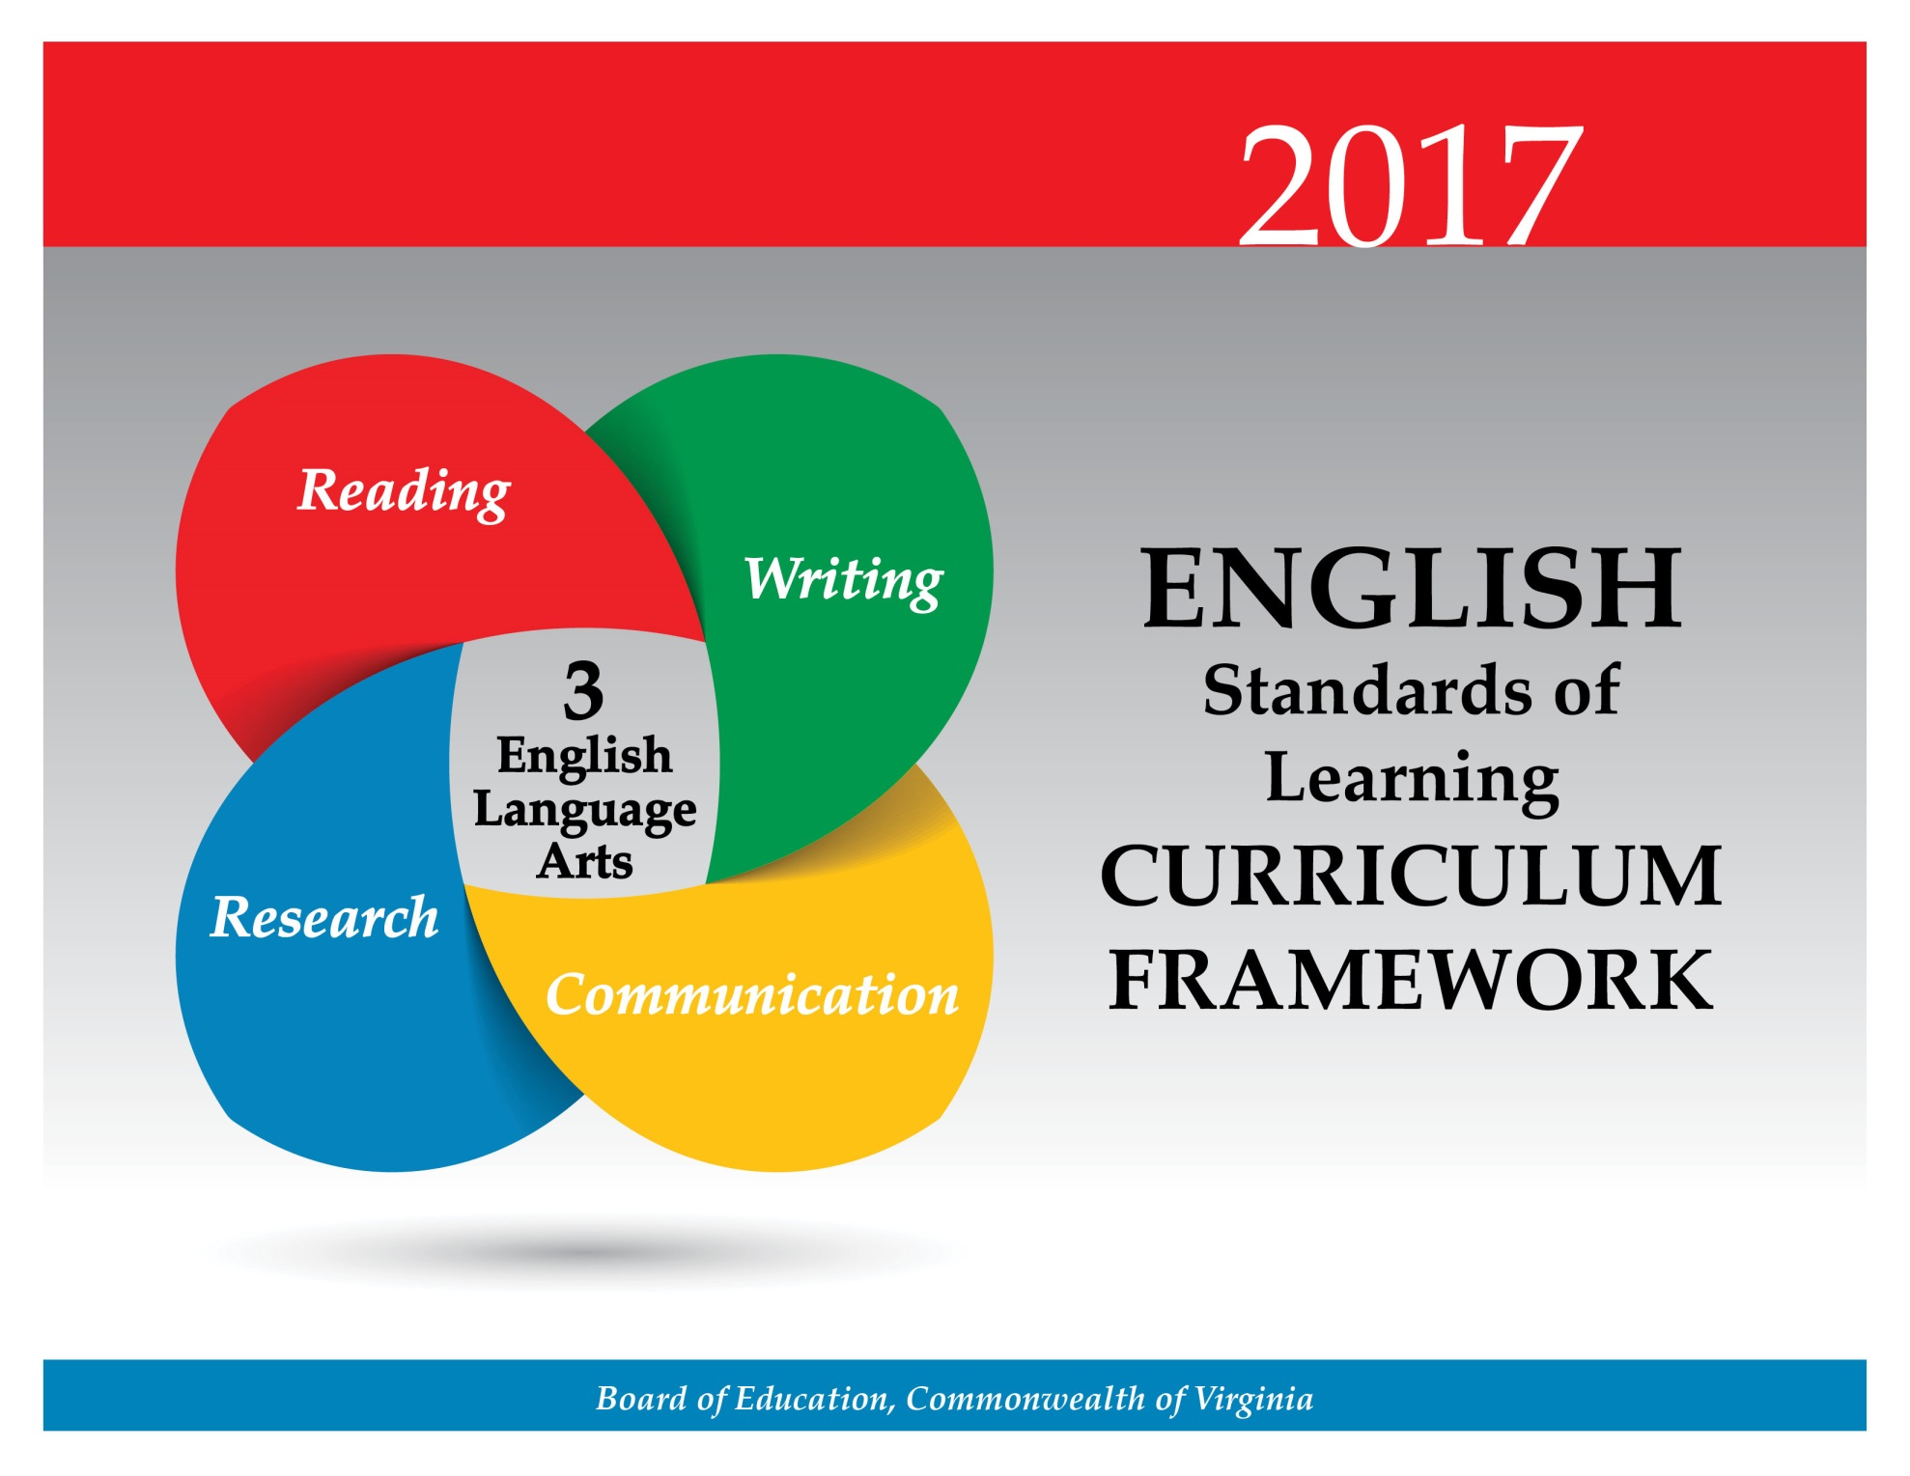
Students will use communication skills to participate in classroom discussions, work respectfully with others in a variety of situations, and develop presentations using multimodal tools. Students will develop specific skills for organizing, expressing, and presenting ideas or information. Teachers will encourage the development of interpersonal skills that are foundational to effective communication and collaboration. These skills are essential for success in future postsecondary education and workplace environments.

Teacher Notes
- Please note student presentation skills may differ within classrooms.
- Teachers should provide opportunities for students to create multimodal presentations independently or collaboratively.
- Multimodal is the strategic use of two or more interdependent modes of communication where both/all modes are essential to convey the intended message (e.g., graphics, written language, moving images, music, audio, presentation technologies, movement).

3.1 The student will use effective communication skills in a variety of settings.
- Use active listening strategies including, but not limited to, making eye contact, facing the speaker, asking questions, and summarizing.
- Present accurate directions to individuals and small groups.
- Ask and respond to questions from teachers and other group members.
- Orally summarize information expressing ideas clearly.
- Use language appropriate for context and audience.
- Increase listening and speaking vocabularies.
- Participate in collaborative discussions.
- Work respectfully with others in pairs, diverse groups, and whole class settings.
ESSENTIAL UNDERSTANDINGS | ESSENTIAL KNOWLEDGE, SKILLS, AND PROCESSES
All students should  - understand the importance of effective communication  - understand the importance of working collaboratively. | To be successful with this standard, students are expected to  - participate in a range of collaborative discussions building on others’ ideas and clearly stating thoughts, opinions, and information  - engage in taking turns in conversations by  - making certain all group members have an opportunity to contribute  - listening attentively  - making eye contact while facing the speaker  - eliciting information or opinions from others  - supporting opinions with appropriate ideas, examples, and details  - indicating disagreement in a constructive manner  - take initiative in moving a group discussion forward by  - following rules for discussions and assigned group roles  - contributing information that is on topic  - answering questions  - asking clarifying questions of the speaker  - summarizing the conclusions reached in the discussion  - explaining what has been learned  - working respectfully with others  - ask and respond to questions to check for understanding or to clarify information presented.

3.2 The student will give oral presentations.
- Speak clearly using appropriate volume.
- Speak at an understandable rate.
- Make eye contact with the audience.
- Organize ideas sequentially or around major points of information using appropriate facts and relevant details.
- Use contextually appropriate language and specific vocabulary to communicate ideas.
- Use multimodal tools to create presentations and enhance communication.
ESSENTIAL UNDERSTANDINGS | ESSENTIAL KNOWLEDGE, SKILLS, AND PROCESSES
All students should understand the process of effectively organizing and presenting ideas and information. | To be successful with this standard, students are expected to  - deliver oral presentations in an engaging manner that maintains audience interest by  - reporting on a topic, telling a story, or recounting an experience with appropriate facts and relevant details  - presenting information with expression and confidence  - varying tone, pitch, and volume to convey meaning  - speaking at an understandable rate  - selecting words and phrases for effect  - using multimodal tools to emphasize or enhance facts or details  - using specific vocabulary appropriate for the audience and the topic  - stay on topic during presentations  - answer questions from the audience  - evaluate their own presentations, using class-designed criteria.

Students will read a variety of fiction and nonfiction texts, which relate to all content areas and personal interests. Students will continue to develop strategic reading skills, such as word analysis and construction of meaning from text. Students will continue to use comprehension strategies to compare and contrast story elements and differentiate between fiction and nonfiction. Teachers will encourage the development of reading skills that are foundational to effective comprehension and critical thinking. These skills are essential for success in future postsecondary education and workplace environments.

Teacher Notes
- Teachers should provide increased opportunities for silent reading with options for student choice.
- Teachers should introduce students to longer and/or more complex texts, both on grade level and above grade level.
- Vocabulary words should be culled from student reading instead of using random lists and should not be taught in isolation.
- Teachers should teach theme as a literary term with fiction texts and main idea with nonfiction texts. Please note these terms are not interchangeable. However, identifying main idea in a paragraph or portion of text is an essential skill for comprehension.
- In teaching fiction, teachers should also note the introduction of story elements including narrator, plot, conflict, and resolution.
- Please note literary nonfiction is now included in the fiction standard.
- Please note although the strands are developed separately, teachers should seamlessly integrate all strands.
  - Teachers may integrate the strands through the use of thematic units.
  - Teachers should ask students to write about what they have read.

3.3 The student will apply word-analysis skills when reading.
- Use knowledge of regular and irregular vowel patterns.
- Decode regular multisyllabic words.
ESSENTIAL UNDERSTANDINGS | ESSENTIAL KNOWLEDGE, SKILLS, AND PROCESSES
All students should understand the need to apply word-analysis skills to decode words. | To be successful with this standard, students are expected to  - apply knowledge of regular and irregular vowel patterns to decode words  - apply knowledge of ambiguous vowel patterns (e.g., ou/ow, oi/oy, oo, aw) to decode words  - apply knowledge of the change in tense (-ed), number (-s), and degree (-er and -est) signified by inflected endings to decode words  - decode regular multisyllabic words to read fluently.

3.4 The student will expand vocabulary when reading.
- Use knowledge of homophones.
- Use knowledge of roots, affixes, synonyms, and antonyms to determine the meaning of new words.
- Apply meaning clues, language structure, and phonetic strategies to determine the meaning of new words.
- Use context to clarify meaning of unfamiliar words.
- Discuss meanings of words and develop vocabulary by listening to and reading a variety of texts.
- Use vocabulary from other content areas.
- Use word-reference resources including the glossary, dictionary, and thesaurus.
ESSENTIAL UNDERSTANDINGS | ESSENTIAL KNOWLEDGE, SKILLS, AND PROCESSES
All students should  - understand that roots, affixes, synonyms, and antonyms can be used to determine the meaning of unfamiliar words  - understand that word reference resources can be used to learn word meanings. | To be successful with this standard, students are expected to  - use knowledge of homophones to understand unfamiliar words  - apply knowledge of roots to decode unknown words with the same root (e.g., company, companion)  - apply knowledge of affixes, (e.g., prefixes such as ex-, dis-, un-, re-, mis-, non-, pre-; suffixes such as -ly, -ful, -less, -able, -tion, -ness, and –ment) to decode words  - determine the meaning of new words formed when a known affix is added to the root word (e.g., care/careless, heat/reheat)  - use knowledge of synonyms  - use knowledge of antonyms  - use context clues to verify meaning of unfamiliar words and determine correct homophone usage  - use context clues, such as a restatement, a synonym, an example, or a direct description or definition included in the sentence or paragraph, to clarify the meaning of unfamiliar words.

3.5 The student will read and demonstrate comprehension of fictional texts, literary nonfiction, and poetry.
- Set a purpose for reading.
- Make connections between reading selections.
- Make, confirm, and revise predictions.
- Compare and contrast settings, characters, and plot events.
- Summarize plot events.
- Identify the narrator of a story.
- Ask and answer questions about what is read.
- Draw conclusions using the text for support.
- Identify the conflict and resolution.
- Identify the theme.
- Use reading strategies to monitor comprehension throughout the reading process.
- Differentiate between fiction and nonfiction.
- Read with fluency, accuracy, and meaningful expression.
ESSENTIAL UNDERSTANDINGS | ESSENTIAL KNOWLEDGE, SKILLS, AND PROCESSES
All students should understand the essential elements and characteristics of fictional text and poetry. | To be successful with this standard, students are expected to  - identify literary nonfiction as a type of narrative text, which uses story elements and language to share accurate information about real people, places, and events, including but not limited to biography and autobiography  - use important plot events to summarize fictional text, literary nonfiction, and poetry  - make a variety of connections with the text, such as:  - connections between the text they are reading and other texts they have read, such as identifying a similar plot or character; and  - connections between what they already know about the topic and what they find in the reading that is new to them  - use specific details to make, confirm, and revise predictions by  - identifying information from the text that supports or contradicts a prediction  - revising predictions based on new understandings  - apply knowledge of characterization by  - describing a character’s attributes (e.g., traits, motivations or feelings)  - using evidence from the text to support generalizations about the character  - comparing and contrasting characters within a selection or between/among two or more selections  - explaining how the actions of characters contribute to the sequence of events  - apply knowledge of setting by  - identifying the time and place of a story, using supporting details from the text  - identifying the details that make settings similar or different  - compare and contrast characters, setting, and plot in at least two versions of the same story (e.g., Cinderella stories)  - identify the main conflict and resolution  - recognize and identify a theme or lesson of fictional text(s)s (e.g., friendship, survival, determination) using key supporting details  - thematic topic  - lessons learned  - learn to differentiate fiction from nonfiction  - demonstrate comprehension by writing about what is read  - read with accuracy, fluency, and meaningful expression to support comprehension.

3.6 The student will read and demonstrate comprehension of nonfiction texts.
- Identify the author’s purpose.
- Use prior and background knowledge as context for new learning.
- Preview and use text features, including table of contents, headings, pictures, captions, maps, indices, and charts.
- Ask and answer questions about what is read, using the text for support.
- Draw conclusions, using the text for support.
- Summarize information found in nonfiction texts.
- Identify the main idea.
- Identify supporting details.
- Use reading strategies to monitor comprehension throughout the reading process.
- Read with fluency, accuracy, and meaningful expression.
ESSENTIAL UNDERSTANDINGS | ESSENTIAL KNOWLEDGE, SKILLS, AND PROCESSES
All students should  - understand that nonfiction texts provide information, explain a process, or persuade  - understand text features serve a purpose  - understand that details and information from the text help the reader draw conclusions. | To be successful with this standard, students are expected to  - identify the author’s purpose for writing, which may include to provide information, to explain a process, or to persuade  - use prior and background knowledge as context for new learning by recognizing similarities between the text they are reading and other texts they have read;  - use text features to preview; set a purpose for reading; make, confirm, and revise predictions; and locate information  - identify details that support the main idea  - state the main idea in their own words  - practice reading and rereading familiar nonfiction texts with fluency and accuracy  - demonstrate comprehension by writing about what is read.

At the third-grade level, students will continue to develop reading and writing together. Students will use the writing process to plan, draft, revise, and edit writing in a variety of forms. Student writing will become more complex, and students will learn to select details to elaborate on the main idea of a paragraph. They will use written communication skills across content areas. Students also will write legibly in cursive. Teachers will encourage the development of writing skills that are foundational to effective written communication and critical thinking. These skills are necessary for success in future postsecondary and workplace environments.

Teacher Notes
- Teachers should model the writing process for students.
- Teachers should refer to examples of writing in mentor texts.
- The focus of writing in third grade is narrative, descriptive, opinion, and expository.
- Teachers will teach students to develop a paragraph including a clear topic sentence that focuses on the main idea.
- Teachers should use student writing to teach editing skills.
- Teachers should introduce students to the three domains of writing:
  - Composing—focusing on a clear, central idea, providing elaboration and organization
  - Written Expression—selected vocabulary and information
  - Usage/Mechanics—grammar, punctuation, and usage as appropriate for the grade level
- Teachers should utilize writing conferences and portfolios to monitor student progress.
- Please note that although cursive letters are introduced in second grade, it is at the third-grade level that the transition from manuscript to cursive should be completed. No specific form of cursive is required.

3.7 The student will write legibly in cursive.
- Write capital and lowercase letters of the alphabet.
- Sign his/her first and last names.
ESSENTIAL UNDERSTANDINGS | ESSENTIAL KNOWLEDGE, SKILLS, AND PROCESSES
All students should understand that neat, legible, cursive handwriting is an important tool of written communication. | To be successful with this standard, students are expected to  - use correct letter formation  - form cursive letters with flow from one letter to the next within names and words.

3.8 The student will write in a variety of forms to include narrative, descriptive, opinion, and expository.
- Engage in writing as a process.
- Identify audience and purpose.
- Use a variety of prewriting strategies.
- Use organizational strategies to structure writing according to type.
- Write a clear topic sentence focusing on main idea.
- Elaborate writing by including supporting details.
- Use transition words to vary sentence structure.
- Express an opinion about a topic and provide fact-based reasons for support.
- Write a well-developed paragraph focusing on the main idea.
- Revise writing for clarity of content using specific vocabulary and information.
ESSENTIAL UNDERSTANDINGS | ESSENTIAL KNOWLEDGE, SKILLS, AND PROCESSES
All students should  - understand that writers use the writing process, including planning, drafting, revising, editing, and publishing  - understand how to plan and compose writing for a variety of purposes. | To be successful with this standard, students are expected to  - use a variety of prewriting strategies to plan and organize writing  - use mentor texts as an example of writing  - develop writing by focusing on one topic  - follow the organization of particular forms of writing for  - descriptive/expository  - introduce a topic and organize information in paragraph(s)  - use facts, definitions, quotations, details, or other examples and information to develop the topic  - use specific vocabulary to inform and explain the topic  - provide a conclusion  - narratives  - sequence events  - use transition words and phrases for sentence variety  - use specific vocabulary to develop a story  - provide a conclusion  - opinion  - state a clear opinion  - provide multiple facts using specific vocabulary as reasons for support  - provide a conclusion  - incorporate transitional words and phrases (e.g., including but not limited to first, next, last, also, another, more, in order to, because of this, for example)  - add specific details for further elaboration  - use precise nouns, verbs, and adjectives  - clarify writing when revising by including specific vocabulary and information.

3.9 The student will edit writing for capitalization, punctuation, spelling, and Standard English.
- Use complete sentences.
- Use the word I in compound subjects.
- Use past and present verb tense.
- Use adjectives correctly.
- Use singular possessives.
- Use commas in a simple series.
- Use simple abbreviations.
- Use apostrophes in contractions with pronouns and in possessives.
- Use the articles a, an, and the correctly.
- Use correct spelling including irregular plurals.
- Indicate paragraphing by indenting or skipping a line.
ESSENTIAL UNDERSTANDINGS | ESSENTIAL KNOWLEDGE, SKILLS, AND PROCESSES
All students should understand editing for correct sentence formation, grammar, capitalization, spelling, and punctuation makes the meaning of the writing clearer to the reader. | To be successful with this standard, students are expected to  - write using complete sentences  - choose and use past and present verb tenses for clarity  - use singular possessives to demonstrate ownership  - use correct punctuation for commas in a simple series and apostrophes in contractions with pronouns (e.g., I’d, we’ve).

Students will continue to identify and use appropriate resources to complete a research product. Students will understand plagiarism and will report information using their own words. Teachers will encourage the development of research skills that are foundational to effective critical thinking and responsible use of information. These skills are necessary for success in future postsecondary education and workplace environments.

Teacher Notes
- Teachers should note that research can be collaborative, cross-curricular, and integrated throughout the year.
- Teachers should utilize librarian/media specialist’s expertise in teaching the research process.
- Teachers should teach students the difference between plagiarism and using their own words.
- Teachers should model responsible use of the Internet.

3.10 The student will demonstrate comprehension of information resources to research a topic and complete a research product.
- Construct questions about the topic.
- Access appropriate resources.
- Collect and organize information about the topic.
- Evaluate the relevance of the information.
- Avoid plagiarism and use own words.
- Demonstrate ethical use of the Internet.
ESSENTIAL UNDERSTANDINGS | ESSENTIAL KNOWLEDGE, SKILLS, AND PROCESSES
All students should  - understand how information should be collected, analyzed, organized, and presented  - understand the difference between plagiarism and using their own words in writing. | To be successful with this standard, students are expected to  - make decisions about which resource is best for locating a given type of information  - focus on a central topic  - develop a list of questions pertaining to a specific topic  - use appropriate resources to gather information  - organize and present information orally and/or in writing  - review writing to check that the language and/or thoughts of another author are given proper credit.

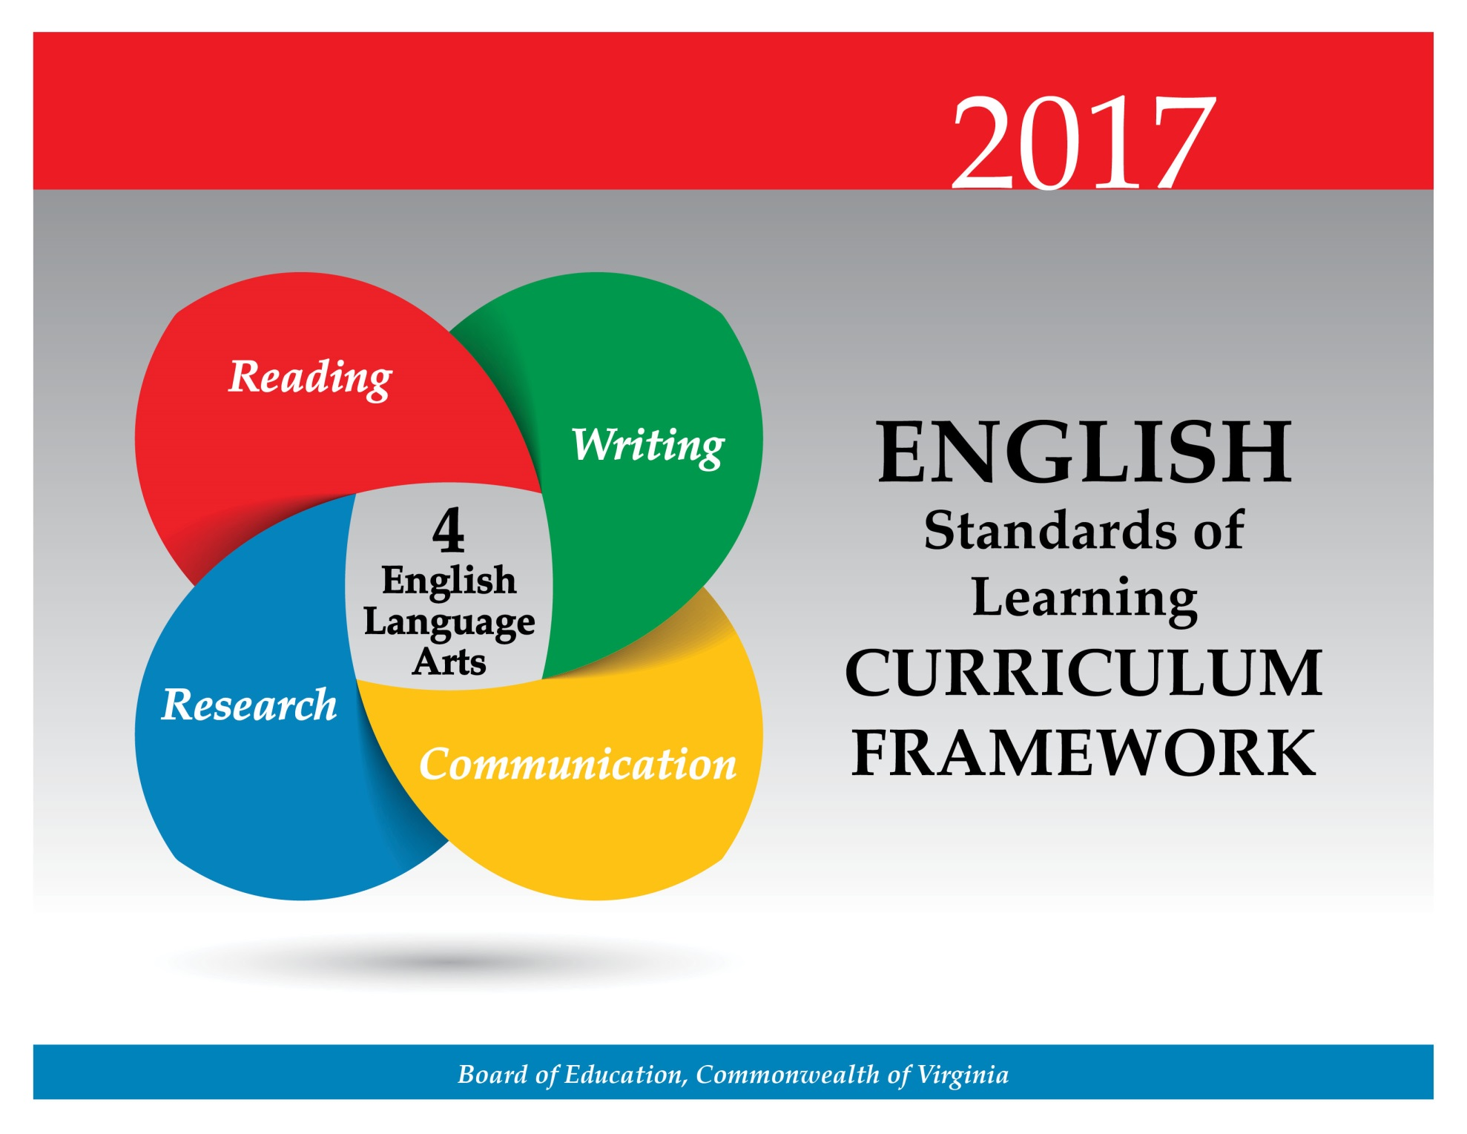

At the fourth-grade level, students will continue to increase communication and collaboration skills by working in diverse teams. To be contributing participants in discussions, students will apply skills to effectively communicate ideas and opinions, while showing value for others’ contributions. Students will deliver interactive, multimodal presentations and begin to examine media messages. Teachers will encourage the development of effective, interpersonal communication and collaboration skills that are essential for success in future postsecondary education and workplace environments.

Teacher Notes
- Please note student presentation skills may differ within classrooms.
- Teachers should explicitly teach effective presentation skills with audience involvement.
- Teachers should provide opportunities for students to create interactive, multimodal presentations.
- Multimodal is the strategic use of two or more interdependent modes of communication where both/all modes are essential to convey the intended message (e.g., graphics, written language, moving images, music, audio, presentation technologies, movement).

4.1 The student will use effective oral communication skills in a variety of settings.
- Listen actively and speak using appropriate discussion rules.
- Contribute to group discussions across content areas.
- Orally summarize information expressing ideas clearly.
- Ask specific questions to gather ideas and opinions from others.
- Use evidence to support opinions and conclusions.
- Connect comments to the remarks of others.
- Use specific vocabulary to communicate ideas.
- Demonstrate the ability to collaborate with diverse teams, while sharing responsibility for the work.
- Work respectfully with others, and show value for individual contributions.
ESSENTIAL UNDERSTANDINGS | ESSENTIAL KNOWLEDGE, SKILLS, AND PROCESSES
All students should understand the process of communicating effectively and working collaboratively to accomplish a variety of tasks and goals. | To be successful with this standard, students are expected to  - participate in a range of discussions, building on others’ ideas and clearly stating thoughts, opinions, and information  - participate in a variety of collaborative discussions by  - following rules for discussions and assigned partner or group roles  - offering comments that are relevant to the topic of discussion  - asking appropriate questions to solicit knowledge and opinions from others  - supporting opinions with appropriate examples and details  - identifying reasons and evidence a speaker provides to support particular points  - communicating new ideas to others  - responding to specific questions to clarify or follow up on information, and make comments that contribute to the discussion and link to the remarks of others  - reviewing key ideas expressed in discussions and explaining own ideas and understanding  - distinguishing fact from opinion  - taking turns speaking during a discussion  - maintaining appropriate eye contact while listening  - respecting the comments of others, especially if the comments express opinions that are different from the student’s own.

4.2 The student will create and deliver multimodal, interactive presentations.
- Locate, organize, and analyze information from a variety of multimodal texts.
- Speak audibly with appropriate pacing.
- Use language and style appropriate to the audience, topic, and purpose.
- Make eye contact with the audience.
- Ask and answer questions to gather or clarify information presented orally.
ESSENTIAL UNDERSTANDINGS | ESSENTIAL KNOWLEDGE, SKILLS, AND PROCESSES
All students should understand how ideas can be best organized and delivered for an effective presentation. | To be successful with this standard, students are expected to  - create and deliver multimodal presentations by  - reporting on a topic or text, telling a story, or recounting an experience in an organized manner, using specific vocabulary, appropriate facts, and descriptive details to support main ideas or themes  - organizing information around a central idea with supporting details and using specific vocabulary  - speaking clearly, using appropriate voice level and speaking rate  - differentiating formal and informal language and style when appropriate to task and situation (e.g., presentations, small-group discussions)  - selecting words and phrases to convey precise ideas  - using voice inflection for effect  - involving audience participation through planned interactions (e.g., questioning, discussion, gathering responses, and movement)  - use active listening skills by  - looking at the speaker  - thinking about the main points the speaker is making  - taking notes.

4.3 The student will learn how media messages are constructed and for what purposes.
- Differentiate between auditory, visual, and written media messages and their purposes.
- Compare and contrast how ideas and topics are depicted in a variety of media and formats.
ESSENTIAL UNDERSTANDINGS | ESSENTIAL KNOWLEDGE, SKILLS, AND PROCESSES
All students should understand attributes of a constructed message (i.e., audience and purpose). | To be successful with this standard, students are expected to  - access media messages and identify what types of media are used  - determine the purpose of various media messages  - compare and contrast messages, facts, and opinions in multiple media formats.

In fourth grade, there is an increased emphasis on reading comprehension by comparing fiction and nonfiction texts, identifying cause-and-effect relationships, and differentiating between fact and opinion. Students will expand vocabulary using knowledge of roots, affixes, synonyms, antonyms, and homophones. Teachers will encourage the development of reading skills that are foundational to effective comprehension and critical thinking. These skills are essential for success in future postsecondary education and workplace environments.

Teacher Notes
- Teachers must provide increased opportunities for silent reading with options for student choice.
- Teachers should introduce students to longer and/or more complex texts both on grade level and above grade level.
- Vocabulary words should be culled from student reading instead of using random lists and should not be taught in isolation.
- Teachers should teach theme as a literary term with fiction texts and main idea with nonfiction texts. Please note these terms are not interchangeable. However, identifying main idea in a paragraph or portion of text is an essential skill for comprehension.
- Please note teachers should introduce specific genres of fiction including, but not limited to, fantasy, humor, fable/fairy tale, realistic fiction, historical fiction, and folklore/tall tales.
- Teachers should use fictional and informational texts paired on a common theme or topic and have students compare/contrast.
- Teachers should teach author’s purpose exclusively with nonfiction texts.
- Please note although the strands are developed separately, teachers should seamlessly integrate all strands.
  - Teachers may integrate the strands through the use of thematic units.
  - Teachers should ask students to write about what they have read.

4.4 The student will expand vocabulary when reading.
- Use context to clarify meanings of unfamiliar words.
- Use knowledge of roots, affixes, synonyms, antonyms, and homophones to determine the meaning of new words.
- Use word-reference materials.
- Use vocabulary from other content areas.
- Develop and use general and specialized vocabulary through speaking, listening, reading, and writing.
ESSENTIAL UNDERSTANDINGS | ESSENTIAL KNOWLEDGE, SKILLS, AND PROCESSES
All students should  - understand that the content and structure of a sentence, paragraph, or reading selection can be used to determine the meaning of an unfamiliar word  - understand that roots, affixes, synonyms, and antonyms can help a reader determine the meaning of unfamiliar words  - understand that word reference resources can help a reader learn word meanings  - understand the type of information found in word reference materials such as a glossary, dictionary, and thesaurus. | To be successful with this standard, students are expected to  - use context as a clue to clarify the meaning of unfamiliar words or phrases (e.g., definitions, examples, or restatements of text)  - use clues in the context of a sentence, paragraph, or reading selection to predict and explain the meanings of words that have more than one definition  - use knowledge of affixes to read and understand the meanings of words  - apply knowledge of synonyms and antonyms to understand the meanings of unfamiliar words  - derive word meaning by using knowledge of homophones such as read/red, no/know, hear/here  - use context to select the applicable definition of a word from a glossary or dictionary  - identify and consult the word-reference material(s), including the glossary, dictionary, and thesaurus, most likely to contain needed information to clarify word meaning  - determine the meaning of general academic and content-specific words or phrases in a text.

4.5 The student will read and demonstrate comprehension of fictional texts, literary nonfiction texts, and poetry.
- Describe how the choice of language, setting, and characters contributes to the development of plot.
- Identify the theme(s).
- Summarize events in the plot.
- Identify genres.
- Identify the narrator of a story and the speaker of a poem.
- Identify the conflict and resolution.
- Identify sensory words.
- Draw conclusions/make inferences about text using the text as support.
- Compare/contrast details in literary and informational nonfiction texts.
- Identify cause and effect relationships.
- Use reading strategies throughout the reading process to monitor comprehension.
- Read with fluency, accuracy, and meaningful expression.
ESSENTIAL UNDERSTANDINGS | ESSENTIAL KNOWLEDGE, SKILLS, AND PROCESSES
All students should  - understand the essential elements and characteristics of fictional text, literary nonfiction, and poetry  - understand the similarities and differences between literary and informational nonfiction texts. | To be successful with this standard, students are expected to  - describe how an author’s choice of language, setting, and characters develops the plot and contributes to the sequence of events  - describe in depth a character, setting, or event, drawing on specific details from the text (e.g., words, actions, or a character’s thoughts).  - identify literary nonfiction as a type of narrative text, which uses story elements and language to share accurate information about real people, places, and events, including but not limited to biography and autobiography  - identify genres including but not limited to: fantasy, humor, fable/fairy tale, realistic fiction, historical fiction, folklore/tall tales  - identify the theme(s) of a text (e.g., friendship, survival, determination)  - thematic topic  - lessons learned  - summarize plot events using supporting details  - identify the main conflict and resolution in a poem, section of text, or book  - analyze the similarities and differences between paired fictional texts and informational nonfiction texts (e.g., similar themes and topics, patterns of events)  - make connections between the text of a story and a visual/oral presentation of the text, identifying where each version reflects specific descriptions and directions in the text  - identify sensory words that describe sights, sounds, smells, and tastes, and describe how they contribute to the text  - refer to details, specific vocabulary, and examples in a text to draw conclusions/make inferences  - use specific details to make, confirm, or revise predictions by  - identifying information from the text that supports or contradicts a prediction  - revising predictions based on new understandings  - demonstrate comprehension and apply strategies by writing about what is read  - read familiar text with fluency, accuracy, and meaningful expression  - read with sufficient accuracy and fluency to support comprehension.

4.6 The student will read and demonstrate comprehension of nonfiction texts.
- Use text features such as type, headings, and graphics to predict and categorize information.
- Explain the author’s purpose.
- Identify the main idea.
- Summarize supporting details.
- Draw conclusions and make inferences using textual information as support.
- Distinguish between cause and effect.
- Distinguish between fact and opinion.
- Use reading strategies throughout the reading process to monitor comprehension.
- Read with fluency, accuracy, and meaningful expression.
ESSENTIAL UNDERSTANDINGS | ESSENTIAL KNOWLEDGE, SKILLS, AND PROCESSES
All students should  - understand that nonfiction texts provide information, explain a process, or persuade  - understand text features serve a purpose  - understand that details and information from the text are used to draw conclusions and make inferences. | To be successful with this standard, students are expected to  - explain how written text and accompanying graphics connect to convey meaning (e.g., charts, graphs, diagrams, timelines, animations)  - explain author’s purpose for writing, which may include providing information, explaining a process, or persuading an audience  - identify the main idea and summarize supporting details  - draw conclusions and make inferences using information from the text  - demonstrate comprehension and apply strategies to write about what is read.

At the fourth-grade level, students will develop and build their reading and writing skills together. Students will use the writing process to plan, draft, revise, and edit writing in a variety of forms to include narrative, descriptive, opinion, and expository. They will select and narrow a topic, develop a plan for writing, and organize information into several paragraphs with a central idea and supporting details. The instructional focus will include an emphasis on composing and written expression. Revising writing for clarity and editing for usage and mechanics will continue to be important at this grade level. Teachers will encourage the development of writing skills that are foundational to effective written communication and critical thinking. These skills are necessary for success in future postsecondary and workplace environments.

Teacher Notes
- Teachers will model the writing process for students.
- Teachers should refer to examples of writing in mentor texts.
- The focus of writing in fourth grade is narrative, descriptive, opinion, and expository.
- Teachers will teach students to develop related paragraphs including a clear topic sentence that focuses on the main idea.
- Teachers should integrate grammar with writing instruction.
- Teachers should use student writing to teach editing and peer-editing skills.
- Teachers may want to consult professional publications.
- Teachers should introduce students to the three domains of writing:
  - Composing—focusing on a clear, central idea, providing elaboration and organization
  - Written Expression— sentence variation, selected vocabulary and information, and word choice
  - Usage/Mechanics— grammar, punctuation, and usage as appropriate for the grade level
- Teachers should use writing conferences and portfolios to monitor student progress.
- Teachers should provide opportunities for independent writing and options for student choice.

4.7 The student will write in a variety of forms to include narrative, descriptive, opinion, and expository.
- Engage in writing as a process.
- Select audience and purpose.
- Narrow the topic.
- Use a variety of prewriting strategies.
- Recognize different forms of writing have different patterns of organization.
- Organize writing to convey a central idea.
- Write a clear topic sentence focusing on the main idea.
- Write related paragraphs on the same topic.
- Elaborate writing by including details to support the purpose.
- Express an opinion about a topic and provide fact-based reasons for support.
- Use transition words and prepositional phrases for sentence variety.
- Utilize elements of style, including word choice and sentence variation.
- Revise writing for clarity of content using specific vocabulary and information.
ESSENTIAL UNDERSTANDINGS | ESSENTIAL KNOWLEDGE, SKILLS, AND PROCESSES
All students should  - understand that writers use the writing process including planning, drafting, revising, editing, and publishing  - understand the domains of writing include composing, written expression, and usage/mechanics. | To be successful with this standard, students are expected to  - write focusing on the composing domain features of central idea, organization, unity, and elaboration  - write focusing on the written expression domain features of word choice, specific vocabulary, and sentence variety  - use mentor texts as an example of writing  - produce clear and coherent writing in which the development and organization are appropriate to the purpose and audience  - recognize different forms of writing have different patterns of organization  - descriptive/expository  - clearly introduce a topic and organize information in paragraphs  - use facts, definitions, opinions, quotations, details, or other examples and  information to develop the topic  - use specific vocabulary to inform and explain the topic; and provide a conclusion related to the topic  - narrative  - organize an event sequence that unfolds naturally  - use transition words and phrases for sentence variety  - provide a conclusion  - use specific vocabulary to develop a story  - opinion  - state a clear opinion  - provide multiple facts as reasons for support  - provide a conclusion  - organize thoughts to convey a central idea before writing  - use a variety of prewriting strategies  - focus, organize, and elaborate to construct an effective, cohesive message for the reader  - select specific information to guide readers more purposefully through the piece  - use specific vocabulary and vivid word choice  - link ideas within paragraphs using transition words and phrases  - include sentences of various lengths and beginnings to create a rhythm  - use available word reference resources (e.g., dictionary and thesaurus) to assist in revising writing  - use facts and details in sentences to elaborate on the main idea.

4.8 The student will self- and peer-edit writing for capitalization, spelling, punctuation, sentence structure, paragraphing, and Standard English.
- Use subject-verb agreement.
- Eliminate double negatives.
- Use noun-pronoun agreement.
- Use commas in series, dates, and addresses.
- Correctly use adjectives and adverbs.
- Use quotation marks with dialogue.
- Use correct spelling, including common homophones.
- Use singular possessives.
ESSENTIAL UNDERSTANDINGS | ESSENTIAL KNOWLEDGE, SKILLS, AND PROCESSES
All students should understand that editing for correct sentence formation, grammar, capitalization, spelling, and punctuation makes the meaning of the writing clearer to the reader. | To be successful with this standard, students are expected to  - apply knowledge of the usage/mechanics writing domain  - use subject-verb agreement (i.e., singular nouns with singular verbs; plural nouns with plural verbs)  - use knowledge of sentence structure to form complete sentences  - use noun/pronoun agreement  - use reflexive pronouns correctly (e.g., myself, ourselves)  - differentiate between and correctly use adjectives and adverbs (e.g., use adverbs instead of adjectives where appropriate, “He played really well.” instead of “He played real well.”)  - use a rubric to self- or peer- assess writing.

Students will demonstrate comprehension of the research process by evaluating the relevance and reliability of information collected to create a research product. Additionally, students will integrate the information while avoiding plagiarism. Teachers will encourage the development of research skills that are foundational to effective critical thinking and responsible use of information. These skills are necessary for success in future postsecondary education and workplace environments.

Teacher Notes
- Teachers should note that research can be collaborative, cross-curricular, and integrated throughout the year.
- Teachers should use the librarian/media specialist’s expertise in teaching the research process.
- Teachers should make students aware of possible consequences of plagiarism.
- Teachers should emphasize giving credit to all sources used when gathering information, including music and graphics.
- Teachers should model responsible use of the Internet.

4.9 The student will demonstrate comprehension of information resources to create a research product.
- Construct questions about a topic.
- Collect and organize information from multiple resources.
- Evaluate the relevance and reliability of information.
- Give credit to sources used in research.
- Avoid plagiarism and use own words.
- Demonstrate ethical use of the Internet.
ESSENTIAL UNDERSTANDINGS | ESSENTIAL KNOWLEDGE, SKILLS, AND PROCESSES
All students should  - understand how information is to be collected, analyzed, organized, and presented.  - understand the importance of avoiding plagiarism and giving credit to sources when gathering and reporting information and ideas. | To be successful with this standard, students are expected to  - formulate questions about a topic and gather information by identifying, locating, exploring, and effectively using a variety of sources  - recognize, select, organize, and record information pertinent to the topic  - decide if information is relevant to the topic and reliable for use  - identify search terms to use in searching for information  - skim to find information related to a topic  - evaluate and synthesize related information from two or more sources  - develop notes that include important concepts, summaries, and identification of information sources  - give credit to sources used  - avoid plagiarism by giving credit whenever using another person’s media, facts, graphics, music, and quotations.

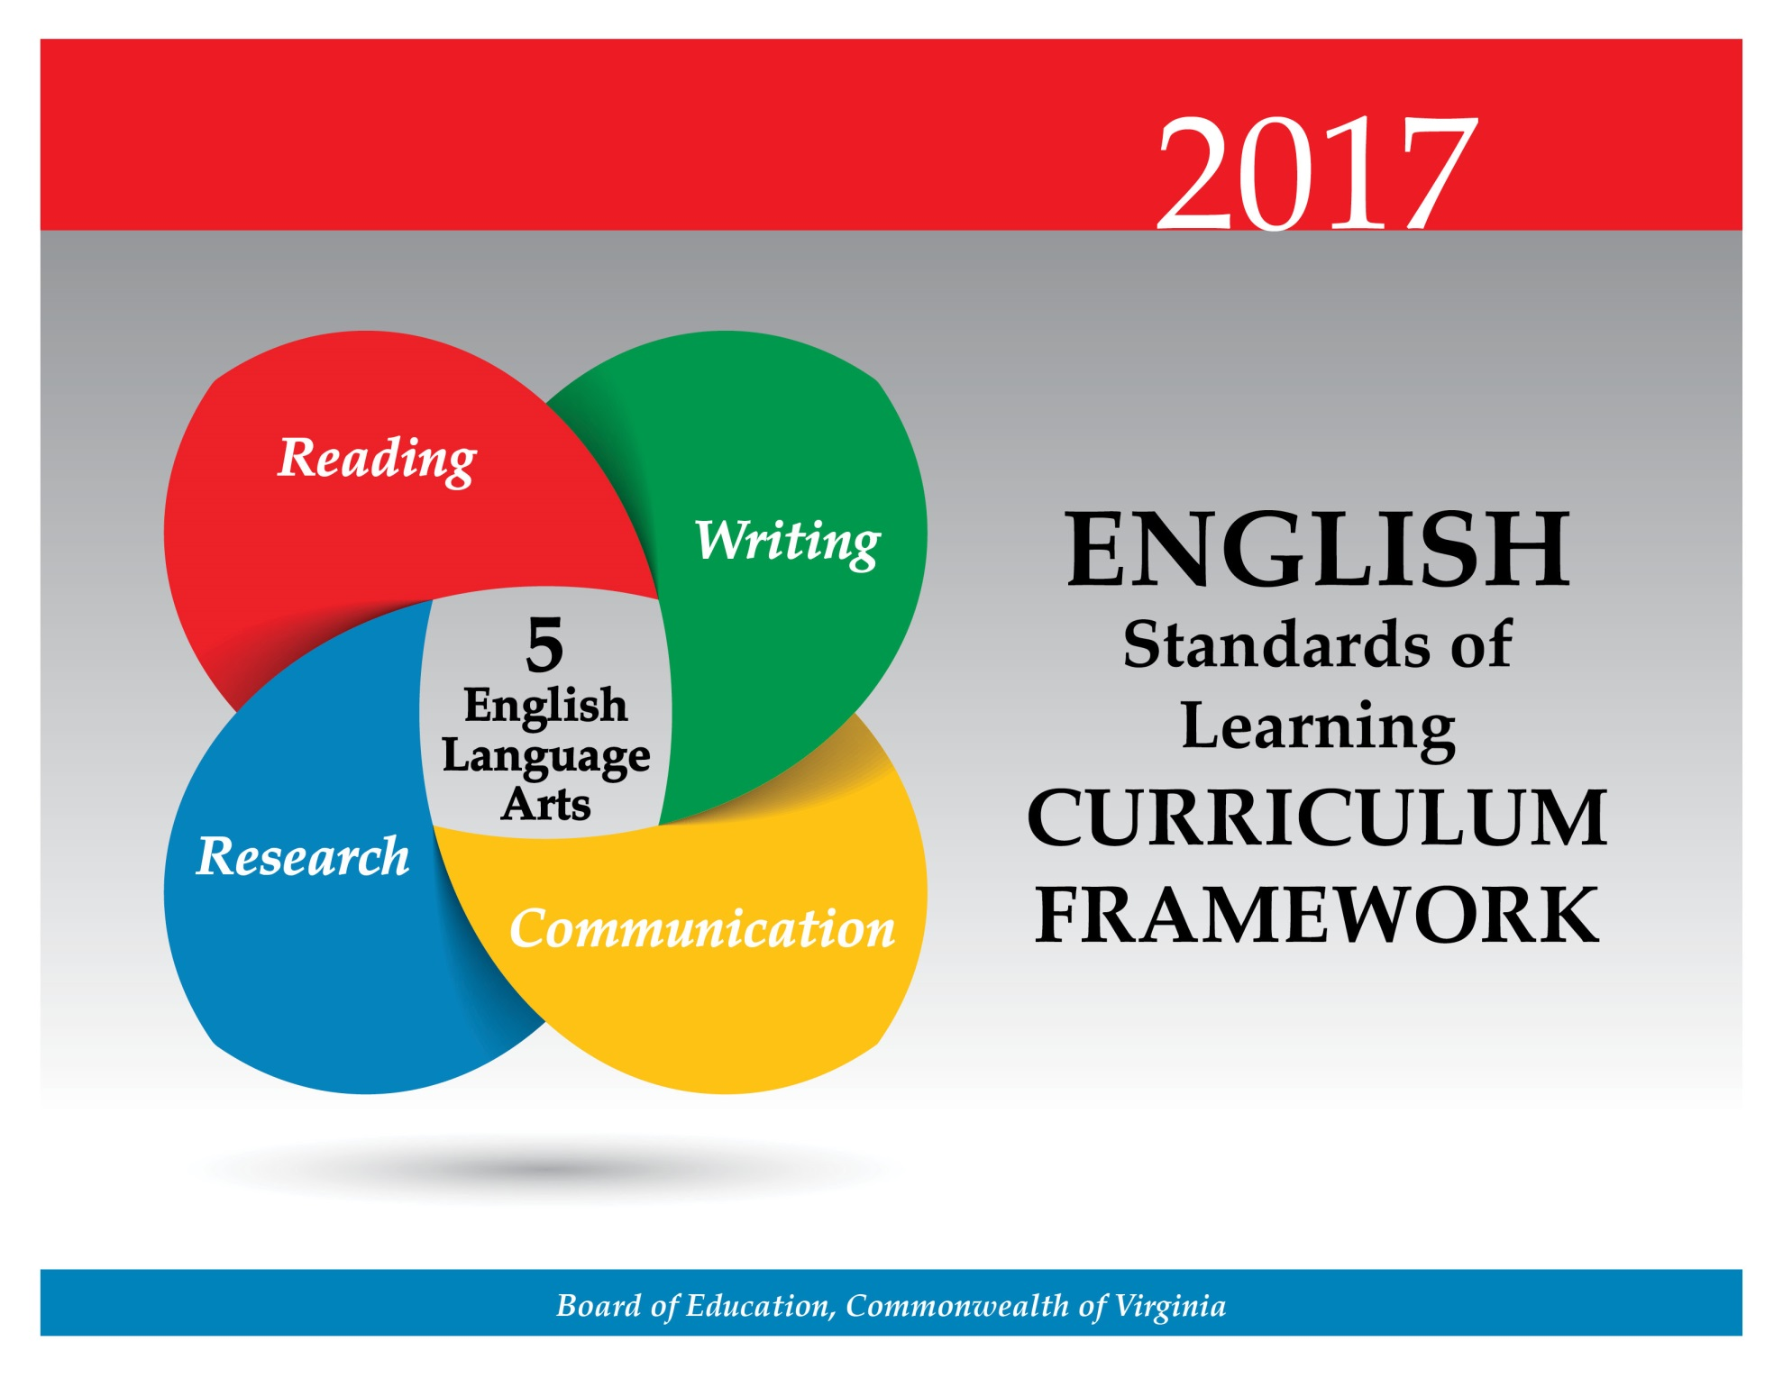

At the fifth-grade level, students will demonstrate the ability to collaborate with diverse teams by working respectfully with others, using active listening skills, and showing value for individual contributions. Students will create and deliver interactive multimodal presentations. Students will compare/contrast a variety of techniques used in media messaging. Teachers will encourage the development of effective interpersonal communication and collaboration skills that are essential for success in future postsecondary education and workplace environments.

Teacher Notes
- Please note student presentation skills may differ within classrooms.
- Teachers should explicitly teach effective presentation skills with audience involvement.
- Teachers should provide opportunities for students to create interactive, multimodal presentations.
- Multimodal is the strategic use of two or more interdependent modes of communication where both/all modes are essential to convey the intended message (e.g., graphics, written language, moving images, music, audio, presentation technologies, movement).

5.1 The student will use effective oral communication skills in a variety of settings.
- Listen actively and speak using appropriate discussion rules with awareness of verbal and nonverbal cues.
- Participate in and contribute to discussions across content areas.
- Summarize information gathered in group activities.
- Orally express ideas clearly in pairs, diverse groups, and whole-class settings.
- Use evidence to support opinions and conclusions.
- Summarize the main points a speaker makes, and connect comments to the remarks of others.
- Demonstrate the ability to collaborate with diverse teams while sharing responsibility for the work.
- Work respectfully with others and show value for individual contributions.
ESSENTIAL UNDERSTANDINGS | ESSENTIAL KNOWLEDGE, SKILLS, AND PROCESSES
All students should  - understand how to prepare, summarize, present, and use information gathered in group activities  - understand the process of communicating effectively and working collaboratively to accomplish a variety of tasks and goals. | To be successful with this standard, students are expected to  - participate in a range of discussions building on others’ ideas and clearly stating thoughts, opinions, and information  - follow rules for discussions and assigned group roles  - participate as active listeners in group learning activities by  - listening for main ideas  - listening for sequence of ideas  - taking notes  - participate as informed contributors in group learning activities by  - asking and answering questions at appropriate times  - responding to specific questions by making comments that contribute to the discussion and elaborating on the remarks of others  - communicating new ideas to others  - clarifying confusing points  - summarizing main ideas  - organizing information from group discussions for presentation  - preparing a prewriting tool (e.g., outline, web, or graphic organizer) for presentation prior to delivery  - collaborate with diverse teams while respecting individual contributions  - work independently on group-related tasks.

5.2 The student will create multimodal presentations that effectively communicate ideas.
- Effectively use verbal and nonverbal communication skills to plan and deliver collaborative and individual, formal, and informal interactive presentations.
- Maintain eye contact with listeners.
- Organize content sequentially around major ideas.
- Use language and style appropriate to the audience, topic, and purpose.
- Ask and answer questions to gather or clarify information presented orally.
ESSENTIAL UNDERSTANDINGS | ESSENTIAL KNOWLEDGE, SKILLS, AND PROCESSES
All students should  - understand how ideas can be best organized and delivered for an effective presentation  - understand how gestures, facial expressions, posture, and body language affect delivery of the message. | To be successful with this standard, students are expected to  - demonstrate appropriate eye contact with listeners  - use appropriate facial expressions and gestures to support, accentuate, or dramatize the message  - speak clearly at an understandable pace  - use acceptable posture, according to the setting and the audience  - select information that develops the topic and is appropriate for the audience  - report on a topic or text, sequencing ideas logically and using relevant facts and descriptive details to support main ideas or themes  - narrow the topic  - put information in order, providing an overview of the information at the beginning or a summary of the information at the end  - use multimodal tools to enhance presentations  - use specific vocabulary to enhance presentations.

5.3 The student will learn how media messages are constructed and for what purposes.
- Identify the purpose and audience of auditory, visual, and written media messages.
- Identify the characteristics and effectiveness of a variety of media messages.
- Compare and contrast techniques used in a variety of media messages.
ESSENTIAL UNDERSTANDINGS | ESSENTIAL KNOWLEDGE, SKILLS, AND PROCESSES
All students should  - understand how to deconstruct media messages by looking at several attributes (e.g., authorship, format, audience, content, and purpose)  - understand how to evaluate the effectiveness of a media message by examining the various attributes of messages. | To be successful with this standard, students are expected to  - access media messages and identify what types of media are used  - identify the attributes of a constructed message (i.e., authorship, format, audience, content, and purpose)  - deconstruct several types of media messages by addressing the main question(s) raised by the media attributes  - compare/contrast techniques used effectively in a variety of media messages (e.g., animation, famous images and logos, music and sound, photo-editing)  - create media messages (e.g., videos, podcasts, print advertisements) for evaluation, focusing on effectiveness of the message.

Students will continue to expand vocabulary using knowledge of roots, affixes, synonyms, antonyms, and homophones. In fifth grade, there is an emphasis on reading comprehension by comparing fiction and nonfiction texts. In fiction texts, students will explain plot development and conflict resolution and differentiate between first and third person points of view. Fifth grade instruction emphasizes nonfiction reading; students will identify authors’ organizational patterns and use texts to support opinions and conclusions. Teachers will encourage the development of reading skills that are foundational to effective comprehension and critical thinking. These skills are essential for success in future postsecondary education and workplace environments.

Teacher Notes
- Vocabulary words should be culled from student reading instead of using random lists and should not be taught in isolation.
- Teachers must provide opportunities for silent reading with options for student choice.
- Teachers should introduce students to longer, more complex texts both on grade level and above grade level.
- Teacher should teach figurative language using fiction and nonfiction texts.
- Teachers should teach theme as a literary term with fiction texts and main idea with nonfiction texts. Please note these terms are not interchangeable. However, identifying main idea in a paragraph or portion of text is an essential skill for comprehension.
- Please note teachers should introduce specific genres of fiction including, but not limited to, fantasy, humor, fable/fairy tale, realistic fiction, historical fiction, folklore/tall tales, mythology, and mystery.
- Teachers should use fictional and informational texts paired on a common theme or topic and have students compare/contrast. Although the standard in fiction requires comparing/contrasting details in literary and informational nonfiction texts, teachers should be using paired passages with a variety of texts.
- Teachers should teach author’s purpose exclusively with nonfiction texts.
- Please note although the strands are developed separately, teachers should seamlessly integrate all strands.
  - Teachers may integrate the strands through the use of thematic units.
  - Teachers should ask students to write about what they have read.

5.4 The student will expand vocabulary when reading.
- Use context to clarify meaning of unfamiliar words and phrases.
- Use context and sentence structure to determine meanings and differentiate among multiple meanings of words.
- Use knowledge of roots, affixes, synonyms, antonyms, and homophones to determine the meaning of new words.
- Identify an author’s use of figurative language.
- Use word-reference materials.
- Develop and use general and specialized content-area vocabulary through speaking, listening, reading, and writing.
ESSENTIAL UNDERSTANDINGS | ESSENTIAL KNOWLEDGE, SKILLS, AND PROCESSES
All students should  - understand that the content and structure of a sentence, paragraph, or reading selection can help the reader determine the meaning of an unfamiliar word  - understand that roots, affixes, synonyms, and antonyms can help the reader determine the meaning of unfamiliar words  - understand that word reference resources can help the reader learn word meanings  - understand the type of information found in word reference materials such as a glossary, dictionary, and thesaurus. | To be successful with this standard, students are expected to  - use context as a clue to infer the correct meanings of unfamiliar words and phrases  - use context and sentence structure to determine meanings and differentiate among multiple meanings of words  - apply knowledge of roots, affixes synonyms, antonyms, and homophones  - identify the meaning of Greek and Latin affixes  - identify when an author uses figurative language  - use word references and context clues to determine which meaning is appropriate in a given situation  - select and use the word-reference material, such as a dictionary, glossary, or thesaurus, that is most likely to contain the information needed.

5.5 The student will read and demonstrate comprehension of fictional texts, literary nonfiction, and poetry.
- Summarize plot events using details from text.
- Discuss the impact of setting on plot development.
- Describe character development.
- Identify theme(s).
- Explain the resolution of conflict(s).
- Identify genres.
- Differentiate between first and third person point of view.
- Differentiate between free verse and rhymed poetry.
- Explain how an author’s choice of vocabulary contributes to the author’s style.
- Draw conclusions and make inferences with support from the text.
- Identify cause and effect relationships.
- Compare/contrast details in literary and informational nonfiction texts.
- Use reading strategies throughout the reading process to monitor comprehension.
ESSENTIAL UNDERSTANDINGS | ESSENTIAL KNOWLEDGE, SKILLS, AND PROCESSES
All students should  - understand the essential elements and characteristics of fictional text, literary nonfiction, and poetry  - understand the similarities and differences between literary and informational nonfiction texts. | To be successful with this standard, students are expected to  - summarize important plot events, using specific details from the text  - describe how characters are developed by  - what a character says  - what a character thinks  - what a character does  - what other characters in the story say or think about them.  - describe how some characters change and how some characters stay the same  - identify and explain the main conflict and resolution of the plot  - identify the events in sequence that lead to resolution of the conflict  - discuss why an author might have used particular words and phrases  - determine who is telling the story and identify if the point-of-view is first or third person  - identify the theme(s) of a text  - thematic topic  - lessons learned  - refer to details, specific vocabulary, and examples in a text to draw conclusions/make inferences  - make, confirm, or revise predictions  - demonstrate comprehension and apply strategies to write about what is read  - identify genres, including, but not limited to, fantasy, humor, fable/fairy tale, realistic fiction, historical fiction, folklore/tall tales, mythology, mystery  - analyze the similarities and differences between paired fictional texts and informational nonfiction texts (e.g., similar themes and topics, patterns of events).

5.6 The student will read and demonstrate comprehension of nonfiction texts.
- Use text features such as type, headings, and graphics, to predict and categorize information.
- Skim materials to develop a general overview of content and to locate specific information.
- Identify the main idea.
- Summarize supporting details.
- Identify organizational pattern(s).
- Identify transitional words and phrases that signal an author’s organizational pattern.
- Locate information from the text to support opinions, inferences, and conclusions.
- Identify cause and effect relationships.
- Differentiate between fact and opinion.
- Compare and contrast details and ideas within and between texts.
- Use reading strategies throughout the reading process to monitor comprehension.
ESSENTIAL UNDERSTANDINGS | ESSENTIAL KNOWLEDGE, SKILLS, AND PROCESSES
All students should  - understand how organizational patterns make the information easier to comprehend  - understand that ideas and topics are presented differently by different authors  - understand that readers draw conclusions and make inferences based on details and information from the text. | To be successful with this standard, students are expected to  - determine the main idea of a text and summarize supporting key details  - identify organizational patterns such as cause and effect, comparison/contrast, problem/solution, and chronological order  - recognize transitional words and phrases authors use to signal organizational patterns, including, but not limited to,  - cause and effect (e.g., if, then)  - comparison/contrast- (e.g, similarly, on the other hand)  - chronological (e.g., today, meanwhile)  - problem/solution (e.g., the issue is, a possible remedy)  - draw conclusions and make inferences using the text as support  - compare and contrast two accounts or perspectives of the same event or topic  - read texts with fluency, accuracy, and meaningful expression  - demonstrate comprehension and apply strategies to write about what is read.

At the fifth grade level, students will continue to develop as readers and writers as they write in a variety of forms including narrative, descriptive, expository, and persuasive. Students will write multiparagraph compositions including evidence to inform or persuade an audience. Precise and descriptive vocabulary and varied sentence structure will become important tools for creating tone and voice within a text. Students will be expected to have greater control over the conventions of writing. Teachers will encourage the development of writing skills that are foundational to effective written communication and critical thinking. These skills are necessary for success in future postsecondary education and workplace environments.

Teacher Notes
- Teachers will model the writing process for students.
- Teachers should refer to examples of writing in mentor texts.
- The focus of writing in fifth grade is narrative, descriptive, persuasive, and expository.
- Teachers should integrate grammar with writing instruction throughout the academic year.
- Teachers should use student writing to teach editing and peer editing skills.
- Teachers may want to consult professional publications.
- Teachers should instruct students in the features of the three domains of writing:
  - Composing—focusing on a clear, central idea, providing elaboration, organization, and unity
  - Written Expression—sentence variation, selected information, word choice, voice, and tone
  - Usage/Mechanics—grammar, punctuation, and usage as appropriate for the grade level
- Teachers should use writing conferences and portfolios to monitor student progress.
- Teachers should provide opportunities for independent writing and options for student choice.
- Teachers should provide the opportunity for students to have practice writing on demand, for shorter time frames, and over extended periods of time.

5.7 The student will write in a variety of forms to include narrative, descriptive, expository, and persuasive.
- Engage in writing as a process.
- Select audience and purpose.
- Use a variety of prewriting strategies.
- Introduce and develop a topic, incorporating evidence and supporting details.
- Organize information to convey a central idea.
- Recognize different forms of writing have different patterns of organization, including story structure for narrative writing.
- Write a clear topic sentence focusing on the main idea.
- Clearly state a position, including supporting reasons and evidence to persuade the intended audience.
- Write multiparagraph compositions.
- Use precise and descriptive vocabulary to create tone and voice.
- Vary sentence structure by using transition words and prepositional phrases.
- Revise writing for clarity of content, using specific vocabulary and information.
ESSENTIAL UNDERSTANDINGS | ESSENTIAL KNOWLEDGE, SKILLS, AND PROCESSES
All students should  - understand that writers use the writing process, including planning, drafting, revising, editing, and publishing  - understand the domains of writing include composing, written expression, and usage/mechanics  - understand voice shows an author’s personality, awareness of audience, and passion for the topic, adding liveliness and energy to writing. | To be successful with this standard, students are expected to  - write focusing on the composing domain features of central idea, organization, unity, and elaboration  - write focusing on the written expression domain features of word choice, specific vocabulary, tone, voice, and sentence variety  - produce a clear and coherent written piece in which the development and organization are appropriate to purpose and audience  - recognize different forms of writing have different patterns of organization  - descriptive/expository  - clearly introduce a topic and organize information in paragraphs  - use facts, definitions, opinions, quotations, details, or other examples and information to develop the topic  - use specific vocabulary to inform and explain the topic  - provide a conclusion related to the topic  - narrative  - organize an event sequence that unfolds naturally  - use transition words and phrases  - use narrative techniques, such as dialogue, description, and pacing to develop experiences or characters  - provide a conclusion  - persuasive  - introduce the position  - provide evidence to support the position  - provide points for the opposite side and argue against them  - provide a conclusion  - use mentor texts as an example of writing  - focus, organize, and elaborate to construct an effective message for the reader  - write a clear topic sentence focusing on the main idea  - purposefully select language to demonstrate an awareness of the intended audience  - select specific information to guide readers more purposefully through the piece  - write multiparagraph compositions focused on a central idea, organizing related information in paragraphs  - choose precise, descriptive vocabulary and information to create tone and voice  - revise writing by consulting with peers or adults  - include sentences of various lengths and beginnings to create a rhythm  - vary sentence structure by using transition words and phrases  - clarify writing when revising  - include supporting details that elaborate the main idea.

5.8 The student will self- and peer-edit writing for capitalization, spelling, punctuation, sentence structure, paragraphing, and Standard English.
- Use plural possessives.
- Use adjective and adverb comparisons.
- Use interjections.
- Use prepositional phrases.
- Use quotation marks with dialogue.
- Use commas to indicate interrupters, items in a series, and to indicate direct address.
- Use a hyphen to divide words at the end of a line.
- Edit for fragments and run-on sentences.
- Eliminate double negatives.
- Use correct spelling of commonly used words.
- Use coordinating conjunctions.
ESSENTIAL UNDERSTANDINGS | ESSENTIAL KNOWLEDGE, SKILLS, AND PROCESSES
All students should understand that editing for correct sentence formation, grammar, capitalization, spelling, and punctuation makes the meaning of the writing clearer to the reader. | To be successful with this standard, students are expected to  - punctuate correctly  - apostrophes in contractions (e.g., isn’t), and possessives (e.g., Jan’s);  - commas (e.g., items in a series, to set off the words yes and no; and to indicate direct address [“Is that you, Zoe?”])  - quotation marks with dialogue  - hyphens to divide words at the end of a line  - indicate titles of works by using underlining, quotation marks, or italics  - use adverb comparisons (e.g., fast, faster, fastest)  - use adjective comparisons (e.g., big, bigger, biggest)  - use adverbs instead of adjectives where appropriate (e.g., “He played really well.” instead of “He played real well.”)  - use a comma to separate coordinate adjectives (e.g., “It was a fascinating, enjoyable movie”)  - use a comma to separate an introductory element from the rest of the sentence  - use plural possessives, (e.g., “The books’ covers are torn.”)  - use interjections (e.g., “Yikes, look at the size of that bug!”)  - form and use the perfect (e.g., “I had walked; I have walked; I will have walked.”) verb tenses  - use verb tense to convey various times, sequences, states, and conditions  - edit to correct fragments and run-ons  - use a rubric to self- and peer- assess writing.

Students will demonstrate comprehension of the research process by evaluating the relevance, reliability, and credibility of information collected. Students will learn to evaluate and synthesize information to use in their oral, visual, written, or multimodal research product. Students will understand there are consequences of plagiarism. Teachers will encourage the development of research skills that are foundational to effective critical thinking and responsible use of information. These skills are necessary for success in future postsecondary education and workplace environments.

Teacher Notes
- Teachers should note that research can be collaborative, cross-curricular, and integrated throughout the year.
- Teachers should use the librarian/media specialist’s expertise in teaching the research process.
- Teachers should make students aware of possible consequences of plagiarism.
- Teachers should emphasize giving credit to all sources used when gathering information, including music and graphics.
- Teachers should demonstrate and encourage responsible use of the Internet.

5.9 The student will find, evaluate, and select appropriate resources to create a research product.
- Construct questions about a topic.
- Collect and organize information from multiple resources.
- Evaluate the relevance, reliability, and credibility of information.
- Give credit to sources used in research.
- Avoid plagiarism and use own words.
- Demonstrate ethical use of the Internet.
ESSENTIAL UNDERSTANDINGS | ESSENTIAL KNOWLEDGE, SKILLS, AND PROCESSES
All students should  - recognize, organize, and record information pertinent to the topic and blend ideas accurately  - understand how information is to be collected, analyzed, evaluated, organized, and presented  - understand the importance of avoiding plagiarism and giving credit to sources when gathering and reporting information and ideas  - understand that there are consequences of plagiarism, according to the guidelines established by local school divisions. | To be successful with this standard, students are expected to  - formulate research questions based on a topic  - identify search terms to use when searching for information  - analyze and use information presented on charts, maps, and graphs  - skim to find information related to a topic  - select information that is related to the topic  - decide if information is relevant to the topic and reliable and credible for use  - evaluate and synthesize related information from two or more sources  - develop notes that include important concepts, summaries, and identification of information sources  - summarize or paraphrase information in notes and finished work  - prevent plagiarism and its consequences by giving credit to authors when ideas or specific words are used in research  - avoid plagiarism by giving credit whenever using another person’s media, facts, graphics, music, and quotations.

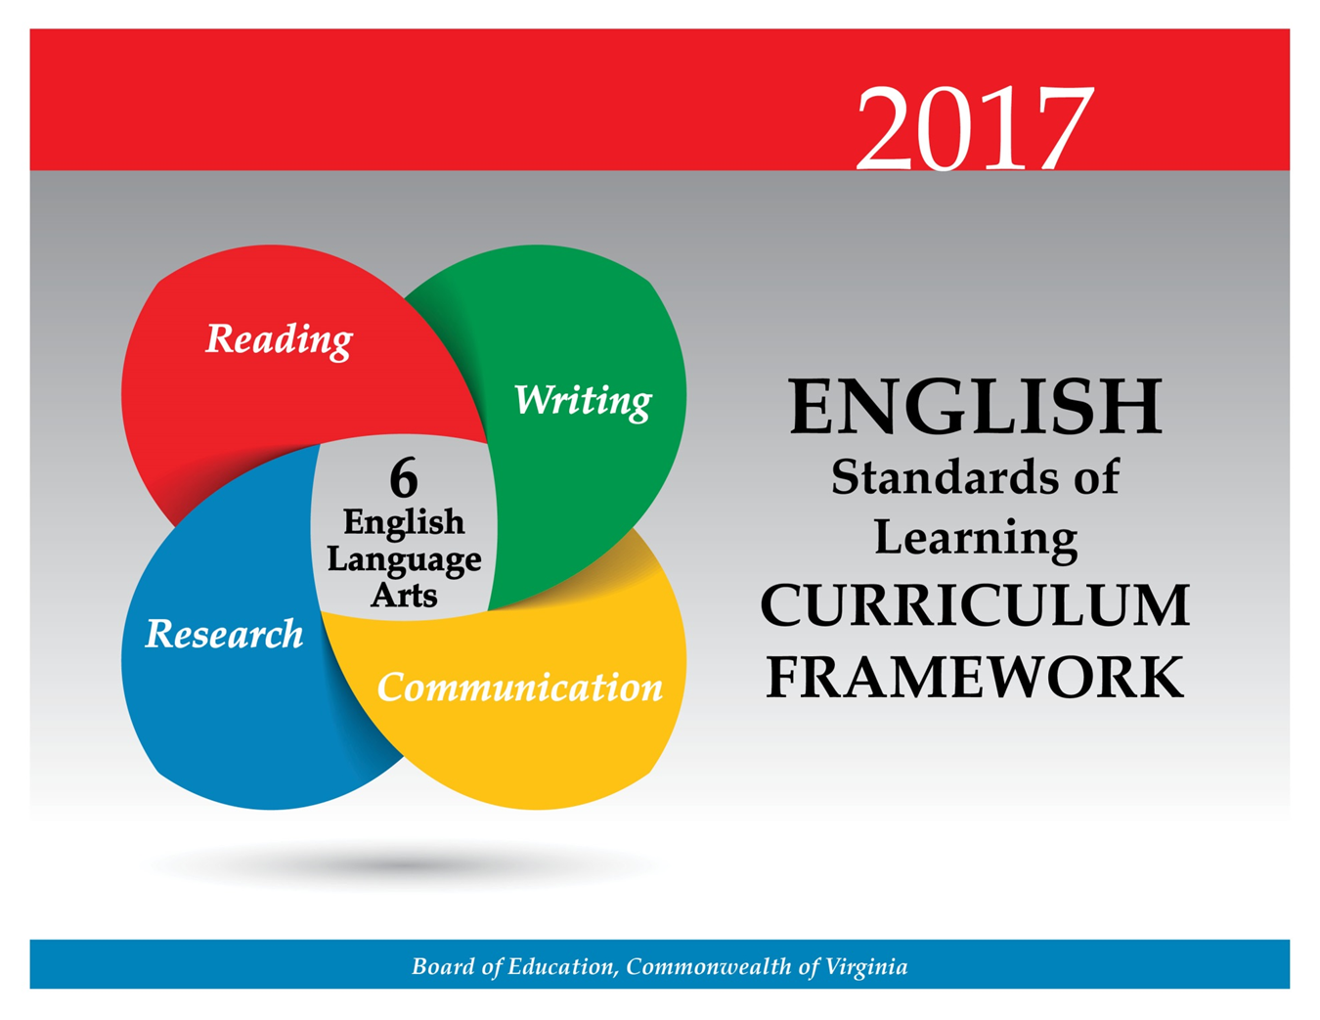

At the sixth-grade level, students will demonstrate the ability to work with diverse teams working respectfully with others, participating both as a facilitator and as a contributor. Small-group analysis and self-analysis of the effectiveness of communication will be introduced. Students will continue to deliver multimodal presentations individually and in collaborative groups. Students will also interpret information presented in diverse media formats. Teachers will emphasize the importance of effective interpersonal communication and collaboration skills that are essential for success in future postsecondary education and workplace environments.

Teacher Notes
- Please note presentation skills may differ within classrooms.
- Teachers should provide opportunities for students to create and deliver interactive, multimodal presentations.
- Multimodal is the strategic use of two or more interdependent modes of communication where both/all modes are essential to convey the intended message (e.g, graphics, written language, moving images, music, audio, presentation technologies, movement).
- Teachers should provide opportunities for students to work in collaborative settings.
- Teachers should provide instruction on how to give constructive, respectful, and productive feedback.

6.1 The student will use effective oral communication skills in a variety of settings.
- Listen actively and speak using appropriate discussion rules with awareness of verbal and nonverbal cues.
- Participate as a facilitator and a contributor in a group.
- Participate in collaborative discussions with partners building on others’ ideas.
- Ask questions to clarify the speaker’s purpose and perspective.
- Summarize the main points a speaker makes.
- Summarize and evaluate group activities.
- Analyze the effectiveness of participant interactions.
- Evaluate own contributions to discussions.
- Demonstrate the ability to collaborate with diverse teams.
- Work respectfully with others and show value for individual contributions.
ESSENTIAL UNDERSTANDINGS | ESSENTIAL KNOWLEDGE, SKILLS, AND PROCESSES
All students should understand verbal and nonverbal feedback from the audience should be used to evaluate contributions. | To be successful with this standard, students are expected to  - ensure that all group members participate in the exchange of information  - evaluate the effectiveness of the contributions of participants in a variety of roles in a discussion group  - use strategies that contribute to the discussion  - receive and understand feedback from others  - pose and respond to questions  - restate briefly and critically the main idea(s) discussed within a group  - use active listening to focus on what is said and what is implied  - retain and rethink ideas based on what is heard  - infer and assimilate new ideas.

6.2 The student will create multimodal presentations that effectively communicate ideas.
- Use effective verbal and nonverbal communication skills to deliver multimodal presentations.
- Use language and vocabulary appropriate to audience, topic, and purpose.
- Give collaborative and individual formal and informal interactive presentations.
- Paraphrase and summarize key ideas of a presentation.
ESSENTIAL UNDERSTANDINGS | ESSENTIAL KNOWLEDGE, SKILLS, AND PROCESSES
All students should  - understand that each member brings a unique viewpoint to the group  - understand paraphrasing and summarizing means restating the main points more succinctly than the original presentation  - understand nonverbal communication and its impact and use it purposefully  - understand that using more than one communication mode creates a more effective presentation. | To be successful with this standard, students are expected to  - create a presentation that uses two or more communication modes to make meaning (e.g., still or moving images, gestures, spoken language and written language)  - plan and deliver a multimodal presentation using the following steps:  - determine topic and purpose  - identify the intended audience  - choose vocabulary appropriate to topic, purpose, and audience  - use strategies for summarizing, such as  - deleting trivial and/or redundant information  - substituting a general term for a list  - creating a main idea statement  - demonstrate appropriate eye contact with listeners  - speak clearly at an understandable pace with appropriate tone and volume  - use acceptable posture according to the setting and the audience.

6.3 The student will determine the purpose of media messages and examine how they are constructed.
- Compare and contrast techniques used in a variety of media messages.
- Identify the characteristics and effectiveness of a variety of media messages.
- Interpret information presented in diverse media formats and explain how it contributes to the topic.
- Craft and publish audience-specific media messages.
ESSENTIAL UNDERSTANDINGS | ESSENTIAL KNOWLEDGE, SKILLS, AND PROCESSES
All students should  - understand that all media messages are intentionally constructed to impact a specific audience  - understand that a public service announcement (PSA) is an advertisement for the benefit of the public and the purpose can be to raise awareness  - understand the effectiveness of any media message is determined by the results and/or impact on the intended audience. | To be successful with this standard, students are expected to  - deconstruct and compare/contrast several types of media messages  - identify elements of media literacy (e.g., authorship, format, audience, content, purpose)  - Who created the message?  - What techniques are used to attract attention?  - How might different people react differently to this message?  - What values, lifestyles and points of view are represented in, or omitted from, this message?  - What is the purpose of this message?  - recognize production elements in media are composed based on audience and purpose  - create media messages, such as public service announcements, aimed at a variety of audiences with different purposes  - integrate information presented in different media or formats (e.g., visual, quantitative) as well as in words to develop a coherent understanding of a topic or issue  - understand that there are different camera angles and shots and each serves a specific purpose  - compare and contrast reading to, listening, or viewing an audio, video, or live version of the same text and discuss the impact.

Students will begin the study of word origins and continue vocabulary development. There is a continued emphasis on reading comprehension by comparing fiction and nonfiction texts. In fiction texts, students will identify elements of narrative structure including identifying theme and analyzing figurative language. In sixth grade, there is an increased emphasis on nonfiction reading by creating objective summaries and drawing inferences using textual evidence. These critical-thinking skills are foundational to technical reading and writing and are transferable across content areas. These skills are essential for success in future postsecondary education and workplace environments.

Teacher Notes
- Please note although the strands are developed separately, teachers should seamlessly integrate all strands.
  - Thematic units and cross-curricular units are effective methods to integrate multiple strands.
  - Teachers should have students write about what they have read.
- Vocabulary words should be culled from student reading rather than from prescribed lists and should not be taught in isolation.
- There is not a specific list of Greek and Latin roots. Teachers may want to consult professional publications.
- While whole-group instruction can be centered on a shared text, teachers should also provide opportunities for student choice with both fiction and nonfiction texts.
- Teachers should introduce students to longer, more complex texts both on grade level and above grade level.
- Teachers should teach figurative language using fiction and nonfiction texts.
- Teachers should teach theme as a literary term with fiction texts and main idea with nonfiction texts. However, main idea is a skill that is still essential in comprehending all texts. Please note these terms are not interchangeable.
- Teachers should teach a balance of fiction (including poetry) and nonfiction throughout the academic year.
- Although the standard in fiction requires comparing/contrasting details in literary and informational nonfiction texts, teachers should be using paired passages with a variety of texts.
- Teachers should have students refer to the text(s) for support.
- Teachers should use fictional and informational texts paired on a common theme or topic and have students compare/contrast.

6.4 The student will read and determine the meanings of unfamiliar words and phrases within authentic texts.
- Identify word origins and derivations.
- Use roots, affixes, synonyms, and antonyms to expand vocabulary.
- Use context and sentence structure to determine meanings and differentiate among multiple meanings of words.
- Identify and analyze the construction and impact of figurative language.
- Use word-reference materials.
- Extend general and cross-curricular vocabulary through speaking, listening, reading, and writing.
ESSENTIAL UNDERSTANDINGS | ESSENTIAL KNOWLEDGE, SKILLS, AND PROCESSES
All students should  - understand that word structure can be analyzed to show relationships among words  - understand that affixes and Greek and Latin roots are clues to determine meanings of words  - recognize that many words have multiple meanings and that context and dictionaries are both supportive in determining which meaning is most appropriate  - recognize that figurative language enriches text. | To be successful with this standard, students are expected to  - use common Greek or Latin affixes and roots as clues to the meaning of a word (e.g., aud – hearing, listening, or sound audience, auditory, audible)  - separate and recombine known word parts to predict the meaning of unfamiliar words, such as separating poly from polygon and phone from telephone to predict the meaning of polyphony  - use context clues to determine meanings of unfamiliar words in text, such as examples, restatements, and contrast  - identify figurative language in text, including simile, hyperbole, and personification  - consult word reference materials to find the pronunciation of a word or to determine or clarify its meaning  - determine or clarify the meaning of unknown and multiple-meaning words and phrases based on reading and content.

6.5 The student will read and demonstrate comprehension of a variety of fictional texts, literary nonfiction, and poetry.
- Identify the elements of narrative structure, including setting, character, plot, conflict, and theme.
- Describe cause-and-effect relationships and their impact on plot.
- Explain how an author uses character development to drive conflict and resolution.
- Differentiate between first and third person point of view.
- Describe how word choice and imagery contribute to the meaning of a text.
- Draw conclusions and make inferences using the text for support.
- Identify the characteristics of a variety of genres.
- Identify and analyze the author’s use of figurative language.
- Compare/contrast details in literary and informational nonfiction texts.
- Identify transitional words and phrases that signal an author’s organizational pattern.
- Use reading strategies to monitor comprehension throughout the reading process.
ESSENTIAL UNDERSTANDINGS | ESSENTIAL KNOWLEDGE, SKILLS, AND PROCESSES
All students should  - understand that the author uses images to craft a message and create characters  - understand that literary nonfiction includes biography, autobiography, and personal essay  - understand that poetry can be rhymed, unrhymed, and/or patterned  - understand that imagery and figurative language enrich texts  - recognize an author’s craft as the purposeful choice of vocabulary, sentence formation, voice, and tone. | To be successful with this standard, students are expected to  - identify setting as time and place  - explain plot as  - the development of the central conflict and resolution  - the sequence of events in the story  - the writer’s map for what happens, how it happens, to whom it happens, when it happens, why it happens, and where it happens  - identify characters as protagonist and antagonist  - identify point of view and distinguish between first and third person  - identify characterization as the way an author presents a character and character traits are revealed by  - what a character says  - what a character thinks  - what a character does  - how other characters respond to the character  - determine a theme(s) and explain how it is developed through specific details  - identify internal and external conflicts, including  - internal conflicts within characters  - external conflicts between characters  - describe how a fictional plot is often episodic, and how characters develop as the plot moves toward a resolution  - notice an author’s craft, including use of  - language patterns  - sentence variety  - vocabulary  - imagery  - figurative language  - word choice to develop mood and tone  - differentiate among a variety of fictional genres, including short story, novel, and drama  - recognize and analyze an author’s use of figurative language including  - simile  - hyperbole  - metaphor  - personification  - differentiate between narrative and poetic forms  - recognize poetic forms, including, but not limited to,  - haiku  - limerick  - ballad  - free verse  - recognize poetic elements in prose and poetry, including, but not limited to,  - rhyme  - rhythm  - repetition  - alliteration  - onomatopoeia  - describe how characters change as a result of incidents in the plot  - identify how transitional words signal an author’s organization, such as words indicating time, cause and effect, or indicating more information  - compare and contrast two or more texts on the same topic or with similar themes  - use evidence from the text(s) for support when drawing conclusions and making inferences  - analyze how an individual, event, or idea is introduced, illustrated, and elaborated in a text (e.g., through examples or anecdotes)  - demonstrate comprehension and apply strategies to write about what is read.

6.6 The student will read and demonstrate comprehension of a variety of nonfiction texts.
- Skim materials using text features such as type, headings, and graphics to predict and categorize information.
- Identify main idea.
- Summarize supporting details.
- Create an objective summary including main idea and supporting details.
- Draw conclusions and make inferences based on explicit and implied information.
- Identify the author’s organizational pattern(s).
- Identify transitional words and phrases that signal an author’s organizational pattern.
- Differentiate between fact and opinion.
- Identify cause-and-effect relationships.
- Analyze ideas within and between selections, providing textual evidence.
- Use reading strategies to monitor comprehension throughout the reading process.
ESSENTIAL UNDERSTANDINGS | ESSENTIAL KNOWLEDGE, SKILLS, AND PROCESSES
All students should  - recognize an author’s patterns of organization can be an aid to comprehension  - recognize an author’s use of technical vocabulary  - understand text features are created purposefully and are an aid to comprehension  - understand that all texts contain messages stated or implied by an author  - understand that there are strategies including context, structural analysis, and reference sources, for determining the meaning of unfamiliar and technical vocabulary  - understand that skilled readers of nonfictional texts apply different reading strategies. | To be successful with this standard, students are expected to  - preview texts using text features such as, but not limited to,  - boldface and/or italics type  - type set in color  - vocabulary  - graphics  - headings and subheadings  - identify common patterns of organizing text including  - chronological or sequential  - comparison/contrast,  - cause and effect  - problem-solution  - generalization  - process  - use context, structural analysis, and reference sources to determine the meaning of unfamiliar and technical vocabulary  - make inferences and draw conclusions using the text(s) for support  - identify similarities and differences in the information found in several sources about the same topic  - use strategies and rules for summarizing, such as  - delete trivia and redundancy  - substitute a general term for a list  - find or create a main idea statement  - summarize the text without providing a personal opinion  - demonstrate comprehension and apply strategies to write about what is read.

At the sixth-grade level, students will continue to develop as readers and writers. Students will also plan, draft, revise, and edit writing in a variety of forms with an emphasis on narrative and reflective writing. Students will write multiparagraph compositions with an emphasis on the development of elaboration and unity. Additionally, students will be introduced to writing thesis statements. Students will be expected to have greater control over the conventions of writing. Teachers will emphasize the importance of effective critical-thinking skills that lead to success in future postsecondary education and workplace environments.

Teacher Notes
- Teachers should recognize the difference between teaching writing and assigning writing.
- Teachers will model the recursive writing process for students.
- Teachers should refer to examples of writing in mentor texts.
- Teachers should recognize that there is not a required number of paragraphs or prescribed structure. Requiring students to use a prescribed model (i.e., five paragraphs) often produces formulaic writing and limits student expression.
- The focus of writing in sixth grade is narrative and reflective.
- Teachers may want to consult professional publications.
- Three examples of reflective writing include the following:
  - Technical— – which includes what worked or did not work and reasons why, problem-solving techniques, and theories that were used or tested
  - Collaborative— – which is centered on team dynamics, how everyone worked together and why, and what worked or did not work and why
  - Individual—focused on questions such as “What did I learn?” “How did I learn it?” and “What could I have done better?”
- Teachers should integrate grammar with writing instruction throughout the academic year.
- Teachers should use student writing to teach editing and peer editing skills. Teachers may want to consult professional publications.
- Teachers should instruct students in the features of the three domains of writing:
  - Composing-focusing on a clear, central idea; providing elaboration; organization and unity
  - Written Expression—sentence variation, selected information, word choice, voice, and tone
  - Usage/Mechanics—grammar, punctuation, capitalization, and usage as appropriate for the grade level
- Teachers should use writing conferences and portfolios to monitor student progress.
- Teachers should provide the opportunity for students to have practice writing on demand, for shorter time frames, and over extended periods of time.
- Teachers should provide opportunities for student choice with topic, audience, and purpose.

6.7 The student will write in a variety of forms, to include narrative, expository, persuasive, and reflective, with an emphasis on narrative and reflective writing.
- Engage in writing as a recursive process.
- Choose audience and purpose.
- Use a variety of prewriting strategies to generate and organize ideas.
- Organize writing to fit mode or topic.
- Write narratives to include characters, plot, setting, and point of view.
- Establish a central idea, incorporating evidence and maintaining an organized structure.
- Compose a thesis statement for expository and persuasive writing.
- Write multiparagraph compositions with elaboration and unity.
- Use transition words and phrases.
- Select vocabulary and information to enhance the central idea, tone, and voice.
- Expand and embed ideas by using modifiers, standard coordination, and subordination in complete sentences.
- Revise writing for clarity of content including specific vocabulary and information.
ESSENTIAL UNDERSTANDINGS | ESSENTIAL KNOWLEDGE, SKILLS, AND PROCESSES
All students should  - understand that writing requires a recursive process that includes planning, drafting, revising, editing, and publishing  - understand that writing should be purposefully crafted with attention to  - deliberate word choice  - precise information and vocabulary  - sentence variety  - tone and voice  - understand that vocabulary impacts tone and must be selected with awareness of audience and purpose  - understand that a thesis statement is not an announcement of the subject (statement of intent) but rather a unified and specific statement. | To be successful with this standard, students are expected to  - compose with attention to central idea, unity, elaboration, and organization  - analyze and use mentor texts as models for writing  - use narrative techniques, such as pacing and description, to develop experiences, events, and/or characters  - write reflectively to explain and analyze an experience, a skill, or an event, and as a response to reading  - recognize that three examples of reflective writing include  - technical— – which includes what worked or did not work and reasons why, problem-solving techniques, and theories that were used or tested  - collaborative— – which is centered on team dynamics, how everyone worked together and why, and what worked or did not work and reasons why  - individual—focused on questions such as, “What did I learn?” “How did I learn it?” and “What could I have done better?”  - write expository texts to examine a topic and convey ideas, concepts, and information  - write using organizational patterns such as definition, comparison/contrast, and cause and effect  - develop the topic using relevant facts, definitions, details, quotations, and/or examples  - use transitional words or phrases to connect parts of sentences to show relationships between ideas, signal a shift or change in the writer's thoughts, signal levels of importance, suggest a pattern of organization, and make sentences clearer  - establish and maintain a formal style of writing when appropriate  - provide an appropriate conclusion for the purpose and form of writing  - identify audience and purpose for any piece of writing  - elaborate to give detail, add depth, and continue the development of an idea  - write an effective thesis statement focusing, limiting, or narrowing the topic  - differentiate between a thesis statement and a topic sentence  - write on any central theme or topic, demonstrating elaboration, coherence, and unity  - incorporate variety into sentences, using appropriate modifier, coordination, or subordination  - revise drafts for improvement using teacher assistance and peer collaboration  - understand that revising to improve a draft includes rereading, reflecting, rethinking, and rewriting to clarify, elaborate, and make more precise.

6.8 The student will self- and peer-edit writing for capitalization, punctuation, spelling, sentence structure, paragraphing, and Standard English.
- Use subject-verb agreement with intervening phrases and clauses.
- Use pronoun-antecedent agreement to include indefinite pronouns.
- Maintain consistent verb tense across paragraphs.
- Eliminate double negatives.
- Use quotation marks with dialogue.
- Choose adverbs to describe verbs, adjectives, and other adverbs.
- Use correct spelling for frequently used words.
- Use subordinating and coordinating conjunctions.
ESSENTIAL UNDERSTANDINGS | ESSENTIAL KNOWLEDGE, SKILLS, AND PROCESSES
All students should  - understand that correct use of language enhances writing and avoids confusing or distracting the reader  - understand that pronouns need to have recognizable antecedents that agree in number and gender. | To be successful with this standard, students are expected to  - edit drafts with teacher assistance, peer collaboration, and growing independence  - use complete sentences with appropriate punctuation  - avoid comma splices and run-on sentences  - avoid using coordinating conjunctions at the beginning of a sentence (e.g., and, so)  - use first-person pronouns appropriately in compound subjects and objects  - differentiate between subjects and objects when choosing pronouns  - recognize and correct vague pronouns  - maintain a consistent verb tense within sentences and throughout and across paragraphs.

At the sixth-grade level, students will find, evaluate, and select appropriate resources for an oral, visual, written, or multimodal research product. They will evaluate the validity and authenticity of texts, and will research, organize, evaluate, and communicate information. In addition, they will learn to cite both primary and secondary sources and follow ethical and legal guidelines for gathering and using information. Teachers will encourage the development of research skills that are foundational to effective critical thinking and responsible use of information. These skills are necessary for success in future postsecondary education and workplace environments.

Teacher Notes
- Teachers should note that research can be individual, collaborative, cross-curricular, and integrated throughout the year.
- Research products can vary from small, informative pieces to large, multimodal presentations.
- Teachers should use the librarian/media specialist’s assistance in teaching the research process.
- Teachers should make students aware of possible consequences of plagiarism.
- Teachers should emphasize giving credit to all sources used when gathering information, including music, graphics, and another person’s media.
- Teachers should demonstrate and encourage responsible use of the Internet.

6.9 The student will find, evaluate, and select appropriate resources to create a research product.
- Formulate and revise questions about a research topic.
- Collect and organize information from multiple sources.
- Evaluate and analyze the validity and credibility of sources.
- Cite primary and secondary sources.
- Avoid plagiarism by using own words and follow ethical and legal guidelines for gathering and using information.
- Demonstrate ethical use of the Internet.
ESSENTIAL UNDERSTANDINGS | ESSENTIAL KNOWLEDGE, SKILLS, AND PROCESSES
All students should  - Understand that research questions may need to be broadened or narrowed based on available sources  - understand that a primary source is an original document or a firsthand or eyewitness account of an event  - understand that a secondary source discusses information originally presented somewhere else (i.e., secondary sources provide analysis, interpretation, or evaluation of the original information)  - understand the purposeful and responsible use of the Internet.  - understand that there are consequences of plagiarism according to the guidelines established by local school divisions. | To be successful with this standard, students are expected to  - understand and use online, print, and media references  - evaluate the validity and credibility of texts, using questions, such as  - Does the writer have something to gain from his opinion?  - Does the information contain facts for support?  - Is the same information found in more than one source?  - Is contact information provided?  - Is there a copyright symbol on the page?  - What is the purpose of the page?  - What is the date of the most recent publication?  - avoid plagiarism and its consequences by giving credit whenever using another person’s media, facts, statistics, graphics, images, music and sounds, quotations, or when paraphrasing another person’s words  - differentiate between a primary and secondary source  - provide a list of sources using a standard form for documenting primary and secondary sources.

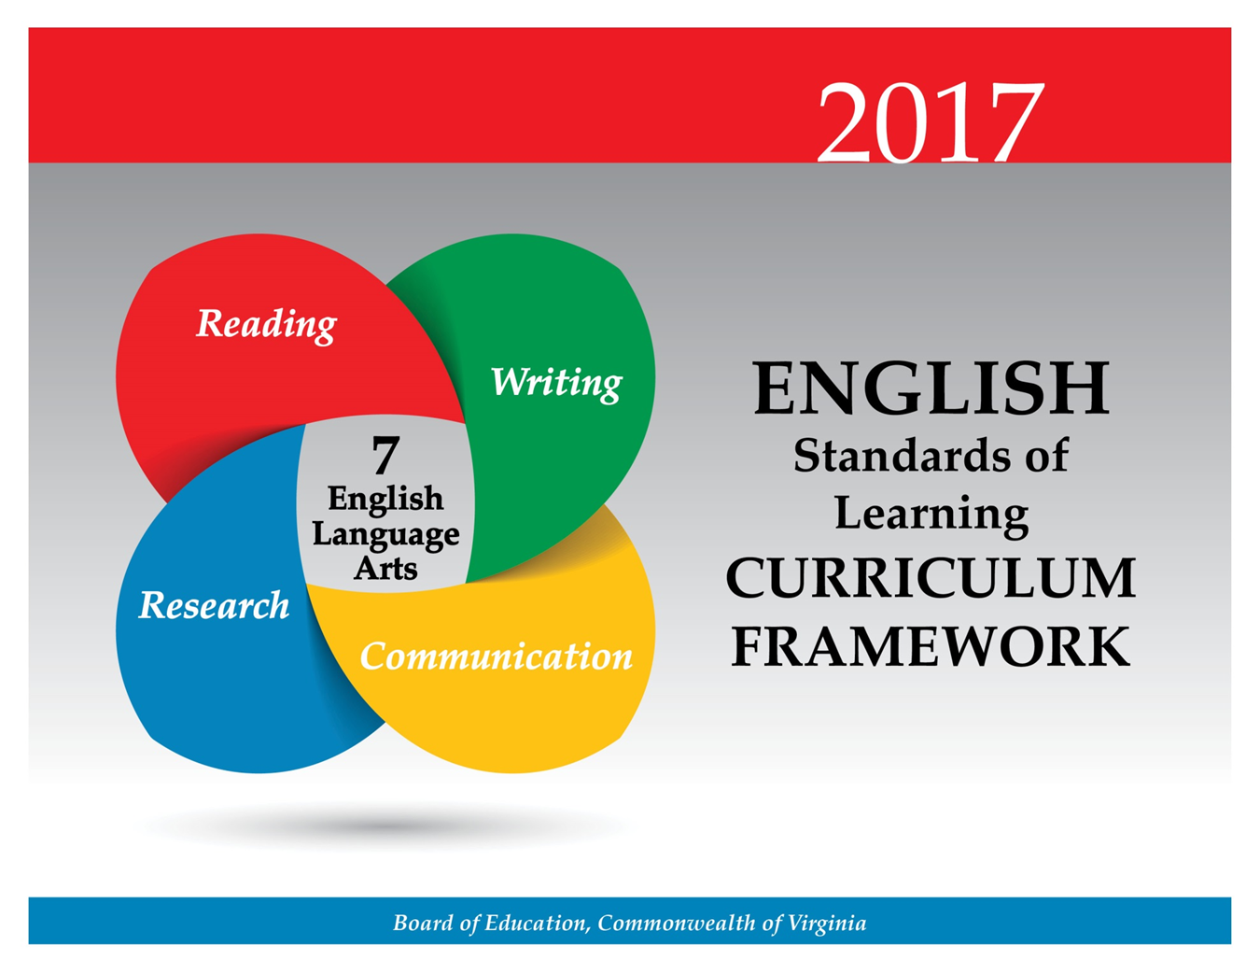

At the seventh-grade level, students will continue to deliver multimodal presentations individually and in collaborative groups. Students will also interpret information presented in diverse media formats. Students share responsibility for collaborative work, as both a contributor and a facilitator, while striving for consensus to accomplish goals. Teachers will emphasize the importance of effective interpersonal communication and collaboration skills that are essential for success in future postsecondary education and workplace environments.

Teacher Notes
- Please note presentation skills may differ within classrooms.
- Teachers should provide opportunities for students to create interactive, multimodal presentations.
- Multimodal is the strategic use of two or more interdependent modes of communication where both/all modes are essential to convey the intended message (e.g, graphics, written language, moving images, music, audio, presentation technologies, movement).
7.1 The student will participate in and contribute to conversations, group discussions, and oral presentations.
- Use a variety of strategies to listen actively and speak using agreed-upon discussion rules with awareness of verbal and nonverbal cues.
- Clearly communicate ideas and information orally in an organized and succinct manner.
- Ask probing questions to seek elaboration and clarification of ideas.
- Participate in collaborative discussions with partners, building on others’ ideas.
- Make statements to communicate agreement or tactful disagreement with others’ ideas.
- Use language and style appropriate to audience, topic, and purpose.
- Give formal and informal presentations in a group or individually, providing evidence to support a main idea.
- Work effectively and respectfully within diverse groups.
- Exhibit willingness to make necessary compromises to accomplish a goal.
- Share responsibility for collaborative work.
ESSENTIAL UNDERSTANDINGS | ESSENTIAL KNOWLEDGE, SKILLS, AND PROCESSES
All students should  - participate effectively in group discussions and presentations  - understand audience, topic, and purpose impact language and style  - recognize that each member brings a unique viewpoint to the group  - understand verbal and nonverbal feedback from the audience should be used to evaluate and adjust presentations. | To be successful with this standard, students are expected to  - contribute relevant ideas, opinions, and feelings in large and small diverse groups  - offer and seek summary statements of ideas  - select vocabulary, tone, and style with audience and purpose in mind  - state points clearly and directly  - maintain a focused discussion  - ask clarifying questions and respond appropriately to others’ questions to encourage discussion, foster understanding, and bring the discussion back to the topic when needed  - provide feedback to other group members, acknowledge new insights expressed by others, and when justified, modify own views  - engage others in conversations by posing and responding to questions in a group situation  - exercise flexibility and willingness in making compromises to accomplish a common goal  - use a variety of strategies to actively listen and show attentiveness, including  - focusing attention to the speaker  - providing appropriate feedback  - allowing the speaker to finish without interruptions.
7.2 The student will create multimodal presentations both individually and in a group that effectively communicate ideas.
- Select, organize, and create content to complement and extend meaning for a selected topic.
- Use effective verbal and nonverbal communication skills to deliver multimodal presentations.
- Use language and vocabulary appropriate to audience, topic, and purpose.
- Paraphrase and summarize a speaker’s key ideas.
ESSENTIAL UNDERSTANDINGS | ESSENTIAL KNOWLEDGE, SKILLS, AND PROCESSES
All students should  - understand nonverbal communication and its impact and use it purposefully  - understand that using more than one communication mode creates a more effective presentation  - understand that each member brings a unique viewpoint to the group. | To be successful with this standard, students are expected to  - match vocabulary and tone to the audience, purpose, and topic of the message  - use proper posture and stance when speaking  - identify whether a nonverbal message complements the spoken message  - plan and deliver an oral presentation, using the following steps:  - determine topic and purpose  - identify the intended audience  - choose vocabulary appropriate to topic, purpose, and audience  - create presentations that use two or more communication modes to make meaning  - use strategies for summarizing, such as  - deleting trivial and/or redundant information  - substituting a general term for a list  - creating a main idea statement  - write reflectively in response to multimodal presentations.

7.3 The student will examine the elements of media literacy.
- Identify persuasive/informative techniques used in media.
- Distinguish between fact and opinion, and between evidence and inference.
- Describe how word choice, visual images, and sound convey a viewpoint.
- Compare and contrast the effectiveness of techniques in auditory, visual, and written media messages.
- Craft and publish audience-specific media messages.
ESSENTIAL UNDERSTANDINGS | ESSENTIAL KNOWLEDGE, SKILLS, AND PROCESSES
All students should  - understand that all media messages are intentionally constructed to impact a specific audience  - understand persuasive language and connotations convey viewpoint  - understand that evidence is fact and a valid inference is the interpretation of fact  - understand that the effectiveness of any media message is determined by the impact on the intended audience. | To be successful with this standard, students are expected to  - deconstruct and analyze the elements of a variety of media  - identify elements of media literacy (e.g., authorship, format, audience, content, purpose)  - Who created the message?  - What techniques are used to attract attention?  - How might different people react differently to this message?  - What values, lifestyles and points of view are represented in, or omitted from, this message?  - What is the purpose of this message?  - recognize that production elements in media are composed based on audience and purpose to create specific effects  - identify persuasive techniques in the media, including, but not limited to,  - name calling or innuendo  - glittering generalities  - card stacking  - bandwagon  - testimonials  - appeal to prestige, snobbery, or plain folks  - appeal to emotions  - analyze a media text message considering what techniques have been used and the purpose and impact of each  - recognize and identify opinions in the media  - recognize and identify facts in the media  - analyze media messages for facts, opinions, persuasive message, word choice, and viewpoints  - create and publish media messages, such as public service announcements, aimed at a variety of audiences with different purposes.

Students will continue the study of word origins and roots and begin identifying connotations. There is a continued emphasis on reading comprehension by comparing fiction and nonfiction texts. In fiction texts, students will identify elements of a variety of genres while focusing on an author’s style. In seventh grade, there is an increased emphasis on nonfiction reading, and students will identify the source, point of view, and purpose of texts. These critical-thinking skills are foundational to technical reading and writing and are transferable across content areas. These skills are essential for success in future postsecondary education and workplace environments.

Teacher Notes
- Please note although the strands are developed separately, teachers should seamlessly integrate all strands.
  - Teachers may integrate the strands through the use of thematic units.
  - Teachers should ask students to write about what they have read.
- Vocabulary words should be culled from student reading rather than from prescribed lists and should not be taught in isolation.
  - There is not a specific list of Greek and Latin roots. Teachers may want to consult professional publications
  - Teachers should provide instruction on word connotations and how they can change meaning of the text.
- While whole-group instruction can be centered on a shared text, teachers should provide opportunities for student choice with both fiction and nonfiction texts.
- Teachers should introduce students to longer, more complex texts both on grade level and above grade level.
- Teachers should teach figurative language using fiction and nonfiction texts.
- Teachers should teach a balance of fiction (including poetry) and nonfiction throughout the academic year.
- Although the standard in fiction requires comparing/contrasting details in literary and informational nonfiction texts, teachers should be using paired passages with a variety of texts.
- Teachers should have students refer to the text(s) for support.
- Teachers should use fictional and informational texts paired on a common theme or topic and have students compare/contrast.

7.4 The student will read and determine the meanings of unfamiliar words and phrases within authentic texts.
- Identify word origins and derivations.
- Use roots, affixes, synonyms, and antonyms to expand vocabulary.
- Identify and analyze the construction and impact of figurative language.
- Identify connotations.
- Use context and sentence structure to determine meanings and differentiate among multiple meanings of words.
- Use word-reference materials to determine meanings and etymology.
- Extend general and cross-curricular vocabulary through speaking, listening, reading, and writing.
ESSENTIAL UNDERSTANDINGS | ESSENTIAL KNOWLEDGE, SKILLS, AND PROCESSES
All students should  - recognize that figurative language enriches text  - understand that affixes and Greek and Latin roots are clues to determine meanings of words  - understand that words have nuances of meaning, including figurative, connotative, and technical that help to determine the appropriate meaning. | To be successful with this standard, students are expected to  - use common Greek or Latin affixes and roots to predict the meaning of unfamiliar words  - separate and recombine known word parts to predict the meaning of unfamiliar words  - recognize, understand, use, and explain the impact of figurative language, including  - simile  - metaphor  - personification  - distinguish among the connotations of words with similar denotations  - recognize that synonyms may have different connotations (e.g., elderly and mature; youthful and juvenile, inexpensive and cheap)  - use context as a clue to the meaning of a word or phrase  - consult word reference materials to find the pronunciation of a word or determine/clarify meanings.

7.5 The student will read and demonstrate comprehension of a variety of fictional texts, literary nonfiction, poetry, and drama.
- Describe the elements of narrative structure including setting, character development, plot, theme, and conflict and how they influence each other.
- Identify and explain the theme(s).
- Identify cause-and-effect relationships and their impact on plot.
- Differentiate between first and third person point of view.
- Identify elements and characteristics of a variety of genres.
- Compare and contrast various forms and genres of fictional text.
- Describe the impact of word choice, imagery, and literary devices, including figurative language, in an author’s style.
- Compare/contrast details in literary and informational nonfiction texts.
- Make inferences and draw conclusions based on the text.
- Use reading strategies to monitor comprehension throughout the reading process.
ESSENTIAL UNDERSTANDINGS | ESSENTIAL KNOWLEDGE, SKILLS, AND PROCESSES
All students should  - understand that the author uses images to craft a message and create characters  - understand that literary nonfiction includes biography, autobiography, and personal essay  - understand that poetry can be rhymed, unrhymed, and/or patterned  - recognize an author’s craft as the purposeful choice of vocabulary, sentence formation, voice, and tone. | To be successful with this standard, the students are expected to  - recognize the elements of narrative structure including  - setting  - character(s) (e.g., protagonist and antagonist)  - external conflicts  - individual vs. individual  - individual vs. nature  - individual vs. society  - individual vs. supernatural  - individual vs. technology  - internal conflict (i.e., individual vs. self)  - plot – development of the central conflict, including  - initiating event  - rising action  - climax  - falling action  - resolution  - theme  - identify and distinguish between first and third person point of view  - distinguish between narrative prose and poetic forms, including  - haiku  - limerick  - ballad  - free verse  - couplet  - quatrain  - differentiate between a variety of fictional genres, including short story, novel, and drama  - identify characterization as the way an author presents a character and reveals character traits by  - what a character says  - what a character thinks  - what a character does  - how other characters respond to the character  - determine the theme(s) of a text and analyze its development over the course of the text  - provide an objective summary of the text  - analyze an author’s choice and use of literary devices, including  - foreshadowing  - irony  - analyze elements of an author’s style, including  - word choice to develop tone  - sentence structure  - imagery  - contrasting points of view  - figurative language  - recognize and analyze the impact of an author’s choice of sound devices, including  - rhyme  - rhythm  - repetition  - alliteration  - onomatopoeia  - compare and contrast two or more texts on the same topic or with similar themes  - use evidence from the text(s) for support when drawing conclusions or making inferences  - analyze how an individual, event, or idea is introduced, illustrated, and elaborated in a text (e.g., through examples or anecdotes)  - demonstrate comprehension and apply strategies to write about what is read.

7.6 The student will read and demonstrate comprehension of a variety of nonfiction texts.
- Skim materials using text features including type, headings, and graphics to predict and categorize information.
- Identify an author’s organizational pattern using textual clues, such as transitional words and phrases.
- Make inferences and draw logical conclusions using explicit and implied textual evidence.
- Differentiate between fact and opinion.
- Identify the source, viewpoint, and purpose of texts.
- Describe how word choice and language structure convey an author’s viewpoint.
- Identify the main idea.
- Summarize text identifying supporting details.
- Create an objective summary, including main idea and supporting details.
- Identify cause-and-effect relationships.
- Organize and synthesize information for use in written and other formats.
- Analyze ideas within and between selections providing textual evidence.
- Use reading strategies to monitor comprehension throughout the reading process.
ESSENTIAL UNDERSTANDINGS | ESSENTIAL KNOWLEDGE, SKILLS, AND PROCESSES
All students should  - understand that an author’s use of connotations and persuasive language conveys viewpoint  - understand that an author’s patterns of organization can aid comprehension  - understand an author’s viewpoint refers to a bias or subjectivity toward the subject; a viewpoint can be positive or negative  - understand that text features are created purposefully and are an aid to comprehension  - understand that there are strategies, including context, structural analysis, and reference sources, for determining the meaning of unfamiliar and technical vocabulary  - understand that skilled readers of nonfictional texts apply different reading strategies. | To be successful with this standard, students are expected to  - use text features to make predictions and enhance comprehension, including, but not limited to,  - boldface and/or italics type  - type set in color  - underlining  - indentation  - sidebars  - illustrations, graphics, and photographs  - headings and subheadings  - footnotes and annotations  - recognize organizational pattern to enhance comprehension, including  - cause and effect  - comparison/contrast,  - enumeration or listing  - sequential or chronological  - concept/definition  - generalization  - process  - problem/solution  - recognize transitional words and phrases authors use to signal organizational patterns,  - determine the central ideas in a text and analyze its development over the course of the text  - provide an objective summary of texts  - analyze how different authors write about the same topic and shape their presentations or viewpoints of key information using facts, opinions, and reasoning  - demonstrate comprehension and apply strategies to write about what is read.

At the seventh-grade level, students will continue to develop as readers and writers. Students will also plan, draft, revise, and edit writing in a variety of forms with an emphasis on expository and persuasive writing. Students will write to develop and modify a central idea, tone, and voice to fit the audience and purpose. Students will write multiparagraph compositions with an emphasis on organization. Additionally, students will write thesis statements that clearly state a position. Students will be expected to have greater control over the conventions of writing. Teachers will emphasize the importance of effective critical-thinking skills that lead to success in future postsecondary education and workplace environments.

Teacher Notes
- Teachers should recognize the difference between teaching writing and assigning writing.
- Teachers should recognize that there is not a required number of paragraphs or prescribed structure. Requiring students to use a prescribed model (i.e., five paragraphs) often produces formulaic writing and limits student expression.
- Teachers will model the recursive writing process for students.
- Teachers should refer to examples of writing in mentor texts.
- The focus of writing in seventh grade is expository and persuasive.
- Teachers should integrate grammar with writing instruction throughout the academic year.
- Teachers should use student writing to teach editing and peer editing skills.
- Teachers may want to consult professional publications.
- Teachers should instruct students in the features of the three domains of writing:
  - Composing-focusing on a clear, central idea; providing elaboration, organization, and unity
  - Written Expression—sentence variation, selected information, word choice, voice, and tone
  - Usage/Mechanics—grammar, punctuation, and usage as appropriate for the grade level
- Teachers should use writing conferences and portfolios to monitor student progress.
- Teachers should provide the opportunity for students to have practice writing on demand, for shorter time frames, and over extended periods of time.
- Teachers should provide opportunities for student choice with topic, audience, and purpose.

7.7 The student will write in a variety of forms to include narrative, expository, persuasive, and reflective, with an emphasis on expository and persuasive writing.
- Engage in writing as a recursive process.
- Choose intended audience and purpose.
- Use a variety of prewriting strategies to generate and organize ideas.
- Organize writing structure to fit form or topic.
- Establish a central idea incorporating evidence, while maintaining an organized structure and a formal style.
- Compose a thesis statement for persuasive writing that includes a position.
- Clearly state a position and organize reasons and evidence, using credible sources.
- Distinguish between fact and opinion to support a position.
- Write multiparagraph compositions with elaboration and unity.
- Use transition words and phrases within and between paragraphs.
- Develop and modify the central idea, tone, and voice to fit the audience and purpose.
- Expand and embed ideas by using modifiers, standard coordination, and subordination in complete sentences.
- Use clauses and phrases for sentence variety.
- Revise writing for clarity of content including specific vocabulary and information.
ESSENTIAL UNDERSTANDINGS | ESSENTIAL KNOWLEDGE, SKILLS, AND PROCESSES
All students should  - understand that writing requires a recursive process that includes planning, drafting, revising, editing, and publishing  - understand that voice in writing is purposefully crafted with attention to deliberate word choice, precise information, and vocabulary  - understand that vocabulary and tone must be selected with awareness of audience and purpose  - understand that effective writing includes elaboration  - understand that a thesis statement is not an announcement of the subject (statement of intent) but rather a unified and specific statement  - understand that effective writing has been improved through revision. | To be successful with this standard, students are expected to  - compose with attention to central idea, unity, elaboration, and organization  - elaborate to give detail, add depth, and continue the development of an idea  - analyze and use mentor texts as models for writing  - identify intended audience and purpose  - use a variety of prewriting strategies  - explain, analyze, or summarize a topic  - write an effective thesis statement that focuses on the topic and explains the writer’s position in an argument  - differentiate between a thesis statement and a topic sentence  - choose an appropriate strategy for organizing ideas, such as comparison/contrast, cause and effect, etc., and provide transitions between ideas  - write reflectively to explain and analyze a text, a presentation, an experience, a skill, or an event  - recognize that three examples of reflective writing include  - technical— – which includes what worked or did not work and reasons why, problem-solving techniques, and theories that were used or tested  - collaborative— – which is centered on team dynamics, how everyone worked together and why, and what worked or did not work and why.  - individual—focuses on questions such as, “What did I learn?” “How did I learn it?” and “What could I have done better?”  - write persuasively, organizing reasons logically and effectively  - create multiparagraph compositions focusing on a central idea and using elaborating details, reasons, or examples as appropriate for audience and purpose  - include an appropriate introduction and conclusion  - sustain a formal style when appropriate  - use written expression to draft and revise compositions with attention to  - voice  - tone  - selection of information  - embedded phrases and clauses that clarify meaning  - vivid and precise vocabulary  - figurative language  - sentence variety  - recognize terms illustrative of tone in mentor texts and student writing  - apply revising procedures in peer and self-review, including  - rereading  - reflecting  - rethinking  - rewriting to clarify, elaborate, and make writing more precise  - revise drafts for improvement using teacher assistance, peer collaboration, and growing independence  - vary sentence structure by using coordinating conjunctions  - use subordinating conjunctions to form complex sentences  - incorporate variety into sentences using simple, compound, and compound-complex sentences, including, but not limited to, coordination, subordination, and modifier.

7.8 The student will self- and peer-edit writing for capitalization, punctuation, spelling, sentence structure, paragraphing, and Standard English.
- Choose appropriate adjectives and adverbs to enhance writing.
- Use pronoun-antecedent agreement to include indefinite pronouns.
- Use subject-verb agreement with intervening phrases and clauses.
- Edit for verb tense consistency and point of view.
- Use quotation marks with dialogue and direct quotations.
- Use correct spelling for commonly used words.
ESSENTIAL UNDERSTANDINGS | ESSENTIAL KNOWLEDGE, SKILLS, AND PROCESSES
All students should  - understand that correct use of language enhances writing and avoids confusing or distracting the reader  - understand that pronouns must agree with antecedents  - understand that verbs must agree with subjects. | To be successful with this standard, students are expected to  - use a singular pronoun to refer to a singular antecedent and a plural pronoun to refer to a plural antecedent  - use punctuation to set off nonrestrictive clauses  - maintain consistent verb tense throughout an entire piece of writing  - maintain consistent point of view through a piece of writing  - use quotation marks to represent the exact language (either spoken or written) of another.

At the seventh-grade level, students will find, evaluate, and select appropriate resources for an oral, visual, written, or multimodal research product. They will evaluate the validity and authenticity of sources, and will apply research techniques to quote, summarize, and paraphrase findings. In addition, students will learn to cite both primary and secondary sources and follow ethical and legal guidelines for gathering and using information. Teachers will encourage the development of research skills that are foundational to effective critical thinking and responsible use of information. These skills are necessary for success in future postsecondary education and workplace environments.

Teacher Notes
- Teachers should note that research can be individual, collaborative, cross-curricular, and integrated throughout the year.
- Research products can vary from small informative pieces to large multimodal presentations.
- Teachers should use the librarian/media specialist’s expertise in teaching the research process.
- Teachers should make students aware of possible consequences of plagiarism.
- Teachers should emphasize giving credit to all sources used when gathering information, including music, graphics, and another person’s media.
- Teachers should demonstrate and encourage responsible use of the Internet.

7.9 The student will find, evaluate, and select appropriate resources to create a research product.
- Formulate and revise questions about a research topic.
- Collect, organize, and synthesize information from multiple sources.
- Analyze and evaluate the validity and credibility of resources.
- Quote, summarize, and paraphrase information from primary and secondary sources using proper citations.
- Avoid plagiarism by using own words and follow ethical and legal guidelines for gathering and using information.
- Demonstrate ethical use of the Internet.
ESSENTIAL UNDERSTANDINGS | ESSENTIAL KNOWLEDGE, SKILLS, AND PROCESSES
All students should  - understand that a primary source is an original document or a firsthand or eyewitness account of an event  - a secondary source discusses information originally presented somewhere else (i.e., secondary sources provide analysis, interpretation, or evaluation of the original information)  - understand to avoid plagiarism, credit must be given when using another person’s ideas, opinions, facts, statistics, or graphics  - understand the purposeful and responsible use of the Internet  - understand that there are consequences of plagiarism, according to the guidelines established by local school divisions  - understand using multiple sources of information produces a more complete understanding of a topic. | To be successful with this standard, students are expected to  - use available resource tools  - organize and synthesize information found in a variety of sources  - differentiate between a primary and a secondary source  - gather relevant information from multiple sources; assess the credibility and validity of each source  - prevent plagiarism and its consequences by giving credit to authors when ideas and/or words are used in direct quotation or paraphrases  - avoid plagiarism and its consequences by giving credit whenever using another person’s media, facts, statistics, graphics, images, music and sounds, quotations, or paraphrases of another person’s words  - evaluate the validity and credibility of texts using questions such as  - Does the writer have something to gain from his opinion?  - Does the information contain facts for support?  - Is the same information found in more than one source?  - Is contact information provided?  - Is there a copyright symbol on the page?  - What is the purpose of the page?  - What is the date of the most recent publication?  - summarize and cite specific evidence from texts to support conclusions.

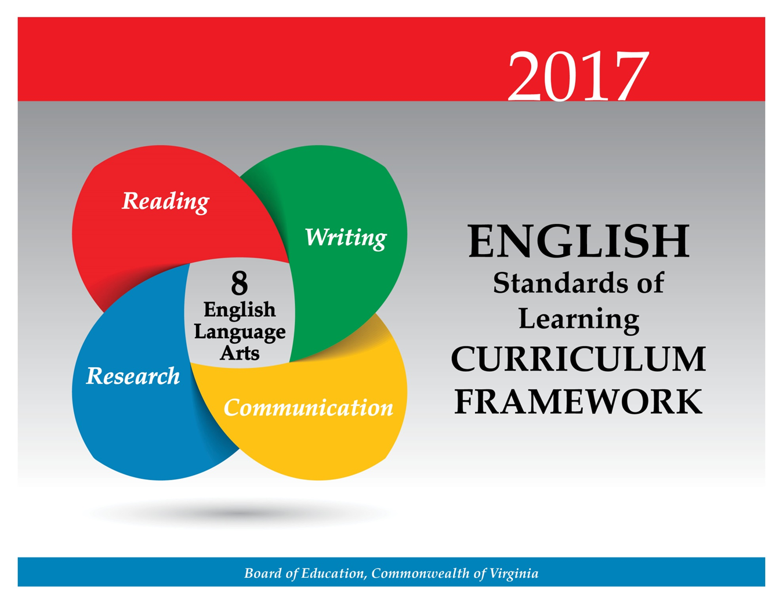

In eighth-grade, students will evaluate, analyze, develop, and produce media messages. Students will create multimodal presentations that include different points-of-view, and collaborate with others to exchange ideas, make decisions, and solve problems. Teachers will emphasize the importance of effective interpersonal communication and collaboration skills that are essential for success in future postsecondary education and workplace environments.

Teacher Notes
- Please note presentation skills may differ within classrooms.
- Teachers should provide opportunities for students to create interactive, multimodal presentations.
- Teachers should note that the communication strand should be integrated with the reading, writing, and research strands throughout the year.
- Multimodal is the strategic use of two or more interdependent modes of communication where both/all modes are essential to convey the intended message (e.g., graphics, written language, moving images, music, audio, presentation technologies, movement).

8.1 The student will participate in, collaborate in, and report on small-group learning activities.
- Assume responsibility for specific group tasks and share responsibility for collaborative work within diverse teams.
- Exhibit willingness to make necessary compromises to accomplish a goal.
- Collaborate with others to exchange ideas, develop new understandings, make decisions, and solve problems.
- Include all group members, and value individual contributions made by each group member.
- Make statements to communicate agreement or tactful disagreement with others’ ideas.
- Use a variety of strategies to listen actively and speak using appropriate discussion rules with awareness of verbal and nonverbal cues.
- Use self-reflection to evaluate one’s own role in preparation and participation in small-group activities.
ESSENTIAL UNDERSTANDINGS | ESSENTIAL KNOWLEDGE, SKILLS, AND PROCESSES
All students should  - recognize that each member brings a unique viewpoint to the group  - understand that verbal and nonverbal feedback from the audience should be used to evaluate contributions. | To be successful with this standard, students are expected to  - contribute relevant ideas, opinions, and feelings in large and small diverse groups  - offer and seek summary statements of ideas  - state points clearly and directly  - maintain a focused discussion  - ask clarifying questions and respond appropriately to others’ questions to encourage discussion, foster understanding, and bring the discussion back to the topic when needed  - provide feedback to other group members, acknowledge new insights expressed by others, and, when justified, modify their own views  - use a variety of strategies to actively listen and show attentiveness, including  - focusing attention to the speaker  - providing appropriate feedback  - asking questions  - assume shared responsibility for collaborative work  - collaborate with peers to set guidelines for group presentations and discussions, set clear goals, and define individual roles  - respond thoughtfully by summarizing points of agreement and disagreement, qualifying views, and demonstrating understanding  - exercise flexibility and willingness in making compromises to accomplish a common goal.

8.2 The student will develop and deliver multimodal, interactive presentations collaboratively and individually.
- Select, organize, and create multimodal content that encompasses opposing points of view.
- Choose vocabulary and tone appropriate to the audience, topic, and purpose.
- Use effective verbal and nonverbal communication skills to deliver multimodal presentations.
- Cite information sources.
- Respond to audience questions and comments.
- Differentiate between Standard English and informal language.
- Evaluate presentations.
ESSENTIAL UNDERSTANDINGS | ESSENTIAL KNOWLEDGE, SKILLS, AND PROCESSES
All students should  - understand audience, topic, and purpose impact language and style  - understand the elements of an effective presentation, including language and nonverbal communication appropriate to purpose and audience  - understand that using more than one communication mode creates a more effective presentation. | To be successful with this standard, students are expected to  - articulate the purpose of the presentation  - select and use information that clearly presents both sides of an issue  - select vocabulary, tone, and style with audience and purpose in mind  - create a presentation that uses two or more communication modes to make meaning  - select and narrow the topic with attention to time limits and audience  - evaluate presentations  - answer questions and respond to comments with relevant evidence, observations, and ideas  - work effectively with diverse groups  - exercise flexibility and work as a constructive team member to accomplish a common goal or reach consensus.

8.3 The student will analyze, develop, and produce creative or informational media messages.
- Analyze the purpose of information and persuasive techniques used in diverse media formats.
- Examine how values and viewpoints are included or excluded and how the media can influence beliefs, behaviors, and interpretations.
- Use media and visual literacy skills to create products to express new understandings.
- Evaluate sources for relationships between intent and factual content.
- Utilize multimedia to clarify information and emphasize differing points of view.
- Evaluate the motives (e.g., social, commercial, political) behind media presentation(s).
- Demonstrate the ethical use of the Internet when evaluating or producing creative or informational media messages.
ESSENTIAL UNDERSTANDINGS | ESSENTIAL KNOWLEDGE, SKILLS, AND PROCESSES
All students should  - understand that all media messages are intentionally constructed to influence a specific audience  - understand that an author’s viewpoint refers to a bias or subjectivity toward the subject  - understand use of persuasive language and connotations to convey viewpoint  - understand that evidence is fact and a valid inference is the interpretation of fact  - understand that the effectiveness of any media message is determined by the impact on the intended audience. | To be successful with this standard, students are expected to  - deconstruct and analyze the elements of a variety of media  - identify and analyze persuasive techniques used in the media, including, but not limited to,  - name calling or innuendo  - glittering generalities  - card stacking  - bandwagon  - testimonials  - appeal to prestige, snobbery, or plain folks  - appeal to emotions  - identify and analyze choice of information in the media  - recognize that production elements in media are composed based on audience and purpose  - analyze the techniques used in media messages  - create and publish media messages, such as public service announcements, aimed at a variety of audiences on different topics  - evaluate the advantages and disadvantages of using different types of media  - identify and analyze the motives (e.g., social, commercial, political) and factual content of media messages.

Students will continue the study of word origins, roots, connotations, and denotations. There is a continued emphasis on reading comprehension by comparing fiction and nonfiction texts. In fiction texts, students will explain the development of theme(s), and compare/contrast authors’ styles. There will be an increased emphasis on nonfiction reading, and students will analyze authors’ qualifications, point of view, and style. These critical-thinking skills are foundational to technical reading and writing and are transferable across all content areas. These skills are essential for success in future postsecondary education and workplace environments.

Teacher Notes
- Please note although the strands are developed separately, teachers should seamlessly integrate all strands.
  - Teachers may integrate the strands through the use of thematic units.
  - Teachers should ask students to write about what they have read.
- Vocabulary words should be culled from student reading rather than from prescribed lists and should not be taught in isolation.
  - There is not a specific list of Greek/Latin roots, or idioms. Teachers may want to consult professional publications.
  - Teachers should provide instruction on word connotations and how they can change meaning of the text.
- While whole-group instruction can be centered on a shared text, teachers should also provide opportunities for student choice with both fiction and nonfiction texts.
- Teachers should introduce students to longer, more complex texts both on grade level and above grade level.
- Teachers should teach figurative language using fiction and nonfiction texts.
- Teachers should teach a balance of fiction (including poetry) and nonfiction throughout the academic year.
- Although the standard in fiction requires comparing/contrasting details in literary and informational nonfiction texts, teachers should be using paired passages with a variety of texts.
- Teachers should have students refer to the text(s) for support.
- Teachers should use fictional and informational texts paired on a common theme or topic and have students compare/contrast.

8.4 The student will apply knowledge of word origins and figurative language to extend vocabulary development within authentic texts.
- Identify and analyze the construction and impact of an author’s use of figurative language.
- Use context, structure, and connotations to determine meaning and differentiate among multiple meanings of words and phrases.
- Use roots, affixes, synonyms, and antonyms to determine the meaning(s) of unfamiliar words and technical vocabulary.
- Identify the meaning of common idioms.
- Use word-reference materials to determine meanings and etymology.
- Discriminate between connotative and denotative meanings and interpret the connotation.
- Extend general and cross-curricular vocabulary through speaking, listening, reading, and writing.
ESSENTIAL UNDERSTANDINGS | ESSENTIAL KNOWLEDGE, SKILLS, AND PROCESSES
All students should  - recognize that words have nuances of meaning, including figurative, connotative, and technical, that help to determine the appropriate meaning  - understand that affixes and Greek and Latin roots are clues to determine meanings of words  - recognize that figurative language enriches text. | To be successful with this standard, students are expected to  - use common roots to determine the meaning of unfamiliar words and make connections with word families (e.g., -phobia, and -ology)  - recognize the relationships among words related by structure and derivation, such as polygraph and graffiti  - distinguish among the connotations of words with similar denotations  - understand, evaluate, and use figurative language, including simile, metaphor, personification, hyperbole, and symbol  - analyze the impact of specific word choices on meaning and tone  - consult reference materials to find the pronunciation of a word or determine/clarify meaning  - recognize that synonyms may have different connotations (e.g., elderly and mature; youthful and juvenile, inexpensive and cheap) and describe the impact on text  - use context as a clue to the meaning of a word or phrase  - use both context and reference skills independently to determine the nuances and connotations of words.

8.5 The student will read and analyze a variety of fictional texts, literary nonfiction, poetry, and drama.
- Analyze how authors’ development of characters, conflict, point of view, voice, and tone convey meaning.
- Identify cause-and-effect relationships and their impact on plot.
- Explain the development of the theme(s).
- Explain the use of symbols and figurative language.
- Make inferences and draw conclusions based on explicit and implied information using references to the text for support.
- Identify and analyze characteristics within a variety of genres.
- Compare/contrast details in literary and informational nonfiction texts.
- Compare and contrast the authors’ use of word choice, dialogue, form, rhyme, rhythm, and voice in different texts.
- Compare and contrast authors’ styles.
- Use reading strategies to monitor comprehension throughout the reading process.
ESSENTIAL UNDERSTANDINGS | ESSENTIAL KNOWLEDGE, SKILLS, AND PROCESSES
All students should  - understand that an author’s voice and tone stem from word choice and the stylized use of literary devices  - understand the relationship between causes and effects  - understand that the author uses images to craft a message and create characters  - understand that literary nonfiction includes biography, autobiography, and personal essay  - understand that analysis of a text should be based on textual references, not on personal opinion. | To be successful with this standard, students are expected to  - identify and analyze narrative elements, including  - setting  - character(s), either:  - static  - dynamic  - identify protagonist and antagonist.  - explain characterization as the way an author presents a character and reveals character traits by  - what a character says  - what a character thinks  - what a character does  - how other characters respond to the character  - identify conflicts  - external conflicts  - individual vs. individual  - individual vs. nature  - individual vs. society  - individual vs. supernatural  - individual vs. technology  - internal conflict (individual vs. self)  - identify the elements of a plot  - initiating event  - rising action  - climax  - falling action  - resolution  - recognize theme(s)  - recognize different plot patterns including subplots  - analyze the interactions between individuals, events, and ideas in a text  - compare and contrast the characteristics of literary forms, including, but not limited to,  - novel  - short story  - biography  - essay  - speech  - poetry  - memoir  - understand and analyze elements of an author’s style, including  - dialogue  - sentence structure  - language patterns  - word choice to develop tone  - voice  - differentiate among points of view in stories, including  - first person  - third-person limited to a character or narrator;  - third- person omniscient  - analyze how differences in points of view can create such effects as suspense or humor  - analyze an author’s use of literary devices, including  - foreshadowing  - irony  - flashback  - symbolism  - analyze poetic devices in prose and poetry, including, but not limited to,  - word choice  - figurative language  - symbolism  - imagery  - rhyme, rhythm, repetition, and sound elements.  - analyze an author’s choice of words and images  - identify poetic forms, including, but not limited to,  - haiku  - limerick  - ballad  - free verse  - couplet  - quatrain  - compare and contrast an author’s choice of sound elements in prose and poetry, including, but not limited to,  - rhyme  - rhythm  - meter  - repetition  - alliteration  - onomatopoeia  - determine a theme of a text and analyze its development  - compare and contrast two or more texts on the same topic or with similar themes.  - use evidence from the text(s) for support when drawing conclusions, making inferences, or making predictions  - analyze how an individual, event, or idea is introduced, illustrated, and elaborated in a text (e.g., through examples or anecdotes and organizational strategies)  - demonstrate comprehension and apply strategies to write about what is read.

8.6 The student will read, comprehend, and analyze a variety of nonfiction texts.
- Identify an author’s organizational pattern using textual clues, such as transitional words and phrases.
- Apply knowledge of text features and organizational patterns to analyze selections.
- Skim materials to develop an overview or locate information.
- Make inferences and draw conclusions based on explicit and implied information using evidence from text as support.
- Analyze the author’s qualifications, viewpoint, word choice, and impact.
- Analyze details for relevance and accuracy.
- Differentiate between fact and opinion.
- Identify the main idea.
- Summarize the text, identifying supporting details.
- Identify cause-and-effect relationships.
- Evaluate, organize, and synthesize information for use in written and other formats.
- Analyze ideas within and between selections, providing textual evidence.
- Use reading strategies to monitor comprehension throughout the reading process.
ESSENTIAL UNDERSTANDINGS | ESSENTIAL KNOWLEDGE, SKILLS, AND PROCESSES
All students should  - understand that an author’s viewpoint is conveyed through word choice and persuasive language  - recognize an author’s use of connotations, and persuasive language convey viewpoint  - understand that an author’s credentials and experiences contribute to his/her viewpoint  - understand that an author’s patterns of organization can aid comprehension  - understand an author’s viewpoint refers to a bias or subjectivity toward the subject; a viewpoint can be positive or negative  - understand that text features are created purposefully and are an aid to comprehension  - understand that there are strategies including context, structural analysis, and reference sources, for determining the meaning of unfamiliar and technical vocabulary  - understand that skilled readers of nonfiction texts apply different reading strategies. | To be successful with this standard, students are expected to  - recognize and identify an author’s use of connotations and persuasive language to convey a viewpoint  - determine an author’s point of view or purpose in a text  - analyze how the author acknowledges and responds to conflicting evidence or viewpoints  - recognize organizational patterns to enhance comprehension, including  - cause and effect  - comparison/contrast,  - enumeration or listing  - sequential or chronological  - concept/definition  - generalization  - problem/solution  - process  - read several texts on a similar topic and synthesize what is read  - use strategies for summarizing  - use text features to enhance comprehension  - boldface and/or italics type  - type set in color  - underlining  - indentation  - sidebars  - illustrations, graphics, and photographs  - headings and subheadings  - footnotes and annotations  - analyze an author’s choice of details by examining  - accuracy  - placement  - thoroughness  - relevance  - effectiveness  - analyze multiple accounts of the same event or topic, noting important similarities and differences in the point of view they represent  - analyze two or more texts with conflicting information on the same topic and identify how the texts disagree  - distinguish between subjective and objective writing  - demonstrate comprehension and apply strategies to write about what is read.

At the eighth-grade level, students will continue to develop as readers and writers. Students will also plan, draft, revise, and edit writing in a variety of forms with an emphasis on expository and persuasive writing. Students will write persuasively and use claims, evidence, and counterclaims to advocate and support a position to fit the audience and purpose. Students will be expected to have greater control over the conventions of writing. Teachers will emphasize the importance of effective critical-thinking skills that lead to success in future postsecondary education and workplace environments.

Teacher Notes
- Teachers should recognize the difference between teaching writing and assigning writing.
- Teachers should recognize that there is not a required number of paragraphs or prescribed structure. Requiring students to use a prescribed model (i.e., five paragraphs) often produces formulaic writing and limits student expression.
- Teachers will model the recursive writing process for students.
- Teachers should refer to examples of writing in mentor texts.
- The focus of writing in eighth grade is expository and persuasive.
- Teachers should integrate grammar with writing instruction throughout the academic year.
- Teachers should use student writing to teach editing and peer editing skills.
- Teachers may want to consult professional publications.
- Teachers should instruct students in the features of the three domains of writing:
  - Composing-focusing on a clear, central idea; providing elaboration, organization, and unity
  - Written expression—sentence variation, selected information, word choice, voice, and tone
  - Usage/Mechanics—grammar, punctuation, and usage as appropriate for the grade level
- Teachers should use writing conferences and portfolios to monitor student progress.
- Teachers should provide the opportunity for students to have practice writing on demand, for shorter time frames, and over extended periods of time.
- Teachers should provide opportunities for student choice with topic, audience, and purpose.

8.7 The student will write in a variety of forms to include narrative, expository, persuasive, and reflective, with an emphasis on expository and persuasive writing.
- Engage in writing as a recursive process.
- Choose intended audience and purpose.
- Use prewriting strategies to generate and organize ideas.
- Organize writing structure to fit form or topic.
- Establish a central idea incorporating evidence, maintaining an organized structure and formal style.
- Compose a thesis statement for persuasive writing that advocates a position.
- Clearly state and defend a position with reasons and evidence from credible sources.
- Identify a counterclaim and provide a counter - argument.
- Distinguish between fact and opinion to support a position.
- Organize information to provide elaboration and unity.
- Develop and modify the central idea, tone, and voice to fit the audience and purpose.
- Revise writing for clarity of content, word choice, sentence variety, and transitions among paragraphs.
ESSENTIAL UNDERSTANDINGS | ESSENTIAL KNOWLEDGE, SKILLS, AND PROCESSES
All students should  - understand that writing requires a recursive process that includes planning, drafting, revising, editing, and publishing  - understand that writing should be purposefully crafted, with attention to deliberate word choice, precise information, and vocabulary  - understand that vocabulary and tone must be selected with awareness of audience and purpose  - understand that effective writing has been elaborated  - understand that a thesis statement is not an announcement of the subject (statement of intent) but rather a unified and specific statement  - understand that good writing has been improved through revision  - understand that a topic sentence supports an essay’s thesis statement. | To be successful with this standard, students are expected to  - write in a variety of forms, including narrative, expository, persuasive, informational, and reflective  - write reflectively to explain and analyze an experience, a skill, or an event  - apply the elements of composing (i.e., central idea, elaboration, unity, and organization)  - use written expression to explain, analyze, or summarize a topic with attention to  - purpose and audience  - a central or controlling idea  - voice  - tone  - coherent selection of information and details  - embedded phrases and clauses that clarify meaning and increase variety  - vivid and precise vocabulary  - figurative language  - sentence variety  - transitional words and phrases  - apply revising procedures, including  - rereading  - reflecting  - rethinking  - rewriting  - including vivid vocabulary  - combining sentences for variety and rhythm  - providing transitions between ideas and paragraphs  - write persuasively, organizing reasons logically and effectively  - identify counterclaims and counter-arguments that address those claims  - create a thesis statement that focuses the essay, expresses the writer’s position in an argument, or explains the purpose of the essay  - elaborate the central idea, providing sustained unity throughout the writing  - choose language that expresses ideas precisely and concisely, recognizing and eliminating wordiness and redundancy  - use appropriate and varied transitions to create cohesion and clarify the relationships among ideas and concepts  - sustain a formal style when appropriate  - develop an effective introduction and conclusion.

8.8 The student will self- and peer-edit writing for capitalization, punctuation, spelling, sentence structure, paragraphing, and Standard English.
- Use and punctuate correctly varied sentence structures to include conjunctions and transition words.
- Correctly use pronouns in prepositional phrases with compound objects.
- Use a variety of sentence structures to infuse sentence variety in writing.
- Maintain consistent verb tense across paragraphs.
- Use comparative and superlative degrees in adverbs and adjectives.
- Use quotation marks with dialogue and direct quotations.
- Use correct spelling for frequently used words.
ESSENTIAL UNDERSTANDINGS | ESSENTIAL KNOWLEDGE, SKILLS, AND PROCESSES
All students should  - understand that correct use of language enhances writing and avoids confusing or distracting the reader  - understand that pronouns must agree with antecedents in gender, number, and person  - understand that verbs must agree with subjects. | To be successful with this standard, students are expected to  - edit drafts with teacher assistance, peer collaboration, and growing independence  - use an ellipsis to indicate an omission  - use a singular pronoun to refer to a singular antecedent and a plural pronoun to refer to a plural antecedent  - use objective pronouns in prepositional phrases with compound objects  - choose and maintain a consistent verb tense throughout an entire paragraph or text.

At the eighth-grade level, students will apply research techniques to analyze information gathered from diverse sources by identifying misconceptions and possible bias. They will evaluate the validity and credibility of sources, and will apply research techniques to quote, summarize, and paraphrase findings. In addition, students will learn to cite sources using the Modern Language Association (MLA) or American Psychological Association (APA) style sheet and follow ethical and legal guidelines for gathering and using information. Teachers will encourage the development of research skills that are foundational to effective critical thinking and responsible use of information. These skills are necessary for success in future postsecondary education and workplace environments.

Teacher Notes
- Teachers should note that research can be individual, collaborative, cross-curricular, and integrated throughout the year.
- Research products can vary from small informative pieces to large multimodal presentations.
- Teachers should use the librarian/media specialist’s expertise in teaching the research process.
- Teachers should make students aware of possible consequences of plagiarism.
- Teachers should emphasize giving credit to all sources used when gathering information, including music, graphics, and another person’s media.
- Teachers should demonstrate and encourage responsible use of the Internet.

8.9 The student will find, evaluate, select, and synthesize appropriate resources to produce a research product.
- Formulate and revise questions about a research topic.
- Collect and synthesize information from multiple sources.
- Evaluate and analyze the validity and credibility of resources.
- Analyze information gathered from diverse sources by identifying misconceptions, main and supporting ideas, conflicting information, point of view, or bias.
- Cite primary and secondary sources using Modern Language Association (MLA) or American Psychological Association (APA) style.
- Quote, summarize, and paraphrase research findings.
- Publish findings and respond to feedback.
- Avoid plagiarism by using own words and follow ethical and legal guidelines for gathering and using information.
- Demonstrate ethical use of the Internet.
ESSENTIAL UNDERSTANDINGS | ESSENTIAL KNOWLEDGE, SKILLS, AND PROCESSES
All students should  - understand that using multiple sources of information produces a more complete understanding of a topic  - understand to avoid plagiarism, credit must be given when using another person’s ideas, opinions, facts, statistics, or graphics  - understand the purposeful and responsible use of the Internet  - understand the importance of evaluating the intent of the author, which may include misinformation, bias, and unsupported assertions  - understand that there are consequences of plagiarism, according to the guidelines established by local school divisions. | To be successful with this standard, students are expected to  - use primary sources such as original documents or a firsthand or eyewitness accounts of an event  - use secondary sources, which provide analysis, interpretation, or evaluation of the original information  - use a variety of strategies to generate notes, determine the central ideas of a primary or secondary source, synthesize information, and provide an accurate summary  - evaluate the validity and credibility of information, using questions such as  - Is the source free from bias? Does the writer have something to gain from his opinion?  - Does the information contain facts for support?  - Is the same information found in more than one source?  - Is contact information provided?  - Is there a copyright symbol on the page?  - What is the purpose of the page?  - What is the date of the most recent publication?  - conduct short research projects to answer questions, drawing on several sources and generating new questions  - document using a standard form such as MLA or APA  - avoid plagiarism and its consequences by giving credit whenever using another person’s media, facts, statistics, graphics, images, music and sounds, quotations, or paraphrases of another person’s words.

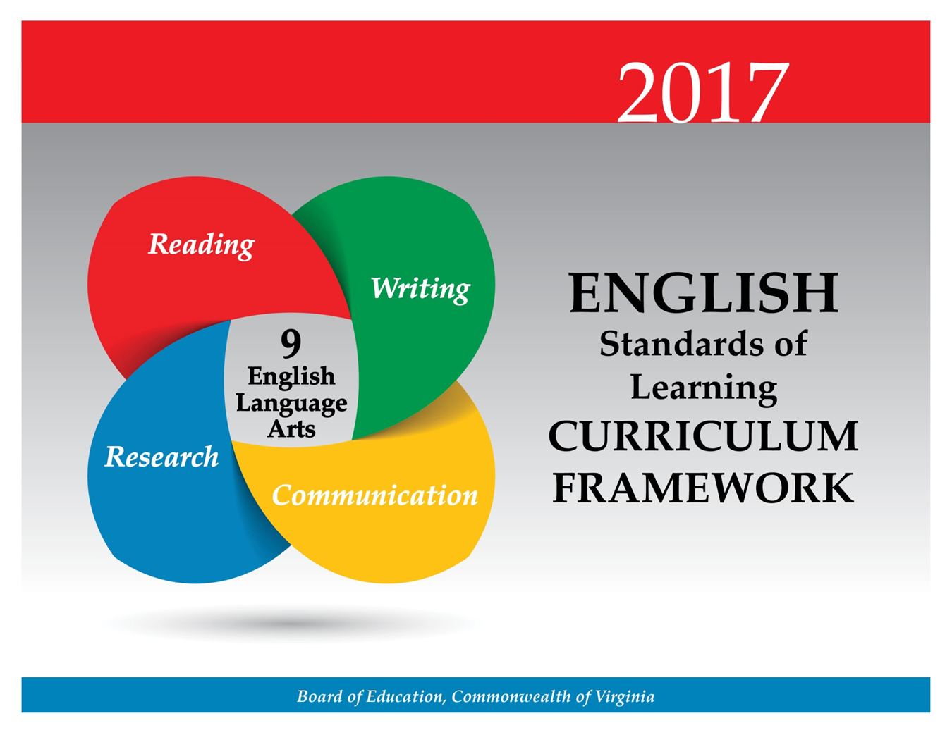
Students will analyze and interpret the social, commercial, and/or political motives behind media messages. Students will use multimodal tools to create presentations both independently and in small groups. Teachers will emphasize the importance of effective interpersonal communication and collaboration skills that are essential for success in future postsecondary education and workplace environments.

Teacher Notes
- Please note presentation skills may differ within classrooms.
- Teachers should provide opportunities for students to create interactive, multimodal presentations.
- Teachers should provide opportunities for small-group analysis and self-analysis of the effectiveness of communication.
- Teachers should note that the communication strand should be integrated with the reading, writing, and research strands throughout the year.
- Multimodal is the strategic use of two or more interdependent modes of communication where both/all modes are essential to convey the intended message (e.g., graphics, written language, moving images, music, audio, presentation technologies, movement).

9.1 The student will participate in, collaborate in, and make multimodal presentations both independently and in small groups.
- Make strategic use of multimodal tools.
- Credit information sources.
- Use vocabulary appropriate to the topic, audience, and purpose.
- Assist with setting rules for group work, including informal consensus, taking votes on key issues, presentation of alternate views, and goal-setting.
- Assume responsibility for specific group tasks.
- Share responsibility for collaborative work.
- Use a variety of strategies to listen actively and speak, using appropriate discussion rules with awareness of verbal and nonverbal cues.
- Include all group members, acknowledge new information expressed by others, and value individual contributions made by each group member.
- Respond thoughtfully and tactfully to diverse perspectives, summarizing points of agreement and disagreement.
- Evaluate impact, purpose, point of view, reasoning, and use of evidence and rhetoric of presentation(s).
- Use self-reflection to evaluate one’s own role in preparation and participation in small-group activities.
ESSENTIAL UNDERSTANDINGS | ESSENTIAL KNOWLEDGE, SKILLS, AND PROCESSES
All students should  - understand that verbal techniques are important for effective communication.  - understand working effectively with diverse groups includes  - exercising flexibility in making necessary compromises to accomplish a common goal  - defining a team goal and working toward it  - treating all ideas respectfully  - demonstrating respect for others’ ideas by acknowledging differing points of view  - coming to agreement by seeking consensus  - understand the importance of self-reflection in small-group activities. | To be successful with this standard, students are expected to  - define technical and specialized language to increase clarity in multimodal presentations  - incorporate pertinent information discovered during research to support main ideas in multimodal presentations  - organize presentation in a structure appropriate to the audience, topic, and purpose  - use word choice and vocabulary appropriate for situation, audience, topic, and purpose  - keep eye contact with audience; adjust volume, tone, and rate; be aware of posture and gestures; use natural tone  - analyze and critique the relationship among purpose, audience, and content of presentations  - collaborate with peers to set guidelines for group presentations and discussions, set clear goals and deadlines, and define individual roles as needed  - engage others in a conversation by posing and responding to questions in a group situation  - demonstrate active listening skills by looking at the speaker, using body language to indicate attentiveness, and giving appropriate feedback  - analyze and critique the effectiveness of a speaker’s or group’s voice, language, clarity, organization, relevance, and delivery.

9.2 The student will produce, analyze, and evaluate media messages.
- Analyze and interpret special effects used in media messages.
- Determine the purpose of the media message and its effect on the audience.
- Analyze the purpose of information and persuasive techniques used in diverse media formats.
- Evaluate the motives (e.g., social, commercial, political) behind media presentation(s).
- Examine how values and viewpoints are included or excluded and how the media can influence beliefs, behaviors, and interpretations.
- Describe possible cause-and-effect relationships between mass media coverage and public opinion trends.
- Evaluate sources, including advertisements, editorials, political cartoons, and feature stories for relationships between intent and factual content.
- Monitor, analyze, and use multiple streams of simultaneous information.
- Demonstrate ethical use of the Internet when evaluating or producing creative or informational media messages.
ESSENTIAL UNDERSTANDINGS | ESSENTIAL KNOWLEDGE, SKILLS, AND PROCESSES
All students should  - understand how special effects are employed in a multimedia message to persuade the viewer  - comprehend persuasive language and word connotations to convey viewpoint and bias  - understand that media messages are constructed based on varying opinions, values, and viewpoints  - recognize that all media messages are constructed and that, to understand the whole meaning of the message, they should be deconstructed. | To be successful with this standard, students are expected to  - create and publish media messages, such as public service announcements, aimed at a variety of audiences and with different purposes  - identify and deconstruct elements of media literacy including authorship, format, audience, content, purpose  - analyze the author’s intended audience and purpose when evaluating media messages  - recognize that persuasive techniques are used to convince viewers to make decisions, change their minds, take a stand on an issue, or predict a certain outcome, including, but not limited to,  - ad hominem  - red herring  - straw man  - begging the question  - testimonial  - ethical appeal  - emotional appeal  - logical appeal  - identify and evaluate word choice, bias, viewpoints, and the effectiveness of persuasive messages in the media  - identify public opinion trends and possible causes  - identify and analyze sources in the media  - analyze information from many sources  - identify basic principles of media literacy  - media messages are constructed  - messages are representations with values and viewpoints  - each form of media uses a unique set of rules to construct messages  - individuals interpret based on personal experience  - media are driven to gain profit or power  - identify key questions of media literacy  - Who created the message?  - What techniques are used to attract attention?  - How might different people react differently to this message?  - What values, lifestyles and points of view are represented in, or omitted from, this message?  - What is the purpose of this message?  - avoid plagiarism by giving credit whenever using another person’s media, facts, statistics, graphics, images, music and sounds, quotations, or paraphrases of another person’s words.

Students will continue to expand vocabulary using the structural analysis of roots and affixes to understand complex words. There is a continued emphasis on reading comprehension by comparing fiction and nonfiction texts. In fiction texts, students will apply knowledge of literary terms and analyze a variety of genres. In ninth grade there will be an increased emphasis on nonfiction reading, and students will make inferences and draw conclusions using explicit and implied textual evidence. These critical-thinking skills are foundational to technical reading and writing and are transferable across all content areas. These skills are essential for success in future postsecondary education and workplace environments

Teacher Notes
- Teachers should teach a balance of fiction (including poetry) and nonfiction throughout the academic year. Nonfiction texts should include informational, persuasive, and technical texts.
- Please note although the strands are developed separately, teachers should seamlessly integrate all strands.
  - Teachers may integrate the strands through the use of thematic units.
  - Teachers should ask students to write about what they have read.
- Vocabulary words should be culled from student reading rather than from prescribed lists and should not be taught in isolation.
  - Although the vocabulary standards in high school remain similar, the words studied should increase in complexity according to a variety of texts read. Students in 9th grade should not be studying the same vocabulary as upperclassmen will receive. Vocabulary can also be differentiated according to text and level of student.
  - There is not a specific list of Greek/Latin roots, or idioms. Teachers may want to consult professional publications.
  - Teachers should provide instruction on classical allusions and how they can impact and deepen the meaning of the text.
- While whole-group instruction can be centered on a shared text, teachers must also provide opportunities for student choice with both fiction and nonfiction texts.
- Although the standard in fiction requires comparing/contrasting details in literary and informational nonfiction texts, teachers should be using paired passages with a variety of texts.
- Teachers should include literary texts that fulfill a social or cultural function depending on the time, location, theme and purpose of the author(s) across texts. For example, To Kill a Mockingbird reflects the time of the Civil Rights Movement that compelled people to examine their social perspectives, prejudices, and attitudes, resulting in a change in the conscience and laws of a nation.
- Teachers should introduce students to longer, more complex texts both on grade level and above grade level.
- Teachers should have students refer to the text(s) for support.
- Teachers should use fictional and informational texts paired on a common theme or topic and have students compare/contrast.

9.3 The student will apply knowledge of word origins, derivations, and figurative language to extend vocabulary development in authentic texts.
- Use structural analysis of roots, affixes, synonyms, and antonyms to understand complex words.
- Use context, structure, and connotations to determine meanings of words and phrases.
- Discriminate between connotative and denotative meanings and interpret the connotation.
- Identify the meaning of common idioms.
- Explain the meaning of literary and classical allusions and figurative language in text.
- Extend general and cross-curricular vocabulary through speaking, listening, reading, and writing.
ESSENTIAL UNDERSTANDINGS | ESSENTIAL KNOWLEDGE, SKILLS, AND PROCESSES
All students should  - understand that figurative language enriches text.  - understand that word structure aids comprehension of unfamiliar and complex words.  - recognize that words have nuances of meaning including figurative, connotative, and technical that help to determine the appropriate meaning  - understand that affixes and Greek and Latin roots are clues to determine meanings of words  - understand that context and connotations help determine the meaning of text  - understand that allusions are used to assist readers in providing connections to other works or historical events. | To be successful with this standard, students are expected to  - use word structure to analyze and relate words  - use roots or affixes to determine or clarify the meaning of new or unfamiliar words  - analyze the author’s use of idioms  - use prior reading knowledge and other sources to identify the meaning of literary and classical allusions  - interpret figures of speech (e.g., euphemism, oxymoron) in context and analyze their role in the text  - analyze connotations of words with similar denotations  - analyze figurative language  - demonstrate understanding of connotations in word meanings.

9.4 The student will read, comprehend, and analyze a variety of fictional texts including narratives, literary nonfiction, poetry, and drama.
- Identify the characteristics that distinguish literary forms.
- Explain the relationships between and among elements of literature: characters, plot, setting, tone, point of view, and theme.
- Interpret how themes are connected across texts.
- Compare and contrast the use of rhyme, rhythm, sound, imagery, and other literary devices to convey a message and elicit the reader’s emotion.
- Analyze the cultural or social function of a literary text.
- Explain the relationship between the author’s style and literary effect.
- Explain the influence of historical context on the form, style, and point of view of a written work.
- Compare and contrast authors’ use of literary elements within a variety of genres.
- Analyze how the author’s specific word choices and syntax impact the author’s purpose.
- Make inferences and draw conclusions using references from the text(s) for support.
- Compare/contrast details in literary and informational nonfiction texts.
- Use reading strategies to monitor comprehension throughout the reading process.
ESSENTIAL UNDERSTANDINGS | ESSENTIAL KNOWLEDGE, SKILLS, AND PROCESSES
All students should  - understand the relationship between an author’s style and literary effect  - understand that analysis of a text should be based on text references, not personal opinion  - understand an author’s use of figurative language creates images, sounds, and effects  - understand how dramatic conventions impact a reader’s comprehension of a play and are often revealed through staging as well as through narration and dialogue  - understand a character’s development throughout a text  - understand how authors are often influenced by culture, society, or current events. | To be successful with this standard, students are expected to  - read paired passages/read across texts to examine author’s word choice, theme development, point of view, etc.  - identify the differing characteristics that distinguish literary forms, including, but not limited to,  - narrative allegory  - epic poetry  - drama  - essay analytical essay,  - literary nonfiction  - personal essays  - identify and analyze elements of dramatic literature  - dramatic structure (i.e., exposition/initiating event, rising action, complication/conflict, climax, falling action, resolution/denouement [conclusion/resolution])  - monologue  - soliloquy  - dialogue  - aside  - dialect  - stage directions  - describe how stage directions help the reader understand a play’s setting, mood, characters, plot, and theme  - explain the relationships among the elements of literature, including, but not limited to,  - protagonist/antagonist and other characters  - plot  - setting  - tone  - point of view (e.g., first person, third-person limited, third-person omniscient)  - theme  - speaker and narrator  - analyze the techniques used by an author to convey information about a character  - analyze character types, including dynamic/round character, static/flat character, and stereotype  - analyze how authors create multilayered characters through the use of literary devices  - indirect and direct methods of characterization  - character’s actions  - interactions with other characters  - dialogue  - physical appearance  - thoughts  - analyze how characters with multiple or conflicting motivations develop over the course of a text and advance the plot or develop theme  - analyze how the plot structures advance the action in literature  - determine a theme of a text and analyze its development  - compare and contrast types of figurative language and other literary devices, including, but not limited to,  - simile  - metaphor  - personification  - analogy  - symbolism  - apostrophe  - allusion  - imagery  - paradox  - oxymoron  - identify and analyze sound devices, including, but not limited to,  - rhyme (approximate, end, slant)  - rhythm  - repetition  - alliteration  - assonance  - consonance  - onomatopoeia  - parallelism  - identify and analyze an author’s presentation of literary content by the use of structuring techniques, such as parallel plots, subplots and multiple story lines  - analyze an author’s use of diction and syntax to convey ideas and content, including, but not limited to,  - rhetorical question  - cliché  - connotation  - denotation  - hyperbole  - understatement  - overstatement  - irony (dramatic, situational, verbal)  - dialect  - pun  - compare and contrast two or more texts on the same topic or with similar themes  - use evidence from the text(s) for support when drawing conclusions, making inferences  - analyze how an individual, event, or idea is introduced, illustrated, and elaborated in a text (e.g., through examples or anecdotes)  - demonstrate comprehension and apply strategies to write about what is read.

9.5 The student will read and analyze a variety of nonfiction texts.
- Apply knowledge of text features and organizational patterns to understand, analyze, and gain meaning from texts.
- Make inferences and draw conclusions based on explicit and implied information using evidence from text as support.
- Analyze the author’s qualifications, viewpoint, and impact.
- Recognize an author’s intended purpose for writing and identify the main idea.
- Summarize, paraphrase, and synthesize ideas, while maintaining meaning and a logical sequence of events within and between texts.
- Identify characteristics of expository, technical, and persuasive texts.
- Identify a position/argument to be confirmed, disproved, or modified.
- Evaluate clarity and accuracy of information.
- Analyze, organize, and synthesize information to solve problems, answer questions, complete a task, or create a product.
- Differentiate between fact and opinion and evaluate the impact of each.
- Analyze ideas within and between selections, providing textual evidence.
- Use the reading strategies to monitor comprehension throughout the reading process.
ESSENTIAL UNDERSTANDINGS | ESSENTIAL KNOWLEDGE, SKILLS, AND PROCESSES
All students should  - understand that specialized vocabulary is vocabulary that is unique to a specific content, topic, or discipline.  - understand that text features are created purposefully, are an aid to comprehension, and should be used to locate information  - understand that an author’s credentials and experiences contribute to his/her viewpoint  - understand an author’s viewpoint refers to a bias or subjectivity toward the subject; a viewpoint can be positive or negative  - understand that skilled readers of nonfiction texts and technical documents apply different reading strategies. | To be successful with this standard, students are expected to  - identify and infer the main idea from a variety of complex informational text  - organize and synthesize information from two texts, while maintaining the intended purpose of each original text  - analyze two or more texts with conflicting information on the same topic and identify how the texts disagree  - demonstrate the use of text features to locate information, including, but not limited to,  - title page  - bolded or highlighted words  - index  - graphics  - charts  - headings  - analyze organizational patterns to aid comprehension, including, but not limited to,  - cause and effect  - comparison/contrast,  - enumeration or listing  - sequential or chronological  - concept/definition  - generalization  - process  - problem/solution  - identify an author’s position/argument within informational text  - evaluate the clarity and accuracy of information found in informational texts  - make inferences and draw conclusions from complex informational text  - demonstrate comprehension and apply strategies to write about what is read.

At the ninth-grade level, students will continue to develop as readers and writers. Students will use the recursive writing process while writing in a variety of forms with an emphasis on analysis and persuasion. Students will write persuasively and analytically using evidence from credible sources and organizational patterns to effectively match the intended audience and purpose. Students will be expected to have greater control over the conventions of writing. Teachers will emphasize the importance of effective critical-thinking skills that lead to success in future postsecondary education and workplace environments.

Teacher Notes
- Teachers should recognize the difference between teaching writing and assigning writing.
- Teachers should recognize that there is not a required number of paragraphs or prescribed structure. Requiring students to use a prescribed model (i.e.,five paragraphs) often produces formulaic writing and limits student expression.
- Teachers will model the recursive writing process for students, including the use of anchor texts that would be acceptable to both postsecondary education and the workplace.
- Teachers should refer to examples of writing in mentor texts.
- The focus of writing in ninth grade is persuasion and analysis.
- Teachers should integrate grammar with writing instruction throughout the academic year.
- Teachers should use student writing to teach editing and peer editing skills.
- Teachers should teach students to blend multiple forms of writing and embed narrative techniques.
- Teachers may want to consult professional publications.
- Teachers should instruct students in the features of the three domains of writing:
  - Composing-focusing on a clear, central idea; providing elaboration, organization, and unity
  - Written Expression—sentence variation, selected information, word choice, voice, and tone
  - Usage/Mechanics—grammar, punctuation, and usage as appropriate for the grade level
- Teachers should use writing conferences and portfolios to monitor student progress.
- Teachers should provide the opportunity for students to have practice writing on demand, for shorter time frames, and over extended periods of time.
- Teachers should provide opportunities for student choice with topic, audience, and purpose.

9.6 The student will write in a variety of forms to include expository, persuasive, reflective, and analytic, with an emphasis on persuasion and analysis.
- Engage in writing as a recursive process.
- Plan, organize, and write for a variety of audiences and purposes.
- Objectively introduce and develop topics, incorporating evidence and maintaining an organized structure and a formal style.
- Blend multiple forms of writing, including embedding a narrative to produce effective essays.
- Communicate clearly the purpose of the writing using a thesis statement.
- Compose a thesis for persuasive writing that advocates a position.
- Clearly state and defend a position, using reasons and evidence from credible sources as support.
- Identify counterclaims and provide counterarguments.
- Determine the best kind of evidence to use for a claim, and effectively use fact and opinion to support a position.
- Use textual evidence to compare and contrast multiple texts.
- Arrange paragraphs in a logical progression, using transitions between paragraphs and ideas.
- Revise writing for clarity of content, accuracy, and depth of information.
ESSENTIAL UNDERSTANDINGS | ESSENTIAL KNOWLEDGE, SKILLS, AND PROCESSES
All students should  - understand that writing requires a recursive process that includes planning, drafting, revising, editing, and publishing  - understand that writing should be purposefully crafted, with attention to deliberate word choice, precise information, and vocabulary  - understand that voice and tone must be developed with awareness of audience and purpose  - recognize the importance of maintaining a formal style and objective tone in academic writing. | To be successful with this standard, students are expected to  - use prewriting strategies and organize writing  - demonstrate the purpose of writing as narrative, persuasive, expository, reflective or analytical  - write reflectively to explain and analyze a text, a presentation, an experience, a skill, or an event  - recognize that three examples of reflective writing include:  - technical— – which includes what worked or did not work and reasons why, problem-solving techniques, and theories that were used or tested  - collaborative— – which is centered on team dynamics, how everyone worked together and why, and worked or did not work and reasons why  - individual—Focuses on questions such as, “What did I learn?” “How did I learn it?” and “What could I have done better?”  - develop and apply embedded narrative techniques to enhance writing  - create a thesis statement that focuses the essay, expresses the writer’s position in an argument, or explains the purpose of the essay  - use embedded clauses for sentence variety  - write persuasively, organizing reasons logically and effectively  - analyze sources and determine the best information to support a position/argument  - use credible, current research and expert opinions to support a position/argument  - identify counterclaims and identify counterarguments that address those claims  - compare/contrast and select evidence from multiple texts to strengthen a position/argument  - select and use the organizational pattern(s) to effectively match the intended audience and purpose  - revise writing for clarity, content, quality of information, and intended audience and purpose.

9.7 The student will self- and peer-edit writing for capitalization, punctuation, spelling, sentence structure, paragraphing, and Standard English.
- Use parallel structure across sentences and paragraphs.
- Use appositives, main clauses, and subordinate clauses.
- Use commas and semicolons to distinguish and divide main and subordinate clauses.
- Distinguish between active and passive voice.
- Use a variety of sentence structures to infuse sentence variety in writing.
ESSENTIAL UNDERSTANDINGS | ESSENTIAL KNOWLEDGE, SKILLS, AND PROCESSES
All students should understand that grammatical and syntactical choices convey a writer’s message. | To be successful with this standard, students are expected to  - differentiate between active and passive voice  - use parallel structure to link coordinate ideas, compare/contrast ideas, and link ideas with correlative conjunctions  - use appositives  - distinguish and divide main and subordinate clauses, using commas and semicolons  - use a semicolon or a conjunctive adverb to link two or more closely-related independent clauses.

At the ninth-grade level, students will apply research techniques to analyze information gathered from diverse sources by identifying misconceptions and possible bias. Students will evaluate the validity and authenticity of sources, and apply research techniques to quote, summarize, paraphrase, and embed findings. In addition, students will learn to cite sources using either the MLA or APA style and follow ethical and legal guidelines for gathering and using information. Teachers will encourage the development of research skills that are foundational to effective critical thinking and responsible use of information. These skills are necessary for success in future postsecondary education and workplace environments.

Teacher Notes
- Teachers should note that research can be individual, collaborative, cross-curricular, and integrated throughout the year.
- Research products can vary from small informative pieces to large multimodal presentations.
- Teachers will teach students how to embed information correctly into research products.
- Teachers should use the librarian/media specialist’s expertise in teaching the research process.
- Teachers will make students aware of possible consequences of plagiarism.
- Teachers should emphasize giving credit to all sources used when gathering information, including music, graphics, and another person’s media.
- Teachers will have students demonstrate responsible use of the Internet.

9.8 The student will find, evaluate, and select credible resources to create a research product.
- Verify the validity and accuracy of all information.
- Analyze information gathered from diverse sources by identifying misconceptions, main and supporting ideas, conflicting information, point of view, or bias.
- Evaluate and select evidence from a variety of sources to support claims and introduce counterclaims.
- Cite sources for both quoted and paraphrased information using a standard method of documentation such as that of the Modern Language Association (MLA) or the American Psychological Association (APA).
- Avoid plagiarism by using own words and follow ethical and legal guidelines for gathering and using information.
- Demonstrate ethical use of the Internet.
ESSENTIAL UNDERSTANDINGS | ESSENTIAL KNOWLEDGE, SKILLS, AND PROCESSES
All students should  - understand the format for citing sources of information  - understand that using a standard form of documentation legally protects the intellectual property of writers  - understand that using multiple sources of information produces a more complete understanding of a topic  - understand that plagiarism is the act of presenting someone else’s work as one’s own  - understand to avoid plagiarism, credit must be given when using another person’s ideas, opinions, facts, statistics, or graphics  - understand the purposeful and responsible use of the Internet  - understand the importance of evaluating the intent of the author, which may include misinformation, bias, and unsupported assertions.  - understand that there are consequences of plagiarism according to the guidelines established by local school divisions and the law.  - understand the ethical issues and responsibility of documentation in research. | To be successful with this standard, students are expected to  - use resources to access, organize, and present information  - focus the topic by  - identifying audience  - identifying purpose  - combining search terms effectively  - review research information and select resources based upon reliability, accuracy, and relevance to the purpose of the research  - differentiate between reliable and unreliable resources  - question the validity and credibility of information  - Is the source free from bias? Does the writer have something to gain from his opinion?  - What is the purpose of the page?  - Is the information current?  - Can the information on the web page be verified?  - Does the information contain facts for support?  - avoid plagiarism by  - recognizing that one must correctly cite sources to give credit to the author, illustrator, or creator of an original work  - recognizing that sources of information must be cited even when the information has been paraphrased  - using quotation marks when someone else’s exact words are quoted  - use a current style sheet, such as MLA or APA, to cite sources.

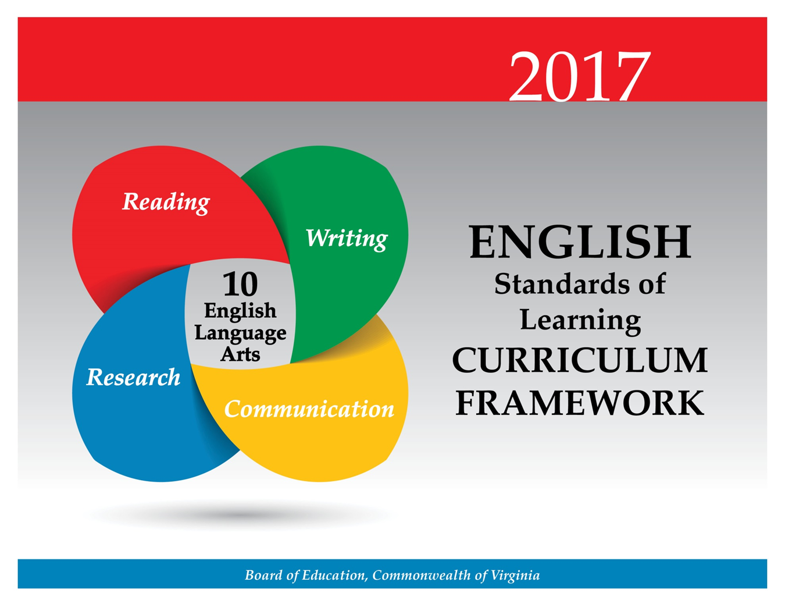

Students will create media messages and analyze the cause-and-effect relationships between mass media coverage and public opinion trends. Students will continue to use multimodal tools to create presentations both independently and in small groups. Tenth-grade students will continue to become skilled communicators, working both independently and in collaborative groups while presenting alternate views and working toward common goals. Teachers will emphasize the importance of effective interpersonal communication and collaboration skills that are essential for success in future postsecondary education and workplace environments.

Teacher Notes
- Please note presentation skills may differ within classrooms.
- Teachers should provide opportunities for students to create interactive, multimodal presentations.
- Teachers should provide opportunities for small-group analysis and self-analysis of the effectiveness of communication.
- Teachers should provide opportunities for students to collaborate to solve problems.
- Teachers should note that the communication strand should be integrated with the reading, writing, and research strands throughout the year.
- Multimodal is the strategic use of two or more interdependent modes of communication where both/all modes are essential to convey the intended message (e.g., graphics, written language, moving images, music, audio, presentation technologies, movement).

10.1 The student will make planned multimodal, interactive presentations collaboratively and individually.
- Make strategic use of multimodal tools.
- Credit information sources.
- Demonstrate the ability to work effectively with diverse teams, including setting rules and goals for group work, such as coming to informal consensus, taking votes on key issues, and presenting alternate views.
- Assume responsibility for specific group tasks.
- Include all group members and value individual contributions made by each group member.
- Use a variety of strategies to listen actively and speak, using appropriate discussion rules with awareness of verbal and nonverbal cues.
- Respond thoughtfully and tactfully to diverse perspectives, summarizing points of agreement and disagreement.
- Choose vocabulary, language, and tone appropriate to the topic, audience, and purpose.
- Access, critically evaluate, and use information accurately to solve problems.
- Use reflection to evaluate one’s own role and the group process in small-group activities.
- Evaluate a speaker’s point of view, reasoning, use of evidence, rhetoric, and identify any faulty reasoning.
ESSENTIAL UNDERSTANDINGS | ESSENTIAL KNOWLEDGE, SKILLS, AND PROCESSES
All students should  - understand that small-group collaboration exists beyond the classroom and the ability to effectively participate is an essential skill  - understand that verbal and nonverbal techniques are important for effective communication  - understand working effectively with diverse groups includes  - exercising flexibility in making necessary compromises to accomplish a common goal  - defining a team goal and working toward it  - treating all ideas respectfully  - demonstrating respect for others’ ideas by acknowledging differing points of view  - coming to agreement by seeking consensus  - understand the importance of self-reflection in small-group activities. | To be successful with this standard, students are expected to  - assume shared responsibility for collaborative work  - collaborate with peers to set guidelines for group presentations and discussions, set clear goals and deadlines, and define individual roles as needed  - demonstrate active listening through the use of appropriate facial expressions and posture  - engage others in a conversation by posing and responding to questions in a group situation  - examine and evaluate strengths and weaknesses when participating in small-group presentations  - evaluate the overall effectiveness of a group’s preparation and presentation  - make compromises to accomplish a common goal(s) and reach consensus  - evaluate the content of presentation(s), including introduction, organization, strengths/weaknesses in evidence and reasoning, and conclusion.

10.2 The student will examine, analyze, and produce media messages.
- Create media messages for diverse audiences.
- Credit information sources.
- Evaluate sources for relationships between intent, factual content, and opinion.
- Analyze the impact of selected media formats on meaning.
- Analyze the purpose of information and persuasive techniques used in diverse media formats.
- Evaluate the motives (e.g., social, commercial, political) behind media presentation(s).
- Describe possible cause-and-effect relationships between mass media coverage and public opinion trends.
- Monitor, analyze, and use multiple streams of simultaneous information.
- Demonstrate ethical use of the Internet when evaluating or producing creative or informational media messages.
ESSENTIAL UNDERSTANDINGS | ESSENTIAL KNOWLEDGE, SKILLS, AND PROCESSES
All students should  - recognize that media messages express a viewpoint and contain values  - understand that there is a relationship between the author’s intent, the factual content, and opinion expressed in media messages  - comprehend how the purposeful use of persuasive language and word connotations convey viewpoint and bias  - understand the difference between objectivity (fact) and subjectivity (bias) in media messages  - understand how special effects are employed in media messages to persuade viewers  - recognize that each media message is constructed and that, to understand the whole meaning of the message, it must be deconstructed. | To be successful with this standard, students are expected to  - identify and analyze the sources and viewpoint of publications including advertisements, editorials, blogs, and websites.  - analyze, compare, and contrast visual and verbal media messages for content (word choice and choice of information), intent (persuasive techniques), impact (public opinion trends), and effectiveness (effect on the audience).  - determine the author’s purpose, factual content, opinion, and/or possible bias as presented in media messages.  - recognize that persuasive techniques are used to convince viewers to make decisions, change their minds, take a stand on an issue, or predict a certain outcome, including, but not limited to,  - ad hominem  - red herring  - straw man  - begging the question  - testimonial  - ethical appeal  - emotional appeal and logical appeal  - avoid plagiarism by giving credit whenever using another person’s media, facts, statistics, graphics, images, music and sounds, quotations, or paraphrases of another person’s words  - analyze media to determine the cause-and-effect relationship(s) between media coverage and public opinion trends.

Students will continue development of vocabulary, with attention to connotations, idioms, classical allusions, and figurative language. There is a sustained emphasis on reading comprehension by comparing fiction and nonfiction texts. Students will analyze the cultural and social function and universal themes of fictional texts from different cultures. Tenth-grade students will analyze and synthesize information from nonfiction texts to solve problems, answer questions, and generate new knowledge. These critical-thinking skills are foundational to technical reading and writing and are transferable across all content areas. *The bodies of literature for grades 10, 11, and 12 are interchangeable and may be taught in any of these grades.*

Teacher Notes
- Teachers should teach a balance of fiction (including poetry) and nonfiction throughout the academic year.
- Nonfiction texts should include informational, persuasive, and technical texts.
- Please note although the strands are developed separately, teachers should seamlessly integrate all strands.
  - Teachers may integrate the strands through the use of thematic units.
  - Teachers should ask students to write about what they have read.
- Vocabulary words should be culled from student reading rather than from prescribed lists and should not be taught in isolation.
  - Although the vocabulary standards in high school remain similar, the words studied should increase in complexity according to a variety of texts read. Vocabulary can also be differentiated according to text and level of student.
  - There is not a specific list of Greek/ Latin roots, or idioms. Teachers may want to consult professional publications.
  - Teachers should provide instruction on classical allusions and how they can impact and deepen the meaning of the text.
- While whole-group instruction can be centered on a shared text, teachers must also provide opportunities for student choice with both fiction and nonfiction texts.
- Although the standard in fiction requires comparing/contrasting details in literary and informational nonfiction texts, teachers should be using paired passages with a variety of texts.
- A list of poetic elements and techniques and literary devices is included in the Essential Knowledge, Skills, and Processes column for English SOL 9.4.
- Teachers should include literary texts that fulfill a social or cultural function depending on the time, location, theme and purpose of the author(s) across texts. For example, Things Fall Apart focuses on the clash of cultures in an African country centered on a prodigal son brought down by hubris.
- Teachers should introduce students to longer, more complex texts both on grade level and above grade level.
- Teachers should have students refer to the text(s) for support.
- Teachers should use fictional and informational texts paired on a common theme or topic and have students compare/contrast.

10.3 The student will apply knowledge of word origins, derivations, and figurative language to extend vocabulary development in authentic texts.
- Use structural analysis of roots, affixes, synonyms, and antonyms to understand complex words.
- Use context, structure, and connotations to determine meanings of words and phrases.
- Discriminate between connotative and denotative meanings and interpret the connotation.
- Explain the meaning of common idioms.
- Explain the meaning of literary and classical allusions and figurative language in text.
- Extend general and cross-curricular vocabulary through speaking, listening, reading, and writing.
ESSENTIAL UNDERSTANDINGS | ESSENTIAL KNOWLEDGE, SKILLS, AND PROCESSES
All students should  - recognize that words have nuances of meaning and that understanding the connotations may be necessary to determine the appropriate meaning  - understand that figurative language enriches text  - understand that word structure aids comprehension of unfamiliar and complex words  - understand that affixes and Greek and Latin roots are clues to determine meanings of words  - understand that context and connotations help determine the meaning of text  - understand that allusions are used to assist readers in providing connections to other works or historical events. | To be successful with this standard, students are expected to  - use roots or affixes to determine or clarify the meaning of words  - demonstrate an understanding of and explain common idioms  - use prior reading knowledge and other sources to identify and explain the meaning of literary and classical allusions  - demonstrate understanding of figurative language and connotations in word meanings.

10.4 The student will read, comprehend, and analyze literary texts of different cultures and eras.
- Make inferences and draw conclusions, using references from the text(s) for support.
- Analyze the similarities and differences of techniques and literary forms represented in the literature of different cultures and eras.
- Interpret the cultural or social function of world and ethnic literature.
- Analyze universal themes prevalent in the literature of different cultures.
- Examine a literary selection from several critical perspectives.
- Critique how authors use key literary elements to contribute to meaning, including character development, theme, conflict, and archetypes.
- Interpret how themes are connected within and across texts.
- Explain the influence of historical context on the form, style, and point of view of a literary text(s).
- Evaluate how an author’s specific word choices, syntax, tone, and voice shape the intended meaning of the text.
- Compare/contrast details in literary and informational nonfiction texts.
- Compare and contrast how literary devices convey a message and elicit a reader’s emotions.
- Compare and contrast character development in a play to characterization in other literary forms.
- Use reading strategies to monitor comprehension throughout the reading process.
ESSENTIAL UNDERSTANDINGS | ESSENTIAL KNOWLEDGE, SKILLS, AND PROCESSES
All students should  - understand that literature is universal and influenced by different cultures and eras  - understand that analysis of a text should be based on textual evidence rather than personal opinion  - understand how dramatic conventions can provide the audience with a deeper understanding of the play  - understand rhyme, rhythm, and sound elements  - understand that writers use techniques and literary devices to evoke emotion in the reader. | To be successful with this standard, students are expected to  - construct meaning from text by making connections between what they already know and the new information they read  - analyze and critique themes across texts and within various social, cultural, and historical contexts  - compare and contrast a variety of literary works from different cultures and eras, including, but not limited to,  - short stories  - poems  - plays  - novels  - essays  - literary nonfiction  - explain similarities and differences among literary genres from different cultures, including, but not limited to,  - sonnets  - myths  - novels  - graphic novels  - short stories  - analyze the different character roles in literary texts (e.g., foil, tragic hero)  - analyze how indirect characterization reveal(s) nuances of character and advances the plot  - analyze universal themes, including, but not limited to,  - struggle with nature  - survival of the fittest  - coming of age  - power of love  - loss of innocence  - struggle with self  - disillusionment with life  - the effects of progress  - power of nature  - alienation and isolation  - honoring the historical past  - good overcoming evil  - tolerance of the atypical  - the great journey  - noble sacrifice  - the great battle  - love and friendship  - revenge  - analyze works of literature for historical information about the period in which they were written  - describe common archetypes that pervade literature including, but not limited to,  - hero/heroine  - trickster  - outsider/outcast  - rugged individualist  - shrew  - vampiric male  - innocent  - caretaker  - rebel  - misfit  - scapegoat  - lonely orphan  - examine a literary selection from several different critical perspectives.  - analyze how an author achieves specific effects and purposes using literary devices and figurative language (e.g., understatement, allusion, allegory, paradox)  - analyze a case in which a point of view requires distinguishing what is directly stated in a text from what is really meant (e.g., satire, irony, understatement)  - analyze a particular point of view or cultural experience reflected in a literary work  - compare and contrast literary devices that convey a poem’s message and elicit a reader’s emotions  - interpret and paraphrase the meanings of selected poems  - identify and describe dramatic conventions  - compare and contrast two or more texts on the same topic or with similar themes  - use evidence from the text(s) for support when drawing conclusions or making inferences  - demonstrate comprehension and apply strategies to write about what is read.

10.5 The student will read, interpret, analyze, and evaluate nonfiction texts.
- Analyze text features and organizational patterns to evaluate the meaning of texts.
- Recognize an author’s intended audience and purpose for writing.
- Skim materials to develop an overview and locate information.
- Compare and contrast informational texts for intent and content.
- Interpret and use data and information in maps, charts, graphs, timelines, tables, and diagrams.
- Draw conclusions and make inferences on explicit and implied information, using textual support as evidence.
- Analyze and synthesize information in order to solve problems, answer questions, and generate new knowledge.
- Analyze ideas within and between selections, providing textual evidence.
- Summarize, paraphrase, and synthesize ideas, while maintaining meaning and a logical sequence of events within and between texts.
- Use reading strategies throughout the reading process to monitor comprehension.
ESSENTIAL UNDERSTANDINGS | ESSENTIAL KNOWLEDGE, SKILLS, AND PROCESSES
All students should  - understand that skilled readers of nonfiction texts and technical documents apply different reading strategies  - understand that informational and technical writing is often non-linear, fragmented, and supported with graphics. | To be successful with this standard, students are expected to  - identify the different formats and purposes of informational and technical texts  - analyze and synthesize information from multiple texts, while maintaining the intended purpose of each original text  - analyze the vocabulary (i.e., content-specific jargon, technical terminology) and ideas of informational texts from various academic disciplines to clarify understandings of concepts  - recognize the non-linear, fragmented, and graphic elements found in informational and technical writing  - analyze two or more texts with conflicting information on the same topic and identify how the texts disagree  - analyze how authors use rhetoric  - identify essential details in complex informational texts  - interpret and analyze information presented in maps, charts, timelines, tables, and diagrams  - make inferences and draw conclusions from complex informational texts  - demonstrate comprehension and apply strategies to write about what is read.

At the 10th grade level, students will continue to develop as readers and writers. Students will use the recursive writing process while writing in a variety of forms with an emphasis on analysis and persuasion. Students will write persuasively and analytically, synthesizing evidence from credible sources, and use organizational patterns to effectively match the intended audience and purpose. Students will be expected to have greater control over the conventions of writing and write and revise to a standard acceptable both in the workplace and postsecondary education.

Teacher Notes
- The focus of writing in 10th grade is persuasion and analysis.
- Teachers should recognize the difference between teaching writing and assigning writing.
- Teachers should recognize that there is not a required number of paragraphs or prescribed structure. Requiring students to use a prescribed model (i.e., five paragraphs) often produces formulaic writing and limits student expression.
- Teachers will model the recursive writing process for students.
- Teachers should reference quality writing in published works as models.
- The focus of writing in 10th grade is persuasion and analysis.
- Teachers will integrate grammar with writing instruction throughout the academic year.
- Teachers will use student writing to teach editing and peer editing skills.
- Teachers will teach students to blend multiple forms of writing and embed narrative techniques.
- Teachers may want to consult professional publications.
- Teachers will instruct students in the features of the three domains of writing:
  - Composing-focusing on a clear, central idea; providing elaboration, organization, and unity
  - Written Expression—sentence variation, selected information, word choice, voice, and tone
  - Usage/Mechanics—grammar, punctuation, and usage as appropriate for the grade level
- Teachers will use writing conferences and portfolios to monitor student progress.
- Teachers will provide the opportunity for students to have practice writing on demand, for shorter time frames, and over extended periods of time.
- Teachers should provide opportunities for student choice with topic, audience, and purpose.

10.6 The student will write in a variety of forms to include persuasive, reflective, interpretive, and analytic, with an emphasis on persuasion and analysis.
- Engage in writing as a recursive process.
- Plan and organize writing to address a specific audience and purpose.
- Adjust writing content, technique, and voice for a variety of audiences and purposes.
- Communicate clearly the purpose of the writing using a thesis statement.
- Objectively introduce and develop topics, incorporating evidence and maintaining an organized structure and a formal style.
- Compose a thesis statement for persuasive writing that advocates a position.
- Clearly state and defend a position using reasons and sufficient evidence from credible sources as support.
- Identify counterclaims and provide counterarguments.
- Show relationships among claims, reasons, and evidence and include a conclusion that follows logically from the information presented.
- Blend multiple forms of writing, including embedding a narrative to produce effective essays.
- Elaborate ideas clearly through word choice.
- Use textual evidence to compare and contrast multiple texts.
- Revise writing for clarity of content, accuracy, and depth of information.
- Write and revise to a standard acceptable both in the workplace and in postsecondary education.
ESSENTIAL UNDERSTANDINGS | ESSENTIAL KNOWLEDGE, SKILLS, AND PROCESSES
All students should  - understand that writing requires a recursive process that includes planning, drafting, revising, editing, and publishing  - understand that writing should be purposefully crafted with attention to deliberate word choice and precise information  - understand the features of the domains of writing, including composing, written expression, and usage/mechanics, are essential to quality writing  - understand that voice and tone must be developed with awareness of audience and purpose. | To be successful with this standard, students are expected to  - demonstrate the purpose of writing as narrative, persuasive, expository, reflective, or analytical  - develop and apply embedded narrative techniques, such as dialogue, description, and pacing to develop experiences or characters and enhance writing  - create a thesis statement that focuses the essay, expresses the writer’s position in an argument, or explains the purpose of the essay  - use effective rhetorical appeals, to establish credibility and persuade intended audience  - use embedded clauses for sentence variety  - write persuasively, organizing reasons logically and effectively  - analyze sources and determine the best information to support a position/argument  - use credible, current research and expert opinions to support a position/argument  - identify counterclaims and use counterarguments that address those claims  - compare/contrast and select evidence from multiple texts to strengthen a position/argument  - use specific revision strategies and adapt content, vocabulary, voice, and tone to audience, purpose, and situation  - revise writing for clarity and quality of information to effectively match the intended audience and purpose of a workplace and/or postsecondary education  - develop ideas deductively and inductively and organize ideas into a logical sequence, applying effective organizational patterns/techniques.

10.7 The student will self- and peer-edit writing for capitalization, punctuation, spelling, sentence structure, paragraphing, and Standard English.
- Use parallel structure across sentences and paragraphs.
- Use complex sentence structure to infuse sentence variety in writing.
- Distinguish between active and passive voice.
- Use colons correctly.
- Analyze the writing of others and suggest how writing might be improved.
ESSENTIAL UNDERSTANDINGS | ESSENTIAL KNOWLEDGE, SKILLS, AND PROCESSES
All students should  - understand that grammatical and syntactical choices convey a writer’s message  - understand that active voice means that the subject of a verb performs the action  - passive voice means that the subject of a verb receives the action  - understand how writers use organization and details to communicate their purposes. | To be successful with this standard, students are expected to  - distinguish between active voice and passive voice to convey a desired effect  - know and apply the rules for the use of a colon  - edit and revise for parallel structure and complex sentences  - use peer- and self-evaluation to edit writing  - proofread and prepare writing for intended audience and purpose  - correct grammatical and usage errors.

At the 10th grade level, students will apply research techniques to analyze information gathered from diverse sources by identifying misconceptions and possible bias. They will evaluate the validity and authenticity of sources, and apply research techniques to quote, summarize, paraphrase, and embed findings. In addition, students will cite sources using either the MLA or APA style sheet and follow ethical and legal guidelines for gathering and using information. Teachers will encourage the development of research skills that are foundational to effective critical thinking and responsible use of information. These skills are necessary for success in future postsecondary education and workplace environments.

Teacher Notes
- Teachers should note that research can be individual, collaborative, cross-curricular, and integrated throughout the year.
- Research products should vary from small informative pieces to large multimodal presentations throughout the academic year.
- Teachers will teach students how to embed information correctly into research products.
- Teachers should use the librarian/media specialist’s expertise in teaching the research process.
- Teachers will make students aware of possible consequences of plagiarism.
- Teachers will emphasize giving credit to all sources used when gathering information, including music, graphics, and another person’s media.
- Teachers will have students demonstrate responsible use of the Internet.

10.8 The student will find, evaluate, and select credible resources to create a research product.
- Verify the accuracy, validity, and usefulness of information.
- Analyze information gathered from diverse sources by identifying misconceptions, main and supporting ideas, conflicting information, and point of view or bias.
- Evaluate and select evidence from a variety of sources to introduce counterclaims and to support claims.
- Cite sources for both quoted and paraphrased ideas using a standard method of documentation, such as that of the Modern Language Association (MLA) or the American Psychological Association (APA).
- Define the meaning and consequences of plagiarism and follow ethical and legal guidelines for gathering and using information.
- Demonstrate ethical use of the Internet.
ESSENTIAL UNDERSTANDINGS | ESSENTIAL KNOWLEDGE, SKILLS, AND PROCESSES
All students should  - understand that using a standard form of documentation legally protects the intellectual property of writers  - understand to avoid plagiarism, credit must be given when using another person’s ideas, opinions, facts, statistics, or graphics  - understand the purposeful and responsible use of the Internet  - understand the importance of evaluating the intent of the author, which may include misinformation, bias, and unsupported assertions  - understand that there are consequences of plagiarism, according to the guidelines established by local school divisions and the law  - understand the ethical issues and responsibility of documentation in research. | To be successful with this standard, students are expected to  - use resources to gather information from various sources by summarizing, paraphrasing, and supporting a thesis, claim, or counterclaim  - organize information and maintain coherence throughout the writing based on the topic, purpose, and audience  - evaluate sources for their credibility, reliability, accuracy, and limitations  - cite primary and secondary sources of information, using the MLA or APA method of documentation for in-text citations and works-cited pages.

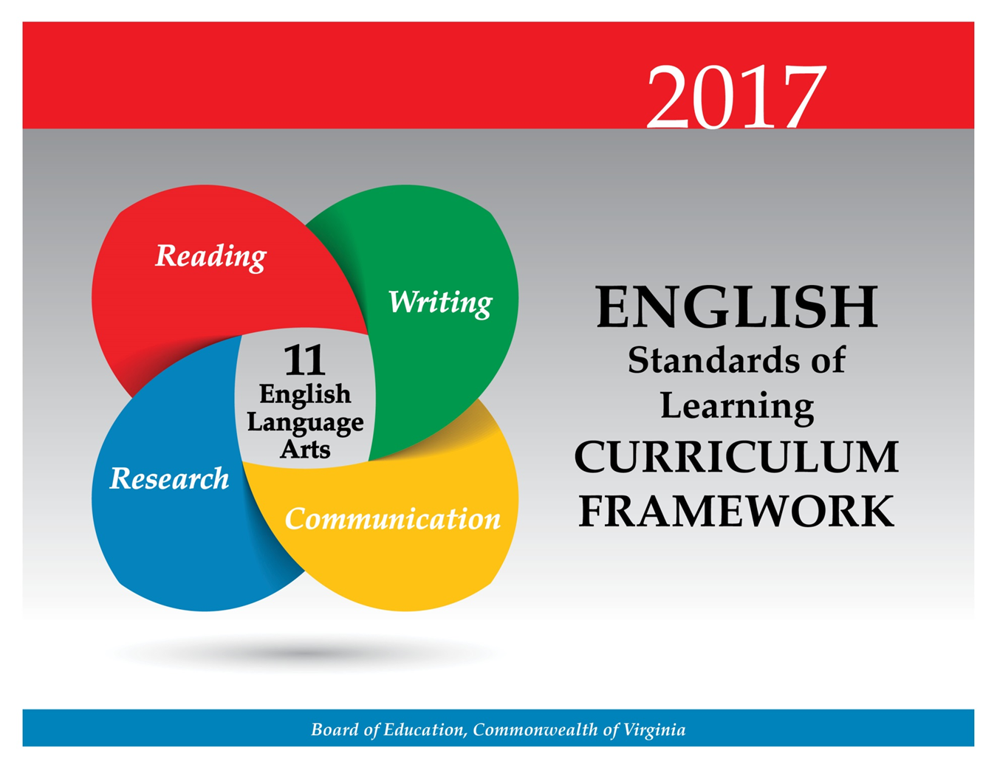

Students will create media messages and analyze the cause-and-effect relationships between mass media coverage and public opinion trends. Students will create persuasive, multimodal presentations that address alternative perspectives. Eleventh-grade students continue to build communication skills, working both independently and in collaborative groups. Students will continue to demonstrate the ability to work within collaborative groups while presenting alternate views and working toward common goals. Teachers will emphasize the importance of effective interpersonal communication and collaboration skills that are essential for success in future postsecondary education and workplace environments.

Teacher Notes
- Please note presentation skills may differ within classrooms.
- Teachers should provide opportunities for students to create interactive, multimodal presentations.
- Teachers should provide opportunities for small-group analysis and self-analysis of the effectiveness of communication.
- Teachers should note that the communication strand should be integrated with the reading, writing, and research strands throughout the year.
- Teachers should provide opportunities for students to collaborate to solve problems.
- Multimodal is the strategic use of two or more interdependent modes of communication where both/all modes are essential to convey the intended message (e.g., graphics, written language, moving images, music, audio, presentation technologies, movement).

11.1 The student will make planned, informative and persuasive, multimodal, interactive presentations, collaboratively and individually.
- Select and effectively use multimodal tools to design and develop presentation content.
- Credit information sources.
- Demonstrate the ability to work collaboratively with diverse teams.
- Respond thoughtfully and tactfully to diverse perspectives, summarizing points of agreement and disagreement.
- Use a variety of strategies to listen actively and speak, using appropriate discussion rules with awareness of verbal and nonverbal cues.
- Anticipate and address alternative or opposing perspectives and counterclaims.
- Evaluate the various techniques used to construct arguments in multimodal presentations.
- Use vocabulary appropriate to the topic, audience, and purpose.
- Evaluate effectiveness of multimodal presentations.
ESSENTIAL UNDERSTANDINGS | ESSENTIAL KNOWLEDGE, SKILLS, AND PROCESSES
All students should  - recognize rhetoric as the art of persuasion and argument  - understand how to evaluate and critique content and delivery of presentations. | To be successful with this standard, students are expected to  - define a position and select evidence to support that position through reading, writing, and discussion  - develop effective multimodal presentations to defend a position or present information  - apply and evaluate persuasive rhetorical devices and techniques  - use effective evidence and presentation skills to convince an audience  - make purposeful language choices based on topic, audience, and situation  - make choices based on predicted audience response  - listen actively by asking clarifying and elaborating questions  - evaluate the use of persuasive techniques, such as  - introduction (for securing interest and establishing unity)  - organization  - proof/support  - logic  - conclusion  - rhetorical devices, including but not limited to:  - call to action  - loaded and elevated language  - rhetorical question  - appeal to emotion  - repetition  - figurative language  - addressing counterclaims  - critique the accuracy, relevance, and organization of evidence  - critique the clarity and effectiveness of delivery.

11.2 The student will examine how values and points of view are included or excluded and how media influences beliefs and behaviors.
- Describe possible cause-and-effect relationships between mass media coverage and public opinion trends.
- Create media messages with a specific point of view.
- Evaluate media sources for relationships between intent and content.
- Analyze the impact of selected media formats on meaning.
- Determine the author’s purpose and intended effect on the audience for media messages.
- Manage, analyze, and synthesize multiple streams of simultaneous information.
- Demonstrate ethical use of the Internet when evaluating or producing creative or informational media messages.
ESSENTIAL UNDERSTANDINGS | ESSENTIAL KNOWLEDGE, SKILLS, AND PROCESSES
All students should  - recognize that media messages express viewpoints and contain values to influence the beliefs and behaviors of the intended audience  - understand the difference between objectivity (fact) and subjectivity (bias) in media messages  - comprehend the purposeful use of persuasive language and how word connotations convey viewpoint and bias. | To be successful with this standard, students are expected to  - evaluate media messages for content, intent, and impact  - analyze and critique how media reach the targeted audience for specific purposes  - analyze media to determine the cause-and-effect relationship(s) between media coverage and public opinion trends  - analyze how the media’s use of symbolism, imagery, and metaphor affects the message  - avoid plagiarism by giving credit whenever using another person’s media, facts, statistics, graphics, images, music and sounds, quotations, or paraphrases of another person’s words.

Students will continue development of vocabulary, with attention to connotations, idioms, classical allusions, and figurative language. In 11th grade, there is a sustained emphasis on reading comprehension of fiction and nonfiction texts. Students will conduct comparative analyses of multiple texts that address the same topic to determine how authors reach similar or different conclusions. Students will examine and analyze fiction texts by American authors describing the contributions of other cultures and identifying prevalent themes and characterizations, which are reflective of American history and culture.
*The bodies of literature for grades 10, 11, and 12 are interchangeable and may be taught in any of these grades.*

Teacher Notes
- Teachers should teach a balance of fiction (including poetry) and nonfiction throughout the academic year.
  - Nonfiction texts should include informational, persuasive, technical texts, and employment documents.
  - Fiction texts should include novels, short stories, poetry, drama, and literary nonfiction which employs the elements of fiction.
- Please note although the strands are developed separately, teachers should seamlessly integrate all strands.
  - Teachers may integrate the strands through the use of thematic units.
  - Teachers should ask students to write about what they have read.
- Vocabulary words should be culled from student reading rather than from prescribed lists and should not be taught in isolation.
  - Although the vocabulary standards in high school remain similar, the word study should increase in complexity according to a variety of texts read. Vocabulary can also be differentiated according to text and level of student.
  - There is not a specific list of Greek/Latin roots, or idioms. Teachers may want to consult professional publications.
  - Teachers should provide instruction on classical allusions and how they can affect and deepen the meaning of the text.
- While whole-group instruction can be centered on a shared text, teachers must also provide opportunities for student choice with both fiction and nonfiction texts.
- Although the standard in fiction requires comparing/contrasting details in literary and informational nonfiction texts, teachers should be using paired passages with a variety of texts.
- Teachers should include literary texts that fulfill a social or cultural function depending on the time, location, theme and purpose of the author(s) across texts. For example, The Grapes of Wrath, which focuses on the plight of migrant farmers, affected the conscience of a nation and helped to change laws.
- Teachers should introduce students to longer, more complex texts both on grade level and above grade level.
- Teachers should have students refer to the text(s) for support.
- Teachers should use fictional and informational texts paired on a common theme or topic and have students compare/contrast.
- Teachers should refer and deepen their understanding of the list of poetic elements and techniques and literary devices included in the Essential Knowledge, Skills, and Processes column for English SOL 9.4.
- Teachers will require analytical and critical-thinking skills to teach the level of skill expected in postsecondary education and the workplace.
11.3 The student will apply knowledge of word origins, derivations, and figurative language to extend vocabulary development in authentic texts.
- Use structural analysis of roots, affixes, synonyms, and antonyms to understand complex words.
- Use context, structure, and connotations to determine meanings of words and phrases.
- Discriminate between connotative and denotative meanings and interpret the connotation.
- Explain the meaning of common idioms.
- Explain the meaning of literary and classical allusions and figurative language in text.
- Extend general and cross-curricular vocabulary through speaking, listening, reading, and writing.
ESSENTIAL UNDERSTANDINGS | ESSENTIAL KNOWLEDGE, SKILLS, AND PROCESSES
All students should  - recognize that words have nuances of meaning and that understanding the connotations and context may be necessary to determine the appropriate meaning  - recognize that figurative language enriches text  - understand that word structure aids comprehension of unfamiliar and complex words  - understand that affixes and Greek and Latin roots are clues to determine meanings of words  - understand that allusions are used to assist readers in providing connections to other works or historical events. | To be successful with this standard, students are expected to  - use roots or affixes to determine or clarify the meaning of words  - demonstrate an understanding of and explain common idioms  - use prior reading knowledge and other sources to identify and explain the meaning of literary and classical allusions  - interpret figures of speech (e.g., paradox) in context and analyze their roles in the text  - analyze the connotation of words with similar denotations  - demonstrate understanding of figurative language and connotations in word meanings.

11.4 The student will read, comprehend, and analyze relationships among American literature, history, and culture.
- Describe contributions of different cultures to the development of American literature.
- Compare and contrast the development of American literature in its historical context.
- Analyze American literature, as it reflects traditional and contemporary themes, motifs, universal characters, and genres.
- Interpret the social or cultural function of American literature.
- Analyze how context and language structures convey an author’s intent and viewpoint.
- Critique how authors use key literary elements to contribute to meaning, including character development, theme, conflict, and archetypes within and across texts.
- Interpret how the sound and imagery of poetry support the subject, mood, and theme and appeal to the reader’s senses.
- Evaluate how specific word choices, syntax, tone, and voice support the author’s purpose.
- Analyze the use of dramatic conventions in American literature.
- Generate and respond logically to literal, inferential, evaluative, synthesizing, and critical-thinking questions about the text(s).
- Compare/contrast literary and informational nonfiction texts.
ESSENTIAL UNDERSTANDINGS | ESSENTIAL KNOWLEDGE, SKILLS, AND PROCESSES
All students should  - understand characteristics and cultures of historical periods and how the literature reflects those characteristics  - recognize and understand universal characters, themes, and motifs in American literature  - understand how an author’s intent is achieved by the use of context and language  - understand dramatic conventions and devices. | To be successful with this standard, students are expected to  - use appropriate reading strategies to approach different genres and reading tasks  - discuss how the subject matter, style, genre, theme, and purpose of literary works often reflect the culture and events of the times in which the works were written  - analyze how connections among motifs, setting, character traits, character development, and plot suggest multiple themes  - analyze and critique themes across texts and within various social, cultural, and historical contexts  - analyze and critique themes and issues within and across texts related to  - religious diversity  - political struggles  - ethnic and cultural mores and traditions  - individual rights, gender equity, and civil rights  - describe and contrast literary movements and representative texts associated with each literary movement, including how two or more texts from the same period treat similar themes or topics  - differentiate archetypes that are common in American literature, including, but not limited to,  - hero/heroine  - trickster  - outsider/outcast  - shrew  - rebel  - misfit  - scapegoat  - analyze major themes in American literature through the perspective of various social, cultural, and historical contexts, including, but not limited to,  - the American Dream  - loss of innocence  - coming of age  - relationship with nature  - alienation and isolation  - rebellion and protest  - analyze texts to identify the author’s viewpoints and beliefs and critique how these relate to larger historical, social, and cultural contexts  - describe how the use of context and language structures conveys an author’s intent and viewpoint  - analyze point of view and distinguish what is directly stated in a text from what is really meant (e.g., satire, irony, sarcasm, understatement)  - use poetic elements to explain, analyze, and evaluate poetry  - compare and contrast the subject matter, theme, form, language, development, and purpose of works of classic poets with those of contemporary poets  - compare how poems of the same form use elements (e.g., sound, figurative language, imagery, symbols, and allusions)differently to convey meaning  - describe the language choices and devices that authors use, including, but not limited to,  - rhetorical question  - sarcasm  - satire  - parallelism  - connotation/denotation  - pun  - irony  - tone  - dialect  - diction  - figurative language  - compare and contrast two or more texts on the same topic or with similar themes  - use evidence from the text(s) for support when drawing conclusions or making inferences  - demonstrate comprehension and apply strategies to write about what is read.

11.5 The student will read, interpret, analyze, and evaluate a variety of nonfiction texts, including employment documents and technical writing.
- Apply information from texts to clarify understanding of concepts.
- Read and correctly interpret an application for employment, workplace documents, or an application for college admission.
- Analyze technical writing for clarity.
- Paraphrase and synthesize ideas within and between texts.
- Draw conclusions and make inferences on explicit and implied information using textual support.
- Analyze multiple texts addressing the same topic to determine how authors reach similar or different conclusions.
- Analyze false premises, claims, counterclaims, and other evidence in persuasive writing.
- Recognize and analyze use of ambiguity, contradiction, paradox, irony, sarcasm, overstatement, and understatement in text.
- Generate and respond logically to literal, inferential, evaluative, synthesizing, and critical-thinking questions about the text(s).
ESSENTIAL UNDERSTANDINGS | ESSENTIAL KNOWLEDGE, SKILLS, AND PROCESSES
All students should  - understand how to analyze informational material  - understand a variety of persuasive techniques and rhetorical devices  - recognize the text structure of informational and technical writing  - understand how format and style in informational text differ from those in narrative and expository text  - understand that skilled readers of nonfiction texts and technical documents apply different reading strategies. | To be successful with this standard, students are expected to  - activate background knowledge to understand handbooks and manuals  - analyze the vocabulary (i.e., content-specific jargon, technical terminology) and ideas of informational texts from various academic disciplines to clarify understandings of concepts  - recognize the non-linear, fragmented, and graphic elements found in informational and technical writing  - analyze and use a variety of persuasive techniques and rhetorical devices, including, but not limited to,  - ethos  - pathos  - logos  - claims/counterclaims  - false premises  - ad hominem arguments  - begging the question  - straw man  - organize and synthesize information from paired texts while maintaining the intended purpose of each  - analyze how authors use persuasive techniques and rhetorical devices to advance their purpose, including, but not limited to,  - ambiguity  - contradiction  - paradox  - irony  - hyperbole  - overstatement and understatement  - identify how authors use rhetorical devices to create ethos, pathos, and logos  - identify different formats and purposes of informational and technical texts  - analyze information from multiple texts to make inferences and draw conclusions  - compare and contrast how complex texts treat the same topics  - provide an objective summary of a text  - analyze how a variety of logical arguments could reach conflicting conclusions  - evaluate the relevance and quality of evidence used to support a claim and address a counterclaim  - analyze and identify false premises that intentionally manipulate audiences  - demonstrate comprehension and apply strategies to write about what is read.

At the 11th-grade level, students will continue to develop as writers using the recursive writing process while writing in a variety of forms with an emphasis on persuasion and argumentation. They will write for multiple purposes and audiences to create focused, organized, and coherent writing. Students will be expected to have greater control over the conventions of writing and write and revise to a standard acceptable both in the workplace and postsecondary education. They will produce arguments in writing that demonstrate knowledgeable judgments and address counterclaims. Students will use knowledge of genres, formats, purposes, audiences, and situations to produce clear and effective products that reflect the application of all stages of the writing process.

Teacher Notes
- Teachers should recognize the difference between teaching writing and assigning writing.
- Teachers should recognize that there is not a required number of paragraphs or prescribed structure. Requiring students to use a prescribed model (i.e., five paragraphs) often produces formulaic writing and limits student expression.
- Teachers should model quality writing through published works and authentic texts.
- The focus of writing in 11th grade is persuasion and argumentation.
- Teachers should demonstrate embedding narrative techniques in multiple forms of writing.
- Teachers may want to consult professional publications.
- Teachers will instruct students in the features of the three domains of writing:
  - Composing-focusing on a clear, central idea; providing elaboration, organization, and unity
  - Written Expression—sentence variation, selected information, word choice, voice, and tone
  - Usage/Mechanics—grammar, punctuation, and usage as appropriate for the grade level
- Teachers will use writing conferences and portfolios to monitor student progress.
- Teachers will provide the opportunity for students to have practice writing on demand, for shorter time frames, and over extended periods of time.
- Teachers should provide opportunities for student choice with topic, audience, and purpose.

11.6 The student will write in a variety of forms, to include persuasive/argumentative, reflective, interpretive, and analytic, with an emphasis on persuasion/argumentation.
- Apply components of a recursive writing process for multiple purposes to create a focused, organized, and coherent piece of writing to address a specific audience and purpose.
- Produce arguments in writing, developing a thesis that demonstrates knowledgeable judgments, addresses counterclaims, and provides effective conclusions.
- Organize claims, counterclaims, and evidence in a sustained and logical sequence.
- Adapt evidence, vocabulary, voice, and tone to audience, purpose, and situation.
- Use words, phrases, clauses, and varied syntax to create a cohesive argument.
- Blend multiple forms of writing, including embedding narratives to produce effective essays.
- Revise writing for clarity of content, accuracy, and depth of information.
- Write and revise to a standard acceptable both in the workplace and in postsecondary education.
ESSENTIAL UNDERSTANDINGS | ESSENTIAL KNOWLEDGE, SKILLS, AND PROCESSES
All students should  - understand that writing requires a recursive process that includes planning, drafting, revising, editing, and publishing  - understand that writing should be purposefully crafted with attention to deliberate word choice, precise information, and vocabulary  - understand the features of the domains of writing, including composing, written expression, and usage/mechanics are essential to quality writing  - understand that voice and tone must be developed with awareness of audience and purpose  - understand that good writing is improved through revision. | To be successful with this standard, students are expected to  - demonstrate the purpose of writing as persuasive/argumentative, reflective, interpretive, or analytical  - develop and apply embedded narrative techniques, such as dialogue, description, and pacing to develop experiences and enhance writing  - refine the thesis by considering whether the claim is logical and meaningful, and whether it expresses the writer’s position in an argument  - use phrases and clauses for sentence variety  - write persuasively/argumentatively, organizing reasons logically and effectively  - analyze sources and determine the best information to support a position/argument  - use credible, current research and expert opinions to support a position/argument  - identify counterclaims and use counterarguments  - compare/contrast and select evidence from multiple texts to strengthen a position/argument  - revise writing for clarity and quality of information to effectively match the intended audience and purpose of the workplace and/or postsecondary education  - anticipate and address counterevidence, counterclaims, and counterarguments  - use effective rhetorical appeals to establish credibility and persuade the intended audience  - introduce claim(s), acknowledge and distinguish claim(s) from alternate or opposing claims  - assess and strengthen the quality of writing through revision  - use specific revision strategies and adapt content, vocabulary, voice, and tone to audience, purpose, and situation  - select an appropriate audience by analyzing assumptions, values, and background knowledge.

11.7 The student will self- and peer-edit writing for capitalization, punctuation, spelling, sentence structure, paragraphing, and Standard English.
- Use complex sentence structure to infuse sentence variety in writing.
- Use verbals and verbal phrases correctly to achieve sentence conciseness and variety.
- Distinguish between active and passive voice.
ESSENTIAL UNDERSTANDINGS | ESSENTIAL KNOWLEDGE, SKILLS, AND PROCESSES
All students should  - understand verbals and verbal phrases and use them appropriately in writing  - understand that grammatical conventions vary syntax and paragraph structures for a variety of purposes and audiences. | To be successful with this standard, students are expected to  - use verbal phrases correctly in writing  - gerund phrase  - infinitive phrase  - participial phrase  - absolute phrase  - differentiate between active and passive voice  - correctly format in-text citations, including parenthetical references to document evidence  - revise and edit writing for appropriate style and language in informal and formal contexts.

At the 11th-grade level, students will apply research techniques to synthesize information from primary and secondary sources to produce a research product. They will evaluate the validity and authenticity of sources and apply research techniques to quote, summarize, paraphrase, and embed findings. In addition, students will cite sources using either the MLA or APA style sheet and follow ethical and legal guidelines for gathering and using information. Teachers will encourage the development of research skills that are foundational to effective critical thinking and responsible use of information. These skills are necessary for success in future postsecondary education and workplace environments.

Teacher Notes
- Teachers should note that research should be integrated throughout the year and can be individual, collaborative and cross-curricular.
- Research products should vary from small, informative pieces to large, multimodal presentations throughout the academic year.
- Teachers will teach students how to embed information effectively into research products.
- Teachers should collaborate with the librarian/media specialists throughout the research process.
- Teachers will make students aware of possible consequences of plagiarism in postsecondary education and the workplace.
- Teachers will emphasize giving credit to all sources used when gathering information, including music, graphics, and another person’s media.
- Teachers will have students demonstrate responsible use of the Internet.

11.8 The student will analyze, evaluate, synthesize, and organize information from a variety of credible resources to produce a research product.
- Critically evaluate quality, accuracy, and validity of information.
- Make sense of information gathered from diverse sources by identifying misconceptions, main and supporting ideas, conflicting information, point of view, or bias.
- Synthesize relevant information from primary and secondary sources and present it in a logical sequence.
- Cite sources for both quoted and paraphrased ideas using a standard method of documentation, such as that of the Modern Language Association (MLA) or the American Psychological Association (APA).
- Define the meaning and consequences of plagiarism and follow ethical and legal guidelines for gathering and using information.
- Demonstrate ethical use of the Internet.
ESSENTIAL UNDERSTANDINGS | ESSENTIAL KNOWLEDGE, SKILLS, AND PROCESSES
All students should  - understand that using a standard form of documentation legally protects the intellectual property of writers  - understand to avoid plagiarism, credit must be given when using another person’s ideas, opinions, facts, statistics, or graphics  - understand the purposeful and responsible use of the Internet  - understand the importance of evaluating the intent of the author, which may include misinformation, bias, and unsupported assertions  - understand that there are consequences of plagiarism, according to the guidelines established by local school divisions and the law  - understand the ethical issues and responsibility of documentation in research. | To be successful with this standard, students are expected to  - identify and narrow a topic for research and develop a plan to locate and collect relevant information from diverse sources  - use a variety of primary and secondary sources of information  - identify valid main and supporting ideas in various sources and distinguish them from misconceptions and biased points of view when information conflicts  - synthesize information in a logical sequence  - document sources using MLA or APA style, including in-text citation and corresponding works cited list  - incorporate ideas and quotations skillfully by directly quoting, paraphrasing, or summarizing text from reliable sources and citing them appropriately.

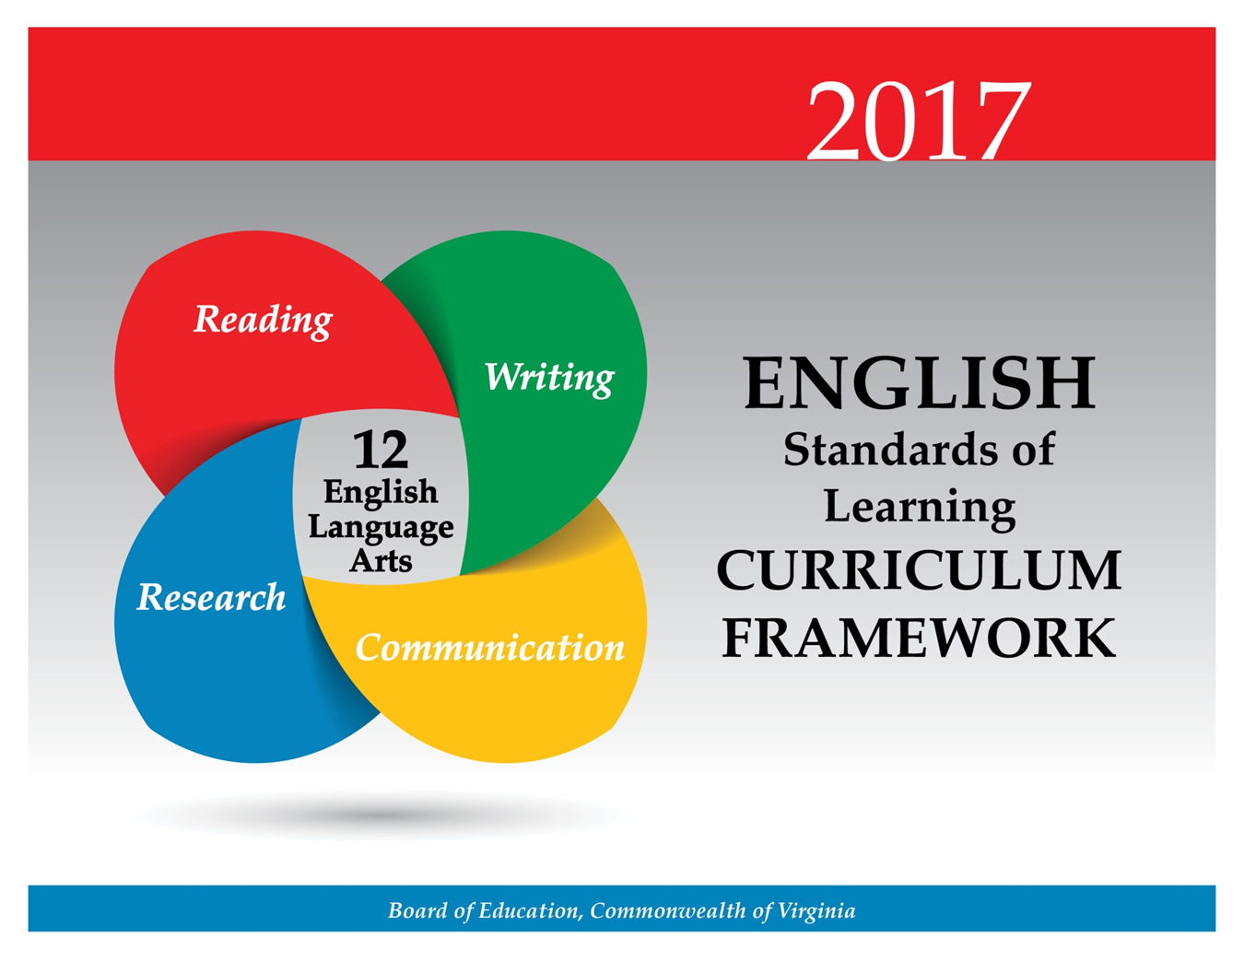

Students will create media messages and analyze the cause-and-effect relationships between mass media coverage and public opinion trends. Students will create persuasive/argumentative, multimodal presentations both independently and in collaborative groups. Students will continue to demonstrate the ability to work within diverse teams and collaborative groups working toward common goals. Teachers will emphasize the importance of effective interpersonal communication and collaboration skills that are essential for success in future postsecondary education and workplace environments.

Teacher Notes
- Please note presentation skills may differ within classrooms.
- Teachers should provide opportunities for students to create interactive, multimodal presentations.
- Teachers should provide opportunities for small-group analysis and self-analysis of the effectiveness of communication.
- Teachers should note that the communication strand should be integrated with the reading, writing, and research strands throughout the year.
- Multimodal is the strategic use of two or more interdependent modes of communication where both/all modes are essential to convey the intended message (e.g., graphics, written language, moving images, music, audio, presentation technologies, movement).

12.1 The student will make planned, persuasive/argumentative, multimodal, interactive presentations collaboratively and individually.
- Select and effectively use multimodal tools to design and develop presentation content.
- Credit information sources.
- Demonstrate the ability to work collaboratively with diverse teams.
- Anticipate and address alternative or opposing perspectives and counterclaims.
- Evaluate the various techniques used to construct arguments in multimodal presentations.
- Use a variety of strategies to listen actively and speak, using appropriate discussion rules with awareness of verbal and nonverbal cues.
- Critique effectiveness of multimodal presentations.
ESSENTIAL UNDERSTANDINGS | ESSENTIAL KNOWLEDGE, SKILLS, AND PROCESSES
All students should  - recognize rhetoric as the art of persuasion  - understand how to evaluate and critique content and delivery of presentations. | To be successful with this standard, students are expected to  - choose appropriate vocabulary, language, and tone for the selected topic, purpose, context, and audience  - examine and evaluate strengths and weaknesses when participating in small-group presentations  - evaluate the overall effectiveness of a group’s preparation and presentation  - make compromises to accomplish a common goal and reach consensus  - evaluate the content of presentation(s), including introduction, organization, strengths/weaknesses in evidence and reasoning, and conclusion  - monitor audience engagement, and adjust delivery accordingly.

12.2 The student will examine how values and points of view are included or excluded and how media influences beliefs and behaviors.
- Describe possible cause-and-effect relationships between mass media coverage and public opinion trends.
- Evaluate media sources for relationships between intent and factual content.
- Evaluate the motives (e.g., social, commercial, political) behind media presentation(s).
- Examine how values and viewpoints are included or excluded and how the media can influence beliefs, behaviors, and interpretations.
- Evaluate sources, including advertisements, editorials, political cartoons, and feature stories for relationships between intent and factual content.
- Manage, analyze, and synthesize multiple streams of simultaneous information.
- Demonstrate ethical use of the Internet when evaluating or producing creative or informational media messages.
ESSENTIAL UNDERSTANDINGS | ESSENTIAL KNOWLEDGE, SKILLS, AND PROCESSES
All students should  - recognize that media messages express points of view and contain values to influence the beliefs and behaviors of the intended audience  - understand the difference between objectivity (fact) and subjectivity (bias) in media messages  - understand the intentional use of persuasive language and word connotations to convey viewpoint and bias. | To be successful with this standard, students are expected to  - organize knowledge and display learning using visual images, text, graphics, and/or music to create media messages with visual, audio, and graphic effects  - evaluate media messages for content, intent, and impact  - analyze and critique how media reaches the targeted audience for specific purposes  - analyze media to determine the cause-and-effect relationship(s) between media coverage and public opinion trends  - analyze how the media’s use of symbolism, imagery, metaphor, and bias affects the message  - avoid plagiarism by giving credit whenever using another person’s media, facts, statistics, graphics, images, music and sounds, quotations, or paraphrases of another person’s words.

Students will continue development of vocabulary, with attention to connotations, idioms, classical allusions, and figurative language. There is a sustained emphasis on reading comprehension of fiction and nonfiction texts. Students will review multiple texts to identify and evaluate resources to make decisions and solve problems. Students will examine and analyze fiction texts by British authors, evaluating how authors use key elements to contribute to meaning and interpreting how themes are connected across texts. *The bodies of literature for grades 10, 11, and 12 are interchangeable and may be taught in any of these grades as determined by the local school division.*

Teacher Notes
- Teachers should teach a balance of fiction (including poetry) and nonfiction throughout the academic year.
- Nonfiction texts should include informational, persuasive, and technical texts, and employment documents.
- Please note although the strands are developed separately, teachers should seamlessly integrate all strands.
  - Teachers may integrate the strands through the use of thematic units.
  - Teachers should have students respond in writing about what they have read, focusing on inferential and evaluative questions about the text(s).
- Vocabulary words should be culled from student reading rather than from prescribed lists and should not be taught in isolation.
- Vocabulary can also be differentiated according to text, and level of student.
  - There is not a specific list of Greek/Latin roots, or idioms. Teachers may want to consult professional publications.
  - Teachers should provide instruction on allusions and how they can impact and deepen the meaning of the text.
- While whole-group instruction can be centered on a shared text, teachers must also provide opportunities for student choice with both fiction and nonfiction texts.
- Although the standard in fiction requires comparing/contrasting details in literary and informational nonfiction texts, teachers should be using paired passages with a variety of texts.
- Teachers should include literary texts that fulfill a social or cultural function depending on the time, location, theme, and purpose of the author(s) across texts. For example, Macbeth focuses on the domineering wife whose ambitions cause the tyranny of her husband and the downfall of a kingdom.
- Teachers should introduce students to longer, more complex texts both on grade level and above grade level.
- Teachers should have students cite the text(s) for support.
- Teachers should use fictional and informational texts paired on a common theme or topic and have students compare/contrast.
- A list of poetic elements and techniques and literary devices is included in the Essential Knowledge, Skills, and Processes column for English SOL 9.4.
- A list of rhetorical and persuasive devices is included in the Essential Knowledge, Skills, and Processes column for English SOL 11.5.
- Teachers will require the use of analytical and critical-thinking skills to teach the level of skill expected in postsecondary education and the workplace.

12.3 The student will apply knowledge of word origins, derivations, and figurative language to extend vocabulary development in authentic texts.
- Use structural analysis of roots, affixes, synonyms, and antonyms, to understand complex words.
- Use context, structure, and connotations to determine meanings of words and phrases.
- Discriminate between connotative and denotative meanings and interpret the connotation.
- Explain the meaning of common idioms and literary and classical allusions in text.
- Extend general and cross-curricular vocabulary through speaking, listening, reading, and writing.
ESSENTIAL UNDERSTANDINGS | ESSENTIAL KNOWLEDGE, SKILLS, AND PROCESSES
All students should  - recognize that words have nuances of meaning and that understanding the connotations may be necessary to determine the appropriate meaning  - recognize how figurative language enriches text  - understand that allusions are used to assist readers in providing connections to other works or historical events. | To be successful with this standard, students are expected to  - use roots or affixes to determine or clarify the meaning of words  - demonstrate an understanding of and explain the use of common idioms  - use prior reading knowledge and other sources to identify and explain the meaning of allusions  - interpret figures of speech (e.g., overstatement, paradox) in context and analyze their role in the text  - analyze positive and negative connotations of words with similar denotations  - demonstrate understanding of figurative language and connotations in word meanings.

12.4 The student will read, comprehend, and analyze the development of British literature and literature of other cultures.
- Compare and contrast the development of British literature in its historical context.
- Analyze how authors use key literary elements to contribute to meaning and interpret how themes are connected across texts.
- Compare/contrast details in literary and informational nonfiction texts.
- Interpret the social and cultural function of British literature.
- Interpret how the sound and imagery of poetry support the subject, mood, and theme, and appeal to the reader’s senses.
- Compare and contrast traditional and contemporary poems from many cultures.
- Evaluate how dramatic conventions contribute to the theme and effect of plays from American, British, and other cultures.
- Use critical thinking to generate and respond logically to literal, inferential, and evaluative questions about the text(s).
ESSENTIAL UNDERSTANDINGS | ESSENTIAL KNOWLEDGE, SKILLS, AND PROCESSES
All students should  - understand characteristics and cultures of historical periods and how the literature reflects those characteristics and cultures  - understand diction affects the tone of literature. | To be successful with this standard, students are expected to  - analyze texts to identify the author’s attitudes, viewpoints, and beliefs and critique how these relate to larger historical, social, and cultural contexts  - recognize major themes and issues related to  - religious diversity  - political struggles  - ethnic and cultural mores and traditions  - individual rights, gender equity, and civil rights  - differentiate between what is directly stated in a text from what is intended or implied because of the use of satire, sarcasm, irony, or understatement  - compare and contrast two or more texts on the same topic or with similar themes  - use evidence from the text(s) for support when drawing conclusions or making inferences  - demonstrate comprehension and apply writing strategies to analyze and reflect on what is read.

12.5 The student will read, interpret, analyze, and evaluate a variety of nonfiction texts.
- Use critical thinking to generate and respond logically to literal, inferential, and evaluative questions about the text(s).
- Identify and synthesize resources to make decisions, complete tasks, and solve specific problems.
- Analyze multiple texts addressing the same topic to determine how authors reach similar or different conclusions.
- Recognize and analyze use of ambiguity, contradiction, paradox, irony, overstatement, and understatement in text.
- Analyze false premises claims, counterclaims, and other evidence in persuasive writing.
ESSENTIAL UNDERSTANDINGS | ESSENTIAL KNOWLEDGE, SKILLS, AND PROCESSES
All students should  - understand that background knowledge may be necessary to understand handbooks and manuals  - understand a variety of persuasive techniques and rhetorical devices  - recognize the text structure of informational and technical writing  - understand how format and style in informational text differ from those in narrative and expository texts  - understand that skilled readers of nonfiction texts and technical documents apply different reading strategies. | To be successful with this standard, students are expected to  - analyze the vocabulary (i.e., content-specific jargon, technical terminology) of informational texts from various academic disciplines to clarify understanding  - analyze how authors use rhetorical devices to create ethos, pathos, and logos  - organize and synthesize information from two texts while maintaining the intended purpose of each original text  - analyze how authors use rhetoric to advance their point of view  - identify different formats and purposes of informational and technical texts  - recognize the non-linear, fragmented, and graphic elements found in informational and technical writing  - demonstrate comprehension and apply strategies to write about what is read  - identify the resources needed to address specific problems and synthesize new information to make decisions and complete tasks such as completing employment, college, and financial applications; compiling résumés; creating portfolios etc.

At the 12th-grade level, students will continue to develop as readers and writers. Students will use the recursive writing process while writing in a variety of forms with an emphasis on persuasion and argumentation. Students will write for multiple purposes and audiences to create focused, organized, and coherent writing. Students will be expected to have greater control over the conventions of writing and write and revise to a standard acceptable both in the workplace and in postsecondary education.

Teacher Notes
- Teachers should recognize the difference between teaching writing and assigning writing.
- Teachers should reference quality writing in published works as models.
- The focus of writing in 12th grade is persuasion and argumentation.
- Teachers will teach students to blend multiple forms of writing and embed narrative techniques.
- Teachers may want to consult professional publications.
- Three examples of reflective writing include the following:
  - Technical— – which includes what worked or did not work and reasons why, problem-solving techniques, and theories that were used or tested
  - Collaborative— – which is centered on team dynamics, how the team worked together and why, and what worked or did not work and reasons why
  - Individual—focused on questions such as, “What did I learn? “How did I learn it?” and “What could I have done better?”
- Teachers will use writing conferences and portfolios to monitor student progress.
- Teachers will provide opportunities for students to write for a variety of circumstances including writing on demand, for shorter time frames, and over extended periods of time.
- Teachers should provide opportunities for student choice with topic, audience, and purpose.

12.6 The student will write in a variety of forms to include persuasive/argumentative reflective, interpretive, and analytic, with an emphasis on persuasion/argumentation.
- Apply components of a recursive writing process for multiple purposes to create a focused, organized, and coherent piece of writing to address a specific audience and purpose.
- Produce arguments in writing that develop a thesis to demonstrate knowledgeable judgments, address counterclaims, and provide effective conclusions.
- Use a variety of rhetorical strategies to clarify and defend a position, organizing claims, counterclaims, and evidence in a sustained and logical sequence.
- Blend multiple forms of writing, including embedding a narrative to produce effective essays.
- Adapt evidence, vocabulary, voice, and tone to audience, purpose, and situation.
- Use words, phrases, clauses, and varied syntax to connect all parts of the argument, creating cohesion from the information presented.
- Revise writing for clarity of content, depth of information, and technique of presentation.
- Write and revise to a standard acceptable both in the workplace and in postsecondary education.
- Write to clearly describe personal qualifications for potential occupational or educational opportunities.
ESSENTIAL UNDERSTANDINGS | ESSENTIAL KNOWLEDGE, SKILLS, AND PROCESSES
All students should  - understand that writing requires a recursive process that includes planning, drafting, revising, editing, and publishing  - understand that effective writing should be purposefully crafted with attention to deliberate word choice, precise information, and vocabulary  - understand the features of the domains of writing, including composing, written expression, and usage/mechanics, are essential to quality writing  - understand that voice and tone must be developed with awareness of audience and purpose. | To be successful with this standard, students are expected to  - demonstrate the craft of writing as persuasive/argumentative, reflective, interpretive, or analytical  - develop and apply embedded narrative techniques, such as dialogue, description, and pacing to develop experiences and enhance writing  - refine the thesis by considering whether the claim is logical, meaningful, and expresses the writer’s position in an argument  - use embedded clauses for sentence variety  - write persuasively/argumentatively, organizing reasons logically and effectively  - analyze sources and determine the best information to support a position/argument  - use credible, current research and expert opinions to support a position/argument  - identify counterclaims and identify counterarguments that address those claims  - compare/contrast and select evidence from multiple texts to strengthen a position/argument  - revise writing for clarity and quality of information to effectively match the intended audience and purpose of a workplace and/or postsecondary education  - anticipate and address counterevidence, counterclaims, and counterarguments  - use effective rhetorical appeals to establish credibility and persuade the intended audience  - develop technical writings (e.g., job description, questionnaire, job application, or business communication) that address clearly identified audiences and have clearly identified purposes  - complete employment forms (e.g. résumé, personal qualifications in a letter of application)  - complete applications, essays, and résumés for college admission  - develop analytical essays that  - examine and evaluate processes/problems and propose solutions  - develop claim(s) and counterclaims thoroughly, supplying the most relevant data and evidence for each while pointing out the strengths and limitations of both  - create cohesion and clarify the relationships between claim(s) and reasons, between reasons and evidence, and between claim(s) and counterclaims  - apply persuasive, rhetorical devices and techniques  - recognize and avoid common logical fallacies or false premises  - assess and strengthen the quality of writing through revision.

12.7 The student will self- and peer-edit writing for Standard English.
- Use complex sentence structure to infuse sentence variety in writing.
- Edit, proofread, and prepare writing for intended audience and purpose.
- Use a style manual, such as that of the Modern Language Association (MLA) or the American Psychological Association (APA), to apply rules for punctuation and formatting of direct quotations.
ESSENTIAL UNDERSTANDINGS | ESSENTIAL KNOWLEDGE, SKILLS, AND PROCESSES
All students should  understand grammatical conventions adjust sentence and paragraph structures for a variety of purposes and audiences. | To be successful with this standard, students are expected to  - use a variety of strategies to evaluate whether the draft is effectively supported and adequately developed  - edit one’s own and others’ work for grammar, style, and tone appropriate to audience, purpose, and context  - apply current MLA or APA style for punctuation conventions and formatting direct quotations, particularly for in-text citation in documented papers.

At the 12th-grade level, students will apply research techniques to synthesize information to produce a research product. They will evaluate the validity and authenticity of sources and apply research techniques to quote, summarize, paraphrase, and embed findings. In addition, students will cite sources using either the MLA or APA style sheet and follow ethical and legal guidelines for gathering and using information. Teachers will encourage the development of research skills that are foundational to effective critical thinking and responsible use of information. These skills are necessary for success in future postsecondary education and workplace environments.

Teacher Notes
- Teachers should note that research should be integrated throughout the year and can be individual, collaborative, and cross-curricular.
- Research products should vary from small informative pieces to large multimodal presentations throughout the academic year.
- Teachers will teach students how to embed information effectively into research products.
- Teachers should use the librarian/media specialist’s assistance in teaching the research process.
- Teachers should instruct students about the various types and possible consequences of plagiarism, including awareness of applicable policies at the postsecondary level and in the workplace.
- Teachers will emphasize giving credit to all sources used when gathering information, including music, graphics, and another person’s media.
- Teachers will make students aware of possible consequences of plagiarism in postsecondary education and the workplace.
- Teachers will have students demonstrate responsible use of the Internet.

12.8 The student will analyze, evaluate, synthesize, and organize information from a variety of credible resources to produce a research product.
- Frame, analyze, and synthesize information to solve problems, answer questions, and generate new knowledge.
- Analyze information gathered from diverse sources by identifying misconceptions, main and supporting ideas, conflicting information, point of view, or bias.
- Critically evaluate the accuracy, quality, and validity of the information.
- Cite sources for both quoted and paraphrased ideas using a standard method of documentation, such as that of the Modern Language Association (MLA) or the American Psychological Association (APA).
- Define the meaning and consequences of plagiarism and follow ethical and legal guidelines for gathering and using information.
- Demonstrate ethical use of the Internet.
ESSENTIAL UNDERSTANDINGS | ESSENTIAL KNOWLEDGE, SKILLS, AND PROCESSES
All students should  - understand that using a standard form of documentation legally protects the intellectual property of writers  - understand to avoid plagiarism, credit must be given when using another person’s ideas, opinions, facts, statistics, or graphics  - understand the purposeful and responsible use of the Internet  - understand the importance of evaluating the intent of the author, which may include misinformation, bias, and unsupported assertions  - understand that there are consequences of plagiarism, according to the guidelines established by local school divisions and the law  - understand the ethical issues and responsibility of documentation in research. | To be successful with this standard, students are expected to  - collect, evaluate, analyze, and synthesize relevant information, using a variety of primary and secondary sources  - evaluate collected information sources by  - determining its validity, accuracy, credibility, reliability, consistency, limitations  - identifying misconceptions, conflicting information, point of view, and/or bias  - formulating a reason/focus to represent findings  - organize information by  - prioritizing and synthesizing information  - summarizing and/or paraphrasing information  - selecting direct quotations  - cite sources of information to avoid plagiarism when paraphrasing, summarizing, quoting, or inserting graphics, using MLA or APA style.

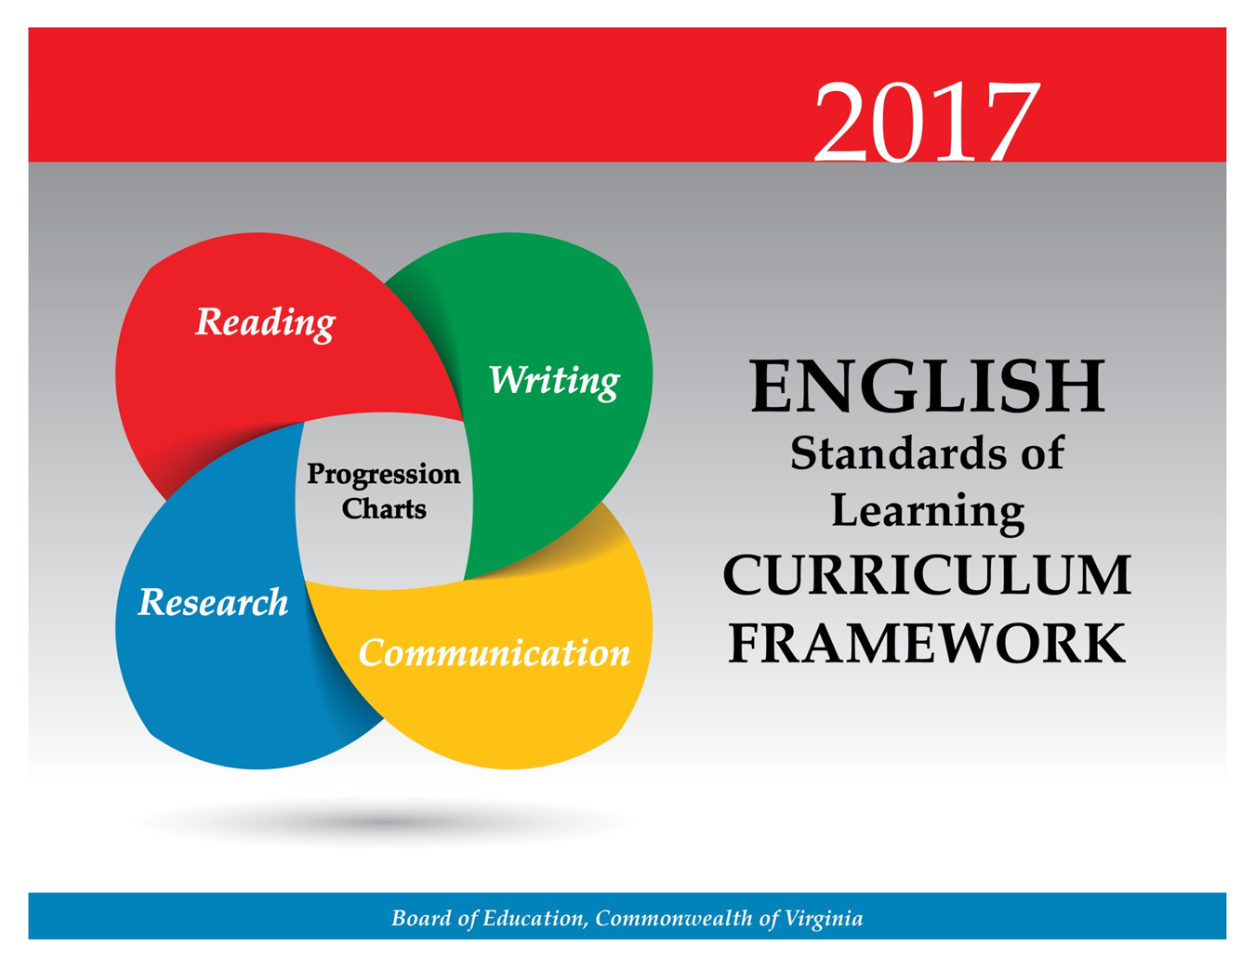

2017 Virginia English Standards of Learning Reading Skills Progression by Grade
Virginia Department of Education—July 2017

Key for Progression Chart
Standard Introduction Level | Symbol
The skill has not been introduced. | -
The skill is introduced and appears in the grade-level reading standards. | I
The skill is not formally introduced in the grade level reading standard. Students should be knowledgeable about the skill from previous instruction. Teachers should review skills taught in previous grades. | P

Progression Chart
Standard | Kindergarten | Grade 1 | Grade 2 | Grade 3 | Grade 4 | Grade 5 | Grade 6 | Grade 7 | Grade 8 | Grade 9 | Grade 10 | Grade 11 | Grade 12
Relate previous experiences to what is read. | I | I | I | P | P | P | P | P | P | P | P | P | P
Identify text features. | I | I | I | I | P | P | P | P | P | P | P | P | P
Set a purpose for reading. | - | I | I | I | P | P | P | P | P | P | P | P | P
Make and confirm predictions. | - | I | I | I | P | P | P | P | P | P | P | P | P
Identify theme. | - | I | I | I | P | P | P | P | P | P | P | P | P
Identify the main idea. | - | I | I | I | P | P | P | P | P | P | P | P | P
Ask and answer questions using the text for support. | - | - | I | I | I | I | P | P | P | P | P | P | P
Describe characters, setting, and plot events in fiction and poetry. | - | - | I | I | I | I | P | P | P | P | P | P | P
Identify the conflict and resolution. | - | - | I | I | I | P | P | P | P | P | P | P | P
Summarize stories and events with beginning, middle, and end in the correct sequence. | - | - | I | I | I | P | P | P | P | P | P | P | P
Draw conclusions based on the text. | - | - | I | I | I | P | P | P | P | P | P | P | P
Make connections between reading selections. | - | - | - | I | I | I | I | P | P | P | P | P | P
Compare and contrast settings, characters, and plot events. | - | - | - | I | I | I | P | P | P | P | P | P | P
Differentiate between fiction and nonfiction. | - | - | - | I | I | P | P | P | P | P | P | P | P
Identify the author’s purpose. | - | - | - | I | I | I | P | P | P | P | P | P | P
Summarize information found in nonfiction texts. | - | - | - | I | I | I | P | P | P | P | P | P | P
Identify supporting details. | - | - | - | I | I | I | P | P | P | P | P | P | P
Describe how the choice of language, setting, and characters contributes to the development of plot. | - | - | - | - | I | I | P | P | P | P | P | P | P
Identify genres. | - | - | - | - | I | I | P | P | P | P | P | P | P
Draw conclusions/make inferences about text using the text as support. | - | - | - | - | I | I | P | P | P | P | P | P | P
Compare/contrast details in literary and informational nonfiction texts. | - | - | - | - | I | I | P | P | P | P | P | P | P
Identify cause-and-effect relationships. | - | - | - | - | I | I | P | P | P | P | P | P | P
Distinguish between fact and opinion. | - | - | - | - | I | I | P | P | P | P | P | P | P
Discuss the impact of setting on plot development. | - | - | - | - | - | I | I | P | P | P | P | P | P
Describe character development. | - | - | - | - | - | I | I | I | P | P | P | P | P
Differentiate between first and third person point of view. | - | - | - | - | - | I | I | I | P | P | P | P | P
Differentiate between free verse and rhymed poetry. | - | - | - | - | - | I | I | P | P | P | P | P | P
Explain how an author’s choice of vocabulary contributes to the author’s style. | - | - | - | - | - | I | I | I | P | P | P | P | P
Skim materials to develop a general overview of content and to locate specific information. | - | - | - | - | - | I | I | I | P | P | P | P | P
Identify organizational pattern(s). | - | - | - | - | - | I | I | I | P | P | P | P | P
Identify transitional words and phrases that signal an author’s organizational pattern. | - | - | - | - | - | I | I | I | P | P | P | P | P
Identify the elements of narrative structure, including setting, character, plot, conflict, and theme. | - | - | - | - | - | - | I | I | I | P | P | P | P
Describe how word choice and imagery contribute to the meaning of a text. | - | - | - | - | - | - | I | I | I | P | P | P | P
Identify and analyze the author’s use of figurative language. | - | - | - | - | - | - | I | I | I | P | P | P | P
Analyze ideas within and between selections providing textual evidence. | - | - | - | - | - | - | I | I | I | I | P | P | P
Describe the elements of narrative structure including setting, character development, plot, theme, and conflict and how they influence each other. | - | - | - | - | - | - | - | I | I | I | P | P | P
Identify the source, viewpoint, and purpose of texts. | - | - | - | - | - | - | - | I | I | I | P | P | P
Explain the use of symbols and figurative language. | - | - | - | - | - | - | - | - | I | I | P | P | P
Compare and contrast the authors’ use of word choice, dialogue, form, rhyme, rhythm, and voice in different texts. | - | - | - | - | - | - | - | - | I | I | P | P | P
Compare and contrast authors’ styles. | - | - | - | - | - | - | - | - | I | I | P | P | P
Analyze details for relevance and accuracy. | - | - | - | - | - | - | - | - | I | I | P | P | P
Identify the characteristics that distinguish literary forms. | - | - | - | - | - | - | - | - | - | I | P | P | P
Analyze the cultural or social function of a literary text. | - | - | - | - | - | - | - | - | - | I | I | P | P
Explain the influence of historical context on the form, style, and point of view of a written work. | - | - | - | - | - | - | - | - | - | I | I | P | P
Identify characteristics of expository, technical, and persuasive texts. | - | - | - | - | - | - | - | - | - | I | I | P | P
Identify a position/argument to be confirmed, disproved, or modified. | - | - | - | - | - | - | - | - | - | I | I | P | P
Evaluate clarity and accuracy of information. | - | - | - | - | - | - | - | - | - | I | I | P | P
Analyze, organize, and synthesize information in order to solve problems, answer questions, complete a task, or create a product. | - | - | - | - | - | - | - | - | - | I | I | P | P
Analyze the similarities and differences of techniques and literary forms represented in the literature of different cultures and eras. | - | - | - | - | - | - | - | - | - | I | I | P | P
Examine a literary selection from several critical perspectives. | - | - | - | - | - | - | - | - | - | - | I | I | P
Compare and contrast character development in a play to characterization in other literary forms. | - | - | - | - | - | - | - | - | - | - | I | I | P
Interpret and use data and information in maps, charts, graphs, timelines, tables, and diagrams. | - | - | - | - | - | - | - | - | - | - | I | I | P
Analyze literature, as it reflects traditional and contemporary themes, motifs, universal characters, and genres. | - | - | - | - | - | - | - | - | - | - | - | I | I
Analyze the use of dramatic conventions. | - | - | - | - | - | - | - | - | - | - | - | I | I
Generate and respond logically to literal, inferential, evaluative, synthesizing, and critical-thinking questions about the text(s). | - | - | - | - | - | - | - | - | - | - | - | I | I
Read and correctly interpret an application for employment, workplace documents, or an application for college admission. | - | - | - | - | - | - | - | - | - | - | - | I | I
Analyze technical writing for clarity. | - | - | - | - | - | - | - | - | - | - | - | I | I
Analyze false premises, claims, counterclaims, and other evidence in persuasive writing. | - | - | - | - | - | - | - | - | - | - | - | I | I
Recognize and analyze use of ambiguity, contradiction, paradox, irony, sarcasm, overstatement, and understatement in text. | - | - | - | - | - | - | - | - | - | - | - | I | I
Identify and synthesize resources to make decisions, complete tasks, and solve specific problems. | - | - | - | - | - | - | - | - | - | - | - | - | I

2017 Virginia English Standards of Learning Writing Skills Progression by Grade
Virginia Department of Education—July 2017

Key for Progression Chart
Standard Introduction Level | Symbol
The skill has not been introduced. | -
The skill is introduced and appears in the grade-level writing standards. | I
The skill is not formally introduced in the grade level writing standard. Students should be knowledgeable about the skill from previous instruction. Teachers should review skills taught in previous grades. | P

Progression Chart
Standard | Kindergarten | Grade 1 | Grade 2 | Grade 3 | Grade 4 | Grade 5 | Grade 6 | Grade 7 | Grade 8 | Grade 9 | Grade 10 | Grade 11 | Grade 12
Differentiate pictures from writing. | I | P Grade 1 | P | P | P | P | P | P | P | P | P | P | P
Generate ideas. | I | I | I | P | P | P | P | P | P | P | P | P | P
Compose simple sentences. | I | I | I | P | P | P | P | P | P | P | P | P | P
Begin each sentence with a capital letter and use ending punctuation. | I | I | I | P | P | P | P | P | P | P | P | P | P
Identify audience and purpose. | - | I | I | I | I | P | P | P | P | P | P | P | P
Use prewriting activities. | - | I | I | I | I | I | I | P | P | P | P | P | P
Focus on one topic. | - | I | I | I | P | P | P | P | P | P | P | P | P
Organize writing to suit purpose. | - | I | I | I | P | P | P | P | P | P | P | P | P
Revise writing by adding description. | - | I | I | I | P | P | P | P | P | P | P | P | P
Write an opinion and give a reason. | - | I | I | I | I | P | P | P | P | P | P | P | P
Engage in the writing process. | - | - | I | I | I | I | P | P | P | P | P | P | P
Use strategies for organization according to writing type. | - | - | I | I | I | I | P | P | P | P | P | P | P
Organize writing to include a beginning, middle and end. | - | - | I | I | P | P | P | P | P | P | P | P | P
Write facts to support the main idea. | - | - | I | I | I | P | P | P | P | P | P | P | P
Revise writing for clarity. | - | - | I | I | I | I | P | P | P | P | P | P | P
Write a clear topic sentence focusing on main idea. | - | - | - | I | I | I | P | P | P | P | P | P | P
Elaborate by adding supporting details. | - | - | - | I | I | I | P | P | P | P | P | P | P
Use transition words for sentence variety. | - | - | - | I | I | I | P | P | P | P | P | P | P
Give fact based support for opinions. | - | - | - | I | I | I | P | P | P | P | P | P | P
Write a paragraph focusing on a main idea. | - | - | - | I | I | I | P | P | P | P | P | P | P
Select audience and purpose. | - | - | - | - | I | I | P | P | P | P | P | P | P
Narrow the topic. | - | - | - | - | I | I | P | P | P | P | P | P | P
Recognize different forms of writing have different patterns of organization. | - | - | - | - | I | I | P | P | P | P | P | P | P
Write related paragraphs on the same topic. | - | - | - | - | I | I | P | P | P | P | P | P | P
Utilize elements of style, including word choice and sentence variation. | - | - | - | - | I | I | I | P | P | P | P | P | P
Clearly state a position including reasons and evidence to persuade the intended audience. | - | - | - | - | - | I | I | I | P | P | P | P | P
Write multiparagraph compositions. | - | - | - | - | I | I | P | P | P | P | P | P | P
Use precise and descriptive vocabulary to create voice and tone. | - | - | - | - | - | I | I | P | P | P | P | P | P
Compose thesis statements for expository and persuasive writing. | - | - | - | - | - | - | I | I | I | P | P | P | P
Select vocabulary and information to enhance central idea, tone, and voice. | - | - | - | - | - | - | I | I | I | P | P | P | P
Expand and embed ideas by using modifiers, standard coordination, and subordination in complete sentences. | - | - | - | - | - | - | I | I | I | P | P | P | P
Use transition words and phrases within and between paragraphs | - | - | - | - | - | - | - | I | I | I | I | P | P
Distinguish between fact and opinion to support a position. | - | - | - | - | - | - | - | I | I | P | P | P | P
Develop and modify the central idea, tone and voice to fit the audience and purpose. | - | - | - | - | - | - | - | I | I | I | P | P | P
Use clauses and phrases for sentence variety. | - | - | - | - | - | - | - | I | I | P | P | P | P
Clearly state and defend a position with reasons and evidence from credible sources. | - | - | - | - | - | - | - | I | I | I | I | P | P
Identify a counter-claim and provide a counter-argument. | - | - | - | - | - | - | - | - | I | I | I | P | P
Blend multiple forms of writing including embedding a narrative. | - | - | - | - | - | - | - | - | - | I | I | P | P
Use textual evidence to compare and contrast multiple texts. | - | - | - | - | - | - | - | - | - | I | I | P | P
Arrange paragraphs in a logical progression using transitions between paragraphs and ideas. | - | - | - | - | - | - | - | - | - | I | I | P | P
Adjust writing content, technique, and voice for a variety of audiences and purposes. | - | - | - | - | - | - | - | - | - | - | I | P | P
Show relationships between claims, reasons and evidence and include a conclusion that follows logically from the information presented.- | - | - | - | - | - | - | - | - | - | - | I | P | P
Write and revise correspondence to a standard acceptable both in the workplace and in postsecondary education. | - | - | - | - | - | - | - | - | - | - | I | I | I
Apply components of a recursive writing process for multiple purposes to create a focused, organized, and coherent piece of writing to address a specific audience and purpose. | - | - | - | - | - | - | - | - | - | - | - | I | I
Produce arguments in writing developing a thesis that demonstrates knowledgeable judgments, addresses counterclaims, and provides effective conclusions. | - | - | - | - | - | - | - | - | - | - | - | I | I
Use a variety of rhetorical strategies to accomplish a specific purpose. | - | - | - | - | - | - | - | - | - | - | - | - | I
Use words, phrases, clauses, and varied syntax to connect all parts of the argument creating cohesion from the information presented. | - | - | - | - | - | - | - | - | - | - | - | - | I
Write to clearly describe personal qualifications for potential occupational or educational opportunities. | - | - | - | - | - | - | - | - | - | - | - | - | I

2017 Virginia English Standards of Learning Grammar Skills Progression by Grade
Virginia Department of Education—July 2017

Key for Progression Chart
Standard Introduction Level | Symbol
The skill has not been introduced. | -
The skill is introduced and appears in the grade-level writing standards. | I
The skill is not formally introduced in the grade level writing standard. Students should be knowledgeable about the skill from previous instruction. Teachers should review skills taught in previous grades. | P

Progression Chart
Standard | Kindergarten | Grade 1 | Grade 2 | Grade 3 | Grade 4 | Grade 5 | Grade 6 | Grade 7 | Grade 8 | Grade 9 | Grade 10 | Grade 11 | Grade 12
Begin each sentence with a capital letter and use ending punctuation. | I | I | I | P | P | P | P | P | P | P | P | P | P
Use complete sentences. | - | I | I | I | P | P | P | P | P | P | P | P | P
Capitalize all proper nouns and the word I. | - | - | I | I | P | P | P | P | P | P | P | P | P
Use singular and plural nouns and pronouns. | - | I | I | I | P | P | P | P | P | P | P | P | P
Use apostrophes in contractions and possessives. | - | - | I | I | I | P | P | P | P | P | P | P | P
Use contractions and singular possessives. | - | - | I | I | I | P | P | P | P | P | P | P | P
Use past and present verb tense. | - | - | I | I | P | P | P | P | P | P | P | P | P
Use commas in a series. | - | - | I | I | P | P | P | P | P | P | P | P | P
Use subject-verb agreement. | - | - | - | I | I | P | P | P | P | P | P | P | P
Use noun-pronoun agreement. | - | - | - | I | P | P | P | P | P | P | P | P | P
Eliminate double negatives. | - | - | - | I | I | I | P | P | P | P | P | P | P
Use quotation marks with dialogue. | - | - | - | I | I | I | P | P | P | P | P | P | P
Use plural possessives. | - | - | - | - | - | I | P | P | P | P | P | P | P
Use adjective and adverb comparisons. | - | - | - | - | - | I | P | P | P | P | P | P | P
Use interjections. | - | - | - | - | - | I | P | P | P | P | P | P | P
Use prepositional phrases. | - | - | - | - | - | I | P | P | P | P | P | P | P
Use commas to indicate interrupters, items in a series, and to indicate direct address. | - | - | - | - | - | I | P | P | P | P | P | P | P
Edit for fragments and run-ons. | - | - | - | - | - | I | P | P | P | P | P | P | P
Use coordinating conjunctions. | - | - | - | - | - | I | P | P | P | P | P | P | P
Use subject-verb agreement with intervening clauses and phrases. | - | - | - | - | - | - | I | I | P | P | P | P | P
Use pronoun-antecedent agreement to include indefinite pronouns. | - | - | - | - | - | - | I | I | P | P | P | P | P
Maintain consistent verb tense across paragraphs. | - | - | - | - | - | - | I | I | I | P | P | P | P
Edit for verb tense consistency and point of view. | - | - | - | - | - | - | - | I | P | P | P | P | P
Use quotation marks with dialogue and direct quotations. | - | - | - | - | - | - | - | I | P | P | P | P | P
Use and punctuate correctly varied sentence structures to include conjunctions and transition words. | - | - | - | - | - | - | - | - | I | P | P | P | P
Correctly use pronouns in prepositional phrases with compound objects. | - | - | - | - | - | - | - | - | I | P | P | P | P
Use comparative and superlative degrees in adverbs and adjectives. | - | - | - | - | - | - | - | - | I | P | P | P | P
Use parallel structures across sentences and paragraphs. | - | - | - | - | - | - | - | - | - | I | P | P | P
Use appositives, main clauses, and subordinate clauses. | - | - | - | - | - | - | - | - | - | - | I | P | P
Use commas and semicolons to distinguish and divide main and subordinate clauses. | - | - | - | - | - | - | - | - | - | - | I | P | P
Distinguish between active and passive voice. | - | - | - | - | - | - | - | - | - | - | I | P | P
Use colons correctly. | - | - | - | - | - | - | - | - | - | - | - | I | P
Use verbals and verbal phrases to achieve sentence conciseness and variety. | - | - | - | - | - | - | - | - | - | - | - | - | I

2017 Virginia English Standards of Learning Research Skills Progression by Grade
Virginia Department of Education—July 2017

Key for Progression Chart
Standard Introduction Level | Symbol
The skill has not been introduced. | -
The skill is introduced and appears in the grade-level research standards. | I
The skill is not formally introduced in the grade level research standard. Students should be knowledgeable about the skill from previous instruction. Teachers should review skills taught in previous grades. | P

Progression Chart
Standard | Kindergarten | Grade 1 | Grade 2 | Grade 3 | Grade 4 | Grade 5 | Grade 6 | Grade 7 | Grade 8 | Grade 9 | Grade 10 | Grade 11 | Grade 12
Generate topics of interest. | I | I | I | P | P | P | P | P | P | P | P | P | P
Generate questions to gather information. | I | I | I | P | P | P | P | P | P | P | P | P | P
Identify pictures, texts, or people as sources of information. | I | I | I | P | P | P | P | P | P | P | P | P | P
Find information from provided sources. | I | I | I | P | P | P | P | P | P | P | P | P | P
Gather and record information. | - | I | I | P | P | P | P | P | P | P | P | P | P
Organize information in writing or a visual display. | - | - | I | I | P | P | P | P | P | P | P | P | P
Create a research product. | - | - | I | I | P | P | P | P | P | P | P | P | P
Describe the difference between plagiarism and using one’s own words. | - | - | I | I | P | P | P | P | P | P | P | P | P
Access appropriate resources. | - | - | - | I | I | I | P | P | P | P | P | P | P
Collect and organize information about the topic. | - | - | - | I | I | P | P | P | P | P | P | P | P
Evaluate the relevance of information. | - | - | - | I | I | I | P | P | P | P | P | P | P
Demonstrate ethical use of the Internet. | - | - | - | I | I | I | I | I | P | P | P | P | P
Collect and organize information from multiple resources. | - | - | - | - | I | I | I | P | P | P | P | P | P
Give credit to sources used in research. | - | - | - | - | I | I | I | P | P | P | P | P | P
Formulate and revise questions about a research topic. | - | - | - | - | - | - | I | I | P | P | P | P | P
Evaluate and analyze the validity and credibility of sources. | - | - | - | - | - | - | I | I | I | P | P | P | P
Cite primary and secondary sources. | - | - | - | - | - | - | I | I | I | P | P | P | P
Avoid plagiarism by using one’s own words and follow ethical and legal guidelines for gathering and using information. | - | - | - | - | - | - | I | I | I | P | P | P | P
Synthesize information from multiple sources. | - | - | - | - | - | - | - | I | I | I | P | P | P
Analyze information gathered from diverse sources by identifying misconceptions, main and supporting ideas, conflicting information, point of view, or bias. | - | - | - | - | - | - | - | - | I | I | I | P | P
Cite sources using Modern Language Association (MLA) or American Psychological Association (APA) style. | - | - | - | - | - | - | - | - | I | I | I | P | P
Quote, summarize, and paraphrased research findings. | - | - | - | - | - | - | - | - | I | I | I | P | P
Publish findings and respond to feedback. | - | - | - | - | - | - | - | - | I | I | I | P | P
Verify the validity and accuracy of all information. | - | - | - | - | - | - | - | - | - | I | I | I | P
Evaluate and select evidence from a variety of sources to support claims and introduce counterclaims. | - | - | - | - | - | - | - | - | - | I | I | I | P
Synthesize relevant information from primary and secondary sources and present it in a logical sequence. | - | - | - | - | - | - | - | - | - | - | - | I | P
Frame, analyze, and synthesize information to solve problems, answer questions, and generate new knowledge. | - | - | - | - | - | - | - | - | - | - | - | - | P

2017 Virginia English Standards of Learning Communication and Multimodal Literacies Progression by Grade
Virginia Department of Education—July 2017

Key for Progression Chart
Standard Introduction Level | Symbol
The skill has not been introduced. | -
The skill is introduced and appears in the grade-level communication standards. | I
The skill is not formally introduced in the grade level communication standard. Students should be knowledgeable about the skill from previous instruction. Teachers should review skills taught in previous grades. | P

Progression Chart
Standard | Kindergarten | Grade 1 | Grade 2 | Grade 3 | Grade 4 | Grade 5 | Grade 6 | Grade 7 | Grade 8 | Grade 9 | Grade 10 | Grade 11 | Grade 12
Listen actively and speak using agreed-upon rules for discussion. | I | I | I | I | I | P | P | P | P | P | P | P | P
Follow implicit rules for conversation, including taking turns and staying on topic. | I | I | P | P | P | P | P | P | P | P | P | P | P
Listen and speak in informal conversations with peers and adults. | I | I | P | P | P | P | P | P | P | P | P | P | P
Discuss various texts and topics collaboratively and with partners. | I | I | I | P | P | P | P | P | P | P | P | P | P
Use voice level, phrasing, and intonation appropriate for various language situations. | I | I | I | P | P | P | P | P | P | P | P | P | P
Ask how and why questions to seek help, get information, or clarify information. | I | I | I | P | P | P | P | P | P | P | P | P | P
Work respectfully with others. | I | I | I | I | P | P | P | P | P | P | P | P | P
Listen and respond to a variety of text and media. | I | I | P | P | P | P | P | P | P | P | P | P | P
Initiate conversation with peers and adults | - | I | P | P | P | P | P | P | P | P | P | P | P
Adapt or change oral language to fit the situation. | - | I | I | I | I | I | I | I | P | P | P | P | P
Use oral language for different purposes: to inform, persuade, entertain, clarify, and respond. | - | - | I | I | I | I | I | I | P | P | P | P | P
Share information orally with appropriate facts and relevant details. | - | - | I | I | P | P | P | P | P | P | P | P | P
Participate as a contributor and leader in collaborative and partner discussions. | - | - | I | I | I | I | P | P | P | P | P | P | P
Create a simple presentation using multimodal tools. | - | - | I | I | I | P | P | P | P | P | P | P | P
Use active listening strategies including but not limited to making eye contact, facing the speaker, asking questions, and summarizing. | - | - | - | I | I | I | P | P | P | P | P | P | P
Orally summarize information expressing ideas clearly. | - | - | - | I | I | I | P | P | P | P | P | P | P
Use language appropriate for context and audience. | - | - | - | I | I | I | P | P | P | P | P | P | P
Organize ideas sequentially or around major points of information using appropriate facts and relevant details. | - | - | - | I | I | I | P | P | P | P | P | P | P
Contribute to group discussions across content areas. | - | - | - | - | I | I | P | P | P | P | P | P | P
Connect comments to the remarks of others. | - | - | - | - | I | I | I | I | P | P | P | P | P
Use specific vocabulary to communicate ideas. | - | - | - | - | I | I | P | P | P | P | P | P | P
Demonstrate the ability to collaborate with diverse teams, while sharing responsibility for the work. | - | - | - | - | I | I | I | P | P | P | P | P | P
Locate, organize, and analyze information from a variety of multimodal texts. | - | - | - | - | I | I | I | I | I | P | P | P | P
Effectively use verbal and nonverbal communication skills to plan and deliver collaborative and individual, formal and informal, interactive presentations. | - | - | - | - | - | - | I | P | P | P | P | P | P
Evaluate group activities. | - | - | - | - | - | - | I | P | P | P | P | P | P
Analyze the effectiveness of participant interactions. | - | - | - | - | - | - | I | I | I | P | P | P | P
Evaluate one’s own contributions to discussions. | - | - | - | - | - | - | I | I | I | P | P | P | P
Give collaborative and individual, formal and informal, interactive presentations. | - | - | - | - | - | - | I | I | I | P | P | P | P
Make statements to communicate agreement or tactful disagreement with others’ ideas. | - | - | - | - | - | - | - | I | I | I | P | P | P
Exhibit willingness to make necessary compromises to accomplish a goal. | - | - | - | - | - | - | - | I | I | I | I | P | P
Collaborate with others to exchange ideas, develop new understandings, make decisions, and solve problems. | - | - | - | - | - | - | - | - | I | I | I | P | P
Select, organize, and create multimodal content that encompasses opposing points of view. | - | - | - | - | - | - | - | - | I | I | I | I | P
Respond to audience questions and comments. | - | - | - | - | - | - | - | - | I | I | P | P | P
Differentiate between Standard English and informal language. | - | - | - | - | - | - | - | - | I | P | P | P | P
Evaluate presentations. | - | - | - | - | - | - | - | - | I | I | I | P | P
Assist with setting rules for group work, including informal consensus, taking votes on key issues, presentation of alternate views, and goal setting. | - | - | - | - | - | - | - | - | - | I | I | I | I
Access, critically evaluate, and use information accurately to solve problems. | - | - | - | - | - | - | - | - | - | - | I | I | I
Evaluate a speaker’s point of view, reasoning, use of evidence, and rhetoric and identify any faulty reasoning. | - | - | - | - | - | - | - | - | - | - | I | I | I
Anticipate and address alternative or opposing perspectives and counterclaims. | - | - | - | - | - | - | - | - | - | - | - | I | I
Evaluate various techniques used to construct arguments in multimodal presentations. | - | - | - | - | - | - | - | - | - | - | - | I | I
Critique effectiveness of multimodal presentations. | - | - | - | - | - | - | - | - | - | - | - | - | I
Media Literacy | - | - | - | - | - | - | - | - | - | - | - | - | -
Differentiate between auditory, visual, and written media messages and their purposes. | - | - | - | - | I | I | P | P | P | P | P | P | P
Compare and contrast how ideas and topics are depicted in a variety of media and formats. | - | - | - | - | I | I | I | I | P | P | P | P | P
Identify the purpose and audience of auditory, visual, and written media messages. | - | - | - | - | - | I | I | I | I | P | P | P | P
Identify the characteristics and effectiveness of a variety of media messages. | - | - | - | - | - | I | I | I | I | P | P | P | P
Interpret information presented in diverse media formats and explain how it contributes to the topic. | - | - | - | - | - | - | I | I | I | P | P | P | P
Craft and publish audience-specific media messages. | - | - | - | - | - | - | I | I | I | P | P | P | P
Identify persuasive/informative techniques used in media. | - | - | - | - | - | - | - | I | I | I | P | P | P
Distinguish between fact and opinion, and between evidence and inference. | - | - | - | - | - | - | - | I | I | P | P | P | P
Describe how word choice, visual images, and sound convey a viewpoint. | - | - | - | - | - | - | - | I | I | P | P | P | P
Examine how values and viewpoints are included or excluded and how the media can influence beliefs, behaviors, and interpretations. | - | - | - | - | - | - | - | - | I | I | P | P | P
Evaluate sources for relationships between intent and factual content. | - | - | - | - | - | - | - | - | I | I | P | P | P
Evaluate the motives (e.g., social, commercial, political) behind media presentation(s). | - | - | - | - | - | - | - | - | I | I | P | P | P
Demonstrate ethical use of the Internet when evaluating or producing creative or informational media messages. | - | - | - | - | - | - | - | - | I | I | P | P | P
Describe possible cause-and-effect relationships between mass media coverage and public opinion trends. | - | - | - | - | - | - | - | - | - | I | I | P | P
Monitor, analyze, and use multiple streams of simultaneous information. | - | - | - | - | - | - | - | - | - | I | I | I | P
Analyze the impact of selected media formats on meaning. | - | - | - | - | - | - | - | - | - | - | I | P | P

