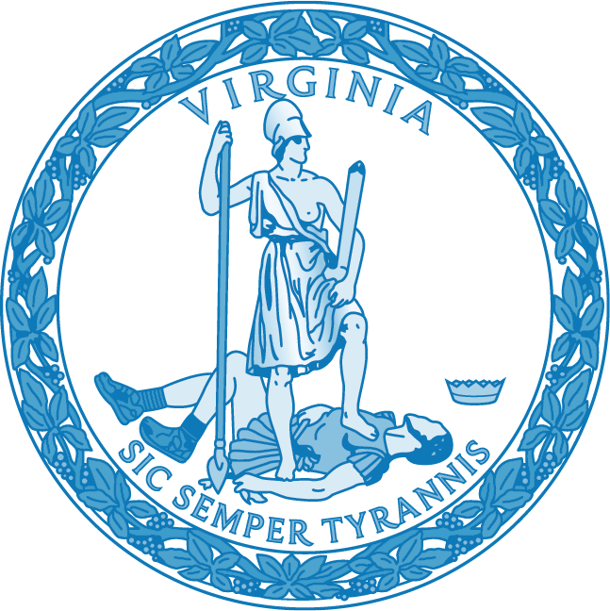

Child Abuse and Neglect Recognition and Intervention Training Curriculum Guidelines

Developed Jointly with the Virginia Department of Social Services

VIRGINIA BOARD OF EDUCATION

Child Abuse and Neglect Recognition and Intervention Training Curriculum Guidelines

The Child Abuse and Neglect Recognition and Intervention Training Curriculum Guidelines were developed in compliance with the Code of Virginia § 22.1-298.1, which requires all persons seeking initial licensure or licensure renewal to complete a study in child abuse recognition and intervention. Such study should address three topics: (a) recognition of child abuse and neglect; (b) reporting child abuse and neglect; and (c) interdisciplinary intervention following a child protective services response.

The guidelines do not prescribe the length or provider of training; rather, the guidelines identify the topic areas that should be addressed. Institutions of higher education, local educational agencies, and other entities employing persons licensed by the Board of Education are free to design and implement the training in any manner, such that the information presented conforms to these guidelines.

Recognizing Child Abuse and Neglect

Goal 1: To become familiar with types of child abuse and neglect (Code of Virginia § 63.2-100)
  - Physical abuse
  - Emotional/mental abuse
  - Sexual abuse
  - Neglect
  - Human trafficking

Goal 2: To be able to recognize physical and behavioral indicators of child abuse and neglect
  - Legal definitions (Code of Virginia § 63.2-100)
  - Operational definitions
  - Child indicators
    - Physical
    - Behavioral
  - Caretaker indicators
  - Abuse and neglect of children with disabilities
    - Risk factors related to the disability
- Reports outside the scope of child abuse and neglect

Reporting Requirements

Goal 3: To be able to identify when it is necessary to report to child protective services
- Mandated report requirements (Code of Virginia § 63.2-1509)
    - Penalty for failure to report
    - Liability for reporting

Goal 4: To understand procedures for reporting to social services
- Reporting procedures
    - Local school division procedures, including use of a designee for each school or division
    - Interagency liaisons
    - Information sharing and confidentiality
- Complaints against school personnel (Code of Virginia §§ 22.1-279.1; 63.2-1511;
63.2-1516.1)

Goal 5: To understand social services’ response to a report
- Mission of child protective services
- Child protective services’ process and authority
    - Parent consent (Code of Virginia § 63.2-1518)
    - Photographs (Code of Virginia § 63.2-1520)
- Types of responses to valid reports: family assessment, investigation
- Human trafficking assessments (Code of Virginia § 63.2-1506.1)
- Types of findings
- Child removal and placement (Code of Virginia § 63.2-1517)
- Information reported back to the reporter

Intervention and Responding to Reports

Goal 6: To understand how to promote resilience in children for mandated reporters
  - Identifying indicators of resilience and assessment of protective factors
  - Trauma-informed approaches to respond to the child who reports being abused or neglected

Goal 7: To become familiar with effective intervention strategies for social services
- Services within a trauma-informed social services system
- Interdisciplinary collaboration with social services (i.e., Systems of Care approach)

Resources

The following resources may be helpful in designing training to assist licensed education personnel in recognizing child abuse and neglect and in fulfilling their legal responsibility to report suspected cases of child abuse.

Legal requirements
- Licensure requirements: Code of Virginia § 22.1-298.1
- Child abuse and neglect: Code of Virginia § 63.2-100
- Mandated reporter requirements: Code of Virginia § 63.2-1509
- Human trafficking: Code of Virginia § 63.2-1506.1
- Complaints against school personnel: Code of Virginia §§ 63.2-1505; 63.2-1511;
63.2-1516.1; 22.1-279.1

Recommended local protocols and procedures
- Superintendent’s Memo 221-20 Local Interagency Agreement for Responding to Reports of Child Abuse and Neglect.

Recognizing child abuse and neglect
- Commonwealth of Virginia Department of Social Services Child Protective Services:
- Recognizing and Reporting Child Abuse and Neglect in Virginia: A Guide for School Employees.
- Commonwealth of Virginia Department of Social Services Child Protective Services:
- A Guide for Mandated Reporters in Recognizing and Reporting Child Abuse and Neglect.

Websites of interest
- Virginia Department of Education: Child Abuse and Neglect
- Virginia Department of Social Services: Child Abuse and Neglect
- Virginia Department of Social Services: Mandated Reporters Training & Resources
- Virginia Commonwealth University’s Partnership for People with Disabilities’ Training on Abuse and Neglect of Children with Disabilities

