Task Overview/Description/Purpose:
- The four bases of a major league baseball field form a square which is 90 feet on each side. A drawing of the field is overlaid on a coordinate grid. The pitching mound is collinear to home plate and second base. The pitching mound is not equidistant from each base. The pitching mound is 60.5 feet from home plate. Students must find and justify using mathematical reasoning the base that is closest to the pitcher’s mound. Students must explain their reasoning.
- The students may use the Pythagorean Theorem, properties of squares, special right triangles or coordinate geometry to justify their reasoning.

Standards Alignment: Strand - Triangles
Primary SOL: G.8 The student will solve
problems, including practical problems, involving right triangles. This will include applying
- the Pythagorean Theorem and its converse;
- properties of special right triangles; and
- trigonometric ratios.
Related SOL (within or across grade levels/courses): G.9, 8.9 (consider using VDOE MVAT)
Learning Intention(s):
- Content (based on Essential Knowledge and Skills) – I am learning how to use right triangle trigonometry to justify and solve problems.
- Language – I am learning how to justify and explain my thinking when using right triangle trigonometry.
- Social – I am learning how to collaborate with my classmates to solve problems, including practical problems, using right triangle trigonometry.
Success Criteria (Evidence of Student Learning):
- I can solve problems, including practical problems, using right triangle trigonometry and properties of special right triangles.
I can solve problems, including practical problems, involving right triangles with missing side lengths or angle measurements, using sine, cosine, and tangent ratios.
- I can solve problems, including practical problems, using the properties specific to parallelograms, rectangles, rhombi, squares, isosceles trapezoids, and trapezoids.
- I can explain my thinking and process for solving right triangle trigonometry problems.
Mathematics Process Goals
Problem Solving | - Students apply the Pythagorean Theorem, special right triangles or properties of a square to determine the distance of diagonals and related information.
Communication and Reasoning | - Students will demonstrate reasoning and justify their solutions and steps with mathematical language that describes their strategy. Students may use DESMOS to place their diagram on the coordinate plane.
Connections and Representations | - Visual (diagram, graph, construction)  - Verbal/Written – Writing their explanation  - Symbolic (algebraic and numeric) - Using the Pythagorean theorem, special right triangles or properties of squares

Task Pre-Planning
Approximate Length/Time Frame: 50 mins
Grouping of Students: First work on the task individually. Next share your solutions with an elbow partner. Finally, as a small group discuss other ways to solve the problem. Students should be given time to independently think through a method of solving the problem for 5 minutes (brainstorming) then given time to work with one partner for the remaining time. Finally conferring with a small group of possible solutions.
Materials and Technology: (e.g., graphic organizers, manipulatives, technology tools, etc.)  - Copy of the Task  - Pencils  - Calculators  - graph paper | Vocabulary: (mathematical vocabulary specific to grade level of the task)  - Pythagorean Theorem  - Hypotenuse  - Collinear  - Equidistant  - Diagonal  - Midpoint distance

Anticipate Responses: See Planning for Mathematical Discourse Chart (Columns 1-3)
Task Implementation (Before)
Task Launch:
Watch this brief video of a baseball game in action where the bases are loaded, and the pitcher is tasked with deciding whether to throw the baseball to the nearest base to win the game. Which base is closest?
- What reading strategies might help students make sense of the task?
Underlining, highlighting, cue words (defining collinear), visual vocabulary word wall bank added to proof chart (collinear, equidistant, midpoint, distance, diagonal of a square, Pythagorean Theorem, square, isosceles triangle, right angle)
- How will students access the prior knowledge and vocabulary needed to understand the task?
VDOE Word Wall Cards displayed. Usage of the definition and properties of a square, isosceles triangle, or right isosceles triangle. Defining the terms: collinear, equidistant, right triangle (legs and hypotenuse). Consider having students share what they notice about a baseball field using those visually supported terms.

Task Implementation (During)
Directions for Supporting Implementation of the Task
- Monitor – Teacher will listen and observe students as they work on task and ask assessing or advancing questions (see chart on next page)
- Select – Teacher will decide which strategies or thinking that will be highlighted (after student task implementation) that will advance mathematical ideas and support student learning
- Sequence – Teacher will decide the order in which student ideas will be highlighted (after student task implementation)
- Connect – Teacher will consider ways to facilitate connections between different student responses
Suggestions For Additional Student Support (possible supports or accommodations for individual student, as needed)
May include, among others:
- Possible use of sentences frames to support student thinking or justifications
  - To determine the length between home base and 2nd base (or the hypotenuse), I….
  - I divided the square (into two right triangles) because…
  - I know the distance between 2nd and 3rd base is ___ because….
If there is a student who has no response or struggling to get started, try these questions
-What does it mean to be if you have a triangle that has two equal sides? (isosceles)
-Where is one point where the distance from first base is equal to the distance from third base? Is that where the pitcher’s mound is located?
-What shapes do you know of that has sides that are the same size length on all sides? (square, rhombus)
- Possible actions to support vocabulary development
-VDOE Word Wall Card, Frayer Model (pre-filled)
- Make word associations clear, e.g. focus on LINE in colLINEar or equal in EQUIdistant. , midpoint as the middle point, etc.
- Possible problem-solving strategies/graphic organizers
- Guess and Check
-Draw a Diagram
-Create a square on the coordinate plane where the coordinates are: finding distance from home to second.
Home Plate (0,0), 1st Base (45√2,45√2), 2nd Base (0,90√2), and 3rd Base (-45√2,45√2).
- For students who may need additional examples to support the skills of working with right triangle trigonometry, include modeled examples. Ask students to notice and wonder about the process of solving those kinds of problems.
Task Implementation (After)
Connecting Student Responses (From Anticipating Student Response Chart) and Closure of the Task:
- Based on the actual student responses, sequence and select particular students to present their mathematical work during class discussion
- Connect different students’ responses and connect the responses to the key mathematical ideas to bring closure to the task
- Consider ways to ensure that each student will have an equitable opportunity to share his/her thinking during task discussion
Teacher Reflection About Student Learning:
- How will student understanding of the content through the use of the process goals be assessed (i.e., task rubric)?
- How will the evidence provided through student work inform further instruction?

Teacher Completes Prior to Task Implementation |  |  | Teacher Completes During Task Implementation
Anticipated Student Response/Strategy  Provide examples of possible correct student responses along with examples of student errors/misconceptions | Assessing Questions – Teacher Stays to Hear Response  Teacher questioning that allows student to explain and clarify thinking | Advancing Questions – Teacher Poses Question and Walks Away  Teacher questioning that moves thinking forward | List of Students Providing Response Who? Which students used this strategy? | Discussion Order - sequencing student responses  - Based on the actual student responses, sequence and select particular students to present their mathematical work during class discussion  - Connect different students’ responses and connect the responses to the key mathematical ideas.  - Consider ways to ensure that each student will have an equitable opportunity to share his/her thinking during task discussion
Anticipated Student Response:  Using the properties of 45-45-90 triangle and subtracting | - What type of triangle was formed?  - What can we conclude about the hypotenuse of a right isosceles triangle? | - What is the length a pitcher would run to from the pitchers’ mound to 1st base?  - What are you planning to do with that information, once you find it out? | Student A
Anticipated Student Response:  Using the Pythagorean Theorem and subtracting | - How did you find the legs of the right triangle?  - Before you calculate that, can you tell us why you'd want to? | - Can you write your reasons for approaching it that way?  - Forget about the question for a second. What's going on in this situation? | Student C
Anticipated Student Response:  Using the properties of squares diagonals are congruent, using the Pythagorean Theorem subtracting. | - What do you know about the diagonals of a square?  - What triangles are formed in a square by its diagonals? | - Would the distance from the pitcher’s mound to first base change if the shape of the baseball field was a rhombus? | Student F
Anticipated Student Response:  Assuming the pitcher’s mound is equidistant to all bases. | - What is the location of the pitcher’s mound?  - Can you read the problem aloud again? | - Did you have a picture in your mind when you read the problem?  - Can you share it with  us so we can see what you saw? | Student B

Name_______________________________ Date________________________
Take Me Out to the Ball Game
The four bases of a major league baseball field form a square which is 90 feet on each side. A drawing of the field is overlaid on a coordinate grid.
- The pitching mound is collinear to home plate and second base.
- The pitching mound is not equidistant from each base.
- The pitching mound is 60.5 feet from home plate.

To which base is the pitcher closest? Mathematically justify your answer and provide a labeled diagram which models the problem and shows all variables to which you will refer.

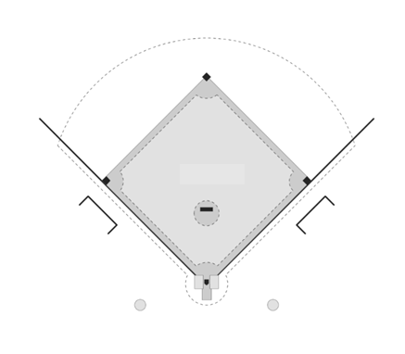
1st Base
Home Base
2nd Base
3rd Base

Rich Mathematical Task Rubric
Mathematical  Understanding | Proficient Plus:  - Uses relationships among mathematical concepts | - Demonstrates an understanding of concepts and skills associated with task  - Applies mathematical concepts and skills which lead to a valid and correct solution | - Demonstrates a partial understanding of concepts and skills associated with task  - Applies mathematical concepts and skills which lead to an incomplete or incorrect solution | - Demonstrates little or no understanding of concepts and skills associated with task  - Applies limited mathematical concepts and skills in an attempt to find a solution or provides no solution
Problem Solving | Proficient Plus:  - Problem solving strategy is efficient | - Problem solving strategy displays an understanding of the underlying mathematical concept  - Produces a solution relevant to the problem and confirms the reasonableness of the solution | - Chooses a problem solving strategy that does not display an understanding of the underlying mathematical concept  - Produces a solution relevant to the problem but does not confirm the reasonableness of the solution | - A problem solving strategy is not evident or is not complete  - Does not produce a solution that is relevant to the problem
Communication  and  Reasoning | Proficient Plus:  - Reasoning is organized and coherent  - Consistent use of precise mathematical language and accurate use of symbolic notation | - Communicates thinking process  - Demonstrates reasoning and/or justifies solution steps  - Supports arguments and claims with evidence  - Uses mathematical language to express ideas with precision | - Reasoning or justification of solution steps is limited or contains misconceptions  - Provides limited or inconsistent evidence to support arguments and claims  - Uses limited mathematical language to partially  communicate thinking with some imprecision | - Provides little to no correct reasoning or justification  - Does not provide evidence to support arguments and claims  - Uses little or no mathematical language to communicate thinking
Representations  and  Connections | Proficient Plus:  - Uses representations to analyze relationships and extend thinking  - Uses mathematical connections to extend the solution to other mathematics or to deepen understanding | - Uses a representation or multiple representations, with accurate labels, to explore and model the problem  - Makes a mathematical connection that is relevant to the context of the problem | - Uses an incomplete or limited representation to model the problem  - Makes a partial mathematical connection or the connection is not relevant to the context of the problem | - Uses no representation or uses a representation that does not model the problem  - Makes no mathematical connections

Task Supporting Documents

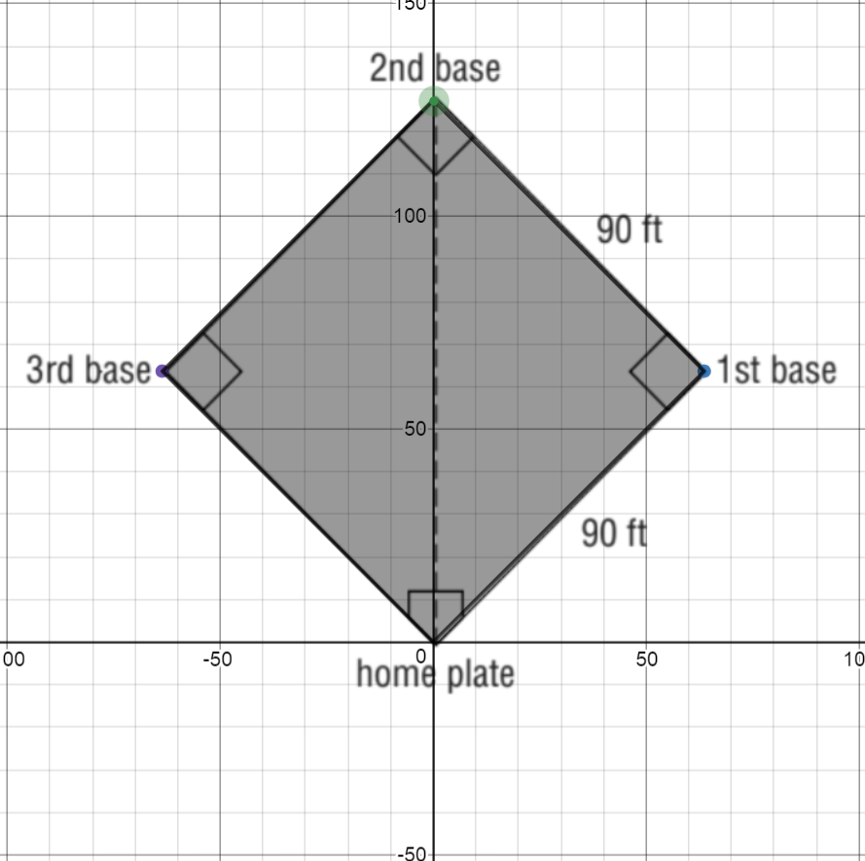
Possible Graphic Organizers

