Task Overview/Description/Purpose:
- A seismometer is an instrument that responds to ground motions, such as caused by earthquakes, volcanic eruptions, and explosions. Seismometers are usually combined with a timing device and a recording device to form a seismograph. After an earthquake, you are given seismograph readings from three locations in Virginia. The students are to determine where the epicenter of the earthquake is located.
- The students may use the equation of a circle, compass tools, DESMOS or coordinate geometry to justify their reasoning.

Standards Alignment: Strand – Polygons and Circles
Primary SOL: G.12 The student will solve problems involving equations of circles.

Related SOL (within or across grade levels/courses): G.8, 8.9

Learning Intentions:
- Content (based on Essential Knowledge and Skills) – I am learning to apply my understanding of equations of circles to analyze a real world problem.
- Language – I am learning to explain my reasoning using geometric language and representations.
- Social – I am justifying my thinking and the validity of my conclusions with my collaborative team.
Success Criteria (Evidence of Student Learning):
- I can identify the coordinates of a point(s) on the circle, given the coordinates of the center and length of the radius of a circle.
- I can determine the equation of a circle given coordinates of the center and a point on the circle or coordinates of the center and the length of the radius or diameter.
Mathematics Process Goals
Problem Solving | Students use an application of the equation of a circle to determine the epicenter of an earthquake. The point where three circles intersect is the epicenter of the earthquake. This technique is called 'triangulation.'
Communication and Reasoning | Students will demonstrate reasoning and justify their solutions and steps with mathematical language that describes their strategy. Students may use DESMOS to place their diagram on the coordinate plane.
Connections and Representations | Visual (diagram, graph, construction)  Verbal/Written – Writing their explanation  Symbolic (algebraic and numeric) – Proper use of the formula and interpreting the information correctly as it relates to the problem.

Task Pre-Planning
Approximate Length/Time Frame: 50 minutes
Grouping of Students:
First, have students work on the task individually. Next ask students to share their solutions with an elbow partner. Finally, create small groups of students to share and discuss other ways to solve the problem. Students should be given time to independently think through a method of solving the problem for 5 minutes (brainstorming) then given time to work with one partner to justify their thinking. Finally students will confer with a small group of students to compare and contrast possible solutions, with the teacher strategically grouping students who have used different methods or representations.
Materials and Technology:  - handheld or Desmos graphing calculators  - pencils  - graph paper  - compass  - Desmos link | Vocabulary:  center  - radius  - diameter  - intersection

Anticipate Responses: See Planning for Mathematical Discourse Chart (Columns 1-3)
Task Implementation (Before)
Task Launch:
A brief video of a National Geographic 101 Earthquake can be shown to detail how earthquake are formed. Scientists use seismographs to locate the epicenter of an earthquake. How Do I Locate That Earthquake's Epicenter?
To figure out just where an earthquake happened, you need to look at your seismogram and you need to know what at least two other seismographs recorded for the same earthquake. You will also need a map of the world, a ruler, a pencil, and a compass for drawing circles on the map. The task simulates a seismologist finding the epicenter of an earthquake in Virginia.

Task Implementation (During)
Directions for Supporting Implementation of the Task
- Monitor – Teacher will listen and observe students as they work on task and ask assessing or advancing questions (see chart on next page)
- Select – Teacher will decide which strategies or thinking that will be highlighted (after student task implementation) that will advance mathematical ideas and support student learning
- Sequence – Teacher will decide the order in which student ideas will be highlighted (after student task implementation)
- Connect – Teacher will consider ways to facilitate connections between different student responses
Suggestions For Additional Student Support
- VDOE Word Wall Cards displayed Pythagorean Theorem, Circle, and Circle Equation
- Possible use of sentences frames to support student thinking
- If there is a student who has no response or struggling to get started, try these questions:
  - Can you read the problem aloud again?
  - Let's go back to the question for a second. Let's refresh our memories about what each of these numbers represents.
  - What's the epicenter being a certain number of units away mean?
  - I'm trying to visualize what's going on in this problem. Can you graph the points? Does that seem possible?
  - Did you have a picture in your mind when you read the problem? Can you share it with
us so we can see what you saw?
- Frayer Model (pre-filled)
- Possible problem solving strategies/graphic organizers
  - Guess and Check
  - Draw a Diagram
  - Students could use the DESMOS link to verify their responses (equations of circles)
Task Implementation (After)
Connecting Student Responses (From Anticipating Student Response Chart) and Closure of the Task:
- Based on the actual student responses, sequence and select particular students to present their mathematical work during class discussion
- Connect different students’ responses and connect the responses to the key mathematical ideas to bring closure to the task
- Consider ways to ensure that each student will have an equitable opportunity to share his/her thinking during task discussion
Teacher Reflection About Student Learning:
- How will student understanding of the content through the use of the process goals be assessed (i.e., task rubric)?
- How will the evidence provided through student work inform further instruction?
- Does vocabulary need further development?
- What was a recurring misconception?
- Are students able to explain their thinking orally or in written form?

Mathematical Task: _________Shake, Rattle, and Roll________________Content Standard(s):_________G.12_______________________
Teacher Completes Prior to Task Implementation |  |  | Teacher Completes During Task Implementation
Anticipated Student Response/Strategy  Provide examples of possible correct student responses along with examples of student errors/misconceptions | Assessing Questions – Teacher Stays to Hear Response  Teacher questioning that allows student to explain and clarify thinking | Advancing Questions – Teacher Poses Question and Walks Away  Teacher questioning that moves thinking forward | List of Students Providing Response Who? Which students used this strategy? | Discussion Order - sequencing student responses  - Based on the actual student responses, sequence and select particular students to present their mathematical work during class discussion  - Consider ways to ensure that each student will have an equitable opportunity to share his/her thinking during task discussion
Anticipated Student Response:  Incorrectly identifies the equation of the circle or does not answer the question | - What is the question asking you to find?  - What do you already know about the problem?  How can you represent this information? | - How can you use this information to check your equation is correct?  - How can you prove that?  - Does that seem reasonable? | Student D
Anticipated Student Response:  Incorrectly identifies the center or confuses the radius with the diameter of the circle | - What shape contains all points in a plane that are equidistant from a given point called the center?  - What is the distance from the center to a point on this shape called?  - Let's refresh our memories about what each of these numbers represents. What does the radius mean? | - You are given readings from three seismographs. At both (2, -5) and (1,2) the epicenter is 5 miles away. At (-2,4) the epicenter is 6 miles away. Where is the epicenter?  - Oh, so you thought about Pythagorean Theorem. Can you tell us how that relates? | Student C
Anticipated Student Response  Trouble starting with the task | - Show students a sample circle drawn on a grid, marked with the coordinates of its center and the coordinates of a point on the circumference. Ask students to figure out the radius of the circle. Relate this to the task. | - Ask students to figure out the coordinates of any x-intercepts or y-intercepts of each circle. | Student E
Anticipated Student Response:  Uses the compass to find the intersection of the three circles incorrectly identifies units | - Using the compass and the coordinate grid, ask students what a unit represents. | - What assumption are you making when you use the compass? | Student C

Name_____________________________________ Date_____________________

A seismometer is an instrument that responds to ground motions, such as caused by earthquakes, volcanic eruptions, and explosions. Seismometers are usually combined with a timing device and a recording device to form a seismograph. After an earthquake, you are given seismograph readings from three locations in Virginia. Your job as a scientist is to determine where the epicenter of the earthquake is located.
- Near Tappahannock at A (2,1), the epicenter is 5 units away.
- Near Farmville at B (-2, -2), the epicenter is 6 units away.
- In Near Harrisonburg at C (-6, 4), the epicenter is 4 units away.
Could a person living in Norfolk, VA feel the effects of the earthquake? Mathematically, justify your answer and provide a labeled diagram which models the problem and shows all variables to which you will refer.
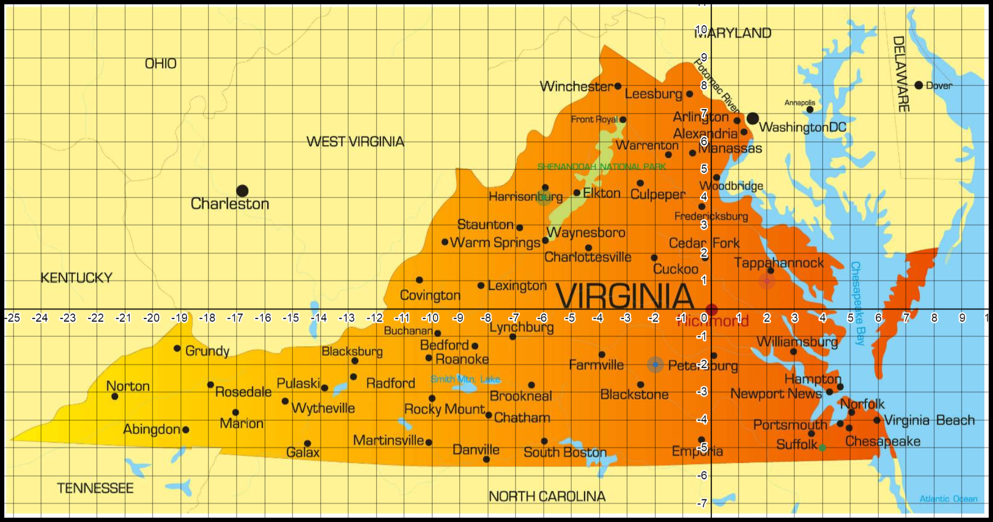
Desmos graphing calculator link
- What are the coordinates of the epicenter?

- People could feel the earthquake up to 9 miles from its epicenter. What equation could represent the circle that encompasses this region?

- Could a person in Norfolk, Virginia (5, -4) feel the effects of the earthquake? Use the equation of a circle created above to justify your answer.

 | Advanced | Proficient | Developing | Emerging
Mathematical  Understanding | Proficient Plus:  - Uses relationships among mathematical concepts | - Demonstrates an understanding of concepts and skills associated with task  - Applies mathematical concepts and skills which lead to a valid and correct solution | - Demonstrates a partial understanding of concepts and skills associated with task  - Applies mathematical concepts and skills which lead to an incomplete or incorrect solution | - Demonstrates little or no understanding of concepts and skills associated with task  - Applies limited mathematical concepts and skills in an attempt to find a solution or provides no solution
Problem Solving | Proficient Plus:  - Problem solving strategy is efficient | - Problem solving strategy displays an understanding of the underlying mathematical concept  - Produces a solution relevant to the problem and confirms the reasonableness of the solution | - Chooses a problem solving strategy that does not display an understanding of the underlying mathematical concept  - Produces a solution relevant to the problem but does not confirm the reasonableness of the solution | - A problem solving strategy is not evident or is not complete  - Does not produce a solution that is relevant to the problem
Communication  and  Reasoning | Proficient Plus:  - Reasoning is organized and coherent  - Consistent use of precise mathematical language and accurate use of symbolic notation | - Communicates thinking process  - Demonstrates reasoning and/or justifies solution steps  - Supports arguments and claims with evidence  - Uses mathematical language to express ideas with precision | - Reasoning or justification of solution steps is limited or contains misconceptions  - Provides limited or inconsistent evidence to support arguments and claims  - Uses limited mathematical language to partially  communicate thinking with some imprecision | - Provides little to no correct reasoning or justification  - Does not provide evidence to support arguments and claims  - Uses little or no mathematical language to communicate thinking
Representations  and  Connections | Proficient Plus:  - Uses representations to analyze relationships and extend thinking  - Uses mathematical connections to extend the solution to other mathematics or to deepen understanding | - Uses a representation or multiple representations, with accurate labels, to explore and model the problem  - Makes a mathematical connection that is relevant to the context of the problem | - Uses an incomplete or limited representation to model the problem  - Makes a partial mathematical connection or the connection is not relevant to the context of the problem | - Uses no representation or uses a representation that does not model the problem  - Makes no mathematical connections

