A seismometer is an instrument that responds to ground motions, such as caused by earthquakes, volcanic eruptions, and explosions. Seismometers are usually combined with a timing device and a recording device to form a seismograph. After an earthquake, you are given seismograph readings from three locations in Virginia. Your job as a scientist is to determine where the epicenter of the earthquake is located.
- Near Tappahannock at A (2,1), the epicenter is 5 units away.
- Near Farmville at B (-2, -2), the epicenter is 6 units away.
- In Near Harrisonburg at C (-6, 4), the epicenter is 4 units away.
Could a person living in Norfolk, VA feel the effects of the earthquake? Mathematically, justify your answer and provide a labeled diagram which models the problem and shows all variables to which you will refer.
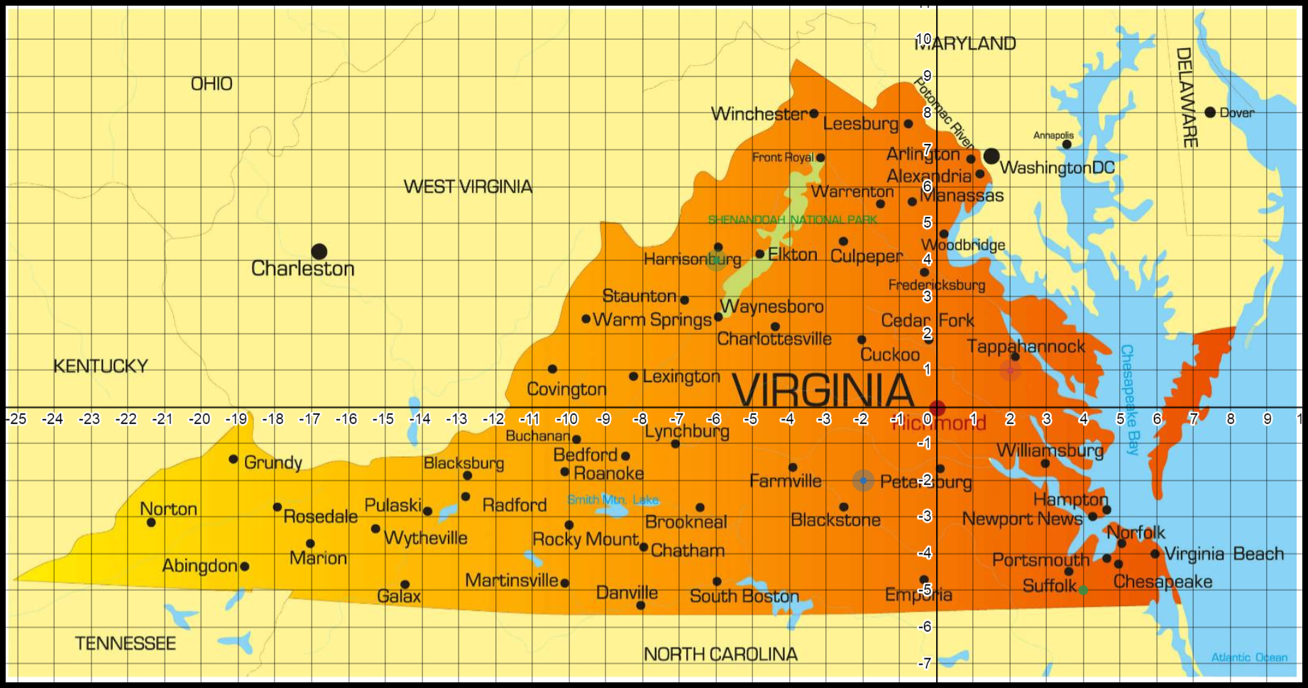
Desmos calculator link
- What are the coordinates of the epicenter?
- People could feel the earthquake up to 9 miles from its epicenter. What equation could represent the circle that encompasses this region?
- Could a person in Norfolk, Virginia (5, -4) feel the effects of the earthquake? Use the equation of a circle created above to justify your answer.

STUDENT A
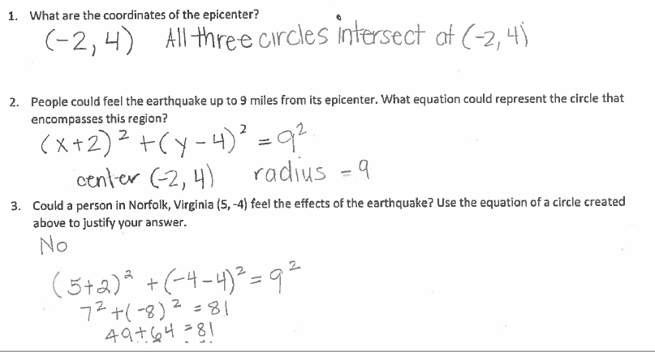
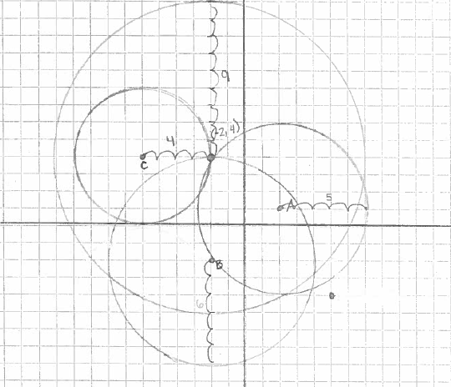

STUDENT B
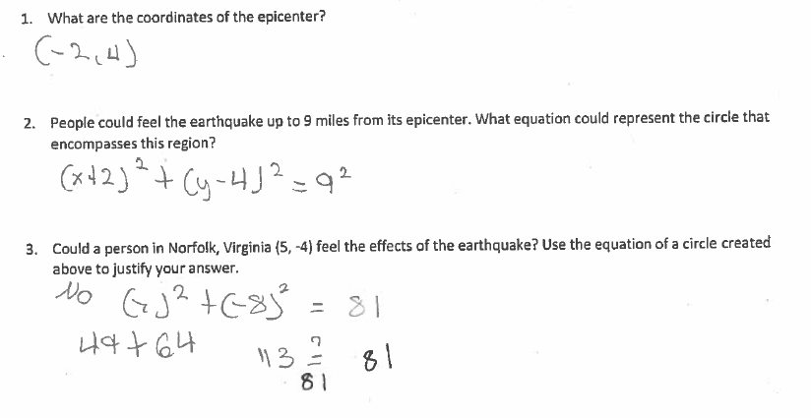
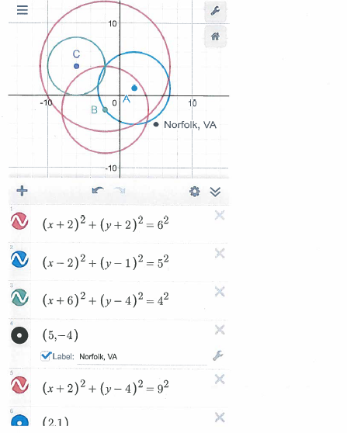

STUDENT C
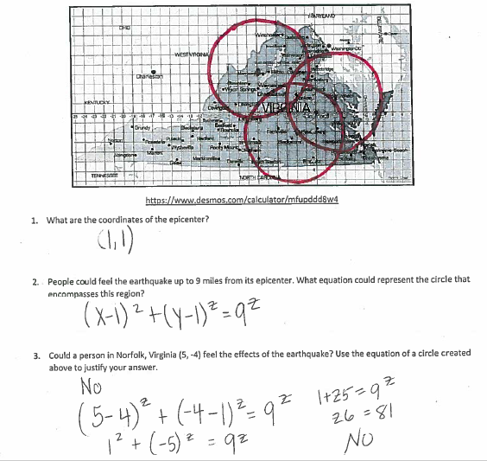

STUDENT D
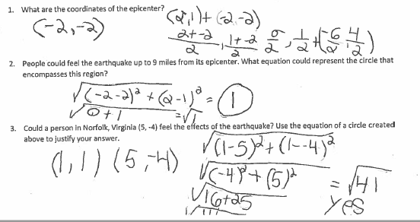

STUDENT E
