Take Me Out to the Ball Game

The four bases of a major league baseball field form a square which is 90 feet on each side. A drawing of the field is overlaid on a coordinate grid.
- The pitching mound is collinear to home plate and second base.
- The pitching mound is not equidistant from each base.
- The pitching mound is 60.5 feet from home plate.

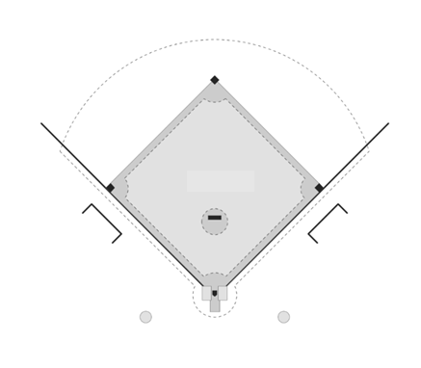To which base is the pitcher closest? Mathematically justify your answer and provide a labeled diagram which models the problem and shows all variables to which you will refer.
1st Base
Home Base
2nd Base
3rd Base

STUDENT A
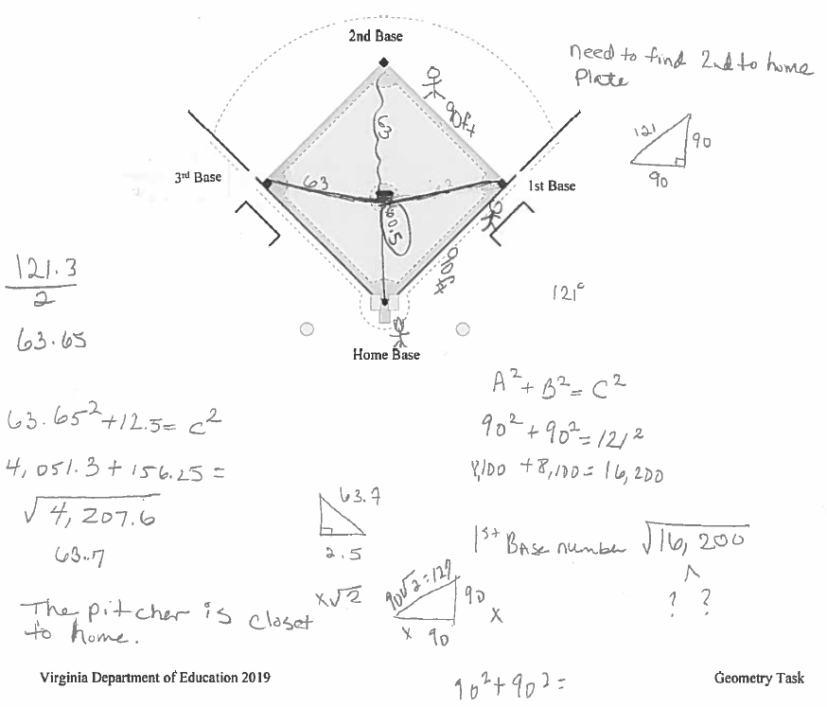
STUDENT B
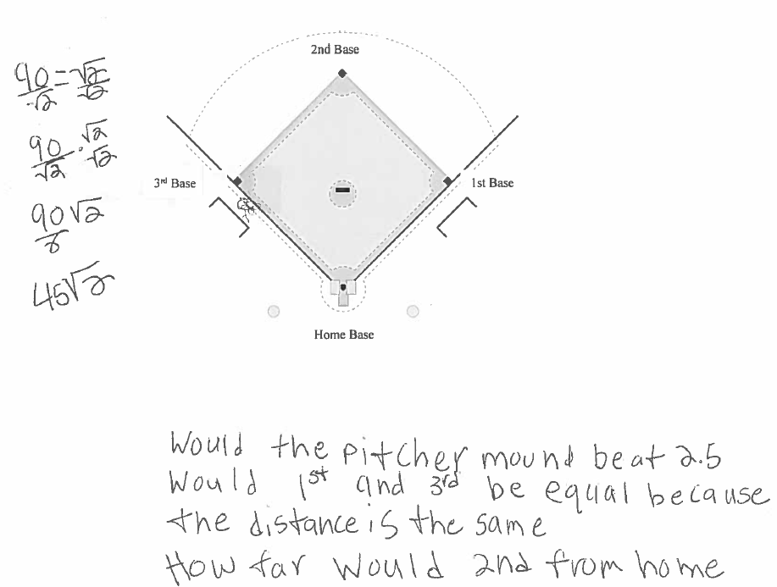
STUDENT C
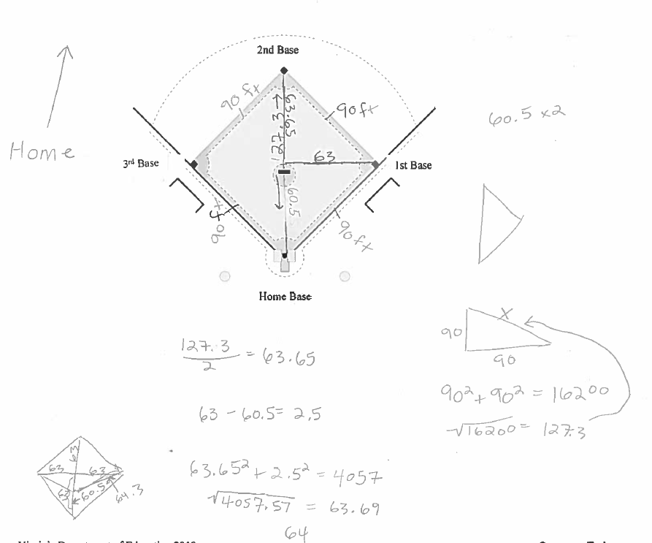
STUDENT D
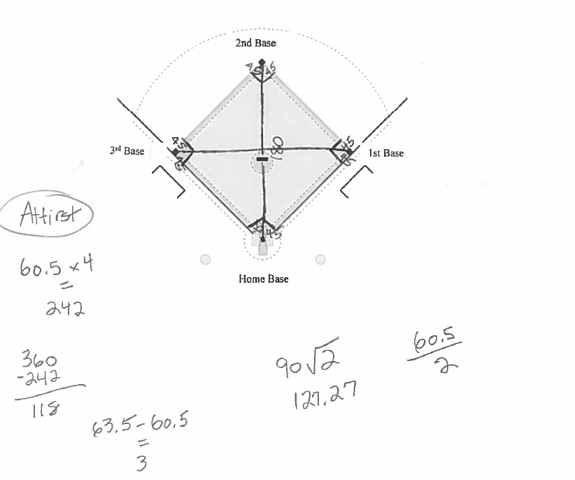
STUDENT E
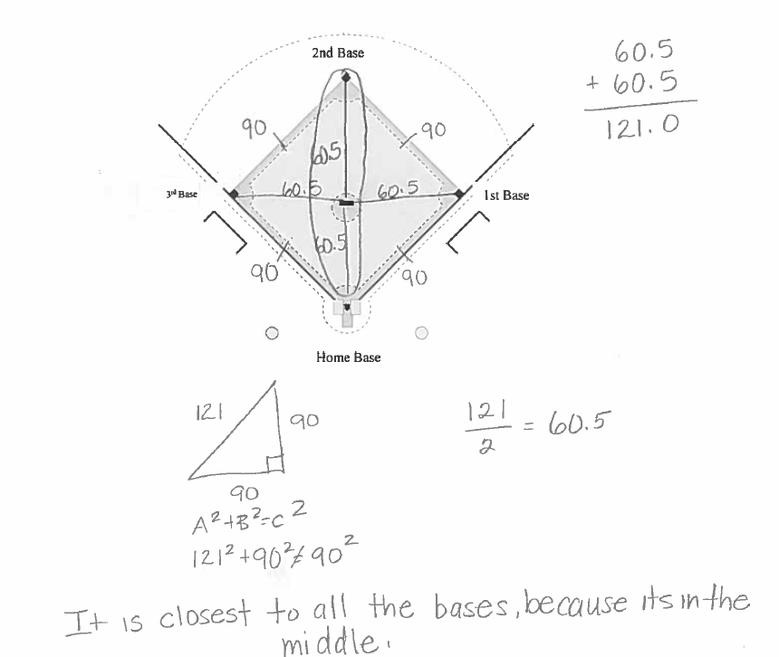
STUDENT F
