Task Overview/Description/Purpose:
- In this task, students will use geometric transformations of their choosing to create a flying path for an airplane.
- The intention of this task is to have students complete it at the end of a unit to assess the student’s understanding of coordinate transformations; specifically translations, reflections, and rotations. In addition to being able to perform these specific transformations, students will need to write the appropriate rule to ensure that transformation happens.

Standards Alignment: Strand – Computation and Estimation
Primary SOL:
G.3 The student will solve problems involving symmetry and transformations. This will include
d) determining whether a figure has been translated, reflected, rotated, or dilated, using coordinate methods.

Related SOL: 7.7, 8.7
Learning Intention(s):
- Content - I am learning to transform an image by translating, reflecting, and rotating it on a coordinate plane in order to create a flying path for an airplane.
- Language - I am learning to explain my thinking using proper mathematical vocabulary and notation.
- Social - I am learning to work with my peers to solve a practical problem.
Success Criteria (Evidence of Student Learning):
- I can translate an image using a specific rule.
- I can write a translation rule using correct geometric notation.
- I can reflect an image over a line.
- I can write the equation of a line of reflection.
- I can rotate an image 90°, 180°, and 270° about the origin.
- I can perform a combination of transformations.
Mathematics Process Goals
Problem Solving | - Students will apply mathematical concepts and skills and the relationships among them and choose an appropriate strategy to solve a problem.
Communication and Reasoning | - Students will explain how they performed their coordinate transformations using proper geometric vocabulary.  - Students will provide work to show how they used their strategy to reach their solution.
Connections and Representations | - Students will provide one or more representations of the situation: drawing, table, and/or graph.

Task Pre-Planning
Approximate Length/Time Frame: 90 - 120 minutes
Grouping of Students:
The intention is to use this task as a summative assessment. Allow students 90 minutes to complete the task independently and then an additional 30 minutes to complete a “Gallery Walk.” For the gallery walk, choose 4-6 different student products for the class to view. During the viewing, for each product, have groups:
- Predict the movements the product creator made (in the correct order)
- Develop the rule the product creator made for each movement
When grouping students, consider:
- Creating heterogeneous groups based formative assessment data
- Consider grouping fluent bilingual students with peers who may struggle with English
Materials and Technology:  - Graph printout with preimage  - White board and markers (to sketch their plan)  - Candle Wax Sticks, Geoboard, or other manipulatives (to allow students to layout their ideas)  - Desmos (to verify their rules) | Vocabulary:  Image  Preimage  Transformation  - Translation  - Reflection  - Rotation  - Rigid Motion  - Origin

Anticipate Responses: See the Planning for Mathematical Discourse Chart (columns 1-3).

Task Implementation (Before) 5-10 minutes
Task Launch:
- Find a quick video of a Blue Angels Airshow to hook students and reference this website:
  - According to https://www.blueangels.navy.mil/faq/, “an estimated 11 million spectators view the squadron airshows each year.”
- Ask students to do a “brain dump” where the write down everything they know about transformations:
  - 2 minutes to write own thoughts
  - 2 minutes to share thoughts with a partner
  - 3 minutes to have a whole group share
- Ensure that students have access to a variety of materials to create their plan.
- Share learning intentions and success criteria with students.
- When students are creating their flying path, allow them to transform their airplane using the specified transformations in any order of their choosing.

Task Implementation (During) 60 - 75 minutes
Directions for Supporting Implementation of the Task
- Monitor – Teacher will listen and observe students as they work on task and ask assessing or advancing questions (see the Planning for Mathematical Discourse chart on next page).
- Select – Teacher will decide which strategies will be highlighted (after student task implementation) that will advance mathematical ideas and support student learning.
- Sequence – Teacher will decide the order in which student ideas will be highlighted (after student task implementation).
- Connect – Teacher will consider ways to facilitate connections between different student responses.
Suggestions for Additional Student Support
May include, among others:
- Possible sentence starters for students:
  - The first movement I made to create a path for the airplane to fly out QIII was ….
  - The next movement I made was …. and the airplane ended in Q___
  - The last movement I made was …
  - In order for the airplane to make this movement, it followed the rule…
- Provide oral instructions
- Allow students to provide oral explanations
- Provide graphic organizer for students to record their transformation rules and coordinate points
- Possible problem solving strategies questions for non-starters:
Can you use Desmos to graph lines of reflection to see where it would be?
- Can you verbally describe a movement you might like to create?
- Where do you want the airplane to go first? How can you get it there?
- Where do you want the airplane to go next? How can you get it there?
- How can you ensure the airplane lands in QIV?

Task Implementation (After) 25 – 30 minutes
Connecting Student Responses (From Anticipating Student Response Chart) and Closure of the Task:
- Based on the “Gallery Walk” described in the “Grouping Students” section, use the following “after viewing” considerations:
  - Have students who created the products viewed present their work. Be sure they:
  - Describe each movement the airplane made
  - Describe the rule that was used in order for the airplane to make each movement
  - Describe the strategy they used to move the airplane
  - Do all groups agree with the steps described in each product? Did other students use different strategies?
- Based on the actual student responses, sequence and select particular students to present their mathematical work during a whole class discussion. Consider students who have plausible methods, but create rules using common misconceptions. These misconceptions can include, but are not limited to:
  - Using y = x or y = -x as a line of reflection, but reflecting points either vertically or horizontally
  - Rotating points, but correctly switching and/or negating x and y values
  - Landing the airplane in what they think is Quadrant IV, but is not actually Quadrant IV
- Connect different students’ responses and connect the responses to the key mathematical ideas to bring closure to the task. Possible questions and sentence frames to connect student strategies:
  - How are these strategies alike? How are they different?
  - __________’s strategy is similar to ________’s strategy because __________
  - How do these connect to our Learning Intentions?
  - Why is this important?
- Highlight student strategies to show the connections, either between different ideas for solutions or to show the connection between levels of sophistication of student ideas. Allow students to ask clarifying questions.
- Close the lesson by returning to the success criteria. Have students reflect on their progress toward the criteria.
Teacher Reflection About Student Learning
- Were the learning intentions and success criteria achieved?
- Which transformations did students complete with mastery?
- Which transformations did students incorrectly follow the rule they made?
- What strategies did students use to solve the problem?
- Did some students create more challenging rules to follow?
- Are students able to communicate their ideas both verbally and in writing?
- Which transformations seemed easiest for students to perform AND write a rule? Which were most difficult?

Planning for Mathematical Discourse
Mathematical Task: Airshow Content Standard(s): ___SOL G.3d__
Teacher Completes Prior to Task Implementation |  |  | Teacher Completes During Task Implementation
Anticipated Student Response/Strategy  Provide examples of possible correct student responses along with examples of student errors/misconceptions | Assessing Questions – Teacher Stays to Hear Response  Teacher questioning that allows student to explain and clarify thinking | Advancing Questions – Teacher Poses Question and Walks Away  Teacher questioning that moves thinking forward | List of Students Providing Response Who? Which students used this strategy? | Discussion Order - sequencing student responses  - Based on the actual student responses, sequence and select particular students to present their mathematical work during class discussion  - Consider ways to ensure that each student will have an equitable opportunity to share his/her thinking during task discussion
Anticipated Student Response A:  Student does not use all three specified transformations to land the plane in QIV. | - What was the first movement your airplane made and to what quadrant did it fly?  - Can you explain to me the transformation rule you used to fly it there?  - How do you know that rule flies it there?  - How did you use the other specified transformations to land the airplane in QIV?  - Are there any patterns you noticed between different coordinates when you completed each transformation? | - Which transformation(s) did you leave out?  - How could you use those transformations to fly the airplane through each quadrant and land it in QIV?  - Is there another strategy you could use to complete the airplane’s path?
Anticipated Student Response B:  Student is able to correctly graph at least one of their transformations with a correct rule they created, but graphs the other 2 using incorrect rules. | - Can you explain to me all three movements your airplane made?  - What rule did you use to complete each transformation?  - Are there any patterns you noticed between different coordinates when you completed each transformation? | - How do you want your airplane to fly through each quadrant?  - Which transformations do you want to use and how can you use those to fly through each quadrant?  - How can you check to see if your transformation is correct?  - Is there another strategy you could use to complete the airplane’s path?  - What evidence do you have that your airplane’s movement matches the rule you created?
Anticipated Student Response C:  Student is able to correctly graph at least two of their transformations with a correct rule they created, but is unable to correctly graph the other one. | - Can you explain to me all three movements your airplane made?  - What rule did you use to complete each transformation?  - Are there any patterns you noticed between different coordinates when you completed each transformation? | - How do you want your airplane to fly through each quadrant?  - Which transformations do you want to use and how can you use those to fly through each quadrant?  - How can you check to see if your transformation is correct?  - Is there another strategy you could use to complete the airplane’s path?  - What evidence do you have that your airplane’s movement matches the rule you created?
Anticipated Student Response D:  Student is able to correctly graph all three transformations, but unable to create the specified rules. | - Can you explain to me all three movements your airplane made?  - What rule did you use to complete each transformation?  - Are there any patterns you noticed between different coordinates when you completed each transformation? | - How do you want your airplane to fly through each quadrant?  - Which transformations do you want to use and how can you use those to fly through each quadrant?  - Is there another strategy you could use to complete the airplane’s path?  - How can you check to see if your transformation is correct?  - What evidence do you have that your airplane’s movement matches the rule you created?
Anticipated Student Response E:  Student is able to correctly graph all transformations with specified rules, but does not ensure the final transformation lands the airplane in QIV. | - Can you explain to me all three movements your airplane made?  - What rule did you use to complete each transformation?  - Are there any patterns you noticed between different coordinates when you completed each transformation? | - How do you want your airplane to fly through each quadrant?  - How can you change your airplane’s flight path so that it will land in QIV?  - Is there another strategy you could use to complete the airplane’s path?  - What evidence do you have that your airplane’s movement matches the rule you created?
Anticipated Student Response F:  Student correctly graphs all three transformations, creates the appropriate rules that match their airplane’s flight path, and lands the plane in QIV. | - Can you explain to me all three movements your airplane made?  - What rule did you use to complete each transformation?  - Are there any patterns you noticed between different coordinates when you completed each transformation? | - Was your airplane’s flight path completed the way you envisioned?  - Is there anything else you could do to cause your airplane’s flight path to be unique from others?  - Is there another strategy you could use to complete the airplane’s path?  - What evidence do you have that your airplane’s movement matches the rule you created?

Name_______________________________________________ Date_____________________
Airshow
Each year, the United States Navy “Blue Angels” put on an airshow. During these air shows, pilots fly through the sky by gliding, rotating, and reflecting.
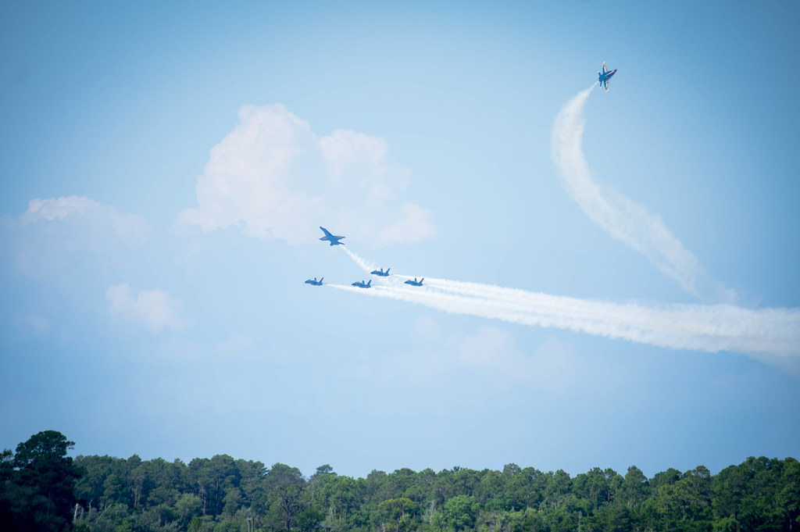
On the next page you will find an airplane graphed on a coordinate plane. Your task is to create a flight path for this airplane when it flies in the airshow. Your flight path must follow a few specifications and you must show the airplane’s movements:
- Its flight path must begin in Quadrant III, must end in QIV, and must go through QI and QII.
- Its flight path must include: (1) a reflection over a line of your choice (you will need to provide the equation of your line of reflection), (2) a rotation about the origin, and (3) a translation using a rule of your choice (you will need to provide a description of your rule).
Once you create your plane’s flight path, answer the following questions:
- When your airplane left QIII…
  - Which quadrant did pass through first? __________

  - What transformation did you use to get it there? _________________________________

  - Explain the motion the airplane makes to complete this transformation.

- What quadrant did your airplane go through next? __________

  - What transformation did you use to get it there? _________________________________

  - Explain the motion the airplane makes to complete this transformation.

- When your airplane’s path ended in QIV…
  - What transformation did you use to get it there? _________________________________

  - Explain the motion the airplane makes to complete this transformation.

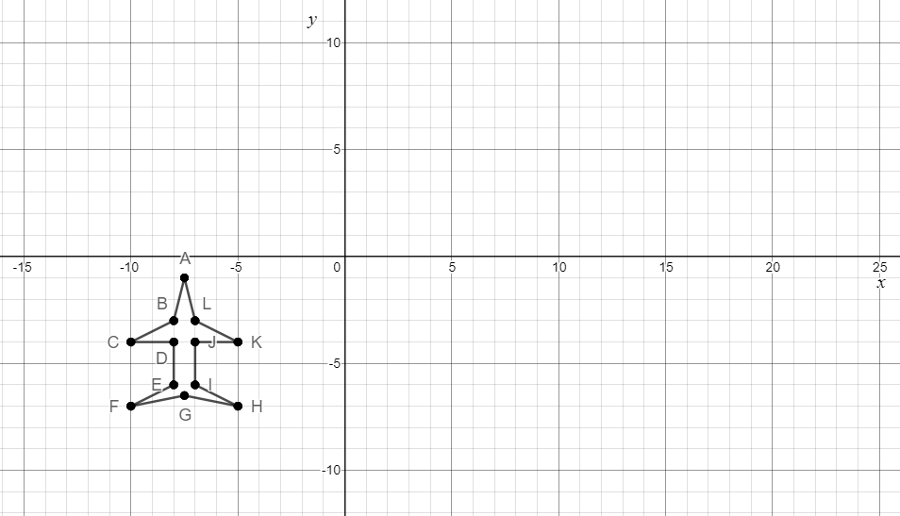

Rich Mathematical Task Rubric
 | Advanced | Proficient | Developing | Emerging
Mathematical  Understanding | Proficient Plus:  - Uses relationships among mathematical concepts or makes mathematical generalizations | - Demonstrates an understanding of concepts and skills associated with task  - Applies mathematical concepts and skills which lead to a valid and correct solution | - Demonstrates a partial understanding of concepts and skills associated with task  - Applies mathematical concepts and skills which lead to an incomplete or incorrect solution | - Demonstrates no understanding of concepts and skills associated with task  - Applies limited mathematical concepts and skills in an attempt to find a solution or provides no solution
Problem Solving | Proficient Plus:  - Problem solving strategy is well developed or efficient | - Problem solving strategy displays an understanding of the underlying mathematical concept  - Produces a solution relevant to the problem and confirms the reasonableness of the solution | - Problem solving strategy displays a limited understanding of the underlying mathematical concept  - Produces a solution relevant to the problem but does not confirm the reasonableness of the solution | - A problem solving strategy is not evident  - Does not produce a solution that is relevant to the problem
Communication  and  Reasoning | Proficient Plus:  - Reasoning or justification is comprehensive  - Consistently uses precise mathematical language to communicate thinking | - Demonstrates reasoning and/or justifies solution steps  - Supports arguments and claims with evidence  - Uses mathematical language to communicate thinking | - Reasoning or justification of solution steps is limited or contains misconceptions  - Provides limited or inconsistent evidence to support arguments and claims  - Uses limited mathematical language to partially communicate thinking | - Provides no correct reasoning or justification  - Does not provide evidence to support arguments and claims  - Uses no mathematical language to communicate thinking
Representations  and  Connections | Proficient Plus:  - Uses representations to analyze relationships and extend thinking  - Uses mathematical connections to extend the solution to other mathematics or to deepen understanding | - Uses a representation or multiple representations, with accurate labels, to explore and model the problem  - Makes a mathematical connection that is relevant to the context of the problem | - Uses an incomplete or limited representation to model the problem  - Makes a partial mathematical connection or the connection is not relevant to the context of the problem | - Uses no representation or uses a representation that does not model the problem  - Makes no mathematical connections

Additional Resources/Graphic Organizers/Etc.
Original Points of Airplane | Ordered Pairs of first movement | Ordered Pairs of second movement | Ordered Pairs of last movement
A
B
C
D
E
F
G
H
I
J
K
L
Graphic Organizer for labeling points:

