Name______________________________________________ Date_____________________
Airshow
Each year, the United States Navy “Blue Angels” put on an airshow. According to https://www.blueangels.navy.mil/faq/, “an estimated 11 million spectators view the squadron airshows each year.” During these air shows, pilots fly through the sky by gliding, rotating, and reflecting.
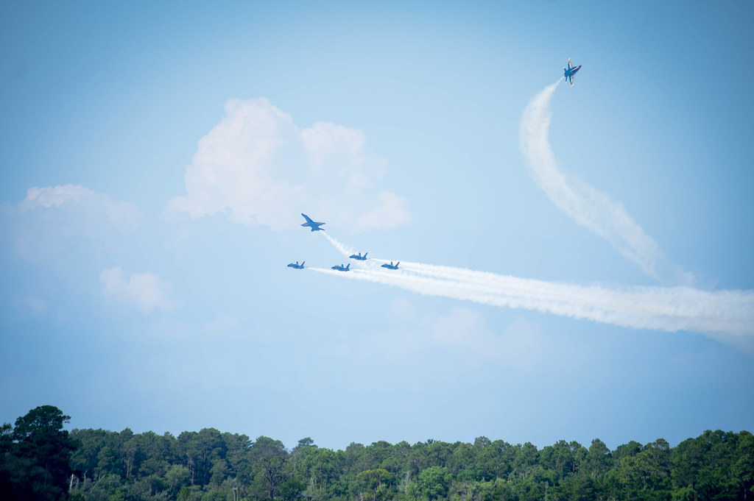
On the next page, you will find an airplane graphed on a coordinate plane. Your task is to create a flight path for this airplane when it flies in the airshow. Your flight path must follow a few specifications and you must show the airplane’s movements:
- Its flight path must begin in Quadrant III, must end in QIV, and must go through QI and QII.
- Its flight path must include: (1) a reflection over a line of your choice (you will need to provide the equation of your line of reflection), (2) a rotation about the origin, and (3) a translation using a rule of your choice (you will need to provide a description of your rule).
Once you create your plane’s flight path, answer the following questions:
- When your airplane left QIII…
  - Which quadrant did pass through first? __________

  - What transformation did you use to get it there? _________________________________

  - Explain the motion the airplane makes to complete this transformation.

- What quadrant did your airplane go through next? __________

  - What transformation did you use to get it there? _________________________________

  - Explain the motion the airplane makes to complete this transformation.

- When your airplane’s path ended in QIV…
  - What transformation did you use to get it there? _________________________________

  - Explain the motion the airplane makes to complete this transformation.

Geometry Task

