NAME _________________________________________ DATE ____________________
Lines & Tigers & Bears, Oh My!
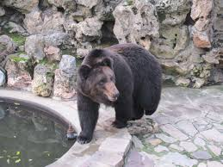

You work for a graphic design company and your next assignment is to design a map of a zoo with the following characteristics:
- Three parallel streets (each street must be named and clearly labeled)
- Two transversal streets which intersect all three parallel lines but are not parallel to each other (each street must be named and clearly labeled)
- One additional street perpendicular to any one of the transversals (clearly named and labeled)
- Create and label at least six different animal exhibits with at least one exhibit on each of the three parallel lines. Describe the location of each exhibit in relationship to another. Use at least 3 different angle relationships of your choice.
- A food court, restrooms, and a water fountain positioned in angle relationships that are congruent.
- A gift shop and parking lot positioned in an angle relationship that is supplementary.

You will demonstrate your knowledge of parallel lines with a transversal and your knowledge of angle pairs formed by the intersection of the lines. You are creating the initial map of a zoo and justifying the design of the lines and the position of the different exhibits in anticipation of a new zoo being built.
Once you have created a map of the zoo, answer the following questions:
- How do you know the three lines you drew are parallel?
- How do you know the street that intersects one of the transversals is perpendicular to it?

