Task Overview/Description/Purpose:
- Within the context of a soccer contest with three contestants, students are given a table of values for one, an algebraic function for another, and a graph for the third. Students are tasked with determining who won the contest and the location of the ball with respect to the goal line. Justification of their choice is required.
- In this task students will explore how quadratic functions can be used to model practical situations and how they can be solved using a variety of methods to develop mathematical understanding of the relationship among the different forms of a function and the meaning of intercepts within the context of the problem.
- The purpose of this task is to deepen the understanding of practical situations within the context within multiple representations of quadratic functions.

Standards Alignment: Strand - Functions
Primary SOL: A.7 The student will
- investigate and analyze linear and quadratic functions families and their characteristics both algebraically and graphically, including
- domain and range;
- zeros;
- intercepts;
- values of a function for elements in its domain;
- and connections between and among multiple representations of functions using verbal descriptions, tables, equations, and graphs.
Related SOL (within or across grade levels/courses): (consider using VDOE MVAT):
A.4 The student will
- solve multi-step linear and quadratic in two variables, including practical problems involving equations.
A.9 The student will
- collect and analyze data, determine the equation of the curve of best fit in order to make predictions, and solve practical problems, using mathematical models of linear and quadratic functions.
AII.7 The student will
- investigate and analyze linear, quadratic, absolute value, square root, cube root, rational, polynomial, exponential, and logarithmic function families algebraically and graphically.
Learning Intentions:
- Content – I am learning to apply my understanding of linear regression to make informed decisions about a real-world problem.
- Language – I am learning to explain my reasoning with mathematical language and provide evidence to support my answers when describing functions and how to solve them.
- Social – I am working toward mathematical and logical consensus with my collaborative team.
Success Criteria (Evidence of Student Learning):
- I can identify the zeros and intercepts of a function presented algebraically or graphically;
- I can determine f(x) for any value, x, in the domain of f.
- I can represent functions using tables, equations, and graph. Given one representation, I can model the function algebraically or graphically.
- I can investigate and analyze characteristics and multiple representations of functions with a graphing utility.
- I can explain how to solve problems with functions. I can compare representations of functions.

Mathematics Process Goals
Problem Solving | - Students will use problem-solving strategies as they apply mathematical concepts and skills related to different forms of quadratic functions within the practical context of a soccer contest.
Communication and Reasoning | - Students will engage in discussions with partners/groups and provide written commentary for their final answer which includes supporting documentation that identifies the evidence and justifies their conclusions.
Connections and Representations | - Students will explore connections among the tables, graphs, and algebraic forms of quadratic functions to determine the winner of the contest.

Task Pre-Planning
Approximate Length/Time Frame: 40-45 minutes
Grouping of Students: Students can work with partners or in small groups of three of four students. They should be given time to work independently to read and process their thinking about the problem. They can then share out with a partner or small group to develop a solution path.
Materials and Technology:  - graphing utilities (Desmos and/or graphing calculators)  - graph paper | Vocabulary:  Parabola  quadratic  solutions  maximum  zeros  intercepts

Anticipate Responses: See Planning for Mathematical Discourse Chart (Columns 1-3)
Task Implementation (Before)
Task Launch: Ask: “Can anyone describe the path of a ball that is thrown in the air?”
Then, using a ball or a rolled-up sheet of paper, toss the ball to a student and ask the class to describe the path that the ball took. Repeat as necessary until they realize that it is parabolic curve.
Now ask: “Would that also be true if a ball was kicked into the air?”

- What reading strategies might help students make sense of the task?
Underlining, highlighting, using cue words (horizontal, vertical, distance, height, etc.), visual vocabulary word walls, making predictions, using visualizations.

- How will students access the prior knowledge and vocabulary needed to understand the task?
Using vocabulary to connect linear to quadratic functions (intercepts, zeros, regression, etc.) *anchor chart with these concepts

Task Implementation (During)
Directions for Supporting Implementation of the Task
- Monitor – Teacher will listen and observe students as they work on task and ask assessing or advancing questions (see chart on next page)
- Select – Teacher will decide which strategies or thinking that will be highlighted (after student task implementation) that will advance mathematical ideas and support student learning
- Sequence – Teacher will decide the order in which student ideas will be highlighted (after student task implementation)
- Connect – Teacher will consider ways to facilitate connections between different student responses
Suggestions For Additional Student Support (possible supports or accommodations for individual student, as needed)
May include, among others:
- Use of sentences frames to support student thinking, justification, or explanations
  - “I chose student ___ because …”
  - “I used the ________ to find …”
  - “I compared _________to find …”
  - First I …
  - To create a graph representing the values in the table, I …
- Use of visual word wall cards or anchor charts that serve as a point of reference for different representations of functions.
- Use of Frayer Model for definitions
- Use of Desmos instead of TI-84 and Casio graphing calculators to visualize all graphs in a readable fashion.
- Use of plain-English version of task with fewer words and bulleted items.
- For students who may speak another language, it may help to read the prompt out loud.
- Use motions to support other language needed (e.g., furthest, height vs. distance, etc.).
- You can also make connections key terms in another language. e.g. competition, quadratic, curve, intercept, distance, goal, motion detector.
• To support mathematical skill development: Create or co-create an anchor chart (as building background) to describe how to solve equations/functions. Include sequence words. The chart should model a couple of examples (words connected to the numerical representation of the equations).
Task Implementation (After)
Connecting Student Responses (From Anticipating Student Response Chart) and Closure of the Task:
- Based on the actual student responses, sequence and select particular students to present their mathematical work during class discussion.
- Connect different students’ responses and connect the responses to the key mathematical ideas to bring closure to the task.
- Consider ways to ensure that each student will have an equitable opportunity to share his/her thinking during task discussion.
Teacher Reflection About Student Learning:
- How will student understanding of the content through the use of the process goals be assessed (i.e., task rubric)?
- How will the evidence provided through student work inform further instruction?
- Does vocabulary need further development?
- What strategies did students use and did they fit with what you expected them to do?
- Did students understand that Student A’s ball is still in the air at 81 feet?
- Were students able to identify regression as a method for determining the distance for Student A?
- Was guess and check used with mathematical understanding? This is not a course level appropriate strategy
- even though it can lead to a correct solution.

Teacher Completes Prior to Task Implementation |  |  | Teacher Completes During Task Implementation
Anticipated Student Response/Strategy  Provide examples of possible correct student responses along with examples of student errors/misconceptions | Assessing Questions – Teacher Stays to Hear Response  Teacher questioning that allows student to explain and clarify thinking | Advancing Questions – Teacher Poses Question and Walks Away  Teacher questioning that moves thinking forward | List of Students Providing Response Who? Which students used this strategy? | Discussion Order - sequencing student responses  - Based on the actual student responses, sequence and select particular students to present their mathematical work during class discussion  - Connect different students’ responses and connect the responses to the key mathematical ideas.  - Consider ways to ensure that each student will have an equitable opportunity to share his/her thinking during task discussion
Anticipated Student Response:  For Student A, assumed the ball landed at a horizontal distance of 81 ft. and did not recognize that the vertical height was 15.8 ft. | What is going on here?  What are you noticing?  Where is the ball in relation to the problem?  What is the vertical distance when the horizontal height represents the ball hitting the ground? | What are in the details?  Why are you figuring this out in the first place?  How do you feel about your answer?  What are you thinking now? | Student B
Anticipated Student Response:  For students A, B, and C, reasonably estimates and guesses to assume the victor. | Did you have a plan or were you trying things out?  How did you arrive at your answer?  Are you confident in your answer? | What resources could you use to confirm the landing points for the students in the problem? | Student A
Anticipated Student Response:  For students A, B, and or C, uses a graphing utility to correctly solve the problem but provides no evidence to support their conclusion. | Did you have a plan or were you trying things out?  Could you explain how you arrived at your conclusions?  How does your answer relate to the problem? | How could you provide evidence to support your conclusions? | Student D
Anticipated Student Response:  For Student A, graphs discrete points that stop short of the x-axis. Does not see the use for regression and relies on estimation. | What do you notice?  What is going on in this situation?  What do you estimate the answer might be?  How are your plotted points showing the path of the ball?  Where is the ball between the points?  How will you determine when it hit the ground? | Did you have a picture in mind when you read the problem?  What are you planning to do with that information?  What did we do earlier when we graphed individual points that followed a path but did not have an equation?
Anticipated Student Response:  When analyzing the given information is looking at the vertical height to determine the winner. | What are you trying to determine in this problem?  What do you predict the solution might be?  What does the height represent?  How does your reasoning of Students B and C affect Student A? | What are you thinking now?  Does everything still make sense?  What are you thinking now?  Does the height of the ball determine how far it will travel down the field?  How can you find the distance from the goal?
Anticipated Student Response:  For Student C, selects points from the graph to create a table of values or determine the function. | What is going on in this situation?  What information are looking for in the graph?  What are you planning on doing with the information?  How will that help you find the horizontal distance? | What information can you get from the graph?  What’s that going to do for you?  How will you decide what to do next?  Does your answer have to be exact to compare to the other Students? | Student C
Anticipated Student Response:  For Student B, substituted zero for distance. | What is going on in this situation?  What does you answer represent?  Did you have a plan or were you trying things out? | How do you feel about that answer?  What tipped you off that something was not right?  Which variable determines the horizontal distance?  How do you know?
Anticipated Student Response:  Student successfully uses regression for Student A, finds the x-intercept for Student B, and appropriately estimates the x-intercept for Student C | Do you feel satisfied, like everything made sense?  How confident are you?  Did anything surprise you, or did it work out as expected? | What if this was a height contest? Who wins?  What are you reasoning through now? | Student E
Anticipated Student Response:  Non-engaged student – does not know where to begin. | What is going on here?  What are you noticing?  What are you wondering?  Can you read the problem aloud again?  Tell me something about this problem?  When you look at the graph for Student C, how can you find where the ball hit the ground?  Can you estimate that value? | Is the problem making sense?  What is going on in this situation?  What does that point represent on the graph of a function?  How can that help you when you look at Student A or Student B?

Mathematical  Understanding | Proficient Plus:  - Uses relationships among mathematical concepts | - Demonstrates an understanding of concepts and skills associated with task  - Applies mathematical concepts and skills which lead to a valid and correct solution | - Demonstrates a partial understanding of concepts and skills associated with task  - Applies mathematical concepts and skills which lead to an incomplete or incorrect solution | - Demonstrates little or no understanding of concepts and skills associated with task  - Applies limited mathematical concepts and skills in an attempt to find a solution or provides no solution
Problem Solving | Proficient Plus:  - Problem solving strategy is efficient | - Problem solving strategy displays an understanding of the underlying mathematical concept  - Produces a solution relevant to the problem and confirms the reasonableness of the solution | - Chooses a problem solving strategy that does not display an understanding of the underlying mathematical concept  - Produces a solution relevant to the problem but does not confirm the reasonableness of the solution | - A problem solving strategy is not evident or is not complete  - Does not produce a solution that is relevant to the problem
Communication  and  Reasoning | Proficient Plus:  - Reasoning is organized and coherent  - Consistent use of precise mathematical language and accurate use of symbolic notation | - Communicates thinking process  - Demonstrates reasoning and/or justifies solution steps  - Supports arguments and claims with evidence  - Uses mathematical language to express ideas with precision | - Reasoning or justification of solution steps is limited or contains misconceptions  - Provides limited or inconsistent evidence to support arguments and claims  - Uses limited mathematical language to partially  communicate thinking with some imprecision | - Provides little to no correct reasoning or justification  - Does not provide evidence to support arguments and claims  - Uses little or no mathematical language to communicate thinking
Representations  and  Connections | Proficient Plus:  - Uses representations to analyze relationships and extend thinking  - Uses mathematical connections to extend the solution to other mathematics or to deepen understanding | - Uses a representation or multiple representations, with accurate labels, to explore and model the problem  - Makes a mathematical connection that is relevant to the context of the problem | - Uses an incomplete or limited representation to model the problem  - Makes a partial mathematical connection or the connection is not relevant to the context of the problem | - Uses no representation or uses a representation that does not model the problem  - Makes no mathematical connections

Name_____________________________________ Date_____________________
The Soccer Competition
The soccer club is holding a competition to see who can kick the ball the farthest down the soccer field. Students signed up to compete. Various methods for measuring the path that the ball travelled for each kick are being used. The soccer club has decided that the winning kick will have travelled the furthest distance horizontally from the goal line.
Student A - A motion detector was used to track the path of the ball and collected data for Student A while the soccer ball was in the air. The table of the data collected is shown below.
Track of Ball Kicked by Student A
Horizontal Distance from the Goal Line  (in feet) | Vertical Height  (in feet)
2.3 | 8.1
12 | 29.2
28 | 51.6
43.3 | 58.6
62 | 48.2
73 | 31.9
81 | 15.8

Student B - A group of students tracking the path of the ball kicked by Student B determined by the equation
$h\left(d\right)= -0.042d^{2}+3.36d+8$ (Track of Soccer Ball Kicked by Student B)
which represents the path the ball took through the air, where $d$ is the horizontal distance of the ball from the goal line and $h$ is the vertical height of the ball from the ground. Both distances are measured in feet.
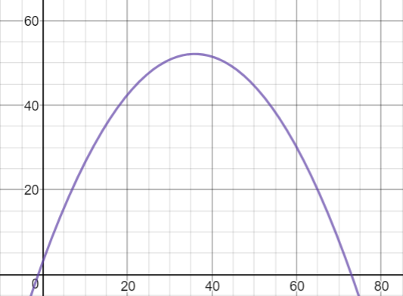Student C – A graph representing the path of the ball kicked by Student C is shown, where the horizontal distance of the ball from the goal line is represented on the x-axis and the height of the ball from the ground is represented on the y-axis.
Height (ft) feet
Distance from the Goal (ft)
Track of Soccer Ball Kicked by Student C
- Based on the data provided for each student participating in the competition, which student won the competition AND at what horizontal distance from the goal line did the ball hit the ground?

- Justify your response with evidence to support your answer.

With only a few minutes left, a fourth student joined the competition.
Student D - Another group of students tracked the path of the ball kicked by Student D determined by the equation
$h\left(d\right)= -0.028d^{2}+2.52d+2.9$ (Track of Soccer Ball Kicked by Student D)
which represents the path the ball took through the air, where $d$ is the horizontal distance of the ball from the goal line and $h$ is the vertical height of the ball from the ground. Both distances are measured in feet.

- Considering this new information, which student won the competition AND at what horizontal distance from the goal line did the ball hit the ground?

- Provide evidence that proves that this student won.

Task Supporting Documents
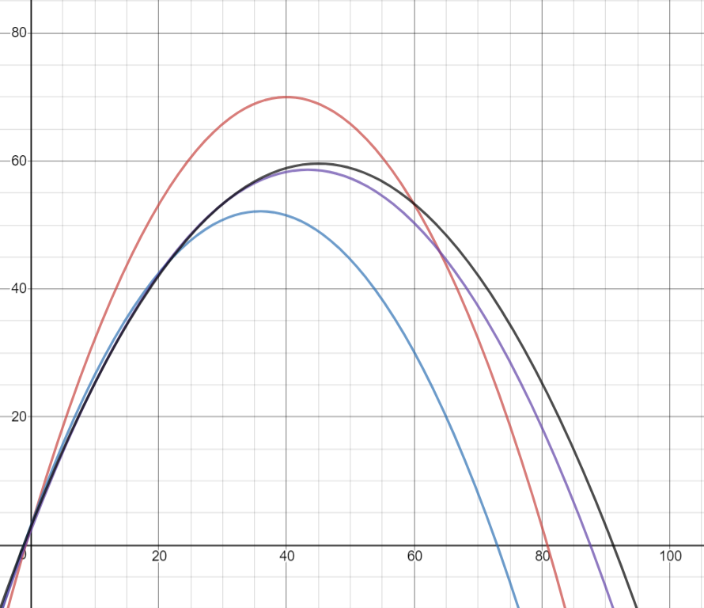
Track of Balls Kicked at the Soccer Contest
Distance from the Goal (ft)
Height from the Ground (ft)

Student B
Student D
Student C
Student A

Student A: Purple graph from table
        - x-intercept (87.542, 0)
        - the winner before Student D entered the contest
Student B: Red graph from first equation
- x-intercept (80.825, 0)
Student C: Blue graph from table
- x-intercept (72.96, 0)
Student D: Black graph from second equation
        - x-intercept (91.136, 0)
        - the final winner
Students are listed on the side of the graph in the order he height of the vertex.

