NAME _________________________________________ DATE ____________________

Bicycle Savings
SOL A.6
- Use the parent function y = x and describe the transformations defined by changes in the slope or y-intercept (c).
Part 1:
y
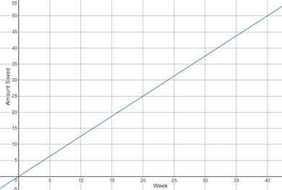x

Sarah is saving $1.25 a week to purchase a bicycle. The graph shows the amount she will have saved.
- Write the equation of the line represented in the graph. Describe how the components of the equation represent the situation.
- What would happen to the graph if she already had $5 saved? Represent this situation on the graph provided. Write the equation of the line represented in the graph. Describe how the components of the equation represent the situation.
- What would happen to the graph if she saved $2.50 a week? Represent this situation on the graph provided. Write the equation of the line represented in the graph. Describe how the components of the equation represent the situation.
- How would the graph change if she already had $5 saved AND started saving $2.50 a week? Represent this situation on the graph provided. Write the equation of the line represented in the graph. Describe how the components of the equation represent the situation.

Part 2:
- Create a situation like the one in Part 1 that can be represented by a linear function.
- Describe the components of the equation and how they represent the situation.
- Graph the linear function.
- Change the situation so that one of the components of the equation is transformed.
- Describe which component was changed and how this would affect the graph.
- Graph the transformed linear function.

