Full Parking Lot

All 20 spaces in my favorite parking lot are filled by vehicles. Some are occupied by two-wheeled motorcycles, and others by cars. Each space has only one vehicle occupying it. To calm myself, I counted wheels and there were exactly 66.
How many cars and how many motorcycles have parked in my lot?
Show all work and explain how you arrived at your final solution.

STUDENT A
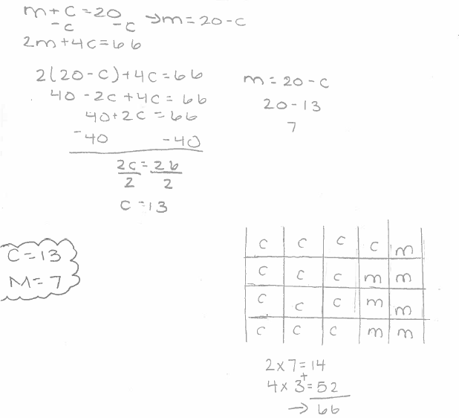
STUDENT B
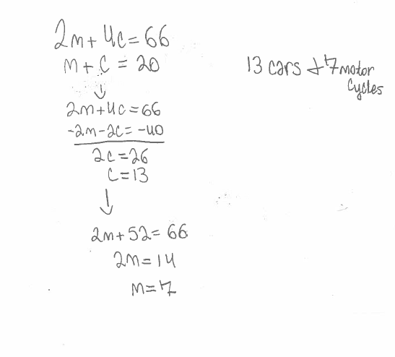
STUDENT C
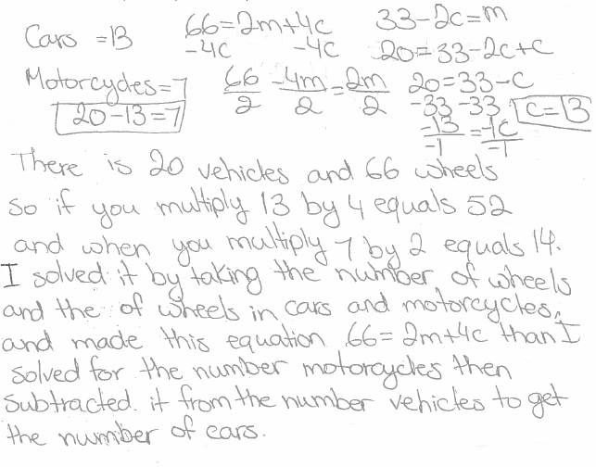
STUDENT D
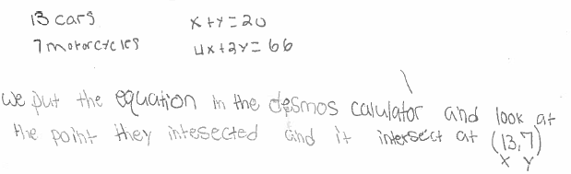
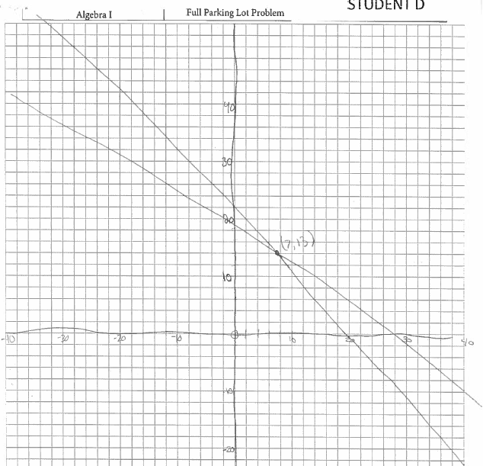
STUDENT E
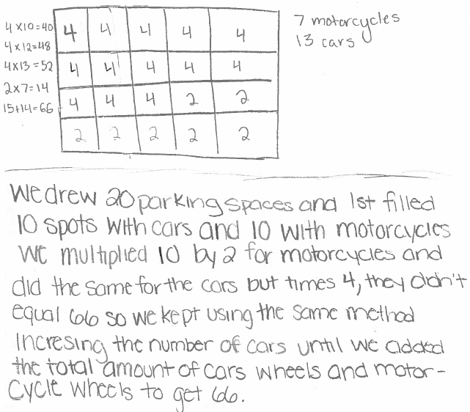
STUDENT F
