Name______________________________________ Date______________________________
Seesaw Fun
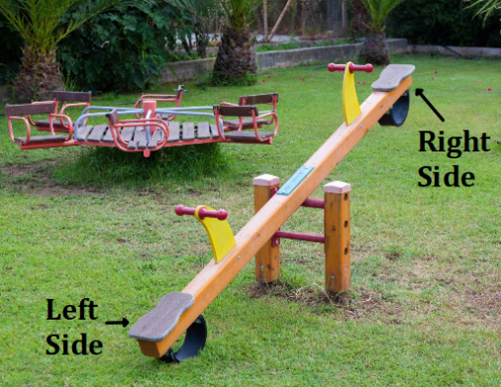

Seesaws (pictured above) are a common item children play on at playgrounds. Juan, Charisse, Mark, and Reniyah are at their playground and want to play on this.

Part I:
- The Desmos activity randomly assigned weights for each of the four friends. Record their weights in the spaces below.

Juan = ______ pounds
Charisse = ______ pounds
Mark = ______ pounds
Reniyah = ______ pounds

- Using the weights listed above, answer the following questions if only Juan is sitting on the left side of the seesaw.
- What would happen to the seesaw if only Charisse sat on the right side? Why do you think that?

- What would happen to the seesaw if only Mark sat on the right side? Why do you think that?

- What would happen to the seesaw if only Reniyah sat on the right side? Why do you think that?

Algebra I Task
Part II:
- Choose two friends with different weights to sit on the seesaw and record their names below. Be sure to place the heavier friend on the left side and ensure the two friends have different weights:
  - Left side: __________________
  - Right side: _________________

- These two friends are both wearing backpacks. If the weights of the backpacks of each friend are the same, is it possible for the seesaw to be balanced?
  - Explain your thinking.

  - Let b = the weight of the backpack of the heavier friend. Write an algebraic equation that represents the situation.

- Given that the heavier friend is still sitting on the left side and “b” still represents the weight of their backpack:

  - If the weights of the backpacks are no longer the same, write an expression for the weight of the backpack of the friend sitting on the right side (in terms of b) so the seesaw will balance.

  - Now that the seesaw is balanced, write an algebraic equation (in terms of b) that represents the situation.

- How are the equations in part b and c alike or different?

- What affect does the weight of the backpack have on whether or not the seesaw is balanced?

