Task Overview/Description/Purpose:
- Students will apply prerequisite skills and use the characteristics of quadratic functions to identify the domain and range. Students will make connections between maximum height and distance and how it relates to possible strategies firefighters use to extinguish fires.
- This task would be used to introduce quadratic functions and explore how domain and range are used to measure height and distance.

Standards Alignment: Strand - Functions
Primary SOL:
AII.7 The student will investigate and analyze linear, quadratic, absolute value, square root, cube root, rational
polynomial, exponential, and logarithmic function families algebraically and graphically.
Key concepts include:
a) domain and range;
f) values of a function for elements in its domain;
g) connections between and among multiple representations of functions using verbal descriptions, tables, equations, and graphs;

Related SOL (within or across grade levels/courses): 8.15ab, A.7abcdef
Learning Intentions:
- Content (based on Essential Knowledge and Skills) – I am learning to interpret the domain, range, zeros, and intercepts of an algebraic and graphical representation of a function that models a practical situation.
- Language – I am learning to justify my thinking using multiple representations and algebraic solutions.
- Social – I am collaborating with others on my team to solve a real world problem and discuss how algebra can help us verify information.
Success Criteria (Evidence of Student Learning):
- I can identify the domain and range of a function presented algebraically or graphically.
- For any x value in the domain of f, I can determine f(x).
- I can represent relations and functions using verbal descriptions, equations, and graphs.
Mathematics Process Goals
Problem Solving | Students will use problem-solving strategies as they apply mathematical concepts and skills related to different forms of parent functions to model data.
Communication and Reasoning | Students will engage in discussions with partners/groups and provide written evidence for their final answer which includes supporting documentation that identifies the solution and justifies their conclusions.
Connections and Representations | Students will explore the connections among the tables, graphs, and algebraic functions to determine the best model of the temperature.

Task Pre-Planning
Approximate Length/Time Frame: 25-30 minutes
Grouping of Students:
(5-Min) Allow students time to read the task and identify information given in the problem that supports their thinking about how to solve it. Students should be given time to work independently to read and process their thinking about the problem.
After students have had an opportunity to read the task, allow them to share strategies with their partner or other groups to support their thinking and develop a solution path.

Materials and Technology:  - graphing utility | Vocabulary:  - domain  - range  - maximum  - initial location  - independent variables  - dependent variables  - interval notation

Anticipate Responses: See Planning for Mathematical Discourse Chart (Columns 1-3)
Task Implementation (Before)
Task Launch:
- Allow students to share information about natural disasters including recent events that relate to wildfires.
- Discuss how wildfires can be prevented and possible ways firefighters may extinguish fires.
- Provide students with opportunities to discuss important information firefighters should know before attempting to extinguish any fire.
What reading strategies might help students make sense of the task?
- Underlining, highlighting, using cue words, vocabulary word walls, making predictions, using visualizations.
How will students access the prior knowledge and vocabulary needed to understand the task?
- Review interval notation
- Teacher created spiral review
- View Wildfire video

- Task Implementation (During)
Directions for Supporting Implementation of the Task
- Monitor – Teacher will listen and observe students as they work on task and ask assessing or advancing questions (see chart on next page)
- Select – Teacher will decide which strategies or thinking that will be highlighted (after student task implementation) that will advance mathematical ideas and support student learning
- Sequence – Teacher will decide the order in which student ideas will be highlighted (after student task implementation)
- Connect – Teacher will consider ways to facilitate connections between different student responses
Suggestions For Additional Student Support
- Use of sentences frames to support student thinking
  - “I chose student ___ because …”
  - “I used the ________ to find …”
  - “I compared _________to find …”
- Use of word wall cards or anchor charts that serve as a point of reference for different representations of functions.
- Use of Frayer Model for definitions
- Use of Desmos, TI-84 and/or Casio graphing calculators to visualize all graphs in a readable fashion.
- Simplify word load of task with fewer words and bulleted items.

Task Implementation (After)
Connecting Student Responses (From Anticipating Student Response Chart) and Closure of the Task:
- Based on the actual student responses, sequence and select particular students to present their mathematical work during class discussion.
- Connect different students’ responses and connect the responses to the key mathematical ideas to bring closure to the task. Discuss similarities and differences between two strategies before adding additional strategies.
- Consider ways to ensure that each student will have an equitable opportunity to share his/her thinking during task discussion.
- Draw out any pertinent vocabulary, if possible, during the closure discussion and post word wall cards.
Teacher Reflection About Student Learning:
- What strategies did students use and did they fit with what you expected them to do?
- How will the evidence provided through student work inform further instruction?
- What were the recurring student misconceptions?
- Does vocabulary need further development?
  - Did students accurately identify the types of functions?
  - Did students accurately identify features of different types of functions?
- Did students understand the need of a fractional coefficient of the quadratic function that would give the curve of best fit?

Mathematical Task: ________Wildfires________________Content Standard(s):_________AII.7a,f,g_______________________
Teacher Completes Prior to Task Implementation |  |  | Teacher Completes During Task Implementation
Anticipated Student Response/Strategy  Provide examples of possible correct student responses along with examples of student errors/misconceptions | Assessing Questions – Teacher Stays to Hear Response  Teacher questioning that allows student to explain and clarify thinking | Advancing Questions – Teacher Poses Question and Walks Away  Teacher questioning that moves thinking forward | List of Students Providing Response Who? Which students used this strategy? | Discussion Order - sequencing student responses  - Based on the actual student responses, sequence and select particular students to present their mathematical work during class discussion  - Consider ways to ensure that each student will have an equitable opportunity to share his/her thinking during task discussion
Anticipated Student Response:  Student does not understand how to find the distance between when the water is 32 ft. above ground and when the water hits the ground at 60 ft. | - At what point (ordered pair) will the water reach a maximum height of 32 ft.? | - How much further must the water travel? How do you define further in this specific problem? | Student C
Anticipated Student Response:  Student demonstrates misconceptions regarding how to find the distance when given the water is 32 ft above ground. | - What values represent height and distance?  - What does 32 ft. represent? | - How do you find the distance between two objects?  - What algebraic method do you use to find the distance? | Student A
Anticipated Student Response:  The student is unsure of how to start solving the problem. | - What information do you know? How do the words used in the problem relate to the question(s) posed?  - Where would you define the initial point where the water (where the firetruck is located on the graph)? | - Can you think of other instances when you were required to find the maximum height of an object? Does the example you provided help you identify the maximum height in this question.
Anticipated Student Response:  Student substituted incorrect values to answer the question “how much farther the water must travel if it is 32 feet above ground?” | - What does x and y represent? Explain the process used to find your initial solution. | - What does this new solution represent? Does this new solution help find “how much farther the water must travel before it hits the ground”?

Name_____________________________________ Date_____________________
Wildfires
Wildfires burn millions of acres every year. Wildfires burn at a rapid speed and can consume everything in their paths. Fire trucks are used to contain wildfires such as those experienced by people living in California.
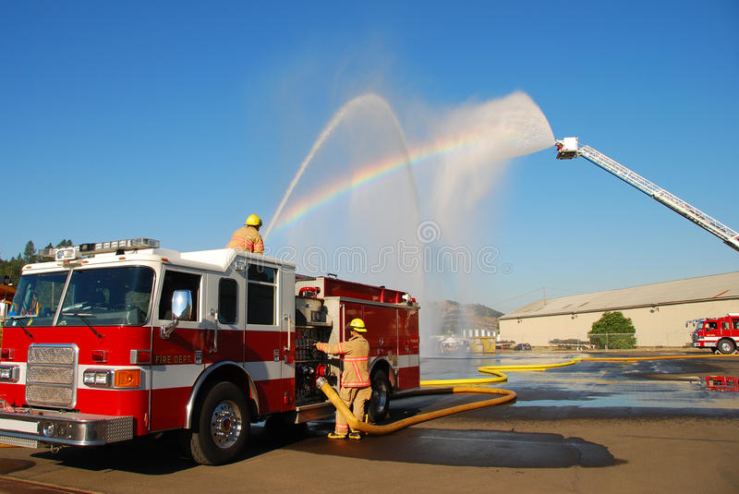
The height of a stream of water from the nozzle of a fire hose is modeled by
h(x) =$-0.03x^{2 }+ x + 48$
where h(x) is the height in feet, of the stream of water x feet from the fire truck.
1. What is the maximum height the water from this nozzle can reach? What is the maximum distance from the firetruck a firefighter can stand and still reach the fire?

2. When the stream of water from the nozzle is 32 feet above ground, how much farther must the water travel before it hits the ground?

3. If the wildfire is located 48 feet from the firetruck. Based on the original function provided, will the firemen be able to put out the fire? Explain why or why not.

4. Based on the original function, if a wildfire is located 63 feet away from the firetruck, will the firemen able to put out the fire? Explain why or why not.

 | Advanced | Proficient | Developing | Emerging
Mathematical  Understanding | Proficient Plus:  - Uses relationships among mathematical concepts | - Demonstrates an understanding of concepts and skills associated with task  - Applies mathematical concepts and skills which lead to a valid and correct solution | - Demonstrates a partial understanding of concepts and skills associated with task  - Applies mathematical concepts and skills which lead to an incomplete or incorrect solution | - Demonstrates little or no understanding of concepts and skills associated with task  - Applies limited mathematical concepts and skills in an attempt to find a solution or provides no solution
Problem Solving | Proficient Plus:  - Problem solving strategy is efficient | - Problem solving strategy displays an understanding of the underlying mathematical concept  - Produces a solution relevant to the problem and confirms the reasonableness of the solution | - Chooses a problem solving strategy that does not display an understanding of the underlying mathematical concept  - Produces a solution relevant to the problem but does not confirm the reasonableness of the solution | - A problem solving strategy is not evident or is not complete  - Does not produce a solution that is relevant to the problem
Communication  and  Reasoning | Proficient Plus:  - Reasoning is organized and coherent  - Consistent use of precise mathematical language and accurate use of symbolic notation | - Communicates thinking process  - Demonstrates reasoning and/or justifies solution steps  - Supports arguments and claims with evidence  - Uses mathematical language to express ideas with precision | - Reasoning or justification of solution steps is limited or contains misconceptions  - Provides limited or inconsistent evidence to support arguments and claims  - Uses limited mathematical language to partially  communicate thinking with some imprecision | - Provides little to no correct reasoning or justification  - Does not provide evidence to support arguments and claims  - Uses little or no mathematical language to communicate thinking
Representations  and  Connections | Proficient Plus:  - Uses representations to analyze relationships and extend thinking  - Uses mathematical connections to extend the solution to other mathematics or to deepen understanding | - Uses a representation or multiple representations, with accurate labels, to explore and model the problem  - Makes a mathematical connection that is relevant to the context of the problem | - Uses an incomplete or limited representation to model the problem  - Makes a partial mathematical connection or the connection is not relevant to the context of the problem | - Uses no representation or uses a representation that does not model the problem  - Makes no mathematical connections

