Wildfires burn millions of acres every year. Wildfires burn at a rapid speed and can consume everything in their paths. Fire trucks are used to contain wildfires such as those experienced by people living in California.
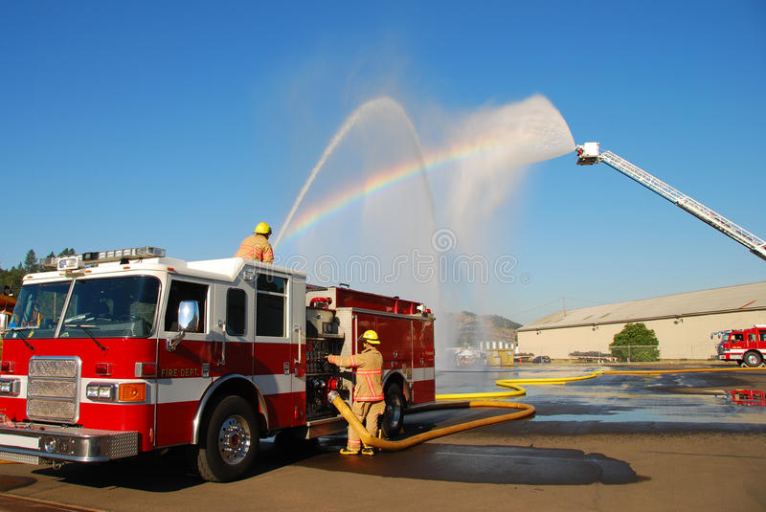
The height of a stream of water from the nozzle of a fire hose is modeled by
h(x) =-0.03x2 + x + 48
Where h(x) is the height in feet, of the stream of water x feet from the fire truck.
1. What is the maximum height the water from this nozzle can reach? What is the maximum distance from the firetruck a firefighter can stand and still reach the fire?
2. When the stream of water from the nozzle is 32 feet above ground, what is the horizontal distance the water travels before it hits the ground?
3. If the wildfire is located 48 feet from the firetruck. Based on the original function provided, will the firemen be able to reach the fire? Explain why or why not.
4. Based on the original function, if a wildfire is located 63 feet away from the firetruck, will the firemen able to put out the fire? Explain why or why not.

STUDENT A

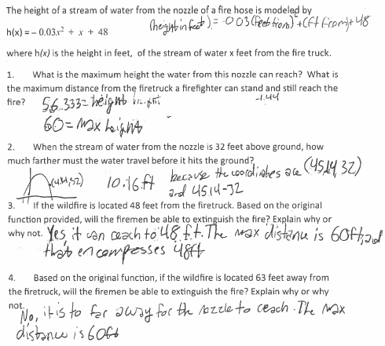
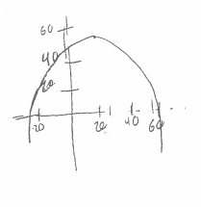

STUDENT B
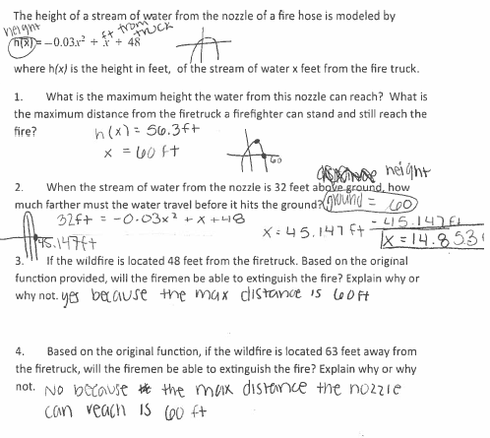

STUDENT C
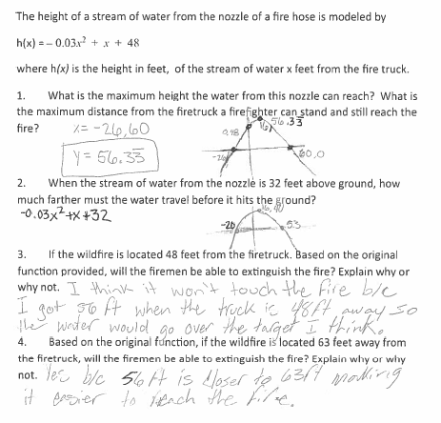

STUDENT D
