Name___________________________ Date___________________
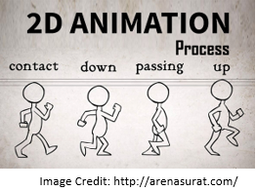
Animate It!
Animation can be done by hand or with the assistance of various computer programs. The process involves recreating figures in different phases of movements and then stringing those images together to create the appearance of seamless movement.

Mathematical transformations can also be strung together to create animations. Desmos graphing calculator can actually animate such transformations through a slider.
Your task is to create a character in the form of an absolute value function and animate it through some transformation using a slider in the equation; vertical shift, horizontal shift, or dilation.
Once you have put a slider into an equation, 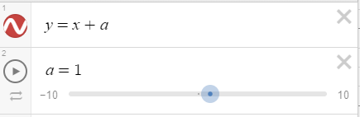, you simply press the button to start the animation.
Explain each of the following aspects of your character:
- Name and type of character.
- Describe the transformations, including what is being animated.
- Explain your process for creating your transformed equation.
  - How did you start the process?
  - How/why did you change aspects of your creation?
  - Were there any problems in your process that you had to work through? If so, explain.
- Describe ways you would like to be able to enhance your character.
Optional: Explain what and how you created any enhancements to your character beyond the required transformations

Algebra II Task

