Name_________________________________ Date________________________

Drone’s Best Friend
Drones have become very popular in recent years, but dogs have been beloved pets for centuries. What happens when the two come together? If you search the internet, you can see images of drones walking dogs, dogs chasing drones, and even drones and dogs working together for search and rescue.

In the image below, a dog is chasing a drone, beginning a jump towards the drone. The x-axis represents the horizontal distance traveled by the drone and dog and the y-axis represents the vertical distance traveled by the drone and dog.
If the path of the drone can be modeled by the line, $y=\frac{1}{2}x+\frac{5}{2}$ and the path of the dog can be modeled by the parabola, $y=-\frac{3}{4}x^{2}+\frac{7}{2}x+\frac{1}{4}$, will the dog catch the drone?
If so, at what point? What does this represent in the context of the situation?
Make sure you have solved the problem both algebraically and graphically to justify your answer.

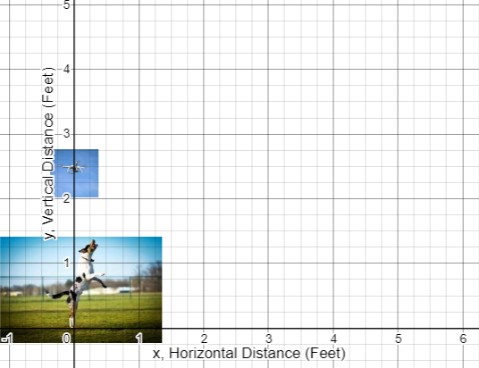

Algebra II Task

