Name_________________________________________Date________________________
How Many Stones Will I Need?
The illustration below shows how a gardening company defines the sizes of its gardens as well as how it puts stepping stones around the outside of each.
size | pattern
1
2
3 | 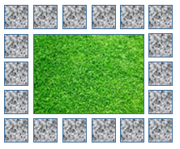
- Fill the table below with values for gardens of given
sizes. Then, generalize by writing an algebraic
expression that could be used to calculate the
number of stones needed for a garden of size n.

Garden Size | # of Stones Wide | # of Stones Long | # of Stones Needed
1
2
3
4
5
10
n

- Explain how the three algebraic expressions that you created in the bottom row relate to the gardens.

- Are your algebraic expressions in their simplest form? If not, simplify them in the space below.

- Use your simplified expression for the number of stones needed to evaluate and determine how many stones are required for a garden of size 100. Does the result make sense? Explain your reasoning.

