Task Overview/Description/Purpose:
- The purpose of this task is to apply transformations, to include translations, reflections, and dilations, in the coordinate plane.
- In this task, students will describe a series of up to five transformations that could be used to capture a group of monsters on a screen (coordinate plane).

Standards Alignment: Strand – Number and Number Sense
Primary SOL: 8.7 The student will
- given a polygon, apply transformations, to include translations, reflections, and dilations, in the coordinate plane; and
- identify practical applications of transformations.
Related SOL (within or across grade levels/courses): 5.14a, 6.8, 7.7
Learning Intention(s):
- Content - I am learning to apply geometric transformations to a polygon in the coordinate plane and list the coordinates for each vertex of the resulting image.
- Language - I am learning to use appropriate mathematical vocabulary when describing geometric transformations (translation, reflection, dilation, scale factor).
- Social - I am learning to actively listen to a classmate as they describe a set of transformations so that I can compare their results to mine.
Success Criteria (Evidence of Student Learning):
- I can apply geometric transformations to a right triangle in the coordinate plane.
- I can list the coordinates for each vertex of a right triangle after it has been transformed on the coordinate plane.
- I can describe individual transformations of a right triangle using appropriate mathematical vocabulary.
- I can actively listen to a classmate as they describe a series of transformations.
- I can communicate similarities and differences between my work and a peer’s work.
Mathematics Process Goals
Problem Solving | - Students will consider different geometric transformations (translation, reflection, and dilation) as they develop a plan to capture monsters that are located in Quadrant I of a coordinate plane.
Communication and Reasoning | - Students will use appropriate mathematical vocabulary, both orally and in written form, as they describe a series of transformations that they used to capture monsters.  - Students will reason logically as they plan a pathway of transformations that will catch the group of monsters.
Connections and Representations | - Students will connect the transformations of a right triangle to other concepts, including plotting/reading ordered pairs on the coordinate plane, congruence, and similarity.  - Students will represent transformations graphically and describe them in words.

Task Pre-Planning
Approximate Length/Time Frame: 45 minutes
Grouping of Students: The task begins with a whole class launch. Then, students work individually on the task. As some will finish earlier than others, the teacher can pair students who have finished to check one another’s work. The pair of students will sit back-to-back and describe their transformations to a partner while the partner sketches on a blank copy of the grid to see if they can follow along. Then, the two will switch jobs. Once everyone has had an opportunity to finish creating their list of transformations, the teacher will return to a whole class setting to share several strategies and debrief.
Materials and Technology:  - Graph paper  - calculator | Vocabulary:  - Translation  - Reflection  - Dilation  - Scale factor  - Pre-image, Image  - Ordered pairs  - Coordinate plane  - x-axis and y-axis  - Quadrants

Anticipate Responses: See the Planning for Mathematical Discourse Chart (columns 1-3).

Task Implementation (Before)
Task Launch:
- Display the image below for the class:
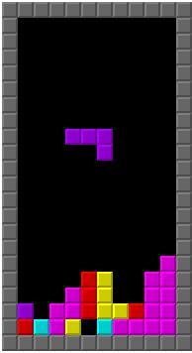
- Ask students if this is a game they recognize. See how many recognize the game of “Tetris.”
- Ask students if they can explain why this game is an application of geometric transformations. They should be able to describe “Tetris” as a game where the player is using translations and rotations to stack shapes. Although rotations are not part of the 8th grade curriculum, students have learned to recognize this transformation as part of the 5th grade curriculum.
- Allow students time to brainstorm other games that apply transformations as they enjoy playing. “Frogger” has the player translate a frog with a goal of making across a busy highway. “Hole.io” is a game where your character dilates as you absorb pieces of landscape.
- Students should realize that not only do players apply transformations as they game, but the professionals who design games must be fluent in programming transformations into their products.
- After this brainstorm session, the teacher should distribute the task and follow a three read protocol.
- The first read is for context. The teacher may want to ask questions to insure that students understand that they are a player in the Monster Transformations game. They are going to simulate one turn in this game.
- The second read is for mathematics. Students should highlight or circle any mathematics vocabulary that they might need assistance with prior to beginning the task.
- The third read allows students a chance to ask any other questions about the scenario itself. These questions might relate to the rules of the game, but they should not unveil any strategy that might be used.

Task Implementation (During)
Directions for Supporting Implementation of the Task
- Monitor – The teacher will observe students as they work independently on the task. The teacher will engage with students by asking assessing or advancing questions as necessary (see attached Planning for Mathematical Discourse Chart).
- Select – The teacher will select students to share their strategy to collect the monsters.
- Sequence – The teacher will select 2-3 student strategies to share with the whole group. One suggestion is to look for one common misconception and two correct responses to share.
- Connect – The teacher will consider ways to facilitate connections between different student representations.
Suggestions For Additional Student Support
- Some students with visual-motor weaknesses may benefit from graph or lined paper to help them organize their work. Another possible support for this group of students, the coordinate plane with an image of the final triangle enclosing the monsters, is provided in the Possible Graphic Organizers section of this template.
- Students with weaknesses in memory and language could benefit from word walls or graphic organizers to activate prior knowledge about transformations.
- Provide manipulatives such as transparent versions of the original and dilated triangles to support visual-spatial-kinesthetic learning. Samples are provided in the Possible Graphic Organizers section of this template.
- Post visual cues such as copies of the Monster Transformations coordinate plane for students who need support with memory.
- Provide a table, as provided in the Possible Graphic Organizers section, to help students who need support organizing their thinking.
- For students who need support in justifying their thinking, you may choose to provide them with the sentence frames below.
  - What I know about the problem is…
  - My method for capturing the monsters was…
  - To reach the final destination, I first…

Task Implementation (After) 20 minutes
Connecting Student Responses (From Anticipating Student Response Chart) and Closure of the Task:
- Based on the actual student responses, sequence and select particular students to present their mathematical work during class discussion.
- Connect different students’ responses and connect the responses to the key mathematical ideas to bring closure to the task.
- Consider ways to ensure that each student will have an equitable opportunity to share his/her thinking during task discussion. For instance, provide the students whose work was not selected as part of the sequence of student work that will be shown the opportunity to validate and/or question what they see.
Teacher Reflection About Student Learning:
- Student understanding of the content through the use of the process goals will be assessed with the Rich Mathematical Task Rubric.
- Students have a variety of ways to enter this task. Teachers will need to anticipate these different entry points but also be prepared for others. The key here is allowing the students to communicate their reasoning as they are working through the task.
- The results of this task will help the teacher assess mastery of the different types of transformations covered in the Math 8 standards and give the students an opportunity to apply their knowledge to a new situation.
- Teachers should use this task to highlight how each student’s entry point was valid as they all reach the final goal of capturing the monsters pictured in Quadrant I.

Planning for Mathematical Discourse
Mathematical Task: __Monster Transformations___ Content Standard(s): ___8.7_____
Anticipated Student Response/Strategy  Provide examples of possible correct student responses along with examples of student errors/misconceptions | Assessing Questions  Teacher questioning that allows student to explain and clarify thinking | Advancing Questions  Teacher questioning that moves thinking forward | List of Students Providing Response Who? Which students used this strategy? | Discussion Order - sequencing student responses  - Based on the actual student responses, sequence and select particular students to present their mathematical work during class discussion  - Connect different students’ responses and connect the responses to the key mathematical ideas  - Consider ways to ensure that each student will have an equitable opportunity to share his/her thinking during task discussion
Anticipated Student Response:  Non-starter | - Is there anything that you need me to clarify about the task?  - What do you notice about $∆ABC$ in relation to the group of monsters? | - What transformation do you want to try first?
Anticipated Student Response:  Student attempts to dilate about the origin first which takes the triangle off of the coordinate plane provided. | - What type of transformation are you using first?  - Why do you want to use that type of transformation?  - What problem are you encountering? | - Is there another transformation that you could apply first that would help you to dilate the triangle without sending it off of the coordinate plane on another move?
Anticipated Student Response:  Student successfully dilates the triangle about a point other than the origin and captures the monsters in 3 moves | - Which transformations did you use to capture the monsters in three moves?  - How did you dilate the triangle on your ____ move?  - How do you know that your method dilated the triangle using your scale factor of ___? | - Your dilation looks good, but it is not situated about the origin like others we have studied this year. Can you think of a way to explain your process to the class?
nticipated Student Response:  Student captures the monsters in 4 moves | - Which transformations did you use to capture the monsters in four moves?  - What was your thought process?  - How did you choose the order for your transformations? | - Do you think this is the only way to capture the monsters in four moves?  - Can you find another way?
Anticipated Student Response:  Student captures the monsters in 5 moves | - Which transformations did you use to capture the monsters in four moves?  - What was your thought process?  - How did you choose the order for your transformations? | - Is there a way to capture the monsters in fewer than five moves?
Anticipated Student Response:  Student work shows images of reflections or translations that are not congruent or images of dilations that are not similar to the original triangle | - Can you describe your process for translating, reflecting, or dilating?  - How can you describe the size and shape of the preimage and image in a translation/reflection?  - How can you describe the size and shape of the preimage and image in a dilation? | - Does your image appear congruent to the preimage after your translation/reflection?  - Does your image appear similar to the preimage after your dilation?

Name_______________________________ Date________________________
Monster Transformations

The goal of this game is to capture all of the monsters with the triangle when it is your turn.
- On your turn, you must perform a series of no more than five transformations on $∆ABC$.
- Possible transformations include translations, reflections, and dilations.
- Dilations are limited to scale factors of 2, 3, and 4.
- You may use from one to five transformations, but the monsters are only captured at the end of your series of transformations.
- Each triangle must stay on the screen.
- Captured monsters must completely fit inside of your final triangle.

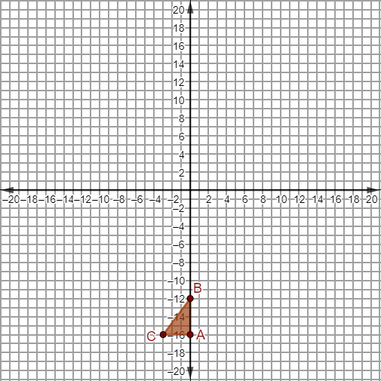

It’s your turn! In the space below, describe the set of transformations that you would use to capture the monsters.
Include each of the following in your description:
- a thorough description of each transformation applied
- the location of the triangle after each transformation
- your reasoning for each transformation chosen

Rich Mathematical Task Rubric
 | Advanced | Proficient | Developing | Emerging
Mathematical  Understanding | Proficient Plus:  - Uses relationships among mathematical concepts or makes mathematical generalizations | - Demonstrates an understanding of concepts and skills associated with task  - Applies mathematical concepts and skills which lead to a valid and correct solution | - Demonstrates a partial understanding of concepts and skills associated with task  - Applies mathematical concepts and skills which lead to an incomplete or incorrect solution | - Demonstrates no understanding of concepts and skills associated with task  - Applies limited mathematical concepts and skills in an attempt to find a solution or provides no solution
Problem Solving | Proficient Plus:  - Problem solving strategy is well developed or efficient | - Problem solving strategy displays an understanding of the underlying mathematical concept  - Produces a solution relevant to the problem and confirms the reasonableness of the solution | - Problem solving strategy displays a limited understanding of the underlying mathematical concept  - Produces a solution relevant to the problem but does not confirm the reasonableness of the solution | - A problem solving strategy is not evident  - Does not produce a solution that is relevant to the problem
Communication  and  Reasoning | Proficient Plus:  - Reasoning or justification is comprehensive  - Consistently uses precise mathematical language to communicate thinking | - Demonstrates reasoning and/or justifies solution steps  - Supports arguments and claims with evidence  - Uses mathematical language to communicate thinking | - Reasoning or justification of solution steps is limited or contains misconceptions  - Provides limited or inconsistent evidence to support arguments and claims  - Uses limited mathematical language to partially communicate thinking | - Provides no correct reasoning or justification  - Does not provide evidence to support arguments and claims  - Uses no mathematical language to communicate thinking
Representations  and  Connections | Proficient Plus:  - Uses representations to analyze relationships and extend thinking  - Uses mathematical connections to extend the solution to other mathematics or to deepen understanding | - Uses a representation or multiple representations, with accurate labels, to explore and model the problem  - Makes a mathematical connection that is relevant to the context of the problem | - Uses an incomplete or limited representation to model the problem  - Makes a partial mathematical connection or the connection is not relevant to the context of the problem | - Uses no representation or uses a representation that does not model the problem  - Makes no mathematical connections

Name________________________________________________ Date________________________

Possible Graphic Organizers

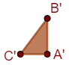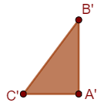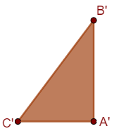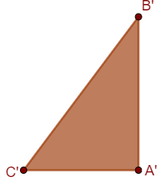

Name_______________________________ Date________________________

Possible Graphic Organizers

 | Description of Transformation Applied | New Image for Vertex A | New Image for Vertex B | New Image for Vertex C | Reasoning for the Transformation Chosen
Transformation #1
Transformation #2
Transformation #3
Transformation #4
Transformation #5

Name_______________________________ Date________________________

Possible Graphic Organizers

