Name________________________________________ Date________________________

Monster Transformations

The goal of this game is to capture all of the monsters with the triangle when it is your turn.
- On your turn, you must perform a series of no more than five transformations on $∆ABC$.
- Possible transformations include translations, reflections, and dilations.
- Dilations are limited to scale factors of 2, 3, and 4.
- You may use from one to five transformations, but the monsters are only captured at the end of your series of transformations.
- Each triangle must stay on the screen.
- Captured monsters must completely fit inside of your final triangle.

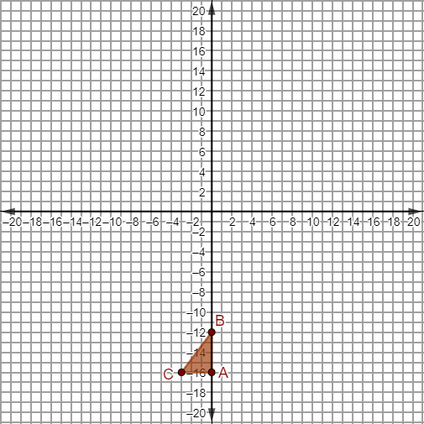

It’s your turn! In the space below, describe the set of transformations that you would use to capture the monsters.
Include each of the following in your description:
- a thorough description of each transformation applied
- the location of the triangle after each transformation
- your reasoning for each transformation chosen

