Name_____________________________________________Date________________________
It’s Peanut Butter Time!
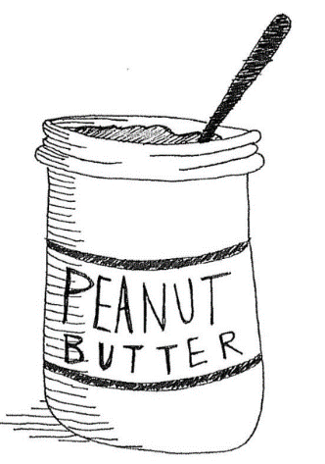
The data below shows the prices per serving in cents for Peanut Butter sold a two grocery stores: Peanut Butter Direct and Peanut Butter Palace.
Peanut Butter Direct: 14, 34, 31, 9, 10, 17, 17, 30, 14, 17, 21, 18, 21, 30, 12, 9, 17, 19, 20
Peanut Butter Palace: 26, 34, 9, 26, 26, 33, 27, 15, 24, 26, 32, 32, 26, 32
- Using the data above and the box plots shown below, decide which plot shows the distribution of prices for Peanut Butter Direct and which plot shows the distribution of prices for Peanut Butter Palace. Explain how you determined your answer.

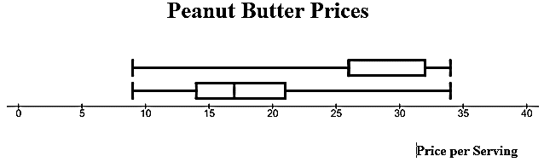

- How do the prices of Peanut Butter Direct compare with the prices of Peanut Butter Palace? Explain how you can make this comparison by using the box plots.

- If price were the only factor a buyer considered, would Peanut Butter Direct or Peanut Butter Palace be a better choice for shopping for peanut butter? Explain your reasoning.

- How would Peanut Butter Direct’s box plot change if the price doubled? Provide evidence to explain your reasoning?

