It’s Your Lucky Day
J. Beans, Inc. produces two different flavor mixes at their jelly bean factory. Their most popular J. Beans are the Original Juicy Beans, but they also sell a surprisingly large quantity of their Junk Beans as well. If you look at flavor guides for these two mixtures, you will see that the Juicy Bean coconut flavor and the Junk Bean soap flavor look identical. Likewise, buttered popcorn and rotten egg look the same.
Ms. Chievous makes two bowls of jelly beans with her own unique mixture of flavors.
The tables show how many jelly beans of each flavor Ms. Chievous placed in the two bowls:
Bowl 1 Bowl 2
Flavor | Number of  Jelly Beans |  | Flavor | Number of  Jelly Beans
Coconut | 3 |  | Buttered Popcorn | 4
Soap | 2 |  | Rotten Egg | 2

Ms. Chievous explains that she will select the name of one student who can have two of the jelly beans from her bowls. It is your lucky day, Ms. Chievous draws your name and asks if you are willing to choose two jelly beans and eat them in front of the entire class. You accept the challenge, but are really hoping to avoid having your mouth taste like it is filled with soap or a rotten egg.
Three of your best friends give you some advice.
Susan suggests that you pick two jelly beans from bowl 1. | Todd advises you to pick both jelly beans from bowl 2. | Jamie tells you that you should pick one jelly bean from each bowl.

Think this through carefully! Ms. Chievous will have the camera rolling as you eat each jelly bean. Whose advice should you follow?

Explain your reasoning thoroughly enough to convince us that you are making the best out of your lucky day.
STUDENT A
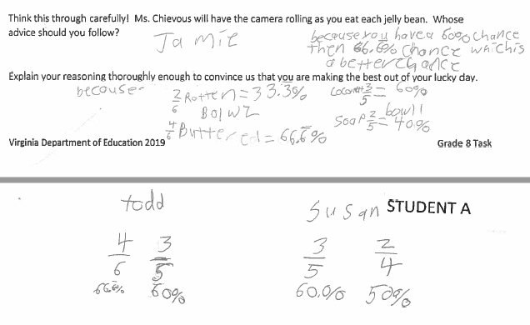

STUDENT B
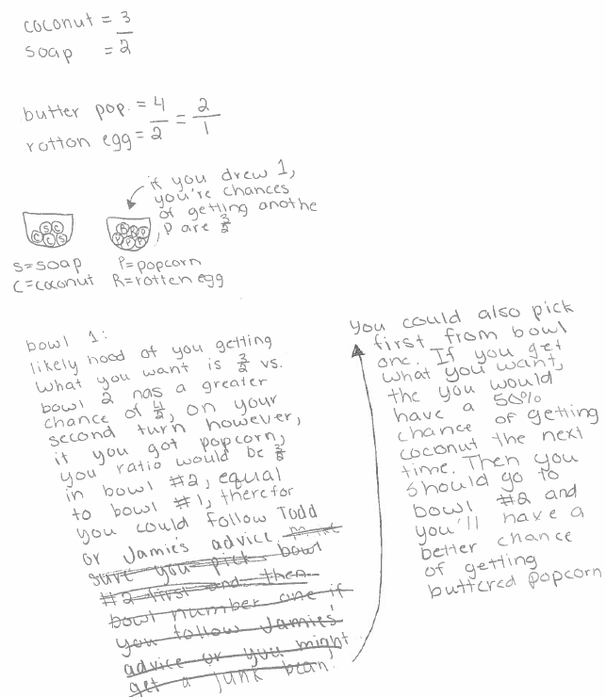
STUDENT C
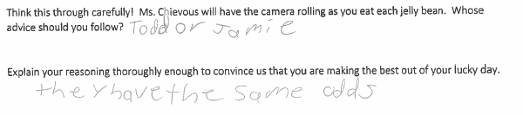
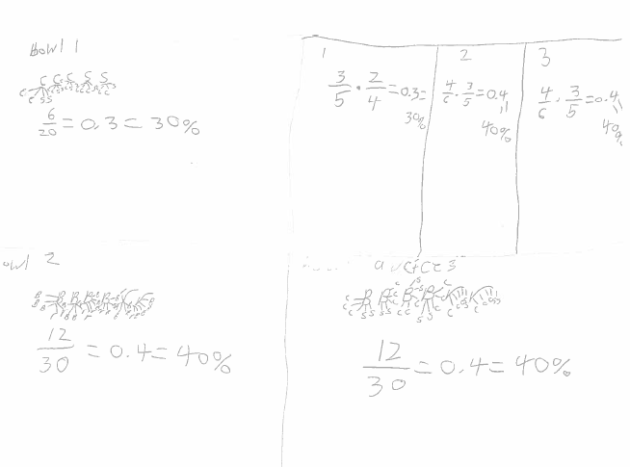
STUDENT D
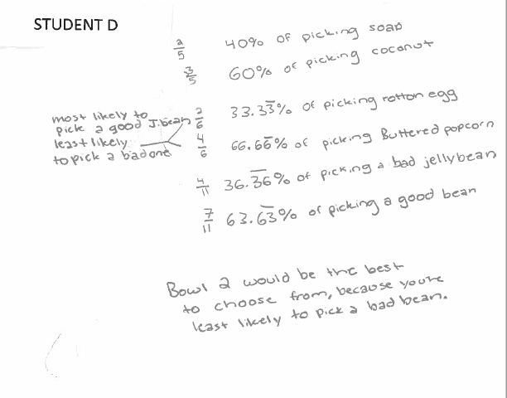

STUDENT E
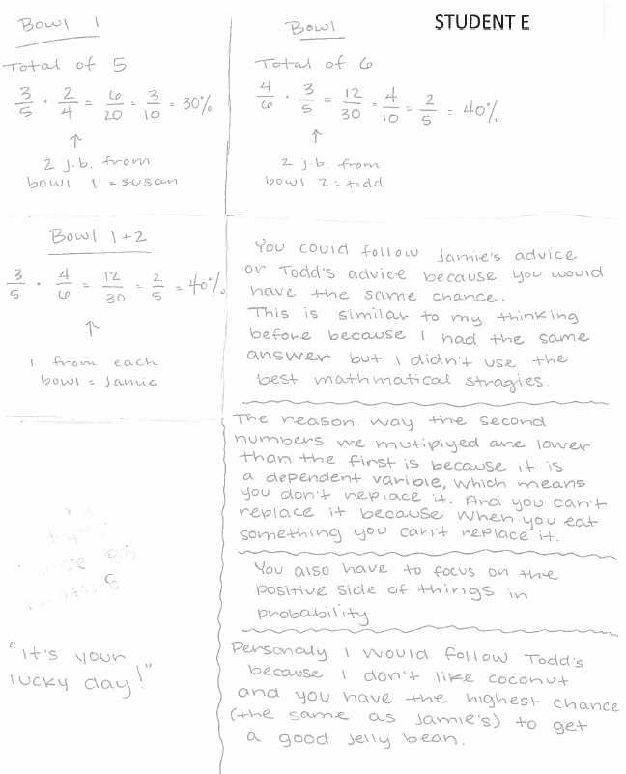
STUDENT F
