Task Overview/Description/Purpose:
- The purpose of this task is to deepen student understanding of the similarities and differences between theoretical and experimental probabilities.
- In this task, students will determine and compare theoretical and experimental probabilities with spinners that have the same number of sectors but with varying sector sizes. Students will analyze three different spinners and are challenged to determine which spinners were used to generate different experimental data sets.

Standards Alignment: Strand – Number and Number Sense
Primary SOL: 7.8 The student will a) determine the theoretical and experimental probabilities of an event; and investigate and describe the difference between the experimental probability and theoretical probability of an event.
Related SOL (within or across grade levels/courses): 4.13bc, 5.15, 6.2b, 7.1c, 8.11
Learning Intention(s):
- Content - I am learning to determine and compare theoretical and experimental probabilities of an event.
- Language - I am learning to explain my problem-solving approach verbally and in writing.
- Social - I am learning to explain my problem-solving thinking to my peers.
Success Criteria (Evidence of Student Learning):
- I can apply strategies for finding experimental probabilities with spinners.
- I can use theoretical probability to determine the frequency outputs for an experiment given a spinner with sections of different areas.
- I can describe changes in the experimental probability as the number of trials increases.
- I can actively listen to a classmate’s explanations of how they determined their experimental frequency outputs.
- I can communicate similarities and differences between my work and a peer’s work.
Mathematics Process Goals
Problem Solving | - Students will use a problem-solving strategy to determine theoretical and experimental probabilities. They will compare the difference between the probabilities of an event found through an experiment versus the theoretical probability of that same event.
Communication and Reasoning | - Students will justify their solutions verbally and with mathematical evidence.  - Students will communicate the outcomes in a practical situation and support their thinking with evidence.
Connections and Representations | - Students will make a mathematical connection between the sizes of the sectors on each spinner to the numbers given in the relative frequency table.  - Students will represent and describe mathematical ideas using a variety of methods such as fractions, decimals, and/or percents or list, tables and/or pictures.

Task Pre-Planning
Approximate Length/Time Frame: 45 minutes
Grouping of Students:
- Large group: Set the stage through a series of questions. Be sure that vocabulary has been presented in previous lessons. Set expectations for each part of the task. Present task.
- Independent Think Time: Allow students 2 minutes to think about the task without writing.
- Shoulder Partners: Allow students 2 minutes to share their ideas of how to approach the problem.
- Independent: Complete task.
- Large Group: In the closing, consider ways to ensure that each student will have an equitable opportunity to share his/her thinking during task discussion. You will select individuals to share their strategies. Have students switch relative frequency tables that were created in part b of the task to determine if it could match Raymond’s spinner.
Materials and Technology:  - Copies of task  - spinners  - calculators | Vocabulary:  - Probability  - Theoretical probability  - Experimental probability  - Chance  - Event  - Likely, not likely, equally likely  - Trials  - Data  - Law of large numbers  - Possible outcomes

Anticipate Responses: See the Planning for Mathematical Discourse Chart (columns 1-3).

Task Implementation (Before)
Task Launch:
- Display the scenario below to the class:
Mollie designed this spinner game for a class project. Predict which space (red, blue, or green) you think Mollie is most likely to spin. Explain your prediction.
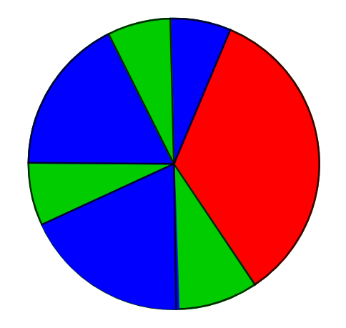
- Allow the students to talk to the partner to make a prediction and give an explanation. Then report to the class. Do not agree or disagree with their explanations.
- As a whole group, the teacher will introduce the task using a reading strategy (Three Read Protocol) to ensure all students understand what the problem is asking and the vocabulary that is used in the task.
  - First read: Students focus on what the situation is about. Teacher debrief providing clarity to the problem and addressing vocabulary questions.
  - Second read: Students identify what the quantities are in the situation. Teacher debrief.
  - Third read: Students identify the mathematical question being asked of this situation. Teacher debrief.
- Provide 2 minutes of independent think time for students without writing.
- Provide 2 minutes for shoulder partners to share their ideas without writing.
- Ask if there are any other questions, provide approximately 15 – 20 minutes for students to complete the task independently.
Task Implementation (During)
Directions for Supporting Implementation of the Task
- Monitor – The teacher will observe students as they work independently on the task. The teacher will engage with students by asking assessing or advancing questions as necessary.
- Select – The teacher will decide which strategies or thinking (how they matched the spinner to the relative frequency table) that will be highlighted (after implementation) that will advance mathematical ideas and support student learning.
- Sequence – The teacher will decide the order in which student ideas will be highlighted during the closure discussion (after implementation).
- Connect – The teacher will consider ways to facilitate connections between different student responses.
Suggestions For Additional Student Support
- Have manipulatives such as spinners out on a central table so that students can get what they need, as they need it.
- Some students get stuck at one way of thinking and using one method. Asking questions like “How confident are you?” and “What would convince someone?” will help students get past this point.
- For students with motor processing difficulties, allow them to communicate the reasoning in other ways such as video recording or typing answers.
- For students with attention challenges, uncover one question at a time.
- For students who need academic language support, consider the use of a visual word wall or reference sheet that includes such terms as probability, theoretical probability, chance, events, likely, and not likely
- For students who need more support in justifying their thinking, you may choose to provide them with the sentence frames below.
  - What I know about the probability is …
  - I chose this table ____for this spinner _____ because….
  - My method for solving the problem was…
- For English learners with first language literacy, try to provide prompt, or parts of prompt, in their home language

Task Implementation (After) 20 minutes
Connecting Student Responses (From Anticipating Student Response Chart) and Closure of the Task:
- Based on the actual student responses, sequence and select particular students to present their mathematical work during class discussion. Suggested sequence would be:
- Students that manipulate the size of the sectors by dividing the spinners so that all the spaces are equal in size.
- Students that used fractions to solve the problem.
- Students that used percentages to solve the problem.
- Lead the class discourse to identify the similarities and differences between the methods used.
- Connect different students’ responses and connect the responses to the key mathematical ideas to bring closure to the task. Possible questions, sentence frames, and strategies to connect student strategies:
- How are these strategies alike? How are they different?
- Where do you see _______’s representation in _________’s work?
- Connect different students’ responses to theoretical and experimental probability.
  - During the discussion, ask students to explain the meaning of any terminology they use.
  - Press students on unsubstantiated claims.
  - For the last question, ensure students are relating their answers to the law of large numbers.
- Consider ways to ensure that each student will have an equitable opportunity to share his/her thinking during task discussion. For instance, provide the students whose work was not selected as part of the sequence of student work that will be shown the opportunity to validate and/or question what they see.

Teacher Reflection About Student Learning:
- Were the instructional objectives met? Were the students able to apply strategies for finding experimental probabilities?
- Were the process goal objectives met? Were students able to explain their work verbally (oral or written)? Does vocabulary need further development?
- Were the students productively engaged?
- Was enough support provided during the task using the chart of anticipated responses? Did additional responses occur that were not anticipated?
- What strategies did the students struggle with the most? Were there reoccurring student misconceptions?
- How will the evidence provided through student work inform further instruction?
- Did the task rubric assist in identifying students who need additional support? What additional assistance and support will be needed for students who are developing or emerging?

Planning for Mathematical Discourse
Mathematical Task: __Spin, Spin, Spin___ Content Standard(s): __SOL 7.8____
Anticipated Student Response/Strategy  Provide examples of possible correct student responses along with examples of student errors/misconceptions | Assessing Questions  Teacher questioning that allows student to explain and clarify thinking | Advancing Questions  Teacher questioning that moves thinking forward | List of Students Providing Response Who? Which students used this strategy? | Discussion Order - sequencing student responses  - Based on the actual student responses, sequence and select particular students to present their mathematical work during class discussion  - Connect different students’ responses and connect the responses to the key mathematical ideas  - Consider ways to ensure that each student will have an equitable opportunity to share his/her thinking during task discussion
Anticipated Student Response:  No approach.  Student has no idea where to begin.  “I don’t know what to do.” | - What are you thinking?  - What facts do you have?  - How would you explain the problem in your own words? | - Can you simulate what your data might look like for each spinner?
Anticipated Student Response:  Logical Thinking Approach  “I just know that the answer is…” | - How do you know?  - Walk me through the steps. Where did you begin?  - How does this help you answer the question? | - Use a mathematical model to represent your thinking?  - What math terms can you use in your justification?
Anticipated Student Response:  Student divides the spinners so that all the spaces are equal in size. | - How did you know how to divide the spinner?  - Can the sections be divided into smaller sections? | - Can you think of another way to justify your solutions?
Anticipated Student Response:  Student uses fractions or percentages | - What do these fractions or percentages represent?  - Why did you choose this number for your denominator? | - Can you think of another way to justify your solutions?  - Can you explain how your fractions connect to the pictures of the spinners?

Name _________________________________________ Date ____________________
Spin, Spin, Spin!
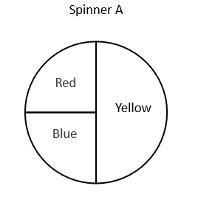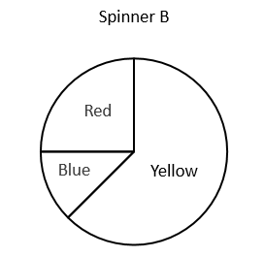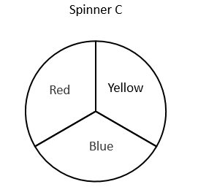
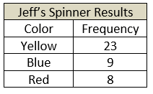
Tiana, Raymond and Jeff each used a different spinner shown above to record the results of 40 spins. The results for two of them are shown in the tables below.
Tiana’s Spinner Results
Color | Frequency
Yellow | 12
Blue | 14
Red | 14

- Determine which spinner most likely belongs to each person. Show your work. Explain how you know.

- Raymond used the remaining spinner. Create a table to show the possible results for Raymond’s 40 spins. Explain your reasoning.

- If Tianna were to spin her spinner one more time, what would you expect it to land on? Justify your thinking.

- If Jeff spins the spinner many more times, how would you expect his results to change? Justify your thinking.

Rich Mathematical Task Rubric
 | Advanced | Proficient | Developing | Emerging
Mathematical  Understanding | Proficient Plus:  - Uses relationships among mathematical concepts or makes mathematical generalizations | - Demonstrates an understanding of concepts and skills associated with task  - Applies mathematical concepts and skills which lead to a valid and correct solution | - Demonstrates a partial understanding of concepts and skills associated with task  - Applies mathematical concepts and skills which lead to an incomplete or incorrect solution | - Demonstrates no understanding of concepts and skills associated with task  - Applies limited mathematical concepts and skills in an attempt to find a solution or provides no solution
Problem Solving | Proficient Plus:  - Problem solving strategy is well developed or efficient | - Problem solving strategy displays an understanding of the underlying mathematical concept  - Produces a solution relevant to the problem and confirms the reasonableness of the solution | - Problem solving strategy displays a limited understanding of the underlying mathematical concept  - Produces a solution relevant to the problem but does not confirm the reasonableness of the solution | - A problem solving strategy is not evident  - Does not produce a solution that is relevant to the problem
Communication  and  Reasoning | Proficient Plus:  - Reasoning or justification is comprehensive  - Consistently uses precise mathematical language to communicate thinking | - Demonstrates reasoning and/or justifies solution steps  - Supports arguments and claims with evidence  - Uses mathematical language to communicate thinking | - Reasoning or justification of solution steps is limited or contains misconceptions  - Provides limited or inconsistent evidence to support arguments and claims  - Uses limited mathematical language to partially communicate thinking | - Provides no correct reasoning or justification  - Does not provide evidence to support arguments and claims  - Uses no mathematical language to communicate thinking
Representations  and  Connections | Proficient Plus:  - Uses representations to analyze relationships and extend thinking  - Uses mathematical connections to extend the solution to other mathematics or to deepen understanding | - Uses a representation or multiple representations, with accurate labels, to explore and model the problem  - Makes a mathematical connection that is relevant to the context of the problem | - Uses an incomplete or limited representation to model the problem  - Makes a partial mathematical connection or the connection is not relevant to the context of the problem | - Uses no representation or uses a representation that does not model the problem  - Makes no mathematical connections

