Name_______________________________________ Date_____________________

Spin, Spin, Spin!

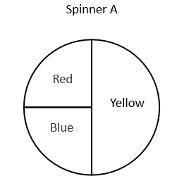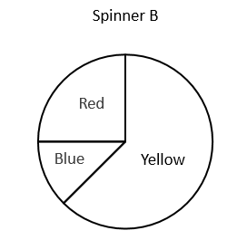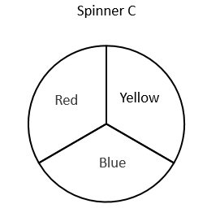
Tiana, Raymond and Jeff each used a different spinner shown above to record the results of 40 spins. The results for two of them are shown in the tables below.
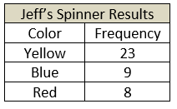
Tiana’s Spinner Results
Color | Frequency
Yellow | 12
Blue | 14
Red | 14

- Determine which spinner most likely belongs to each person. Show your work. Explain how you know.

- Raymond used the remaining spinner. Create a table to show the possible results for Raymond’s 40 spins. Explain your reasoning.

- If Tianna were to spin her spinner one more time, what would you expect it to land on? Justify your thinking.

- If Jeff spins the spinner many more times, how would you expect his results to change? Justify your thinking.

