Name_________________________________ Date________________________
Expressions for Gardening
Part 1:
Farmer Brown planted a vegetable garden. It was split into four sections.
- In section 1, the farmer planted lettuce.
- In section 2, he planted strawberries.
- In section 3, Farmer Brown planted some tomatoes.
- In section 4, he planted corn.
The measurements for each section are given as variable terms.
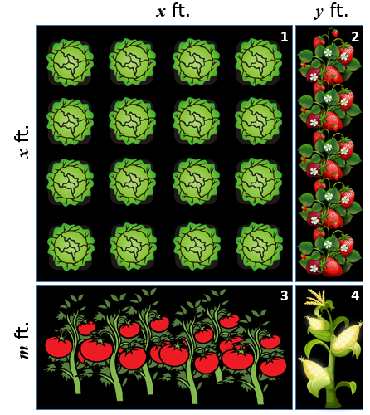
Farmer Brown needs to cover the entire garden with fertilizer.
If $m=3\frac{3}{5}$, $x=10$, and $y=2\frac{1}{2}$, what is the total area of the garden? Explain how you arrived at your solution.

Part 2:
Farmer Brown frequently plants gardens like this, with four sections that all need to be fertilized.
He knows there must be an algebraic expression that could be used to calculate the total area for any of his gardens.
He promises his two children that he will build them a treehouse in his spare time if they can help him by making one of these time-saving expressions.
Each child came up with their own possibility.

Daughter Brown | Son Brown
$$x^{2}+xy+mx+my$$ | $$(x+m)(x+y)$$

Decide which of Farmer Brown’s children is correct, and explain Daughter Brown and/or Son Brown’s reasoning for why their expression should work.

Sequel:
Farmer Brown is offering to come plant one of his gardens for you with one criteria: the total area must be 122.5 ft².
Determine values for m, x, and y that will create a garden to match Farmer Brown’s criteria.
Explain how you found these values and why you are confident that they will produce the required total area.
Also, let Farmer Brown know what you plan to plant in each section and why you made each of those selections.

