Summer Passes

Michael, Susie, and Karl plan to purchase summer passes to a local amusement park. They decide to work summer jobs to earn the money for the summer passes.
- Michael will babysit his little brother every day. He will earn $10 a day for babysitting.
- Susie’s sister has a summer lawn care business. Susie will help her sister pull weeds out of the flower beds every day. Her sister will pay her $50 upfront and then a dollar each day.
- Karl has already saved $35 for his summer pass. His mom agrees to give him one dollar for every day that he does his chores. Karl does his chores every day.

If a summer pass to the amusement park costs $86, who will be the first one to have enough money to buy the pass? How long will it be before they can all go together? Explain your reasoning and give evidence of your position.

STUDENT A
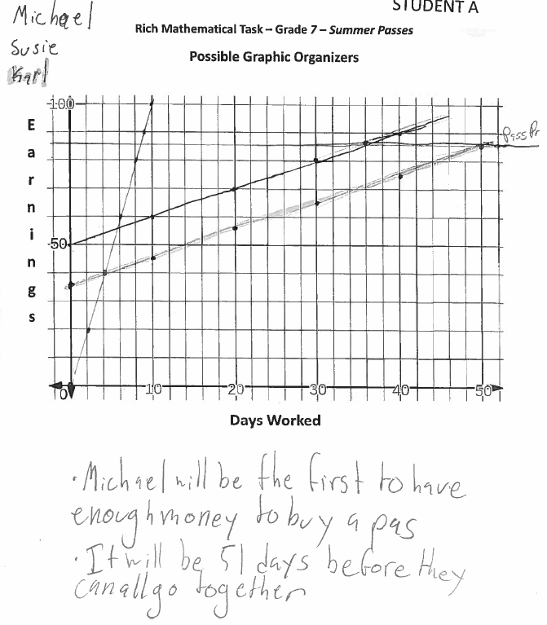
STUDENT A Continued
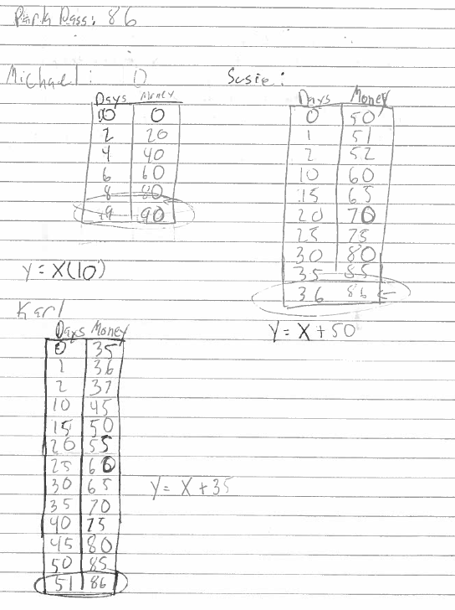
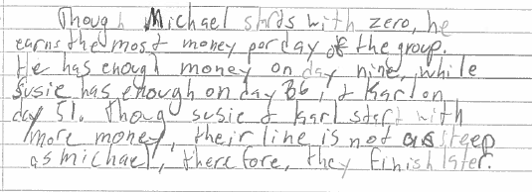
STUDENT B
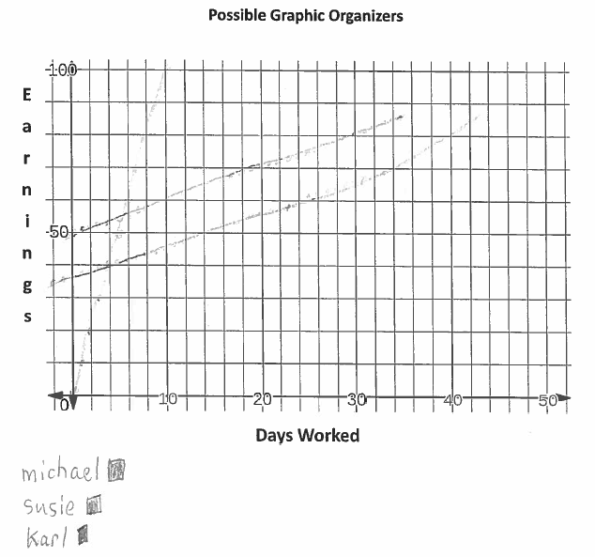
STUDENT B Continued
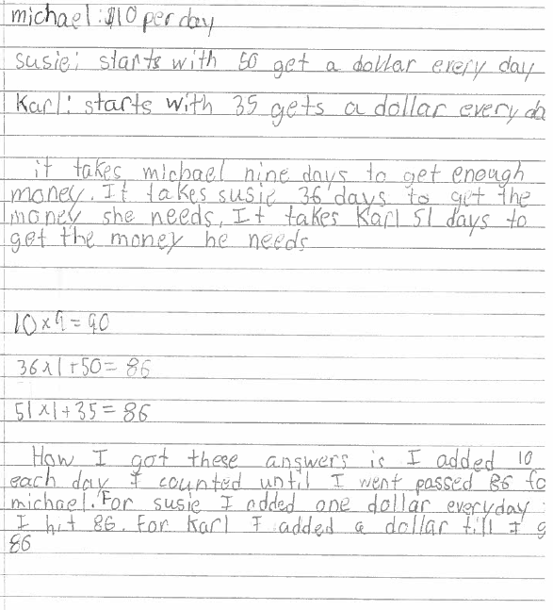
STUDENT B Continued
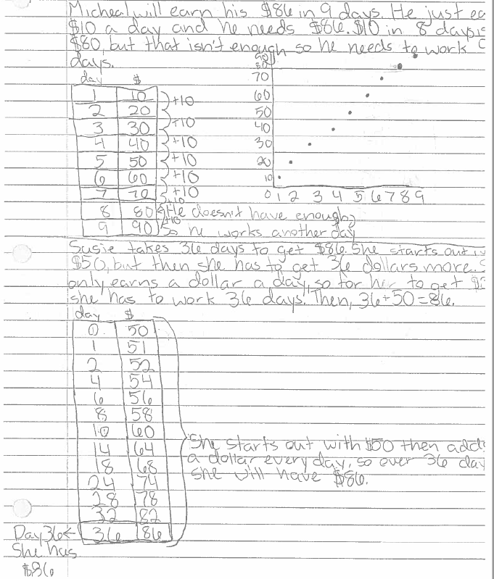
STUDENT B Continued
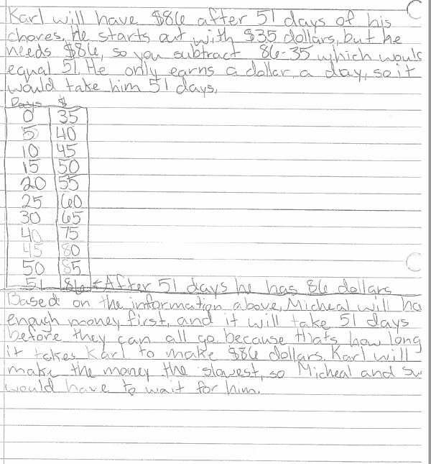
STUDENT C
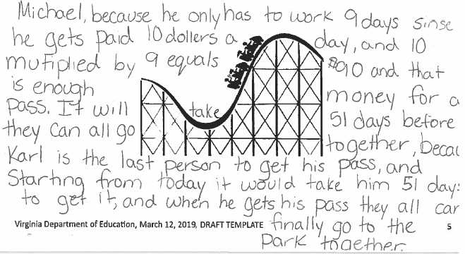
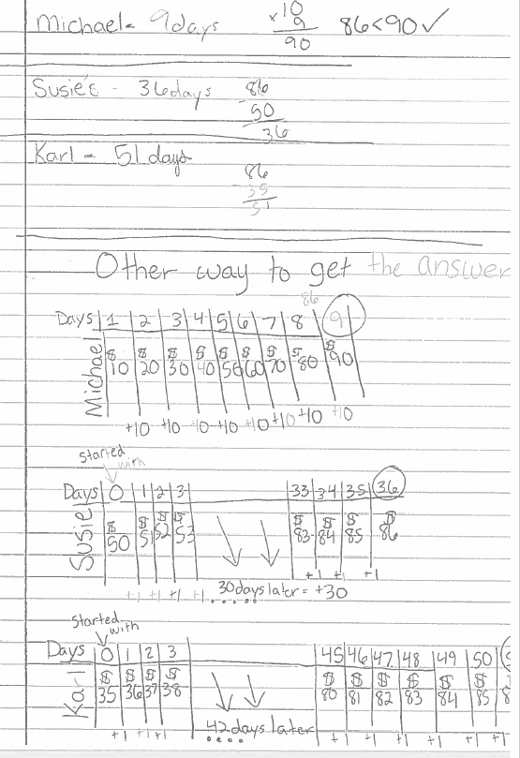
STUDENT D
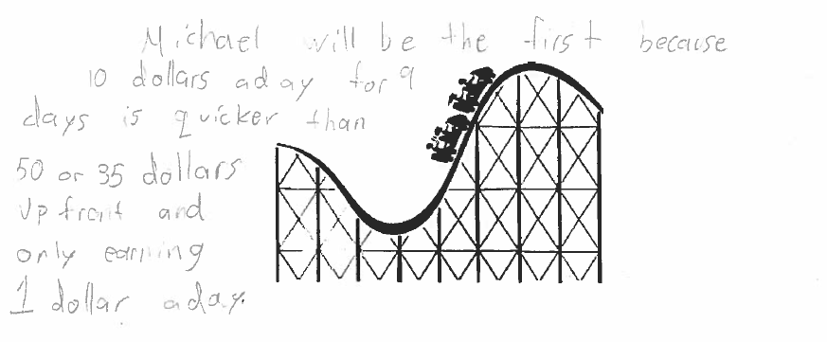
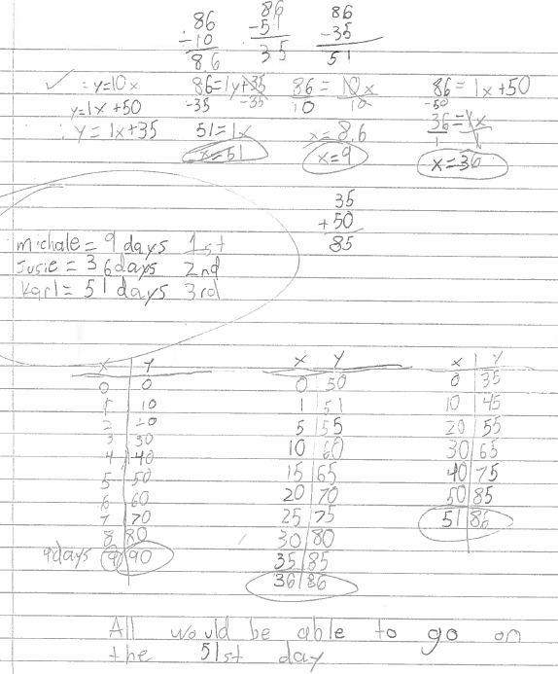
STUDENT E
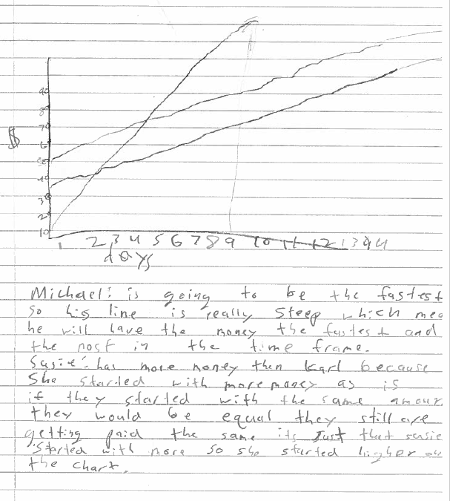
STUDENT F
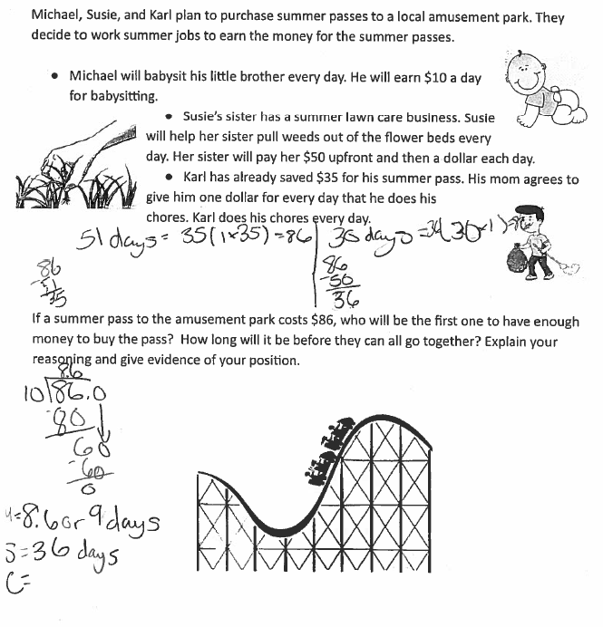
STUDENT F Continued
