Name________________________________________________ Date_____________________

A Walk in the Park

The distance around a parallelogram park is 324 yards.
- Paul’s house and Marco’s house are on opposite corners. There is a 57-yard sidewalk that connects these two houses.
- The school and the library are also on opposite corners. There is a 150-yard sidewalk that connects these two locations.
- The distance between Marco’s house and the school is 86 yards, however this road is closed for construction and unpassable. The only way to get from Marco’s to the school is to walk through the park.
It has been raining for a few days, so Paul can only walk on the pathways or roads. Paul first walks to school. After school, he must go to the library and Marco’s house before returning home. What is the shortest route Paul can take? Justify how you know it is the shortest route.

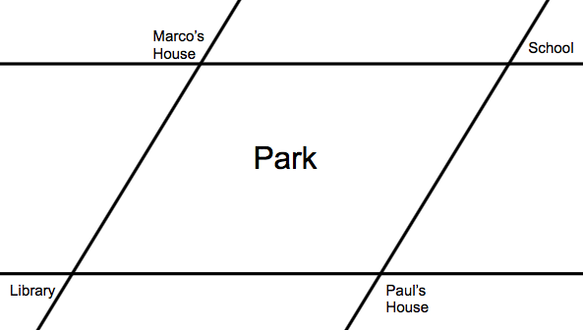

How much further did he have to walk because the road was closed?

