Name___________________________________________ Date_________________________

Designing a Shipping Box Filled with Candy

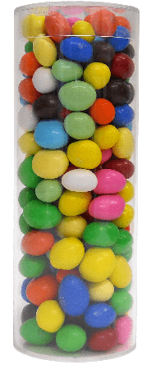
A candy company wants you to design a shipping box that will contain 16 candy containers.
Your design must consider the following:
- The candy container is a cylinder that is 8 inches tall and 3 inches in diameter.
- The needed shipping box must be made in the form of a rectangular prism.

- Draw a picture of your shipping box with its labeled dimensions. Explain how you determined your dimensions.

- Determine the amount of cardboard needed to make your shipping box. Explain how you determined your answer.

- Compare your shipping box with a classmate’s shipping box that is different. Decide which shipping container is the most efficient in terms of the amount of cardboard needed?

