Planning a Dog Park
Your parents have asked you to design an enclosed area in your backyard for your dog.
- The enclosed area can be in the shape of a square or a rectangle.
- The area will be enclosed with a fence that cannot be attached to another structure (i.e., the house, shed, etc.).
- There is 72 yards of fencing available.
- The dimensions of your rectangular backyard is 30 yards by 35 yards.
What is the largest area in your backyard that can be enclosed for your dog? What are the dimensions of this enclosed area? Justify how you know that your design provides the largest area.

Sequel: What is the largest area in your backyard for your dog if the enclosure can be a circle? How does this change your answer?
STUDENT A
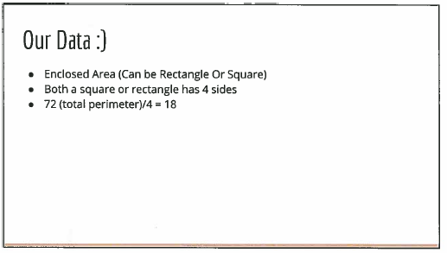
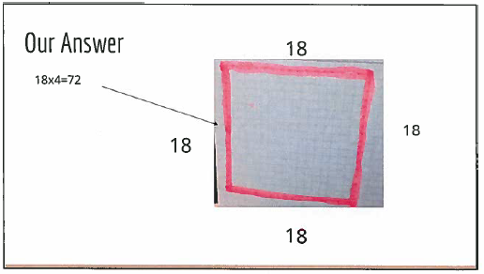
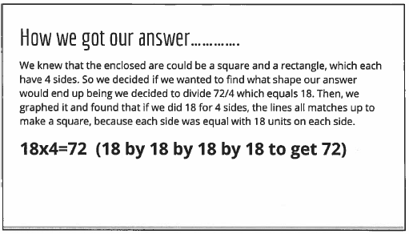
STUDENT B
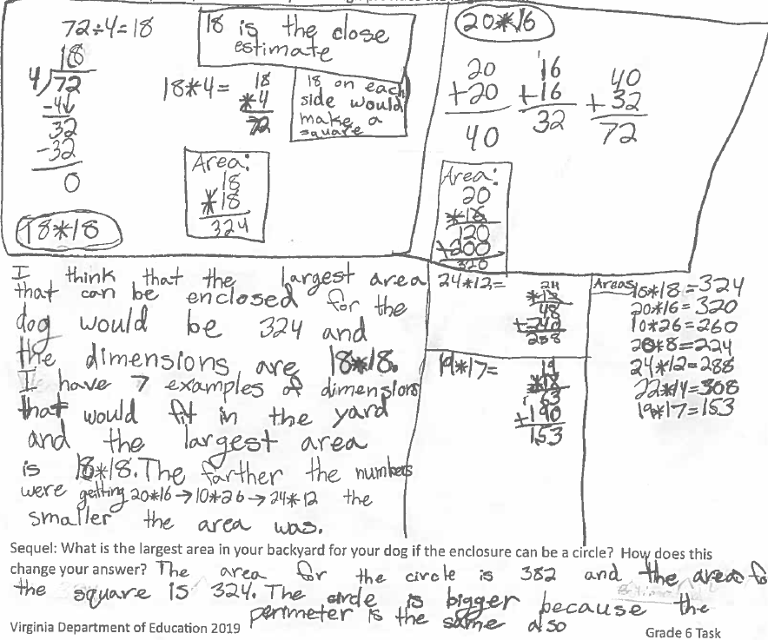
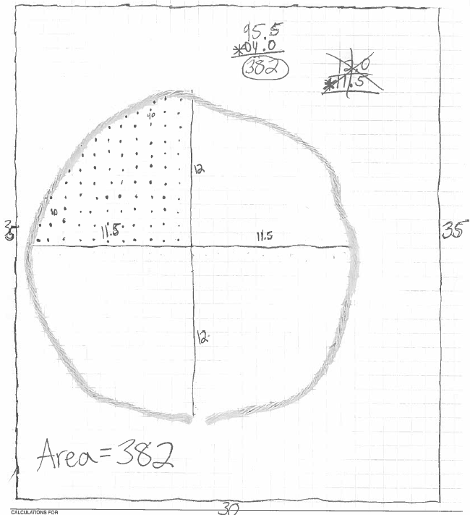
STUDENT C
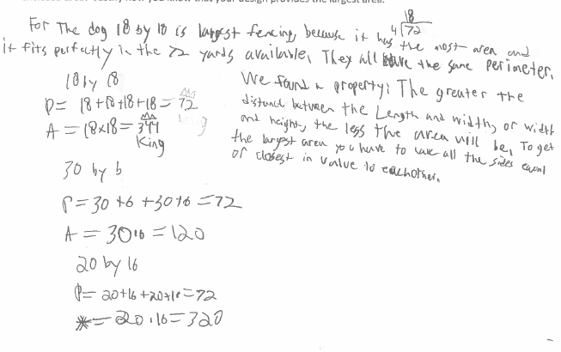
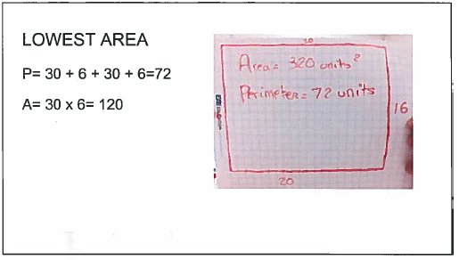
STUDENT C continued
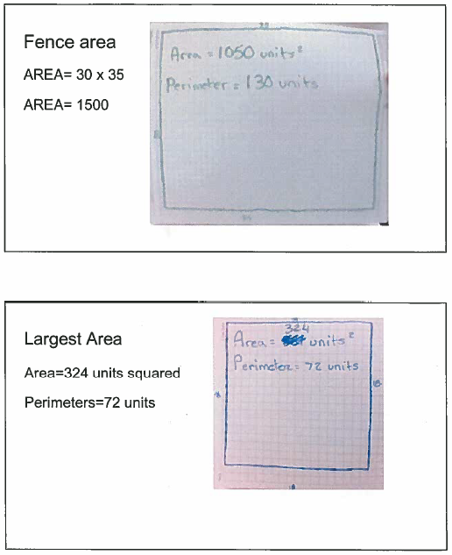
STUDENT D
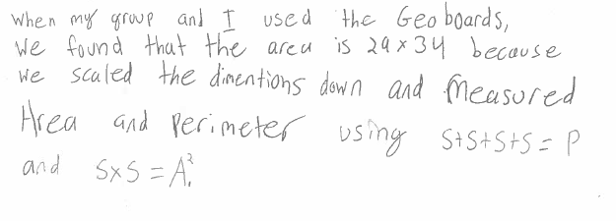
STUDENT E
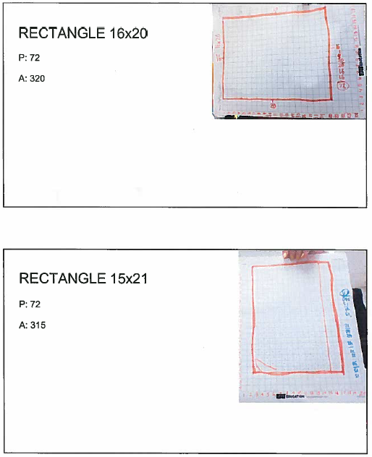
STUDENT E Continued
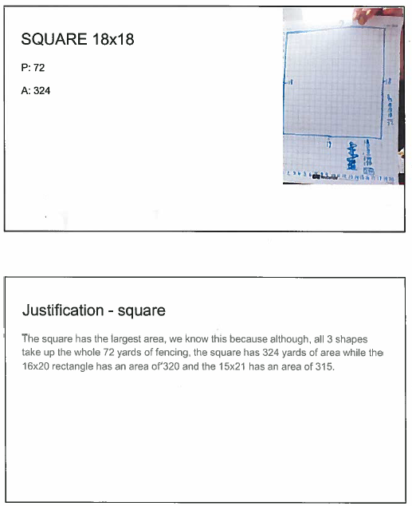
STUDENT E Continued
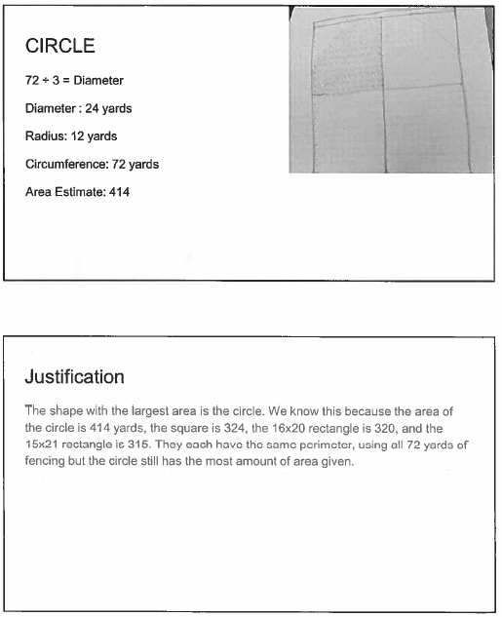
STUDENT F
