**Designing Windows**

Student A

Marisol designs windows. She has been asked to create different colored glass for each polygon within the stained glass window below. Marisol needs to measure each angle, but her protractor is broken. She recorded the following facts to help her find the angle measurements:

* Polygon ACEF is a square
* Polygon DEFG is a rectangle

PIcture of the Window

1. Without using a protractor, determine and label the angle measurements for the shaded shape. Describe the strategy you used to determine the angle measurements of the shaded shape.

1. Marisol was able to find 16 angle measurements for the window. Using a strategy, label as many angles as possible. Be prepared to prove your thinking.

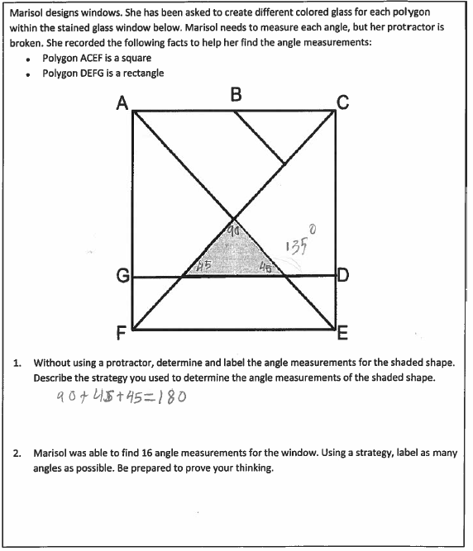

Student A Continued

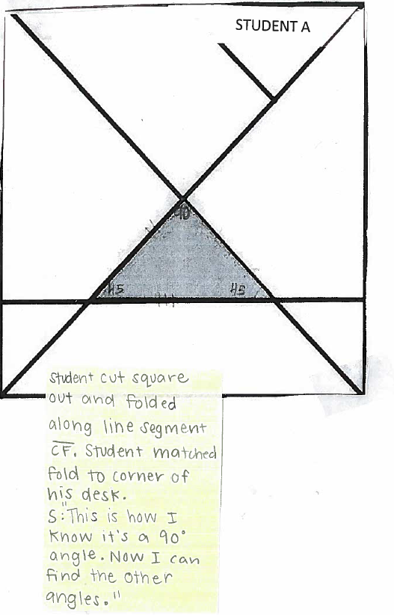

Student B

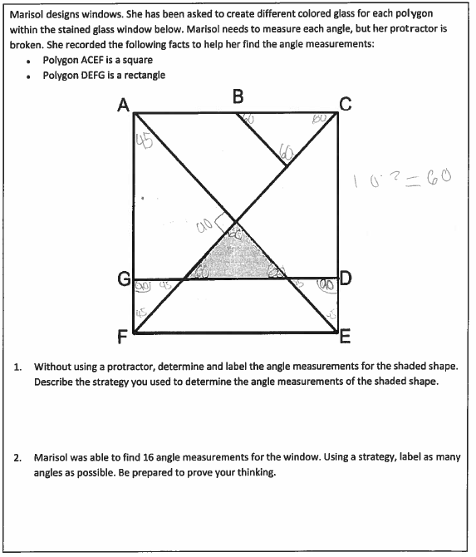

Student B continued

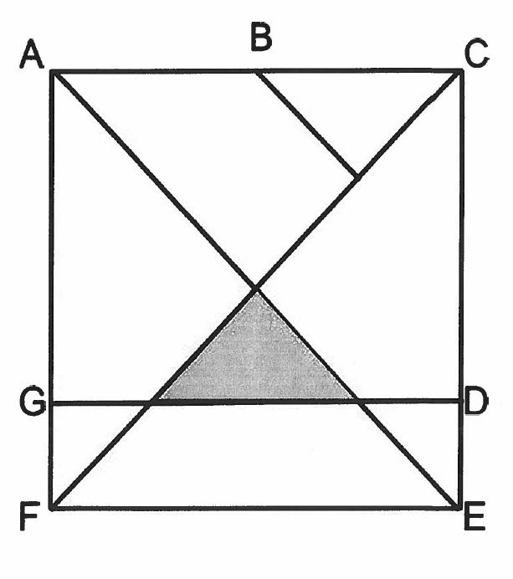

Student C

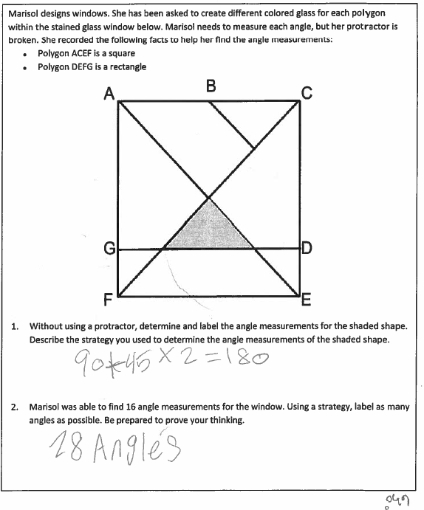

Student C Continued

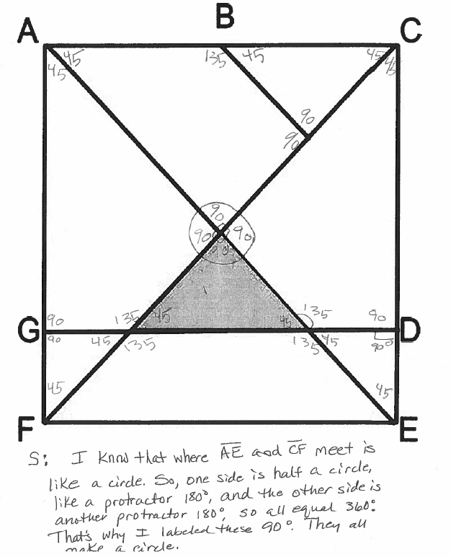

Student D

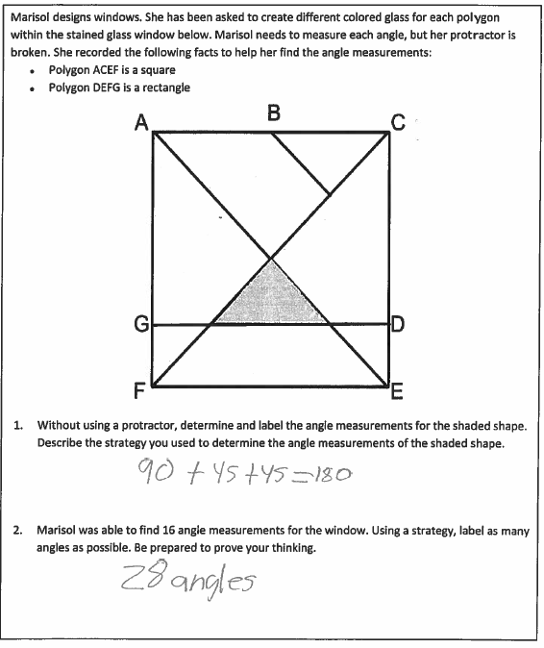

Student D Continued

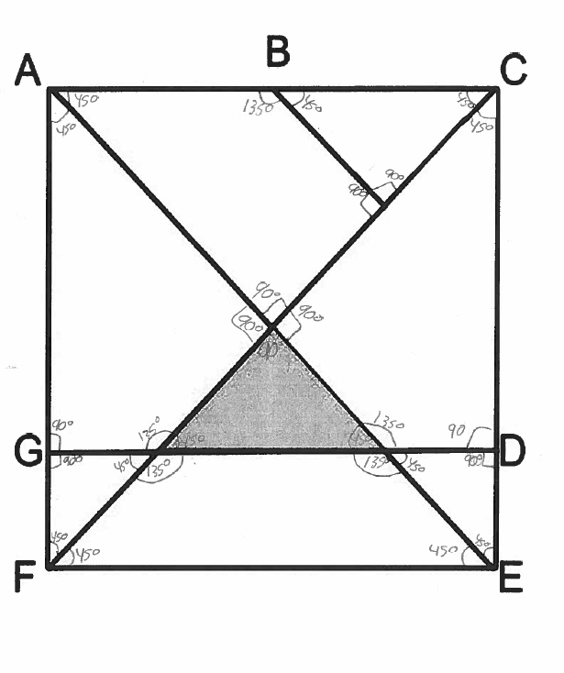

Student E

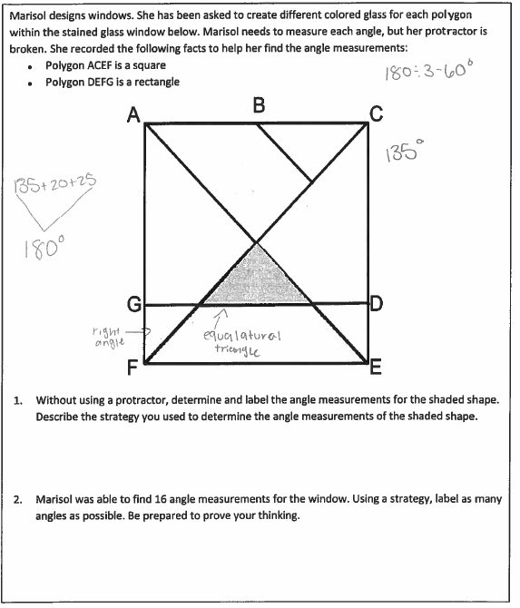

Student E Continued

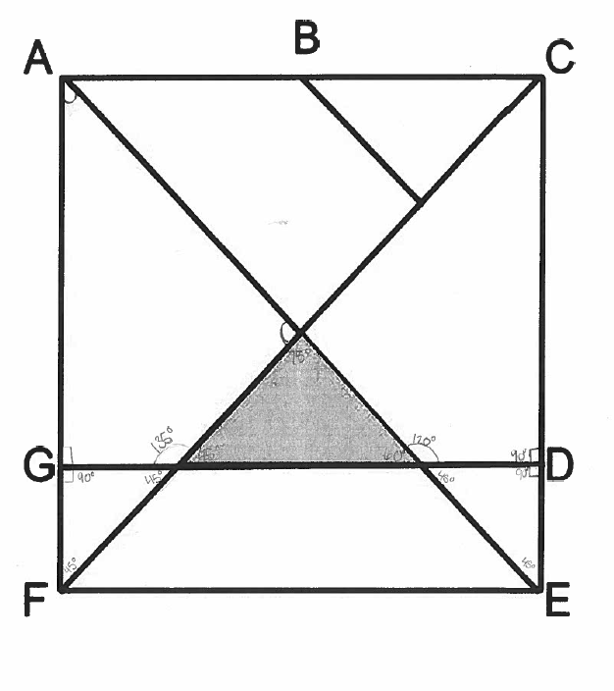

Student F

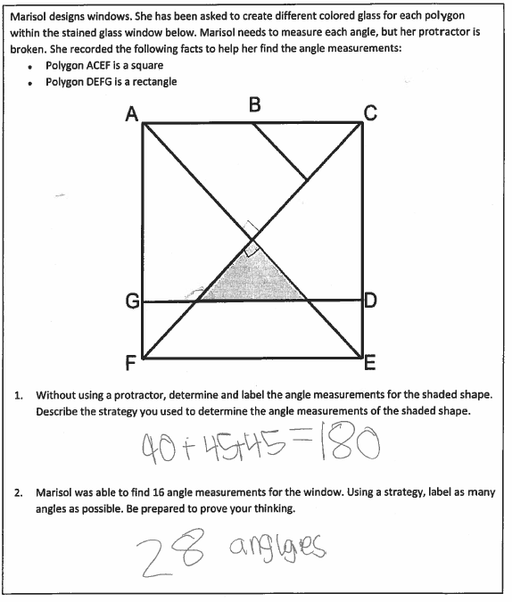

Student F Continued

