**Bus A or Bus B?**

You will take a bus trip across the country to see a professional football game. You have a choice of two buses. (Both bus trips will arrive the day before the game.)

* Bus A departs at 7:47 am and arrives at 8:14 pm.
* Bus B is 12 hours and 53 minutes in length. Both trips cost $200. Which bus would you choose, Bus A or Bus B? Why?

Show your thinking using pictures, words, and symbols.

STUDENT A

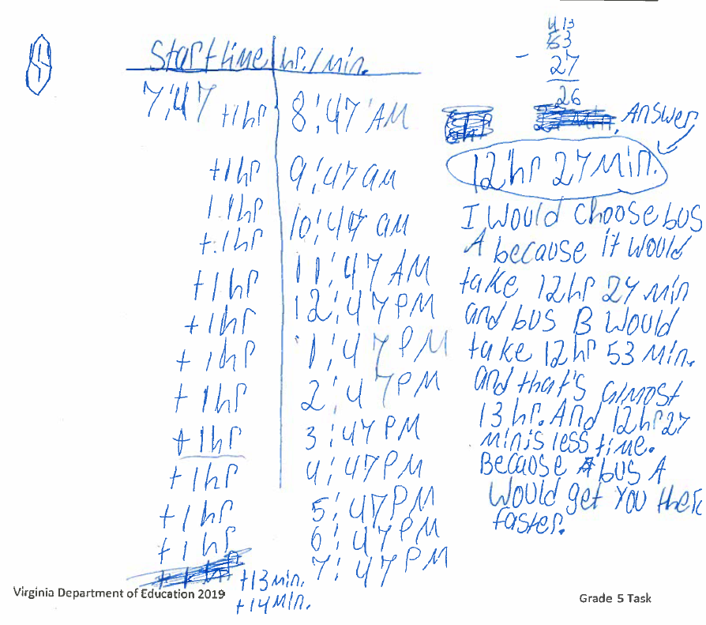

Student B

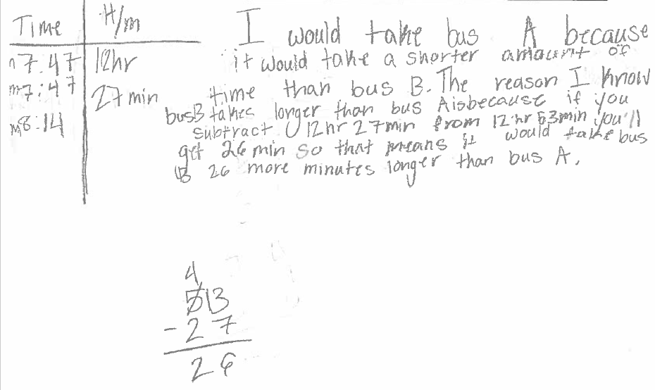

Student C

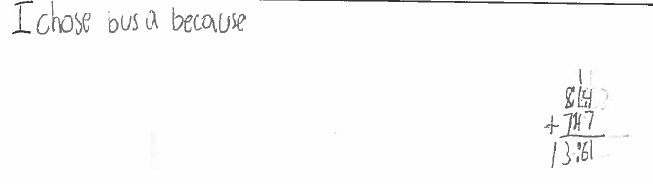

Student D

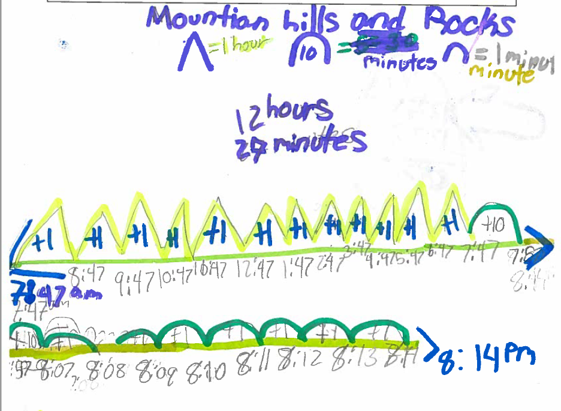

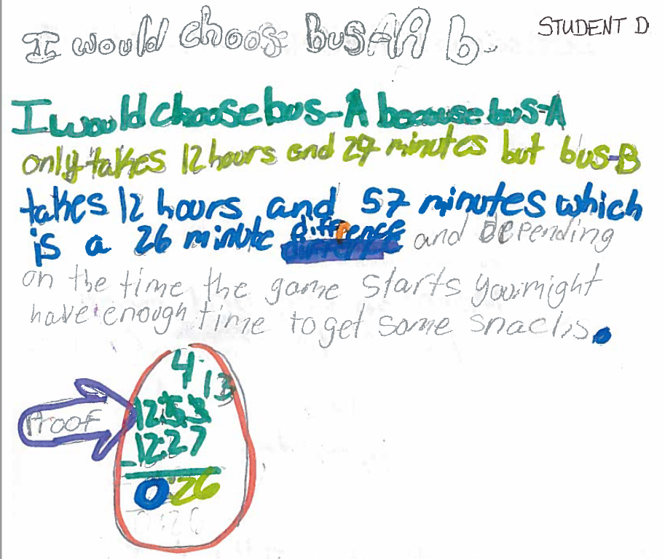

Student E

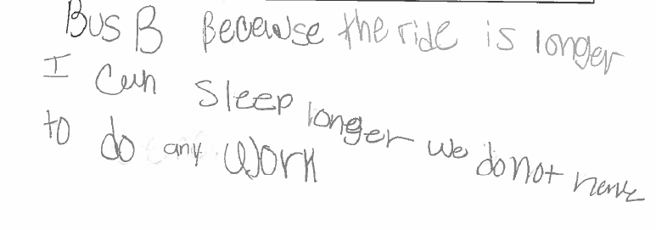

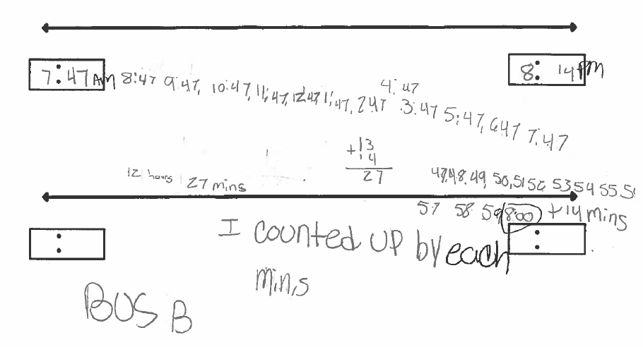

Student F

