Name ___________________________ Date __________________
Equality Possibilities
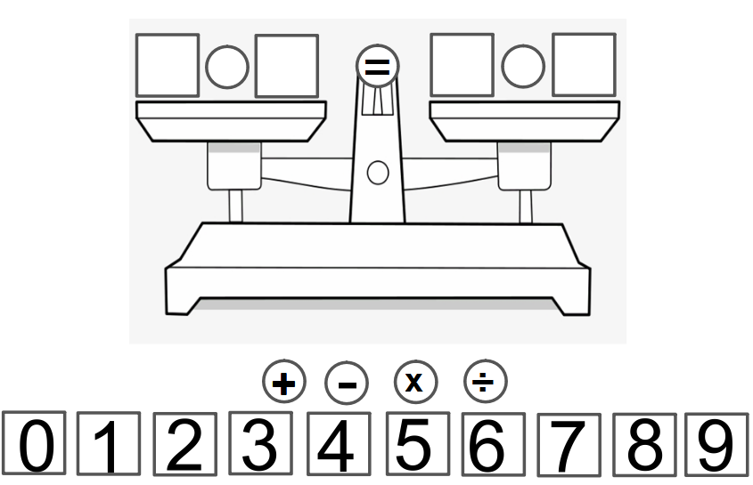

- What numbers and operations would make this equation true?
- How many possibilities can you come up with? Show more than one way.
- Show your thinking using pictures, words, and symbols.

