Name ___________________________ Date _____________________
Exploring Quadrilaterals
Create a quadrilateral to place in at least 3 different boxes on the attached grid based on the number of pairs of parallel sides and congruent sides. Create drawings that represent your shapes and explain why they fit using mathematical vocabulary. Use any available tools to assist with your drawings.

Shape ____ makes sense because _______________________________________________________________________

_______________________________________________________________________

_______________________________________________________________________

Shape ____ makes sense because _______________________________________________________________________

_______________________________________________________________________

_______________________________________________________________________

Shape ____ makes sense because _______________________________________________________________________

_______________________________________________________________________

_______________________________________________________________________

Keep thinking!
Are there any boxes in the grid that could have more than one quadrilateral? Explain.

Were there any boxes for which no quadrilateral would fit? Explain.

 | DA  DA | Pairs of Congruent Sides
 | A | 0  B | 1  C | 2
Pairs of Parallel Sides | 0 | 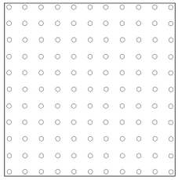
 | 1  D  G | E |  | F
 | 2 | H |  | I

