Name_________________________________ Date________________________

Lunch at Leonardo’s
Creek has $25 to spend on lunch at Leonardo’s Pizza and Subs Restaurant. He wants to buy lunch for himself and his friend Nolan.
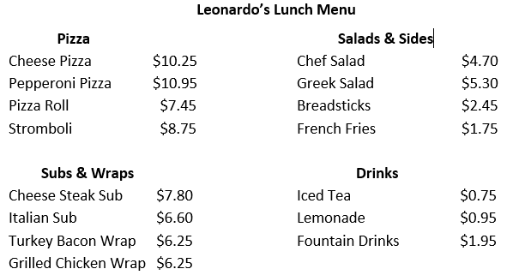
Use the menu above to plan Creek’s lunch purchase at Leonardo’s.
- About how much do you think lunch for Creek and Nolan will cost? About how much money do you think Creek will have left over after he buys lunch?
- Create a lunch order for both Creek and Nolan. Determine the cost of each lunch and the amount of money Creek will have left.
- Justify your thinking using pictures, numbers, and words.

