Rich Mathematical Task – Grade 4 – Pouring Paints

Task Overview/Description/Purpose:
- Uh oh! There is leftover paint in several cups in art class. Marie has been tasked with combining the paint into only one. Can you help her?
- In this task students will explore combining fractional parts in order to develop mathematical understanding of addition of fractions.
- The purpose of this task is to deepen understanding about combining fractions with unlike denominators in connection to the concept of one whole.

Standards Alignment: Strand – Computation and Estimation
Primary SOL: 4.5 The student will
c) solve single-step practical problems involving addition and subtraction with fractions and mixed numbers.
Related SOL (within or across grade levels/courses): 3.5, 4.2b*, 4.5b, 5.6ab
*On the state assessment, items measuring this objective are assessed without the use of a calculator.
Learning Intentions:
- Content - I am learning to apply strategies to solve practical problems involving addition with fractions having unlike denominators.
- Language - I am learning how to use part/whole and fraction language to explain my mathematical thinking.
- Social - I am learning to make connections between my peer’s strategy and my own.
Evidence of Student Learning:
- I can solve a practical problem involving addition with fractions having unlike denominators.
- I can communicate my mathematical thinking to my peers using fraction language such as part/whole.
- I can use at least one representation to support my mathematical thinking.
- I can make connections between different representations of mathematical thinking.
Mathematics Process Goals
Problem Solving | - Students will choose an appropriate strategy or strategies to combine the paint into one container.  - Students will accurately apply their strategy to obtain at least one valid solution.
Communication and Reasoning | - Students will communicate their thinking process of combining paint into one container to their peers and their learning community.  - Students will justify their solution steps in an organized and coherent matter.  - Students will use appropriate mathematical language, including part/whole and fraction vocabulary, to express ideas with accuracy and precision.
Connections and Representations | - Students will show at least one representation to explore and model the problem and their solution steps.  - Students will describe connections between their representation and the representations of their peers.  - Students will make connection to mathematical ideas, such as concept of one whole, part/whole, equivalent fractions and combining parts.

Task Pre-Planning
Approximate Length/Time Frame: 60 minutes
Grouping of Students: Students will begin working independently, then will be purposefully partnered based on teacher monitoring of strategies.
Materials and Technology:  - fraction circles  - Cuisenaire rods  - fraction strips  - anchor chart paper and markers  - paper, pencil  - copy of task, graphic organizer | Vocabulary:  fraction  part, whole  numerator, denominator  sum  equivalent fraction  common denominator

Anticipate Responses: See the Planning for Mathematical Discourse Chart (columns 1-3).

Task Implementation (Before) 10-15 minutes
Task Launch:
- The teacher will display the Notice/Wonder version of the task and read it aloud.
- Next, students will engage in a notice/wonder group discussion while the teacher facilitates and records on a T-chart. See example:
Notice | Wonder
- Some important ideas to listen for and expand upon are:
  - Each cup must contain 1 whole or less
  - Cups are all the same size
  - Marie’s cup is the same size as the cups from the tables
  - Connections to self
- The teacher will then give students the directions of the task alongside the “I Can” statements. Following independent think time, students will be able to share their mathematical thinking with a partner. Partnerships will decide on a strategy to demonstrate on anchor chart paper.
- The teacher will ask the questions to make sure the task is understood: “What are we trying to figure out?” “What do you already know that can help you get started?”
Task Implementation (During) 25- 30 minutes
Directions for Supporting Implementation of the Task
- Monitor – Teacher will listen and observe students as they work on task and ask assessing or advancing questions (see chart on page 4)
- Select – Teacher will decide which strategies or thinking will be highlighted (after student task implementation) that will advance mathematical ideas and support student learning
- Sequence – Teacher will decide the order in which student ideas will be highlighted (after student task implementation)
- Connect – Teacher will consider ways to facilitate connections between different student responses
- Students have independent think time for 5-10 minutes.
- Students work in purposefully planned partnerships for 20-25 minutes to share strategies, decide on one to present, and transfer their ideas to anchor chart paper to share.
    - As teacher is monitoring, teacher will look for partnerships that make sense depending on what students are doing independently.
    - Partnerships could be planned to counter misconceptions, move someone along in the sophistication of ideas, or to explore different ways to solve the same problem.
Suggestions For Additional Student Support
- Sentence frames for supporting student-to-student discourse:
  - I noticed _______, so I __________.
  - My partner noticed _______, so they ________.
  - First I _______, then I _________.
- Graphic organizer of cups for students to choose to use
- Wide variety of manipulatives available for students to choose -- possible choices could be:
  - Fraction circles
  - Cuisenaire rods
  - Fraction bars
  - Fraction strips
- Students who have visual-processing disabilities may benefit from the use of highlighters or colored pencils to emphasize important parts of the task (i.e. the teacher might highlight the question).
- Students who have memory disabilities may benefit from role-playing to combining of paint into cups or explicit connection of the context of the task to the student’s own experiences in school.
- Students who have attention-deficit disabilities may benefit from pre-teaching of any underdeveloped fraction vocabulary using the Frayer Model or other graphic organizer and/or pre-teaching reading comprehension strategies alongside task for understanding of task.
- Students who have cognitive and metacognitive disabilities may benefit from pre-teaching a modeled think-aloud for problem-solving a different problem and/or generating a list of strategies the student uses to solve similar types of fraction problems.
- Provide sentence frames to support student justifications and explanations of mathematical processes such as:
  - I would combine cups __ and __. I can add/ I added...
  - ___ and ____ are parts of a whole. When I add them, I get ___.
  - To add denominators of two unlike fractions, I could ….
  - ___ and ___ are equivalent fractions. I know this because ….
  - If I add __ and ___, the cup would overflow because they equal more than one whole.
- Motions and/or visuals to help remember vocab/concepts: fill, overflow, part/whole
Task Implementation (After) 15-20 minutes
Connecting Student Responses (From Anticipating Student Response Chart) and Closure of the Task:
- Based on the actual student responses, sequence and select particular students to present their mathematical work during class discussion. Some possible big mathematical ideas to highlight could include:
  - a common misconception;
  - trajectory of sophistication in student ideas (i.e. concrete to abstract; learning trajectories for addition of fractions);
  - several different solutions for the same task; and
  - concept of combining fractions to fill a whole.
- Connect different students’ responses and connect the responses to the key mathematical ideas to bring closure to the task. Possible questions and sentence frames to connect student strategies:
  - How are these strategies alike? How are they different?
  - __________’s strategy is like ________’s strategy because __________
  - How do these connect to our mathematical goal?
  - Why is this important?
- Point to/highlight/draw on student strategies to show the specific connections, either between different ideas for solutions or to show the connection between levels of sophistication of student ideas.
- Students can gallery walk to see all strategies prior to coming together to discuss selected strategies.
- Consider ways to ensure that each student will have an equitable opportunity to share his/her thinking during task discussion.
Teacher Reflection About Student Learning
- Teacher will use the Planning for Mathematical Discourse Chart (anticipated student solutions) to monitor which students are using which strategies. This will include: possible misconceptions, learning trajectories and sophistication of student ideas, and multiple solution pathways. Next steps based on this information could include:
  - Informing sequence of tasks. What will come next in instruction to further student thinking in fraction computation?
  - Informing small groups based on misconceptions that are not addressed in sharing.
  - Informing small groups based on movement along the learning trajectory/growing in sophistication of ideas (i.e. concrete to abstract).
- After task implementation, the teacher will use the Rich Mathematical Task Rubric criteria to assess where students are in their mathematical understanding and use of the process goals. This could be a focus on one category. Next steps based on this information could include:
  - Informing sequence of tasks. What will come next in instruction to further student understanding and engagement in the process goal(s)?
  - Informing small groups based on where students are in engagement in the process goal(s) (i.e. think- aloud, using specific sentence frames for communication, etc.).

Planning for Mathematical Discourse
Mathematical Task: ____Pouring Paints _____________________ Content Standard(s): ____SOL 4.5________
Teacher Completes Prior to Task Implementation |  |  | Teacher Completes During Task Implementation
Anticipated Student Response/Strategy  Provide examples of possible correct student responses along with examples of student errors/misconceptions | Assessing Questions – Teacher Stays to Hear Response  Teacher questioning that allows student to explain and clarify thinking | Advancing Questions – Teacher Poses Question and Walks Away  Teacher questioning that moves thinking forward | List of Students Providing Response Who? Which students used this strategy? | Discussion Order - sequencing student responses  - Based on the actual student responses, sequence and select particular students to present their mathematical work during class discussion  - Connect different students’ responses and connect the responses to the key mathematical ideas  - Consider ways to ensure that each student will have an equitable opportunity to share his/her thinking during task discussion
Anticipated Student Response:  *Common misconception  Student may add the numerators and denominators, viewing the fraction as separate wholes instead of one value.  Example:  $\frac{4}{6}$ + $\frac{1}{3}$ = $\frac{5}{9}$ | - Tell me about your thinking.  - Can you explain where these fractions are in your representation?  - How does your representation/thinking show that your solution is true? | - Can you use fraction circles (or another tool if one wasn’t used) to show that $\frac{4}{6}$ + $\frac{1}{3}$ = $\frac{5}{9}$ ?
Anticipated Student Response:  *Misconception  Student may have limited understanding of fractional parts and how to represent parts of a whole.  Example: A student draws 1/3 as one shaded piece and three not shaded pieces (four pieces in the whole) | - Tell me about your thinking.  - Can you explain where these fractions are in your representation?  - How does your representation/thinking show that your solution is true? | - Can you use another tool to prove that your drawing makes sense? | See Student C’s misconception about representing the fractions 5/10 and 3/4.
Anticipated Student Response:  Students use fraction circles to combine the pieces in a guess and check to show Marie’s cup.  Examples:  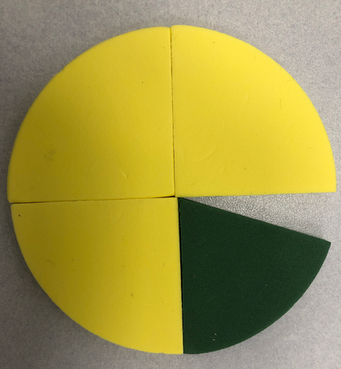 or 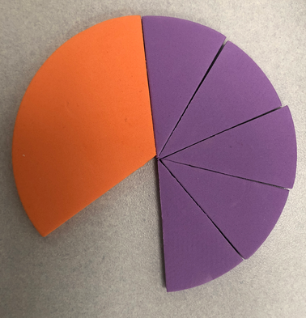 | - Tell me about your thinking.  - Can you explain where these fractions are in your representation?  - How does your representation/thinking show that your solution is true? | - Can you prove how much paint is in each cup?  - Explore the “keep thinking!” part of the task. | See Student B for an example of this strategy and the use of the “advancing” question.
Anticipated Student Response:  Students notice that  $\frac{3}{4}$ + $\frac{2}{8}$ = 1 whole and put those in Marie’s cup. | - Tell me about your thinking.  - Can you explain where these fractions are in your representation?  - How does your representation/thinking show that your solution is true? | - Explore the “keep thinking!” part of the task. | See Students A and D for different ways that students considered this relationship.
Anticipated Student Response:  Students use common denominators to combine fractions. This could be done with our without fraction circles or a tool.  Example 1:  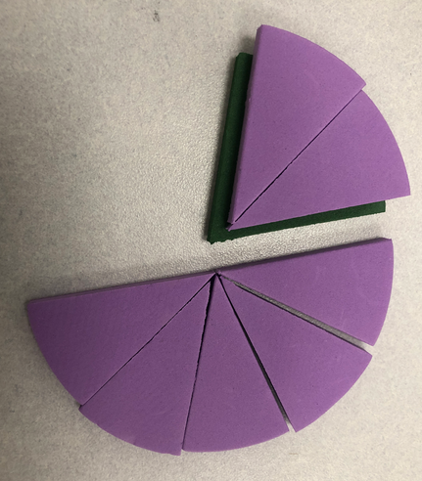 or 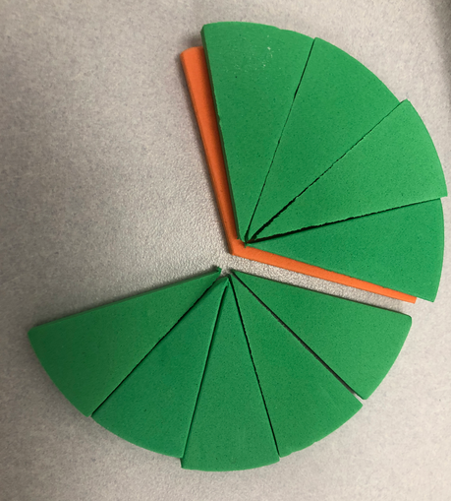  Example 2:  $\frac{2}{8}$ = $\frac{10}{40}$ $\frac{5}{10}$ = $\frac{20}{40}$ | - Tell me about your thinking.  - Can you explain where these fractions are in your representation?  - How does your representation/thinking show that your solution is true? | - Explore the “keep thinking!” part of the task. | See how Student B used fraction circles to find a common denominator of sixths using fraction circles.  See how Student F used a drawing of fraction circles to find a common denominator of 12.  See how Student E found a common denominator of 48.
Anticipated Student Response:  Students use reasoning skills to combine parts.  Examples:  I know that $\frac{2}{8}$ and $\frac{1}{3}$ are both less than $\frac{1}{2}$ , so together they will not be over 1 whole cup.  I know that $\frac{5}{10}$ is equal to $\frac{1}{2}$, so I could combine it with $\frac{2}{8}, \frac{1}{3}$ , $\frac{5}{12}$, or $\frac{1}{5}$ because they are all less than $\frac{1}{2}$. | - Tell me about your thinking.  - How does your representation/thinking show that your solution is true? | - Explore the “keep thinking!” part of the task. | - See how Student E initially thought that because 1/3 and 1/5 are less than 1/2, together they would also be less than 1/2.

Name _________________________________ Date ____________________
Pouring Paints 1
At the end of art class, six tables had leftover blue paint. The amounts are shown below:

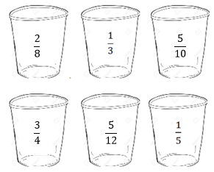

The art teacher asked Marie to combine two cups of paint into her empty cup. Her cup is the same size as the ones on the tables. Which containers could Marie combine into her paint cup without it overflowing? Show your math thinking using tools, pictures, words or numbers.

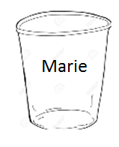
Keep thinking!
Is there another way she could pour the paint? Why or why not? How close to a full cup can she get? Show your math thinking.

Rich Mathematical Task Rubric
 | Advanced | Proficient | Developing | Emerging
Mathematical  Understanding | Proficient Plus:  - Uses relationships among mathematical concepts | - Demonstrates an understanding of concepts and skills associated with task  - Applies mathematical concepts and skills which lead to a valid and correct solution | - Demonstrates a partial understanding of concepts and skills associated with task  - Applies mathematical concepts and skills which lead to an incomplete or incorrect solution | - Demonstrates little or no understanding of concepts and skills associated with task  - Applies limited mathematical concepts and skills in an attempt to find a solution or provides no solution
Problem Solving | Proficient Plus:  - Problem solving strategy is efficient | - Problem solving strategy displays an understanding of the underlying mathematical concept  - Produces a solution relevant to the problem and confirms the reasonableness of the solution | - Chooses a problem solving strategy that does not display an understanding of the underlying mathematical concept  - Produces a solution relevant to the problem but does not confirm the reasonableness of the solution | - A problem solving strategy is not evident or is not complete  - Does not produce a solution that is relevant to the problem
Communication  and  Reasoning | Proficient Plus:  - Reasoning is organized and coherent  - Consistent use of precise mathematical language and accurate use of symbolic notation | - Communicates thinking process  - Demonstrates reasoning and/or justifies solution steps  - Supports arguments and claims with evidence  - Uses mathematical language to express ideas with precision | - Reasoning or justification of solution steps is limited or contains misconceptions  - Provides limited or inconsistent evidence to support arguments and claims  - Uses limited mathematical language to partially  communicate thinking with some imprecision | - Provides little to no correct reasoning or justification  - Does not provide evidence to support arguments and claims  - Uses little or no mathematical language to communicate thinking
Representations  and  Connections | Proficient Plus:  - Uses representations to analyze relationships and extend thinking  - Uses mathematical connections to extend the solution to other mathematics or to deepen understanding | - Uses a representation or multiple representations, with accurate labels, to explore and model the problem  - Makes a mathematical connection that is relevant to the context of the problem | - Uses an incomplete or limited representation to model the problem  - Makes a partial mathematical connection or the connection is not relevant to the context of the problem | - Uses no representation or uses a representation that does not model the problem  - Makes no mathematical connections

Task Supporting Documents

Pouring Paints—Notice/Wonder
At the end of art class, six tables had leftover blue paint. The amounts are shown below:
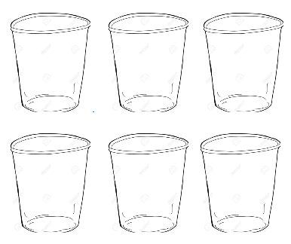

The art teacher asked Marie to combine two cups of paint into her empty cup. Her cup is the same size as the ones on the tables. Which containers could Marie combine into her paint cup without it overflowing? Show your math thinking using tools, pictures, words or numbers. .

Possible Graphic Organizer(s)

Pouring Paints—Cups Graphic Organizer

