At the end of art class, six tables had leftover blue paint. The amounts are shown below:

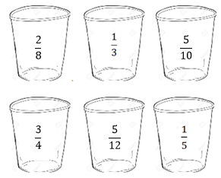

The art teacher asked Marie to combine two cups of paint into her empty cup. Her cup is the same size as the ones on the tables. Which containers could Marie combine into her paint cup without it overflowing? Show your math thinking using tools, pictures, words or numbers.

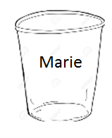

**Keep thinking!**

Is there another way she could pour the paint? Why or why not? How close to a full cup can she get? Show your math thinking.

STUDENT A

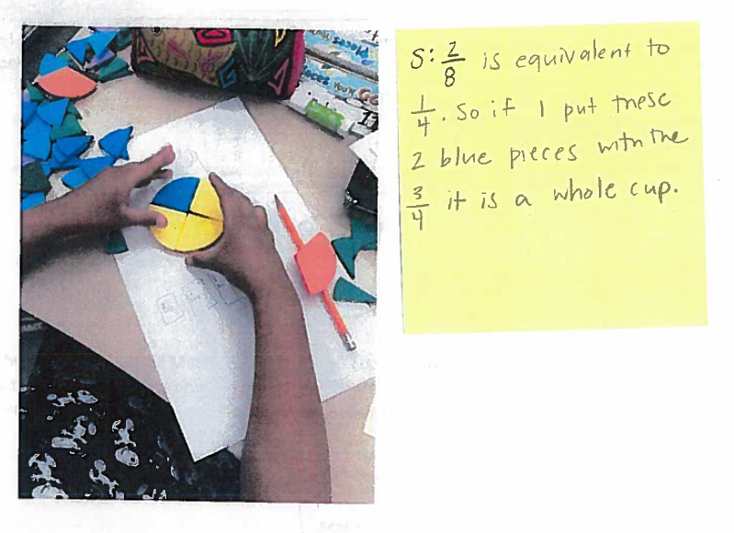

STUDENT B

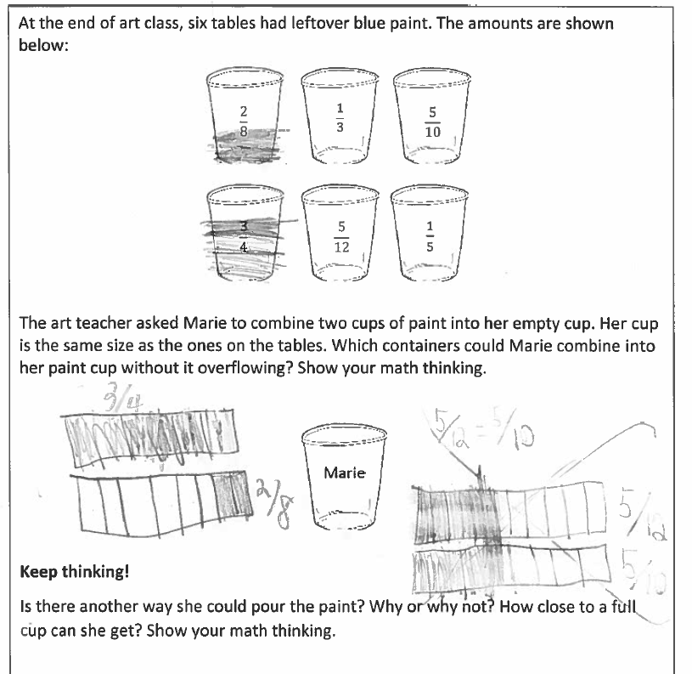

Student B Continued

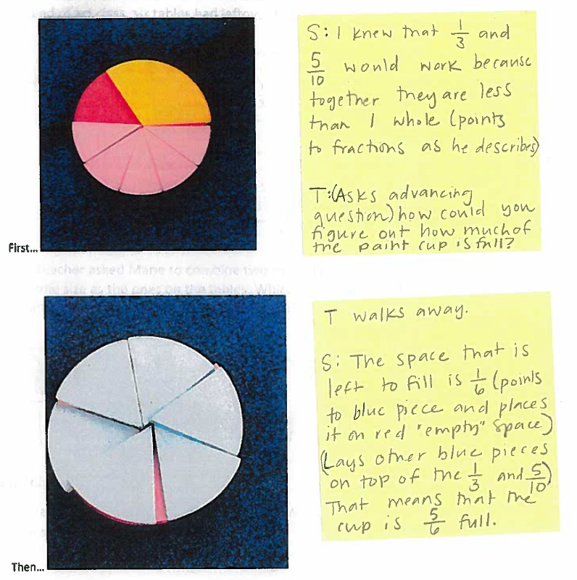

STUDENT C

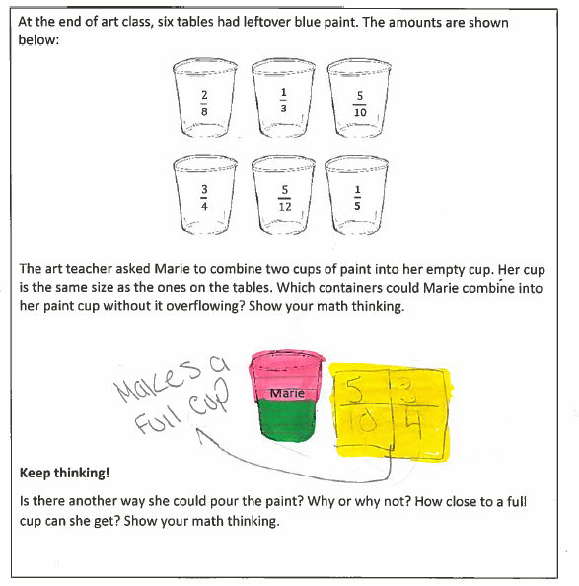

STUDENT D

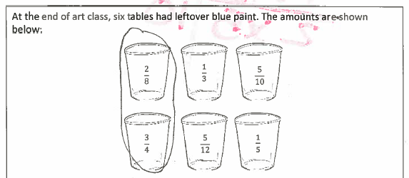

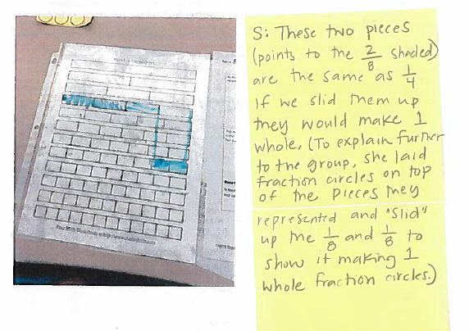

STUDENT E

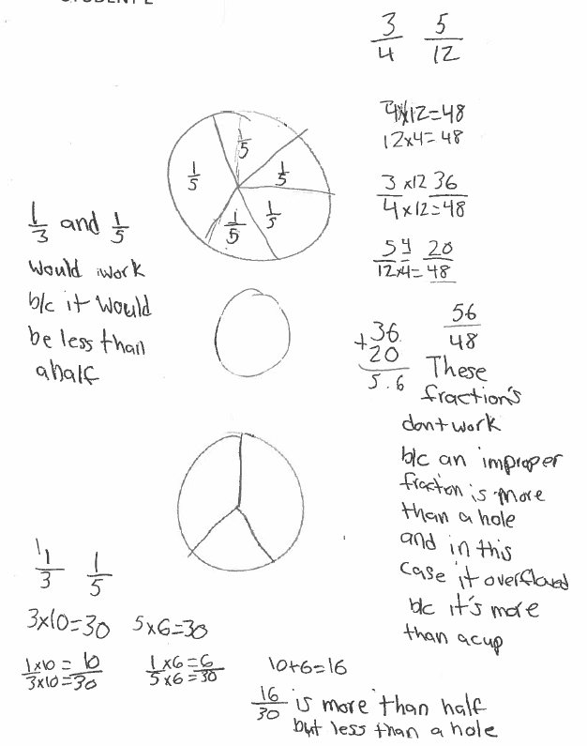

STUDENT F

