Name_________________________________ Date________________________

Trip Transportation
The fourth grade won a field trip paid for by a local car rental company. They may use any combination of vans, SUVs, and economy cars. Seating capacity is listed below.

- Drivers are included and not figured into the passenger information.

- There are 87 students and 7 teachers. They may invite up to 15 chaperones.

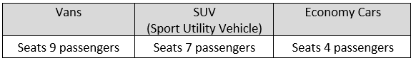
Which combination of vans, SUVs, and compact cars would you order? How many chaperones would be invited? Any empty seats?

Explain your thinking using pictures, numbers, and words.

