Task Overview/Description/Purpose:
- In this task students will combine three polygons to create a new polygon. They will then name the new polygon based on the number of sides.
- The purpose of this task is for students to:
  - combine polygons to create new polygons; and
  - use the number of sides in the new polygon to name the resulting polygon.

Standards Alignment: Strand – Number and Number Sense
Primary SOL: 3.12 The student will
- identify and name polygons with 10 or fewer sides; and
- combine and subdivide polygons with three or four sides and name the resulting polygon(s).
Related SOLs: 3.12a
Learning Intention(s):
- Content - I am learning to combine shapes to create new shapes.
- Language - I am learning to create polygons and name them according to their number of sides.
- Social - I am learning to explain my thinking as it relates to creating different polygons. I am learning to listen to and explain my peers’ strategies.
Success Criteria (Evidence of Student Learning):
- I can create and name a new polygon using three polygons.
- I can create more than one new polygon using the same (or different) polygons and name it based on each polygon’s number of sides.
Mathematics Process Goals
Problem Solving | - Students will combine any three of seven polygons to create and name a new polygon.  - Students will explore ways to make new polygons with three (same or different) shaped polygons.
Communication and Reasoning | - Students will communicate their thinking process for how they chose to combine 3 polygons to create and name a new polygon through words, picture representations, and numbers.  - Students will explain how and why the polygon they make changes when they manipulate the 3 shapes they use.  - Students will use appropriate and accurate written and/or oral mathematical language to express ideas.  - Students will demonstrate sound reasoning and justify their solutions in an organized and coherent manner.
Connections and Representations | - Students will create various representations as they use any 3 polygons to create a new polygon.  - Students will make connections between their representations and the number of sides of the polygons they created.

Task Pre-Planning
Approximate Length/Time Frame: 60 minutes
Grouping of Students: Students should begin the task independently. After actively monitoring student strategies and responses, the teacher should purposefully pair students together.
Materials and Technology:  - copy of task, supporting documents and pencil  - polygon shapes  - scissors  - graph paper  - pegboard and bands  - pegboard dot paper  - interactive geoboard app  - interactive shapes | Vocabulary:  - polygon  - triangle, quadrilateral, pentagon, hexagon, heptagon, octagon, nonagon, decagon  - combine/subdivide

Anticipate Responses: See the Planning for Mathematical Discourse Chart (columns 1-3).
Task Implementation (Before)
Task Launch:
- Anticipate prior knowledge: The teacher will access students’ prior knowledge related to polygons by engaging students in a discussion about examples of polygon versus non-examples. Students will sort a variety of examples in a table similar to the one below. Lead students in a discussion of why specific figures are or are not polygons according to the definition included in the VDOE Curriculum Framework: A polygon is a closed plane figure composed of at least three line segments that do not cross. As students create polygons by combining other polygons, remind them that line segments do not cross.
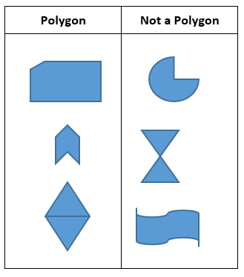
- Ensure understanding of task: The teacher will read the task aloud to all students. Discuss the various types of polygons.
- Establish clear expectations: Review rubric with students as a tool for monitoring their proficiency. Review classroom expectations for working independently.

Task Implementation (During)
Directions for Supporting Implementation of the Task
- Monitor – The teacher will observe students as they work independently on the task. The teacher will engage with students by asking assessing or advancing questions as necessary (see Planning for Mathematics Discourse Chart).
- Select –The teacher will select students to pair up based on the strategies used. The teacher may decide to pair students who used similar strategies to produce different solutions. Allow students time to work together in pairs on the task. The teacher will engage with pairs by asking assessing or advancing questions as necessary (see Planning for Mathematical Discourse Chart).
- Sequence – The teacher will select 2-3 student strategies to share with the whole group. One suggestion is to look for one common misconception and two correct responses to share.
- Connect – The teacher will consider ways to facilitate connections between different student representations.
Suggestions For Additional Student Support
- Sentence frames:
  - I used ________, ________, and ________, to create a new shape.
  - I made a ________ with my 3 polygons.
  - I can create a ________ with these polygons ________,________,________.
- Vocabulary development:
  - Post an anchor chart with names of polygons and the number of sides for each for student reference.
  - Reference the visual as needed to reinforce verbal, written, and graphic representations of new vocabulary words.
- Organization:
  - Students may benefit from tracing the outline of their new polygon to better see and count the sides.
- Extension:
  - How many different polygons (ex. hexagons, octagons) can you create using the same shapes? Different shapes?
- Some students may benefit from using concrete objects such as polygon shapes. Be sure to only use triangles and quadrilaterals as noted in the VDOE Curriculum Framework.
- Some students may benefit from using pegboards and bands to manipulate polygons.
Task Implementation (After) 20 minutes
Connecting Student Responses (From Anticipating Student Response Chart) and Closure of the Task:
- Allow students time to walk around and see the strategies of other students (Gallery Walk).
- Based on the actual student responses, select and sequence particular students to present their mathematical work during class discussion. Consider sharing one strategy that shows a common misconception, and two other strategies that can connect to each other. Facilitate a discussion about similarities and differences between the strategies.
- Connect different students’ responses to the key mathematical ideas to bring closure to the task.
- Consider ways to ensure that each student will have an equitable opportunity to share his/her thinking during task discussion (opportunity for Gallery Walk or think/pair/share with a partner or small group).
- Close the lesson by returning to the success criteria. Have students reflect on their progress related to the criteria.
Teacher Reflection About Student Learning:
- How will student understanding of the content through the use of the process goals be assessed?
  - Problem solving
  - Communication and Reasoning
  - Connections and Representations
- How will the evidence provided through student work inform further instruction?
  - Creating small groups to address misconceptions
  - Individualized learning goals related to the standard (based on proficiency with the task)

Planning for Mathematical Discourse
Mathematical Task: ___Polygon Puzzles_____ Content Standard(s): ____SOL 3.12bc___
Anticipated Student Response/Strategy  Provide examples of possible correct student responses along with examples of student errors/misconceptions | Assessing Questions  Teacher questioning that allows student to explain and clarify thinking | Advancing Questions  Teacher questioning that moves thinking forward | List of Students Providing Response Who? Which students used this strategy? | Discussion Order - sequencing student responses  - Based on the actual student responses, sequence and select particular students to present their mathematical work during class discussion  - Connect different students’ responses and connect the responses to the key mathematical ideas  - Consider ways to ensure that each student will have an equitable opportunity to share his/her thinking during task discussion
Anticipated Student Response:  Student does not know how to get started. | - What do you know about the problem?  - How can you show that?  - What 3 polygons would you like to start with? | - How can you use the same 3 polygons to create a new polygon?  - Can you use the same 3 polygons to create a new one with more/fewer sides?
Anticipated Student Response:  Student was able to use three polygons to make one new polygon. | - What polygons did you use to make your new polygon?  - Is there more than one way to make the same polygon?  - How is your polygon similar to/different than your partner’s polygon? | - Can you use 3 different polygons to create the same new polygon?
Anticipated Student Response:  Student was able to make more than one new polygon using the same 3 shapes. | - What is the same or different about each of your new polygons? | - How would your new polygon change if you changed one of your 3 original polygons?  - What if you changed 2 of your 3 polygons?
Anticipated Student Response:  The student is able to make a variety of new polygons using 3 polygons. | - Have you found all possible polygons to make using the 7 shapes given? How do you know? | - How many polygons do you need to make a “decagon, nonagon, octagon, heptagon, or hexagon”?  - Using any 3 polygons, which new polygon can you make that will have the most number of sides?

Name_________________________________ Date________________________
Polygon Puzzles
Catalina had these polygons. She combined three of them to create one new polygon.
- What are some new polygons she could have made?
- Label the polygons she could have used.
- Name the new polygon she could have created.
Explain your thinking using pictures, numbers and words.
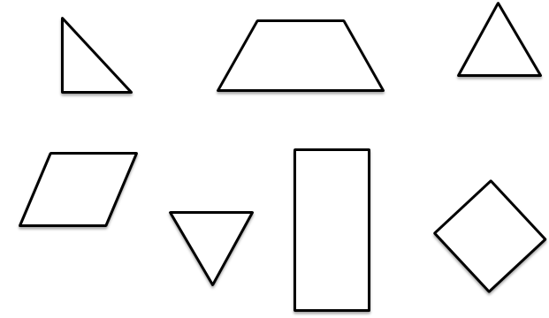

Rich Mathematical Task Rubric
 | Advanced | Proficient | Developing | Emerging
Mathematical  Understanding | Proficient Plus:  - Uses relationships among mathematical concepts or makes mathematical generalizations | - Demonstrates an understanding of concepts and skills associated with task  - Applies mathematical concepts and skills which lead to a valid and correct solution | - Demonstrates a partial understanding of concepts and skills associated with task  - Applies mathematical concepts and skills which lead to an incomplete or incorrect solution | - Demonstrates no understanding of concepts and skills associated with task  - Applies limited mathematical concepts and skills in an attempt to find a solution or provides no solution
Problem Solving | Proficient Plus:  - Problem solving strategy is well developed or efficient | - Problem solving strategy displays an understanding of the underlying mathematical concept  - Produces a solution relevant to the problem and confirms the reasonableness of the solution | - Problem solving strategy displays a limited understanding of the underlying mathematical concept  - Produces a solution relevant to the problem but does not confirm the reasonableness of the solution | - A problem solving strategy is not evident  - Does not produce a solution that is relevant to the problem
Communication  and  Reasoning | Proficient Plus:  - Reasoning or justification is comprehensive  - Consistently uses precise mathematical language to communicate thinking | - Demonstrates reasoning and/or justifies solution steps  - Supports arguments and claims with evidence  - Uses mathematical language to communicate thinking | - Reasoning or justification of solution steps is limited or contains misconceptions  - Provides limited or inconsistent evidence to support arguments and claims  - Uses limited mathematical language to partially communicate thinking | - Provides no correct reasoning or justification  - Does not provide evidence to support arguments and claims  - Uses no mathematical language to communicate thinking
Representations  and  Connections | Proficient Plus:  - Uses representations to analyze relationships and extend thinking  - Uses mathematical connections to extend the solution to other mathematics or to deepen understanding | - Uses a representation or multiple representations, with accurate labels, to explore and model the problem  - Makes a mathematical connection that is relevant to the context of the problem | - Uses an incomplete or limited representation to model the problem  - Makes a partial mathematical connection or the connection is not relevant to the context of the problem | - Uses no representation or uses a representation that does not model the problem  - Makes no mathematical connections

