**Packing Pencils**

The Pencil Company sells pencils in the following quantities:

* Singles (1 pencil)
* Bundles (10 pencils)
* Boxes (100 pencils)
* Cases (1,000 pencils)

The Pencil Company just received an order for 2,342 pencils. However, they currently have only one case of pencils in stock, but they have a large quantity of the other packing sizes.

Show at least three different ways that the pencils could be packed for this order. Explain your thinking using pictures, numbers, and words.

STUDENT A

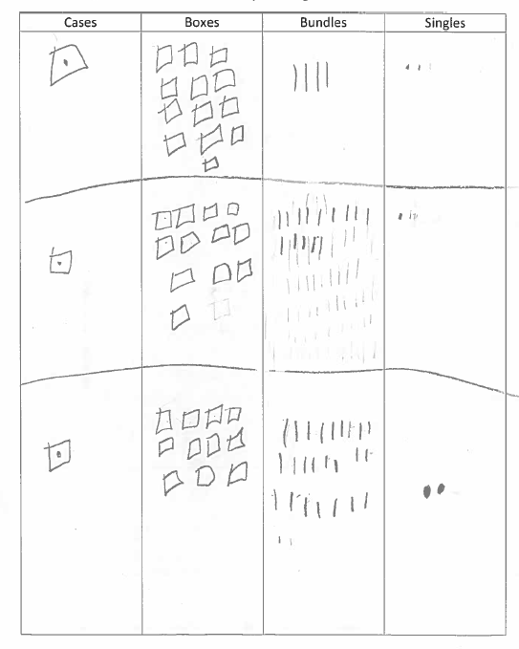

STUDENT B

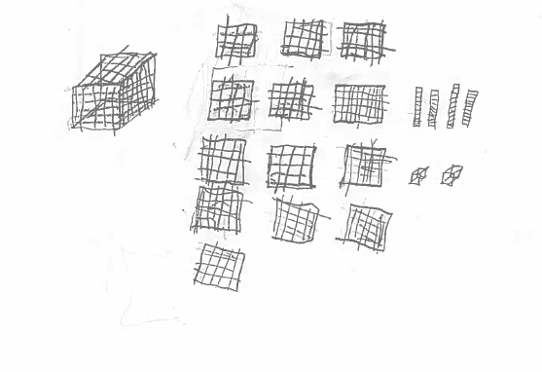

STUDENT C

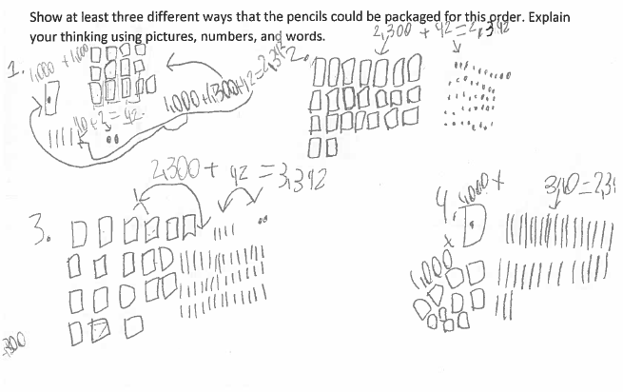

STUDENT D

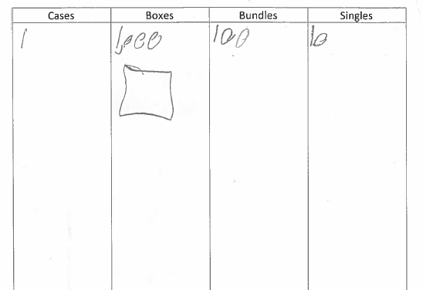

STUDENT E

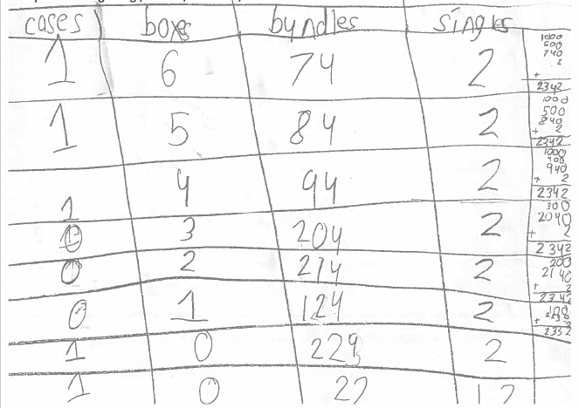

STUDENT E Continued

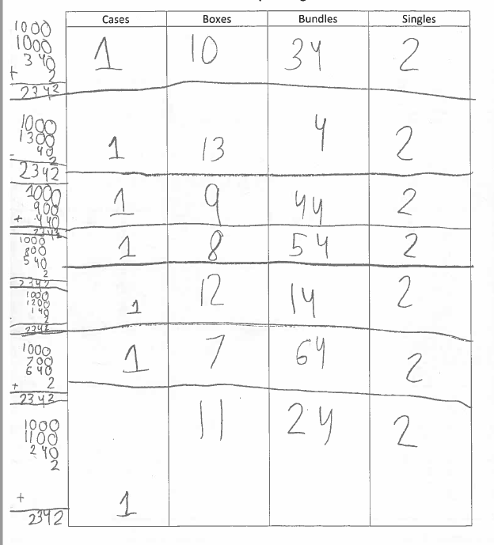

STUDENT F

